**Interquartile Range (IQR)**

**To find the outlier, IQR can be used.** **The placement data determines the IQR range of score in the main exams and the salary range given to them.**

|  |
| --- |
|  |

**Points to know from the table:**

* The IQR range from the table shows that the value from secondary to degree remains constant and for entrance test it increases and then gets drop down for mba
* The 1.5 rule value also continues to be in the same range for the following exams as like IQR.
* The outlier range for lesser and greater must be the final value for the outlier can exist for the dataset considered so min and max values are calculated to know whether they exist within the range of outlier value.
* The higher secondary score has a value in the dataset contains the min value that is lower than the lesser IQR and max value higher than the greater IQR.
* Finally, the salary range also has a greater range value than the greater range IQR.

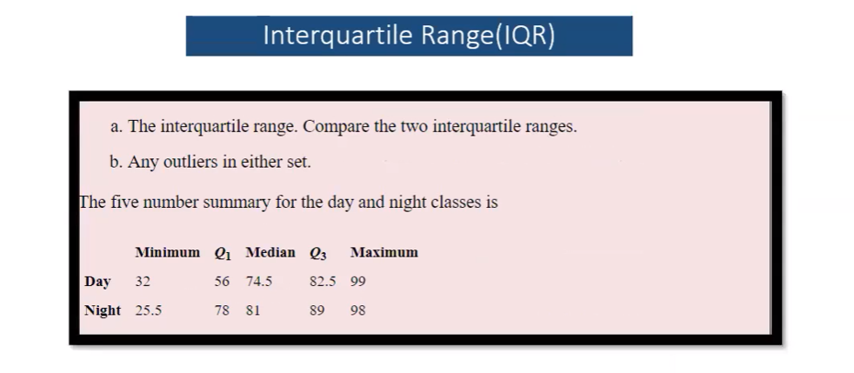

**SOLUTION:**

Day IQR=Q3-Q1 == 82.5-56 =26.5

Night IQR=Q3-Q1 ==89-78=11

1.5rule= Day- 39.75

1.5 rule night-16.5

Lesser Day=q1-1.5rule=16.25

Lesser night=q1-1.5rule=61.5

Greater Day=q3+1.5rule=122.5

Greater night =Q3+1.5 rule=105.5

The outlier can be found in the highlighted section.