







| **LEARNER** | Kalon Markides |
| --- | --- |
| **TRAINER** | Craig Reeves |
| **DATE** | 11/01/2022 |

| **ACTIVITY 1: SOURCES OF DATA** |
| --- |
| Write a description of the following sources of data and include 2 examples of each, where they can be gathered from.  **Primary Data**  Gathered directly from the source of your target market. Information that has been gathered first hand by yourself/  A survey or questionnaire  Interviews  **Secondary Data**  Obtained from another source. Data that has already been gathered through primary data and made available through other formats.  Government records  Websites  **Tertiary Data**  Referenced from another source. Information gathered through primary and secondary data sources.  Text books  Bibliographies  **Public or Open Data (What’s the difference?)**  Public Data  Can be obtained from a public source. Public data is information that can be freely used, reused and redistributed by anyone with no existing local, national or international legal restrictions on access or usage.  Open Data  *Open data* is data that can be freely used, re-used and redistributed by anyone. It is data that exists everywhere.  Maps  Libraries |

| **ACTIVITY 2: TYPES OF DATA** |
| --- |
| Write a description of each type of data gathered and provide 2 example scenarios where this can occur.  **Observational**  Data captured through observation. Captured in realtime impossible to recreate if it is lost.  Asking people on a street how many pets they have  Observing how many people drive a particular car on a street  **Experimental**  Data captured through performing experiments.  The effects of a dosage of a drug in a medical experiment  One drug by itself compared with that drug used in conjunction with another  **Derived/Compiled**  Data taken from other sources then combined to make a new data set  Combining area and population data from a city area to create population density data  Combining the age of mobile phone users and model of phone . |

| **ACTIVITY 3: DATA GATHERING** |
| --- |
| List at least 5 data gathering techniques and provide a description of each, along with the advantages and disadvantages. When would be appropriate to use each one?  **Surveys - They are used to ask respondents a set of questions (both types – open- and closed-ended questions). Over the past decade, the use of online surveys has skyrocketed.**  **Pros**  Ease of data collection  Low cost  Easily accessible  Easy to analyse  **Cons**  Maybe subject to bias  Cannot fully capture emotions or feelings  Some questions maybe unanswered  **Interviews - The interview is a meeting between an interviewer and interviewee. Interviews can be done face-to-face or via video conferencing tools.**  **Pros**  Accurate screening to target right audience  Easier to capture emotions and tone  Can ask follow up questions  **Cons**  Time consuming  High costs  Quality of data is dependant on the interviewer  **Focus Groups - A focus group includes dialogue with a group of deliberately selected participants who discuss a particular topic. Participants’ answers influence each other during the discussion. The focus group is led by a person called a moderator.**  **Pros**  Easy to measure reaction of customers  Can observe non verbal responses  **Cons**  High costs  Subject to moderator bias  For sensitive topics participants cannot answer honestly  **Observation - Observation involves a person who observes events, people, and interactions around a topic to provide a rich description of them.**  **Pros**  Simple to collect  Allows for a detailed description of data  Greater accuracy and data quality  Does Not depend on people's willingness to respond  **Cons**  Can be time consuming  Potential for observers bias  Expensive  Past situations cannot be observed  **Records/Documents - This method involves extracting and analyzing data from existing documents.**  **Pros**  Easy to collect  Allows progress tracking  Don’t need to search or motivate respondents  **Cons** |
| Information may be outdated  Can be time consuming  Data may be incomplete |
|  |

| **ACTIVITY 4: DATA GATHERING** |
| --- |
| Screenshot the form or type out the questions below. Write a short report or annotate the form – what was the purpose of each question and the format in which they could answer it (yes/no, scale of 1 – 10, or a short answer). |

| **ACTIVITY 5: CREATING A USE CASE DIAGRAM** |
| --- |
| Think of an online retail system called Amazon where customers can access products to view and buy, administrators can maintain the website. What type of use cases may stem from both customers and administrators? Create a simple use-case diagram to demonstrate this. |

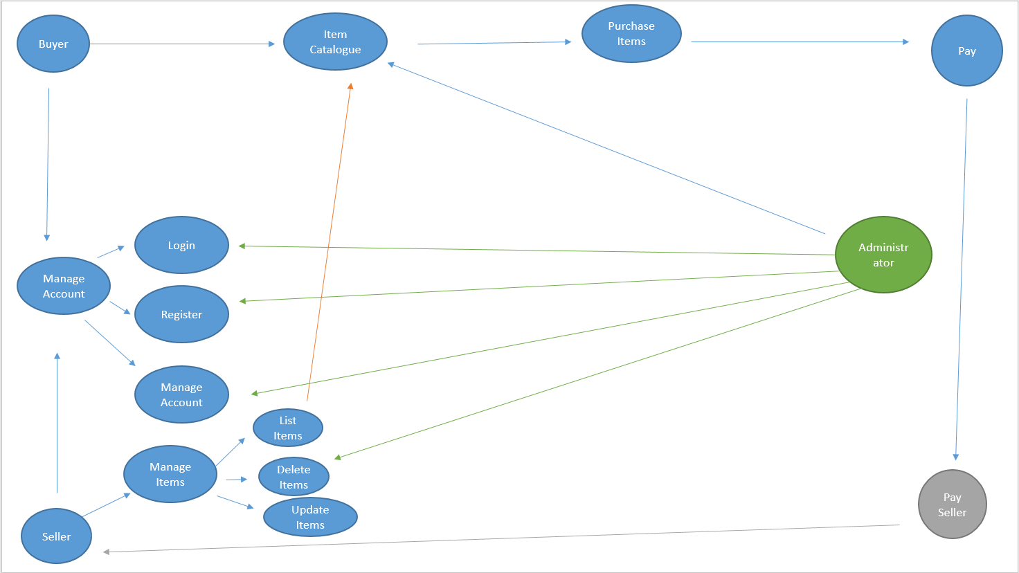

| **ACTIVITY 6: DOCUMENTING A USE CASE DIAGRAM** |
| --- |
| Consider the following scenario:  A library keeps records of loans, books and members. It stores members’ names, loan limit (number of books a member may borrow) and date of birth. The library also stores information about its books: title, authors, publishers, publication date, ISBN and purchase price.  As some books are very popular, the library often buys several copies of the same book. All loans are for three weeks. The library needs to be able to record, edit and delete book details; record loans and returns, and reserve books. Overdue notices are to be sent when books are overdue.  It also wants its library system to automatically update member status. The system must also record the current price of a book.  List all the use case scenarios in the tables provided below, adding any more you can think of. |

| Use Case | Create a new member profile |
| --- | --- |
| Brief Description | Create a new member profile with name ,loan limit (number of books a member may borrow) and date of birth. |
| Actors | Librarian |
| Precondition | Not an existing member |
| Main flow | Create new member record |
| Alternative flow | N/A |
| Post condition | Confirmation email |

| Use Case | Add new book |
| --- | --- |
| Brief Description | Add a new book with information on title, authors, publishers, publication date, ISBN , purchase price, quantity and record the current price of a book. |
| Actors | Librarian |
| Precondition | Not an existing book |
| Main flow | Add a new book |
| Alternative flow | N/A |
| Post condition | Confirmation message that book has been added |

| Use Case | Edit book |
| --- | --- |
| Brief Description | Edit if the book is loaned out,when it will return and if it is overdue, delete book details, edit current price, edit quantity. |
| Actors | Librarian |
| Precondition | Must be an existing book |
| Main flow | Edit book |
| Alternative flow | N/A |
| Post condition | Confirmation message that book has been edited |

| Use Case | Search for book |
| --- | --- |
| Brief Description | A book can be searched for using its information on title, authors, publishers, publication date and ISBN |
| Actors | Librarian |
| Precondition | Must be an existing book |
| Main flow | Search for book |
| Alternative flow | N/A |

| Use Case | View book information |
| --- | --- |
| Brief Description | Displays information on a book's title, authors, publishers, publication date and ISBN ,if the book is loaned out,when it will return and if it is overdue. |
| Actors | Librarian |
| Precondition | Must be an existing book |
| Main flow | View book information |
| Alternative flow | N/A |

| Use Case | Reserve books |
| --- | --- |
| Brief Description | A member can reserve a book with the librarian |
| Actors | Member, Librarian |
| Precondition | Book is not in stock and user is a member, member is not at book limit |
| Main flow | Book is Reserved books and systems updates member added to reserve list |
| Alternative flow | Notify book is already reserved |
| Post condition | A book is reserved if it is available |

| Use Case | Return Book |
| --- | --- |
| Brief Description | A member can return a book that is overdue or on loan and the librarian updates information on the book. |
| Actors | Member, Librarian |
| Precondition | Book must be on loan |
| Main flow | Return book |
| Alternative flow | Edit Book if reserved notify member it is ready to collect |
| Post condition | A book is returned by the member and the librarian updates the book's information. |

| Use Case | Loan Book |
| --- | --- |
| Brief Description | If a book is available a member can loan it and the librarian will update the information on the book. |
| Actors | Member, Librarian |
| Precondition | Book must be available |
| Main flow | Loan Book |
| Alternative flow | Reserve book |
| Post condition |  |

| Use Case | Cancel membership |
| --- | --- |
| Brief Description | A user can cancel their membership via an app which updates their membership status |
| Actors | Member, Database |
| Precondition | Must be an existing member with no overdue or on loan books |
| Main flow | Cancel membership |
| Alternative flow | Return books |
| Post condition | Membership is cancelled and members record is deleted |

| Use Case | Send overdue notice |
| --- | --- |
| Brief Description | Librarian sends an overdue notice to any members who have overdue books |
| Actors | Librarian |
| Precondition | Book must be overdue |
| Main flow | Send overdue notice |
| Alternative flow |  |
| Post condition | Overdue notice is sent |

| Use Case | Login to account |
| --- | --- |
| Brief Description | A buyer or seller can login into their account if they are already registered |
| Actors | Buyer, Seller |
| Precondition | Must be registered |
| Main flow | User logs in to their account if they have one |
| Alternative flow | Register User |
| Post condition | User logs into their account |

| Use Case | Register account |
| --- | --- |
| Brief Description | A new buyer or seller registers a new account |
| Actors | Buyer, Seller, |
| Precondition | Cannot be an existing member |
| Main flow | User Registers a new account |
| Alternative flow | Account already registered, reset account details |
| Post condition | A new user is registered |

| Use Case | Manage account |
| --- | --- |
| Brief Description | A registered buyer or seller can update their account details or delete their account, admin can delete account or reset password for user |
| Actors | Buyer, Seller, Admin |
| Precondition | Must be an existing member, must be logged in |
| Main flow | Manage account |
| Alternative flow |  |
| Post condition | Account details are updated or account is deleted |

| Use Case | List items |
| --- | --- |
| Brief Description | A registered seller can list items they have for sale, price, product title, product amount, delivery options and time |
| Actors | Seller |
| Precondition | Must be an existing member, must be logged in , must be a seller |
| Main flow | List items |
| Alternative flow |  |
| Post condition | Items are listed by the seller |

| Use Case | Buy items |
| --- | --- |
| Brief Description | A registered user purchases items |
| Actors | Buyer |
| Precondition | Must be an existing member, must be logged in , item must be available |
| Main flow | A user buys an item if it is available if not they are notified when it is in stock |
| Alternative flow | Notify user when item is available |
| Post condition | A user buys an item if it is available |

| Use Case | View items |
| --- | --- |
| Brief Description | A buyer can view available items that a seller has listed |
| Actors | Buyer |
| Precondition | Must be an existing member, must be logged in , must be a buyer , must have searched for items |
| Main flow | A buyer can view items they wish to purchase |
| Alternative flow | Notify buyer item is not currently listed |
| Post condition | User views items they wish to buy |

| Use Case | Pay for items |
| --- | --- |
| Brief Description | A buyer pays for any available items they have purchased |
| Actors | Buyer, Seller |
| Precondition | Must be an existing member, must be logged in , must be a buyer , must have searched for items and added to basket |
| Main flow | A buyer pays for items |
| Alternative flow | Payment declined |
| Post condition | buyer pays for items and money is sent to seller |

| Use Case | Delete items |
| --- | --- |
| Brief Description | A seller can delete an item or an admin can if the item is prohibited |
| Actors | Buyer |
| Precondition | Must be an existing member, must be logged in , must be a seller or admin |
| Main flow | Seller deleted item and items are update, admin deletes items and items are updated and user is notified they were selling a prohibited item |
| Alternative flow |  |
| Post condition | Item(s) deleted |







| **LEARNER** | Kalon Markides |
| --- | --- |
| **TRAINER** | Craig Reeves |
| **DATE** | 12/01/2022 |

| **ACTIVITY 1: EXCEL FUNCTIONS** |
| --- |
| Download the Statistics file excel sheet. Using the excel functions:   * Show the average marks that students achieve * Show the number of students that took the exam * Show the number of students who did not take the exam   Screenshot the results along with the function used below. |
| **ACTIVITY 2: FLAT FILE VS RELATIONAL DATABASES** |
| Do some research on the difference between a flat file database and a relational database. Write a short report on the comparisons between them and the appropriate time to use one or the other.  **Flat File Databases**  Stores data in a single table structure.  Typically plain text files that store one record per line with record fields delimited by whitespace or a delimiting character . An example of a delimiting character would be the “,” in a .csv file.  Flat files can be read directly by a variety of software.  **Relational Database**  Uses Multiple table structures, cross-referencing records between tables.  In addition to the data tables, relational databases use “indexes” to quickly find records based on search criteria.  Relational databases generally require a relational database management system(RDBMS) to manage and access the data.  Some advantages of Flat file databases are simple and can be used with the requirement of special software, they reduce the risk of data loss and can be saved in a variety of forms. There are some disadvantages of using Flat file databases as they are limited in what they can do as a database and that they are typically accessed offline and are local to the device or machine they are contained to.  Flat file databases could be used to store usernames or passwords, product details, games or music collections, contact details and entities and attributes.  Some advantages of Relational databases are they are faster and more efficient than flat file databases and use “indexes” to quickly find records based on search criteria, are more secure and can be protected, more accessible through means of networking. Relational databases tend to be prone to information loss as they can be transferred from one system to another, they can become slower as more data is added and they require more physical memory and storage space.  Relational databases could be used for financial transactions, customer or employee details and medical records. |

| **ACTIVITY 3: CREATING SCATTER DIAGRAM** |
| --- |
| Using the same file as before, create scatter diagrams with lines of best fit for:   * The age of the students and the year they were born in * Time spent studying and the exam results they received * The age of students and time spent studying   For each diagram, screenshot them into your workbook and write a brief description on your findings.      From the chart above can see that students who spent more hours learning achieved a higher exam score.    From the chart above we can see that more students who took the exam where between the ages fof 18-20 and where born between the years 2002 and 2004 |
| **ACTIVITY 4: ENTITIES AND ATTRIBUTES** |
| In a group or individually, decide which of the following are entities or attributes.   |  | **Attribute or Entity?** | | --- | --- | | **ORDER_NUMBER** | **Attribute** | | **ORDER** | **Entity** | | **CUSTOMER_ID** | **Attribute** | | **DELIVERY_ADDRESS** | **Attribute** | | **BILLING_ADDRESS** | **Attribute** | | **CUSTOMER_NAME** | **Attribute** | | **PRODUCT_NUMBER** | **Attribute** | | **PRODUCT** | **Entity** | | **PRODUCT_DESCRIPTION** | **Attribute** | | **CUSTOMER** | **Entity** |   Using the above example. Identify which attributes belong to which entities.  **Customer - Entity**  Customer name - Att  Customer ID - Att  Billing Address - Att  Delivery Address - Att  **Product - Entity**  Product Number - Att  Product Description - Att  **Order - Entity**  Order Number - Att  Delivery Address - Att |

| **ACTIVITY 5: DATA TYPES** |
| --- |
| Do some research online and try to identify what you think the best database data type for the following forms of data might be.  **A NUMBER (e.g. the number 1000)**  INTEGER  **A SHORT PIECE OF TEXT (e.g. an email address)**  VARCHAR  CHAR(size)  **A LONG SECTION OF TEXT (e.g. a short essay)**  MEDIUMTEXT  LONGTEXT  **A DATE**  DATE  DATETIME  **A TIME**  TIME  TIMESTAMP  **A YES/NO VALUE**  BOOLEAN  BOOL  SET(val1, val2, val3, ...)  **AN IMAGE**  VARBINARY(MAX)  IMAGE  BLOB  Not recommended to store large images in a DB or use a link or store to a separate source with a link |
|  |

| **ACTIVITY 6: CREATING AN ERD** |
| --- |
| Using the example from the previous slide, create an ERD with for a university that consist of the following tables:   * Courses * Modules * Students * Lecturers   In your ERD, show the relationship between these tables. |

