





| **LEARNER** | Kalon Markides |
| --- | --- |
| **TRAINER** | Craig Reeves |
| **DATE** | 20/01/2022 |
| **ACTIVITY 1: NESTED FUNCTIONS** |
| Using the Statistics Example Spreadsheet find solutions for the following problems  **Based on the following grade boundaries, write a function that determines the letter grade for each student:**  (70+ A, 60-69 B, 50-59 C, 40-49 D, 0-39 F)  **Amend your previous function to include those without a score as “FAIL”**  Extension  **Use functions to calculate the average numerical score per Tutor**  **Use functions to calculate the average letter grade per Tutor** |

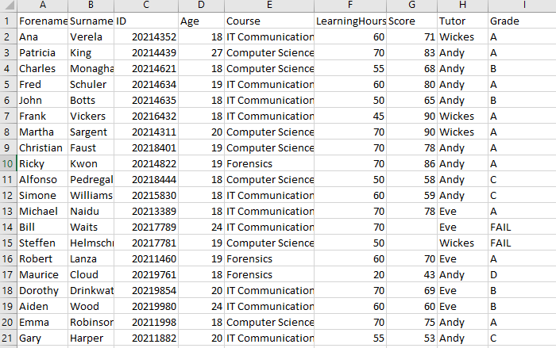

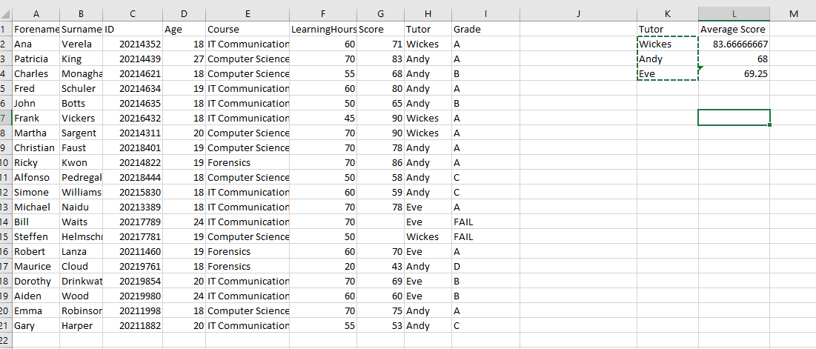

| **ACTIVITY 2: CREATING A DASHBOARD** |
| --- |
| Revisit the reports you made for our University in the Database Development Workbook. Using the knowledge you have gained about Charts and KPIs, try to design a Dashboard for the performance of the University |

| **ACTIVITY 3: JOHN SNOW** |
| --- |
| Do some research on the works of John Snow with regards to the outbreak in Soho, London.  Compile your information into a short report, providing evidence and sources to back up your conclusion. Use the headings as a guide for each section. Approx. 400 words.  Introduction about John Snow  John Snow was an English physician and a leader in the development of anaesthesia and medical hygiene. He is considered one of the founders of modern epidemiology, in part because of his work in tracing the source of a cholera outbreak in Soho, London, in 1854, which he curtailed by removing the handle of a water pump. Snow’s findings inspired the adoption of anaesthesia as well as fundamental changes in the water and waste systems of London, which led to similar changes in other cities, and a significant improvement in general public health around the world.John snow was indeed called the "Father of modern Epidemiology"  Cholera Outbreak in London  Preceding the 1854 Broad Street cholera outbreak, physicians and scientists held two competing theories on the causes of cholera in the human body: miasma theory and germ theory.The London medical community debated between these causes for the persistent cholera outbreaks in the city. The cholera-causing bacterium [*Vibrio cholerae*](https://en.wikipedia.org/wiki/Vibrio_cholerae) was isolated in 1854, but the finding did not become well known and accepted until decades later.  John Snow’s Findings  After the cholera epidemic had subsided, government officials replaced the Broad Street pump handle. They had responded only to the urgent threat posed to the population, and afterward they rejected Snow's theory. To accept his proposal would have meant indirectly accepting the faecal-oral route of disease transmission, which was too unpleasant for most of the public to contemplate.  It was not until 1866 that [William Farr](https://en.wikipedia.org/wiki/William_Farr), one of Snow's chief opponents, realised the validity of his diagnosis when investigating another outbreak of cholera at [Bromley by Bow](https://en.wikipedia.org/wiki/Bromley_by_Bow) and issued immediate orders that unboiled water was not to be drunk.  Farr denied Snow's explanation of how exactly the contaminated water spread cholera, although he did accept that water had a role in the spread of the illness. In fact, some of the statistical data that Farr collected helped promote John Snow's views  Snow's conclusions were not predominantly based on the Broad Street outbreak, as he noted that he hesitated to come to a conclusion based on a population that had predominantly fled the neighbourhood and redistributed itself. He feared throwing off results of the study.  Snow later used a [dot map](https://en.wikipedia.org/wiki/Dot_map) to illustrate how cases of cholera occurred around this pump.[[14]](https://en.wikipedia.org/wiki/1854_Broad_Street_cholera_outbreak#cite_note-FOOTNOTESnow185545-14) Snow's efforts to connect the incidence of cholera with potential geographic sources was based on creating what is now known as a [Voronoi diagram](https://en.wikipedia.org/wiki/Voronoi_diagram). He mapped the locations of individual water pumps and generated cells which represented all the points on his map which were closest to each pump. The section of Snow's map representing areas in the city where the closest available source of water was the Broad Street pump included the highest incidence of cholera cases. Snow also performed a statistical comparison between the [Southwark and Vauxhall Waterworks Company](https://en.wikipedia.org/wiki/Southwark_and_Vauxhall_Waterworks_Company), and a waterworks at [Seething Wells](https://en.wikipedia.org/wiki/Seething_Wells) (owned by the [Lambeth Waterworks Company](https://en.wikipedia.org/wiki/Lambeth_Waterworks_Company)) that was further upriver and hence had cleaner water; he showed that houses supplied by the former had a cholera mortality rate 14 times that of those supplied by the latter.  There was one significant anomaly—none of the workers in the nearby Broad Street [brewery](https://en.wikipedia.org/wiki/Brewery) contracted cholera. As they were given a daily allowance of beer, they did not consume water from the nearby well.[[](https://en.wikipedia.org/wiki/1854_Broad_Street_cholera_outbreak#cite_note-FOOTNOTESnow185542-17)During the brewing process, the [wort](https://en.wikipedia.org/wiki/Wort) (or unfermented beer) is boiled in part so that [hops](https://en.wikipedia.org/wiki/Hops) can be added. This step killed the cholera bacteria in the water they had used to brew with, making it safe to drink. Snow showed that the Southwark and Vauxhall Waterworks Company was taking water from sewage-polluted sections of the Thames and delivering it to homes, resulting in an increased incidence of cholera among its customers. Snow's study is part of the history of [public health](https://en.wikipedia.org/wiki/Public_health) and [health geography](https://en.wikipedia.org/wiki/Health_geography). It is regarded as the founding event of [epidemiology](https://en.wikipedia.org/wiki/Epidemiology). Snow calculated the cholera rates for a 7-week period in homes supplied by each of the two in possibly the most famous presentation table in epidemiology.Snow also performed a statistical comparison between the [Southwark and Vauxhall Waterworks Company](https://en.wikipedia.org/wiki/Southwark_and_Vauxhall_Waterworks_Company), and a waterworks at [Seething Wells](https://en.wikipedia.org/wiki/Seething_Wells) (owned by the [Lambeth Waterworks Company](https://en.wikipedia.org/wiki/Lambeth_Waterworks_Company)) that was further upriver and hence had cleaner water; he showed that houses supplied by the former had a cholera mortality rate 14 times that of those supplied by the latte  Conclusion  Although the methods of analysing data have changed a lot, the methods used to gather or obtain data are very similar to today's methods such as the use of surveys, voronoi diagrams, tables and dot maps. Snow was conscious of obscuring data and understood that results could be thrown due to redistribution of the population during the outbreak. Snow even used a statistical comparison which is a method still used today.  Fun facts  He personally administered chloroform to Queen Victoria when she gave birth to the last two of her nine children, Leopold in 1853 and Beatrice in 1857.  In 1857 Snow made an early and often overlooked contribution to epidemiology in a pamphlet, On the adulteration of bread as a cause of rickets  Snow became a [vegetarian](https://en.wikipedia.org/wiki/Vegetarianism) at the age of 17 and was a [teetotaller](https://en.wikipedia.org/wiki/Teetotaller).He embraced an [ovo-lacto vegetarian](https://en.wikipedia.org/wiki/Ovo-lacto_vegetarian) diet by supplementing his vegetables with dairy products and eggs. On this diet he excelled at swimming.He later became a [vegan](https://en.wikipedia.org/wiki/Veganism). In the mid-1840s, his health deteriorated and he suffered a renal disorder which he attributed to his vegan diet so he took up meat-eating and drinking wine.  **Sources**  **https://www.ncbi.nlm.nih.gov/pmc/articles/PMC7150208/**  **https://www.10-facts-about.com/dr.-john-snow/id/1481**  [**https://en.wikipedia.org/wiki/John_Snow**](https://en.wikipedia.org/wiki/John_Snow)  **"Shephard, David A. E. John Snow: Anaesthetist to a Queen and Epidemiologist to a Nation. Cornwall, Prince Edward Island: York Point Publishing, 1995."**  **Source: Snow J. On the mode of transmission of cholera. London: John Churchill, 1855, pp. 55–98. Part 3, Table IX, Reprinted by UCLA Fielding School of Public Health 2001. Available at:** [**http://www.ph.ucla.edu/epi/snow/snowbook3.html**](http://www.ph.ucla.edu/epi/snow/snowbook3.html) **(accessed 26 June 2016).** |

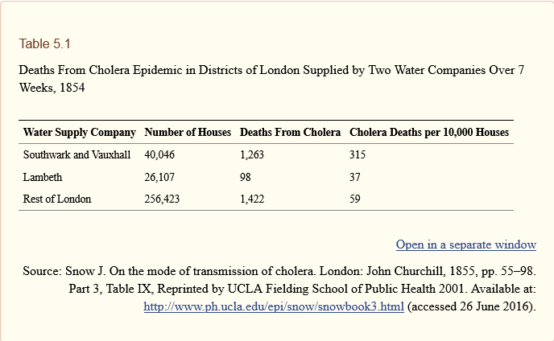

| **ACTIVITY 4: FINANCIAL CRISIS AND THE GREAT RECESSION** |
| --- |
| Using the IMF data supplied and what you have learned so far about charts and spreadsheets to see if you can identify a relationship between any of the variables |

