Open a new Python interpreter(REPL) and use it to find the value of 2 + 3

a = 2

b = 3

print(a+b)

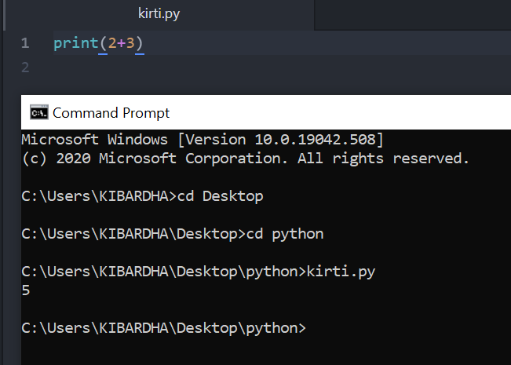

Create a python script to print hello, world! four times.

a = ["Hello!world", "Hello!world", "Hello!world","Hello!world"]

for x in a:

print(x)

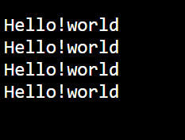

What will be output of the following program? print (2 < 3 and 3 > 1) print (2 < 3 or 3 > 1) print (2 < 3 or not 3 > 1) print (2 < 3 and not 3 > 1)

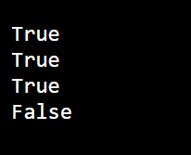

What will be output of the following program? x = 4 y = 5 p = x < y or x < z print (p)

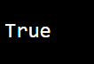

What will be output of the following program? True, False = False, True print (True, False) print (2 < 3)

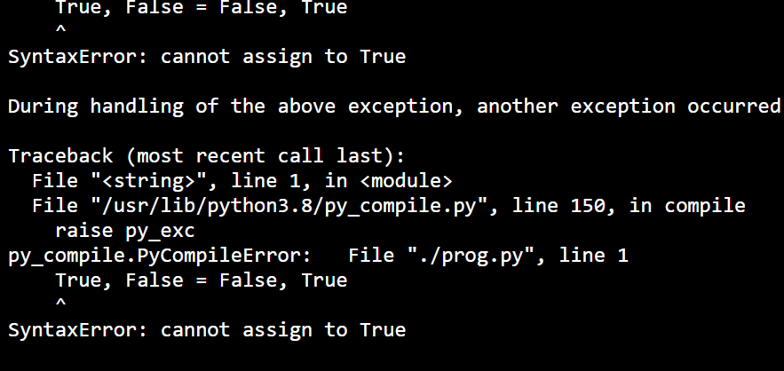

What happens when the following code is executed? Will it give any error? Explain the reasons. x = 2 if x == 2: print x else: print y

It will give indentation Error

What happens the following code is executed? Will it give any error? Explain the reasons. x = 2 if x == 2: print x else: x +

At line 3 indentation is expected

Write a program add.py that takes 2 numbers as command line arguments and prints its sum.as follows

x = input("enter first number: ")

y = input("enter second number: ")

sum = int(x) + int(y)

print("the sum is:",sum)

Write a function, isharshad that determines whether a number is a Harshad number (for number base 10). A Harshad number is an integer that is divisible by the sum of its digits -(Wikipedia) Example: 81 ? 8 + 1 = 9 ? 81/9 = 9 ? Harshad! >>> isharshad(81) True Hint: convert the number to a string

num = 156;

rem = sum = 0;

#Make a copy of num and store it in variable n

n = num;

#Calculates sum of digits

while(num > 0):

rem = num%10;

sum = sum + rem;

num = num//10;

#Checks whether the number is divisible by the sum of digits

if(n%sum == 0):

print(str(n) + " is a harshad number");

else:

print(str(n) + " is not a harshad number");

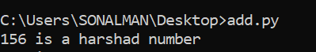

wirte a program which will find all such numbers which are divisible by 7 but are not a multiple of 5, between 2000 and 3200 (both included). The numbers obtained should be printed in a comma-separated sequence on a single line. Hints: Consider use range(#begin, #end) method940,2975,3010,3045,3080,3115,3150,3185

22030,2065,2100,2135,2170,2205,2240,2275,2310,2345,2380,2415,2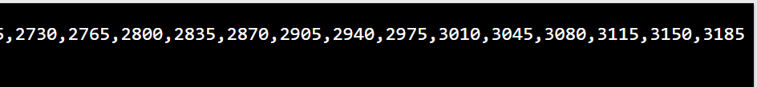

Write a program which can compute the factorial of a given numbers. The results should be printed in a comma-separated sequence on a single line. Suppose the following input is supplied to the program: 4

def factorial(n): if n == 0: return 1 else: return n * factorial(n-1) n=int(input("Input a number to compute the factiorial : "))

print(factorial(n))



Write a program which accepts a sequence of comma-separated numbers from console and generate a list and a tuple which contains every number. Suppose the following input is supplied to the program: 34,67,55,33,12,98 Then, the output should be: ['34', '67', '55', '33', '12', '98'] ('34', '67', '55', '33', '12', '98')

number = int(input("Type a number: "))

numberDict = {}

for i in range(1, number+1):

numberDict[i] = i*i

print(numberDict)

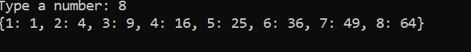2555,2590,2625,2660,2695,2730,2765,2800,2835,2870,2905,2940,

Project Euler is a website with mathematical problems that should/could be solved by computers. Go to the Web-site http://projecteuler.net/ and solve some of the problems using Python

Write a program that calculates and prints the value according to the given formula: Q = Square root of [(2 * C * D)/H] Following are the fixed values of C and H: C is 50. H is 30. D is the variable whose values should be input to your program in a comma separated sequence.

import math

numbers = input("Provide D: ")

numbers = numbers.split(',')

result_list = []

for D in numbers:

Q = round(math.sqrt(2 * 50 * int(D) / 30))

result_list.append(Q)

print(result_list)

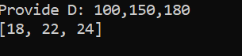

Write a program which takes 2 digits, X,Y as input and generates a 2-dimensional

array. The element value in the i-th row and j-th column of the array should be

i*j.

Note: i=0,1.., X-1; j=0,1,¡Y-1.

ExampleSuppose the following inputs are given to the program:3,5Then, the output of the program should be:[[0, 0, 0, 0, 0], [0, 1, 2, 3, 4], [0, 2, 4, 6, 8]]

m=int(input("Row:"))

n=int(input("Column:"))

matrix=[[0 for col in range(n)] for row in range(m)]

for row in range(m):

for col in range(n):

matrix[row][col]=row*col

print(matrix)

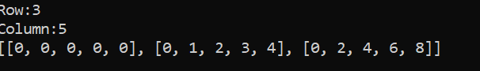

2030,2065,2100,2135,2170,2205,2240,2275,2310,2345,2380,2415, Write a program that accepts a comma separated sequence of words as input and

prints the words in a comma-separated sequence after sorting them

alphabetically.

Suppose the following input is supplied to the program:

without,hello,bag,world

Then, the output should be:

bag,hello,without,world

phrase = input("Input words: ")

phrase_list = phrase.split(",")  
phrase_list.sort()  
print((', ').join(phrase_list))



Write a program that accepts sequence of lines as input and prints the lines

after making all characters in the sentence capitalized.

Suppose the following input is supplied to the program:

Hello world

Practice makes perfect

Then, the output should be:

HELLO WORLD

PRACTICE MAKES PERFECT

lines = []

while True:

l = input()

if l:

lines.append(l.upper())

else:

break;

for l in lines:

print(l)

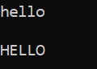

Write a program that accepts a sequence of whitespace separated words as input

and prints the words after removing all duplicate words and sorting them

alphanumerically.

Suppose the following input is supplied to the program:

hello world and practice makes perfect and hello world again

Then, the output should be:

again and hello makes perfect practice world

phrase = input("Type in: ")

phrase_splited = phrase.split(' ')

word_list = []

for i in phrase_splited:

if i not in word_list:

word_list.append(i)

else:

continue

word_list.sort()

print((' ').join(word_list))





Write a program which accepts a sequence of comma separated 4 digit binary

numbers as its input and then check whether they are divisible by 5 or not. The

numbers that are divisible by 5 are to be printed in a comma separated sequence.

Example:

0100,0011,1010,1001

Then the output should be:

1010

Notes: Assume the data is input by consol

items = []

num = [x for x in input().split(',')]

for p in num:

x = int(p,2)

if not x%5:

items.append(p)

print(','.join(items))

Write a program, which will find all such numbers between 1000 and 3000 (both

included) such that each digit of the number is an even number.

The numbers obtained should be printed in a comma-separated sequence on a single

line.

Write a program that accepts a sentence and calculate the number of letters and

digits.

Suppose the following input is supplied to the program:

hello world! 123

Then, the output should be:

LETTERS 10

DIGITS 3

s = input("Input a string")

d=l=0

for c in s:

if c.isdigit():

d=d+1

elif c.isalpha():

l=l+1

else:

pass

print("Letters", l)

print("Digits", d)

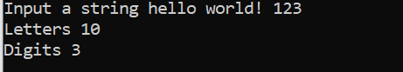

Write a program that accepts a sentence and calculate the number of upper case

letters and lower case letters.

Suppose the following input is supplied to the program:

Hello world!

Then, the output should be:

UPPER CASE 1

LOWER CASE 9

phrase = input("Type in: ")

phrase = list(phrase)

u, l = 0, 0

for i in phrase:

if i.isupper():

u = u + 1

if i.islower():

l = l + 1

else:

pass

print("UPPER:", u)

print("lower:", l)

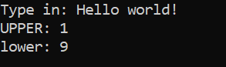

Write a program that computes the value of a+aa+aaa+aaaa with a given digit as

the value of a.

Suppose the following input is supplied to the program:

9

Then, the output should be:

11106

value = input("Enter value: ")

n1 = value * 1

n2 = value * 2

n3 = value * 3

n4 = value * 4

total = int(n1) + int(n2) + int(n3) + int(n4)

print(total)

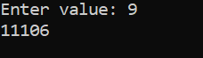

Use a list comprehension to square each odd number in a list. The list is input

by a sequence of comma-separated numbers.

Suppose the following input is supplied to the program:

1,2,3,4,5,6,7,8,9

Then, the output should be:

1,3,5,7,9

while True:  
s = input().split()  
if not s: # break if the string is empty  
break  
cm,num = map(str,s) # two inputs are distributed in cm and num in string data type

if cm=='D':  
total+=int(num)  
if cm=='W':  
total-=int(num)

print(total)

Write a program that computes the net amount of a bank account based a

transaction log from console input. The transaction log format is shown as

following:

D 100

W 200

D means deposit while W means withdrawal.

Suppose the following input is supplied to the program:

D 300

D 300

W 200

D 100

Then, the output should be:

500

total = 0

while True:

s = input().split()

if not s: # break if the string is empty

break

cm,num = map(str,s) # two inputs are distributed in cm and num in string data type

if cm=='D':

total+=int(num)

if cm=='W':

total-=int(num)

print(total)

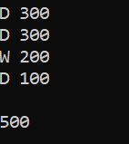

A website requires the users to input username and password to register. Write a

program to check the validity of password input by users.

Following are the criteria for checking the password:

1. At least 1 letter between [a-z]

2. At least 1 number between [0-9]

1. At least 1 letter between [A-Z]

3. At least 1 character from [$#@]

4. Minimum length of transaction password: 6

5. Maximum length of transaction password: 12

Your program should accept a sequence of comma separated passwords and will

check them according to the above criteria. Passwords that match the criteria

are to be printed, each separated by a comma.

Example

If the following passwords are given as input to the program:

ABd1234@1,a F1#,2w3E*,2We3345

Then, the output of the program should be:

ABd1234@1

import re

passwords = input("Type in: ")

passwords = passwords.split(",")

accepted_pass = []

for i in passwords:

if len(i) < 6 or len(i) > 12:

continue

elif not re.search("([a-z])+", i):

continue

elif not re.search("([A-Z])+", i):

continue

elif not re.search("([0-9])+", i):

continue

elif not re.search("([!@$%^&])+", i):

continue

else:

accepted_pass.append(i)

print((" ").join(accepted_pass))

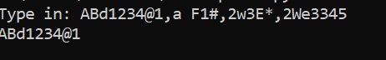

A robot moves in a plane starting from the original point (0,0). The robot can

move toward UP, DOWN, LEFT and RIGHT with a given steps. The trace of robot

movement is shown as the following:

UP 5

DOWN 3

LEFT 3

RIGHT 2

¡

The numbers after the direction are steps. Please write a program to compute the

distance from current position after a sequence of movement and original point.

If the distance is a float, then just print the nearest integer.

Example:

If the following tuples are given as input to the program:

UP 5

DOWN 3

LEFT 3

RIGHT 2

Then, the output of the program should be:

2

import math

x, y = 0, 0

while True:

step = input("Type in UP/DOWN/LEFT/RIGHT #step number: ")

if step == "":

break

else:

step = step.split(" ")

if step[0] == "UP":

y = y + int(step[1])

elif step[0] == "DOWN":

y = y - int(step[1])

elif step[0] == "LEFT":

x = x - int(step[1])

elif step[0] == "RIGHT":

x = x + int(step[1])

c = math.sqrt(x**2 + y**2)

print("Distance:", c)

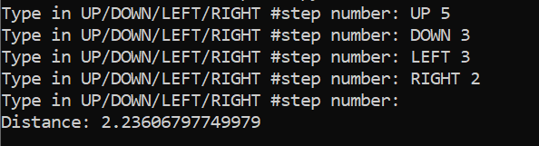

Write a program to compute the frequency of the words from the input. The output

should output after sorting the key alphanumerically.

Suppose the following input is supplied to the program:

New to Python or choosing between Python 2 and Python 3? Read Python 2 or Python

3.

Then, the output should be:

2:2

3.:1

3?:1

New:1

Python:5

Read:1

and:1

between:1

choosing:1

or:2

to:1

import operator

text_line = input("Type in: ")

freq_dict = {}

for i in text_line.split(' '):

if i.isalpha():

if i not in freq_dict:

freq_dict[i] = 1

elif i in freq_dict:

freq_dict[i] = freq_dict[i] + 1

else:

pass

sorted_freq_dict = sorted(freq_dict.items(), key = operator.itemgetter(0))

print(sorted_freq_dict)

for i in sorted_freq_dict:

print(i[0], i[1])

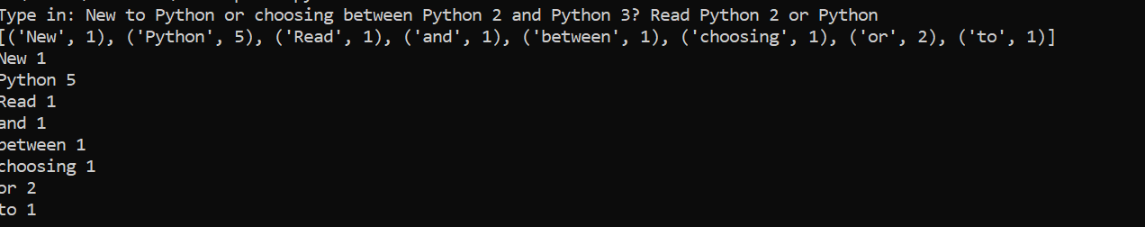

Write a method which can calculate square value of number

number = int (input ("Enter an integer number: "))

square = number**2

print ("Square of {0} is {1} ".format (number, square))



Python has many built-in functions, and if you do not know how to use it, you can read document online or find some books. But Python has a built-in document function for every built-in functions.  
Please write a program to print some Python built-in functions documents, such as abs(), int(), raw_input()  
And add document for your own function

def absolute(number):

return abs(number)

print (absolute(int(input('Enter Number :')))

print (abs.__doc__)

print (int.__doc__)

print (input.__doc__)

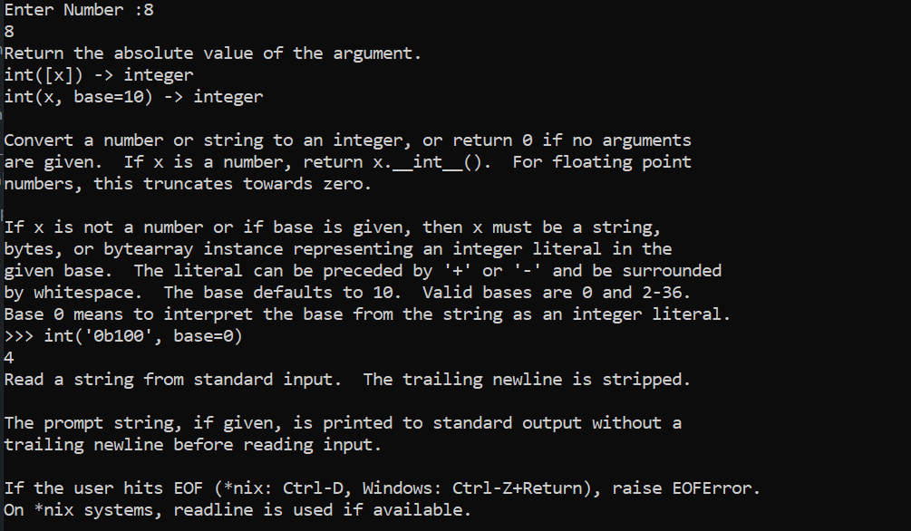

Define a class, which have a class parameter and have a same instance parameter.

Hints:  
Define a instance parameter, need add it in __init__ method  
You can init a object with construct parameter or set the value later

class Robot:

__counter = 0

def __init__(self):

type(self).__counter += 1

def RobotInstances(self):

return Robot.__counter

if __name__ == "__main__":

x = Robot()

print(x.RobotInstances())

y = Robot()

print(x.RobotInstances())

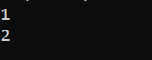

Define a function which can compute the sum of two numbers.

x= int(input("Enter first number:"))  
y= int(input("Enter second number:"))  
sum=x+y  
average=sum/2  
print("Sum of the given two numbers is:", sum)  
print("Average of the given numbers is:", average)

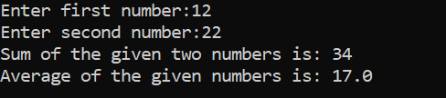

Define a function that can receive two integral numbers in string form and compute their sum and then print it in console.

sum = lambda s1,s2 : int(s1) + int(s2)

print(sum("10","45"))



Define a function which can compute the sum of two numbers.x

sum = lambda n1,n2 : n1 + n2

print(sum(1,2))

**

Define a function that can convert a integer into a string and print it in console.

conv = lambda x : str(x)

n = conv(10)

print(n)

print(type(n))

**

Define a function that can receive two integer numbers in string form and compute their sum and then print it in console.

sum = lambda s1,s2 : int(s1) + int(s2)

print(sum("10","45"))



Define a function that can accept two strings as input and print the string with maximum length in console. If two strings have the same length, then the function should print all strings line by line.

def printVal(s1,s2):

len1 = len(s1)

len2 = len(s2)

if len1 > len2:

print(s1)

elif len1 < len2:

print(s2)

else:

print(s1)

print(s2)

s1,s2=input().split()

printVal(s1,s2)



Define a function which can print a dictionary where the keys are numbers between 1 and 20 (both included) and the values are square of keys.

def printDict():

dict={i:i**2 for i in range(1,21)}

print(dict)

printDict()

**

Define a function which can generate a dictionary where the keys are numbers between 1 and 20 (both included) and the values are square of keys. The function should just print the keys only.

def printDict():

dict = {i: i**2 for i in range(1, 21)}

print(dict.keys())

printDict()

**

Define a function which can generate and print a list where the values are square of numbers between 1 and 20 (both included).

*def printList():*

*lst = [i ** 2 for i in range(1, 21)]*

*print(lst)*

*printList()*

**

Define a function which can generate a list where the values are square of numbers between 1 and 20 (both included). Then the function needs to print the first 5 elements in the list

def printList():

lst = [i ** 2 for i in range(1, 21)]

for i in range(5):

print(lst[i])

printList()

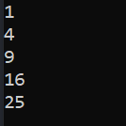.

With a given tuple (1,2,3,4,5,6,7,8,9,10), write a program to print the first half values in one line and the last half values in one line.

tpl = (1,2,3,4,5,6,7,8,9,10)

lst1,lst2 = [],[]

for i in range(0,5):

lst1.append(tpl[i])

for i in range(5,10):

lst2.append(tpl[i])

print(lst1)

print(lst2)

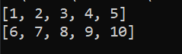

Write a program to generate and print another tuple whose values are even numbers in the given tuple (1,2,3,4,5,6,7,8,9,10).

tpl = (1,2,3,4,5,6,7,8,9,10)

tpl1 = tuple(i for i in tpl if i%2 == 0)

print(tpl1)



Write a program which accepts a string as input to print "Yes" if the string is "yes" or "YES" or "Yes", otherwise print "No".

text = input("Please type something. --> ")

if text == "yes" or text == "YES" or text == "Yes":

print("Yes")

else:

print("No")



Write a program which can map() to make a list whose elements are square of elements in [1,2,3,4,5,6,7,8,9,10].

li = [1,2,3,4,5,6,7,8,9,10]

squaredNumbers = map(lambda x: x**2, li)

print(list(squaredNumbers))



Write a program which can map() and filter() to make a list whose elements are square of even number in [1,2,3,4,5,6,7,8,9,10].

def even(x):

return x%2==0

def squer(x):

return x*x

li = [1,2,3,4,5,6,7,8,9,10]

li = map(squer,filter(even,li))



Write a program which can filter() to make a list whose elements are even number between 1 and 20 (both included).

def even(x):

return x%2==0

evenNumbers = filter(even, range(1,21))

print(list(evenNumbers))

