Product Requirements Document (PRD) v3.0 - May 1, 2026 – Week 15 Final

Hilo Eco-tourism Rental
Term Project 3 - Full Stack Website - Spring 26

OVERVIEW

Problem statement: A website app to service (marketing, booking, contact) for a vacation rental property in Hilo, Hawaii.
Property/Audience: The target market is eco-tourism due to the close proximity to Kilauea, Mauna Loa, Mauna Kea, and beaches along the Big Island’s windward coastline. Hilo was chosen (rather than a location closer to Kilauea) because of the amenities found in the larger town, hopefully opening up to a broader range of customers.
Website Requirements: The site will consist of three/four pages:
R1) a) a marketing page that includes a hero section, b) a dashboard for displaying charts/stats (from stored records) and current weather (from an API), c) amenities of the property listing, d) a way to get to the booking page.
R2) a booking page/modal houses a form to inquire for more information, an email is sent to admin accounts. (booking capabilities can be outsourced)
R4) and an Admin page for updating content.
R5) a dashboard that presents relevant information to the user (Weather, property location, kilauea eruption frequency, current kilauea conditions)
UX/ CSS Design –
R5) All pages will include responsive design (grid/flexbox, UX feedback), be accessible (proper headers, alt-text, >4.5 contrast, mobile-friendly at 375px), and keep a consistent design to invoke similarity.
Technical Architecture – The app will use the following:
1) React for rendering HTML/CSS in a dynamic way client-side,
2) a JavaScript Node.js environment running Express.js for handling backend routes/ REST API needs,
3) MongoDB/Mongoose.js for storing data (DBEDT records, property info, reviews, bookings) and data modeling,
4) Chart.js/D3.js for data visualization in dashboard,
5) authentication using passport.js to manage admin page credentials.
Security should be a concern throughout (no hardcoded/public secrets, input sanitization, HTTP security, CORS security, and password/login protections at the minimum).

User Personas | John Doe  Visitor, looking housing options, to see Kilauea | Jane Who  Already booked, confirming reservation, planning trip | Operator  adding/ updating content, fit into busy schedule
Information/ Functionality/ Wants | - good first impression  - easy to read info  - simple user flow  - local recommendations (activities, food)  - wifi? home rules? parking? costs? bedrooms? | - easy to find booking info  - see status, add to calendar  - what amenities are with property  - ‘springboard’ to find things to do nearby  - how to get to things nearby? | + easy to use UI  + easy to use login (reset password?)  + see what is currently posted  + age of information (since last update)  + privileged access unique to an admin role
Considerations/ Goals/ Needs | - reaching out for help?  - why this place over somewhere else?  - disability accommodations?  - hotel level quality at a discount | - know who the user is  - update /cancel booking?  - further links to amenities if possible | + update content  — add/remove property/packages  — update property info  + see backend status  — is db running, console errors  + see website stats  — # of bookings and when  — page visits, etc.
Possible frustrations | - is the owner trustworthy?  - Bad UX? Too easy?  - others’ reviews? | - dont know password  - avoid information overload  - bad actors modifying data if unsecure route exists | + no web development experience  + avoid overly complicated  + dont know password  + admin access gets compromised

Component Requirements
Marketing Page | Header HeroSection Dashboard About Section Amenities Section CTASection Footer  – logo is anchor to home page – links to other pages – image of house/kilauea – “address” title – “vacation rental” subtitle – DBEDT charts + (arrivals [month/year] + visitor origin (pie) + other stats – current weather (via api) – property description + geo-tourism – property location – list of amenities – [Book Now] button – Contact Information – links to other pages – copyright, year
Booking Page/ Modal | Login Form (in Modal)  Email, Password, Submit button
About Page | Website Header About HeroSection AboutSection Website Footer  – logo is anchor to home page – links to other pages – “About/Contact” title – different image – owner image – owner background – owner contact – links to other pages – copyright, year
Admin | Admin/login Admin/dashboard  – login page (stores a session for 7 days) – update property/package information (options = backend status, site stats, is info old?)

App -> child diagram


App
HeroSection
Dashboard
Header
AboutSection
AmenitiesSection
Header

Header
HeroSection
AboutSection
Footer
CTASection
Footer
Stats
WeatherAPI
DBEDT charts
BookingForm
Footer

loginForm
admin/login

dashboardSection
admin/dashboard
Dashboard
Marketing Page
Booking Page
Contact Page
Admin Login
Admin Dash

Data Flow
APIs that are exposed:

Property Info
DBEDT records
reviews
bookings
login credentials
MongoDB Collections
Fetch
Express Server
mongoose.js

API
Client
React
Response
Request
Google OAuth
/properties | GET /properties? – (returns JSON list of filterable properties)  GET /properties:id – (returns JSON of info of one property by its MongoDB id)  POST properties/:id/reviews – (add review to database)
/auth | GET admin/login - render react login page  POST admin/login - serialize login attempt  GET admin/logout - signout, redirect to homepage
/admin  (protected) | If authorized –  GET admin/dashboard react page  POST admin/updates – update content (post add/remove property/package)

Authentication and Security
Authentication Requirements –
Method: username + password using a local strategy (passport.js), store credentials in password database (MongoDB). Passwords are salted to prevent misuse of authorization if compromise happens. Makes authorization easier.
Method: Google OAuth where the user is redirected to Google Sign In, authentication is passed back to the server for a persistent session. This lifts the authentication burden from the backend towards a trusted source.
Admin User/Model: maintainer of site content. Can view the admin dashboard for updating page content / seeing relevant backend information. Authentication happens either through a googleId match or a username + password match. A session is created and access to the protected admin/dashboard route is authorized. Admin Users need to be created through a seed script on the back end to have authorization.
Logic Flow: admin login form is submitted, Post request is sent to server, credentials are compared to what is stored. If passed, then loads admin/dashboard. If failed, then prompt an error message and log the erroneous attempt.
Session Management: trust is saved for 7 days. If inactive for > 1 hour, then log out.
Protected Routes: /admin/dashboard needs passport’s isAuthenticated() to return true to access.
Secrets Management: Backend secrets are housed in .env file (MONGO_URI, SESSION_SECRET, GOOGLE_CLIENT_ID, GOOGLE_CLIENT_SECRET), client API key is bundled with Vite build (VITE_OPENWEATHER_KEY). .env is in .gitignore.
Threats the design mitigates:
OWASP 01 Broken access control – admin dashboard route is protected with isAdmin.js middleware checking for role = ‘admin’.
OWASP 03 Injection - user dependent NOSQL queries ( /login, /register) are sanitized before they are run
OWASP 07 Identification and Authentication Failures - Passport, bcrypt verification, session serialization, logout, and Google OAuth work in tandem to harden the backend.
(Partial) OWASP 02 - passwords are hashed and sessions are server-side, but cookies are not secure

Acceptance Criteria (

AC-1 Public marketing page
GIVEN any visitor / WHEN they request GET / / THEN the marketing page returns HTTP 200 and renders the property name, hero image, and at least 3 amenities.

AC-2 Visitor dashboard
GIVEN any visitor / WHEN they request GET /dashboard / THEN three Chart.js
visualizations are rendered with non-empty data.

AC-3 Local sign-up
GIVEN a new e-mail / WHEN POST /register with valid e-mail and password ≥ 8 chars
/ THEN HTTP 302 to /admin/dashboard, the users collection contains the new
document, password is bcrypt-hashed (not plaintext).

AC-4 Local sign-in
GIVEN a registered user / WHEN POST /login with correct credentials / THEN HTTP
302 to /admin/dashboard and a session cookie is set.

AC-5 Google OAuth sign-in
GIVEN any user with a Google account / WHEN they click "Sign in with Google" and
consent / THEN HTTP 302 to /admin/dashboard, users collection contains a document
with googleId and provider='google'.

AC-6 Protected route guard
GIVEN an unauthenticated visitor / WHEN they request /admin/dashboard / THEN
HTTP 302 redirects to /login and no admin content is rendered.

AC-7 Logout
GIVEN an authenticated user / WHEN they POST /logout / THEN session cookie is
cleared and req.user is undefined on the next request.

AC-8 Secret hygiene
GIVEN the deployed application / WHEN inspecting the GitHub repository / THEN .env
is absent, .env.example is present, and no API keys appear in any file.
git log --all --full-history -- .env ## blank output == good
AC-9 Load Time
GIVEN any visitor / WHEN they load any page / THEN it takes no longer than 500 ms to load most of the content.
AC-10 Booking Flow
GIVEN a visitor that wants to make a booking / WHEN they try to
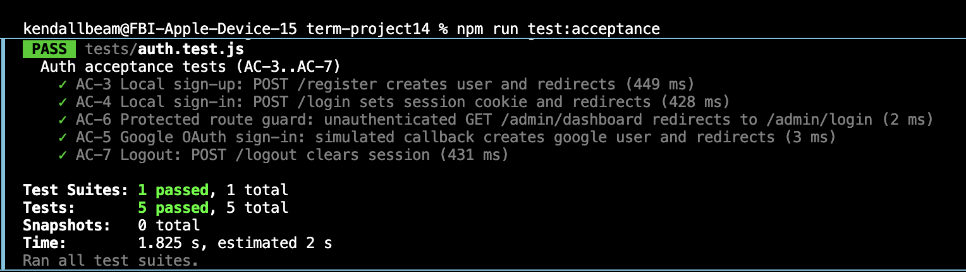AI use: Jest + supertests were generated by GPT5.3 Codex, so validity should be taken with a grain of salt.

