This is the simple example template containing only headers for each report item and the bookmarks.
Modify it according to your own needs and standards.

Measurement Conditions: (Bookmark 1)

Comment Configuration=Spinner Stage, Owner=User-1, Creation date=11/4/2002 10:20:02 AM
Comment Goniometer=PW3050/60 (Theta/Theta); Minimum step size 2Theta:0.001; Minimum step size Omega:0.001
Comment Sample stage=Spinner PW3064
Comment Diffractometer system=XPERT-PRO
Comment Measurement program=geo2, Owner=geology, Creation date=7/19/2004 1:29:17 PM
Comment 5-85,0.02,5s (Nora)
Measurement Date / Time 3/28/2011 2:42:47 PM
Operator Administrator
Raw Data Origin XRD measurement (*.XRDML)
Scan Axis Gonio
Start Position [°2Th.] 5.0080
End Position [°2Th.] 84.9760
Step Size [°2Th.] 0.0170
Scan Step Time [s] 5.0800
Scan Type Continuous
PSD Mode Scanning
PSD Length [°2Th.] 2.12
Offset [°2Th.] 0.0000
Divergence Slit Type Fixed
Divergence Slit Size [°] 0.4785
Irradiated Length [mm] 10.00
Specimen Length [mm] 10.00
Measurement Temperature [°C] 25.00
Anode Material Cu
Generator Settings 45 kV, 40 mA
Goniometer Radius [mm] 240.00
Dist. Focus-Diverg. Slit [mm] 91.00
Incident Beam Monochromator No
Spinning No

Main Graphics, Analyze View: (Bookmark 2)

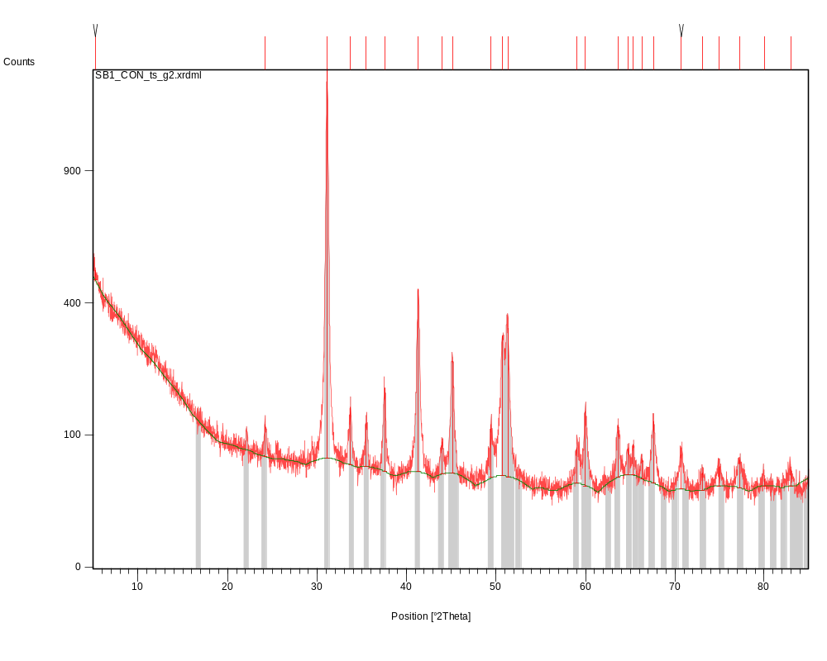

Peak List: (Bookmark 3)

Pos. [°2Th.] | Height [cts] | FWHM [°2Th.] | d-spacing [Å] | Rel. Int. [%]
5.2130 | 33.53 | 0.4015 | 16.95247 | 2.47
24.2274 | 45.99 | 0.2007 | 3.67371 | 3.39
31.1544 | 1355.91 | 0.2175 | 2.87089 | 100.00
33.7698 | 86.97 | 0.2676 | 2.65428 | 6.41
35.4705 | 60.66 | 0.2007 | 2.53082 | 4.47
37.5483 | 131.84 | 0.2342 | 2.39542 | 9.72
41.3050 | 392.26 | 0.3011 | 2.18582 | 28.93
43.9833 | 39.91 | 0.3346 | 2.05873 | 2.94
45.1631 | 191.85 | 0.2342 | 2.00766 | 14.15
49.4399 | 70.78 | 0.2007 | 1.84354 | 5.22
50.7225 | 258.70 | 0.2676 | 1.79989 | 19.08
51.3468 | 279.70 | 0.2342 | 1.77947 | 20.63
59.0140 | 41.41 | 0.3346 | 1.56526 | 3.05
59.9550 | 100.51 | 0.1673 | 1.54292 | 7.41
63.6602 | 68.40 | 0.2676 | 1.46176 | 5.04
64.7428 | 31.09 | 0.2676 | 1.43991 | 2.29
65.3364 | 36.86 | 0.2007 | 1.42826 | 2.72
66.2881 | 22.32 | 0.2676 | 1.41005 | 1.65
67.5990 | 81.19 | 0.3346 | 1.38586 | 5.99
70.7038 | 37.08 | 0.3346 | 1.33243 | 2.73
73.0933 | 16.91 | 0.4015 | 1.29465 | 1.25
74.8936 | 19.22 | 0.5353 | 1.26794 | 1.42
77.2221 | 30.04 | 0.5353 | 1.23542 | 2.22
80.0108 | 5.95 | 0.8029 | 1.19923 | 0.44
82.9870 | 16.27 | 0.6528 | 1.16265 | 1.20

Pattern List: (Bookmark 4)

Visible | Ref. Code | Score | Compound Name | Displacement [°2Th.] | Scale Factor | Chemical Formula
* | 79-1349 | 62 | Ankerite | 0.000 | 0.920 | Ca.997 ( Mg.273 Fe.676 Mn.054 ) ( C O3 )2

Document History: (Bookmark 5)

Insert Measurement:
- Scan name = "SB1_CON_ts_g2.xrdml"
- Modification time = "8/16/2012 4:16:26 PM"
- Modification editor = "Administrator"

Interpolate Step Size:
- Step Size = "Derived"
- Modification time = "8/16/2012 4:16:26 PM"
- Modification editor = "Administrator"

Determine Background:
- Correction method = "Automatic"
- Bending factor = "5"
- Use smoothed input data = "Yes"
- Add to net scan = "Nothing"
- Modification time = "8/16/2012 4:16:28 PM"
- Modification editor = "Administrator"

Search Peaks:
- Minimum significance = "2.00"
- Minimum tip width = "0.01"
- Maximum tip width = "1.00"
- Peak base width = "2.00"
- Method = "Minimum 2nd derivative"
- Modification time = "8/16/2012 4:16:28 PM"
- Modification editor = "Administrator"

Search-Match:
- Data source = "Profile and peak list"
- Restriction = "Restriction set"
- Description = "Minerals subfile only"
- All of: elements = ""
- At least one of: elements = ""
- None of: elements = ""
- Maximum no. of elements = "105"
- Skip marked as deleted by ICDD = "No"
- Skip marked as deleted by a user = "No"
- Quality marks set = ""
- Subfiles = "M"
- Scoring schema = "Multi phase"
- Auto residue = "Yes"
- Match intensity = "Yes"
- Demote unmatched strong = "Yes"
- Allow pattern shift = "No"
- Two theta shift = "0"
- Identify = "Yes"
- Max. no. of accepted patterns = "5"
- Minimum score = "27"
- Search depth = "6"
- Min. new lines / total lines = "40"
- Minimum new lines = "3"
- Minimum scale factor = "0.06"
- Modification time = "8/16/2012 4:16:33 PM"
- Modification editor = "Administrator"

More items… (Bookmark 6)

More items… (Bookmark 7)

More items… (Bookmark 8)

More items… (Bookmark 9)

More items… (Bookmark 10)

More items… (Bookmark 11)

More items… (Bookmark 12)

More items… (Bookmark 13)

More items… (Bookmark 14)

More items… (Bookmark 15)

