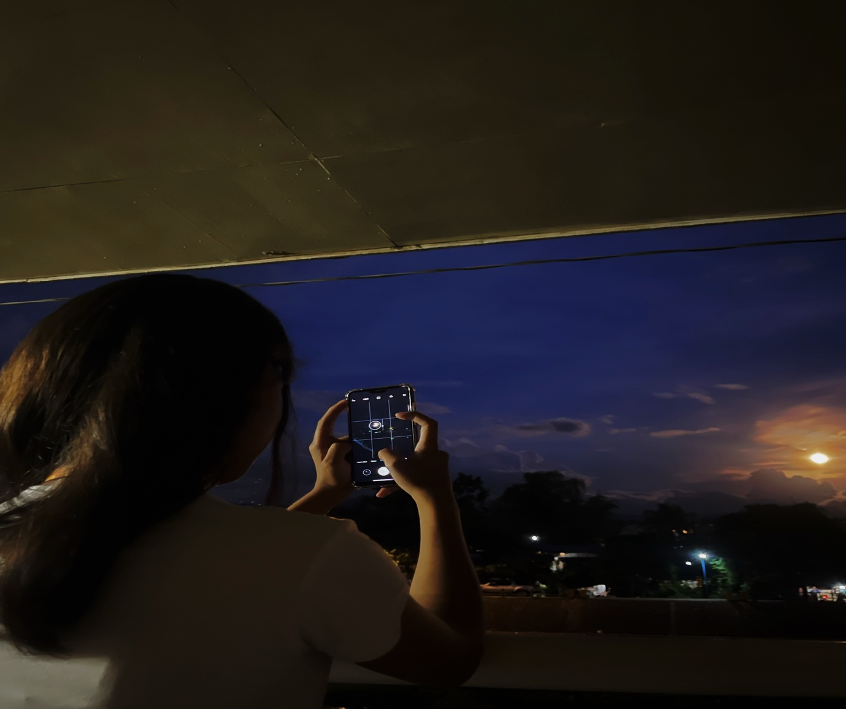

Hi Shai, nakoy ingon nimo ayg ka lain ha hehe. I Just wanted to let you know that I find you attractive and cute. Samot nag masuko ka or magtinaray...

I have to admit, di na nako mapugngan sig huna2x nimo.

guess you’ve captured my thoughts completely. And I like you.

I also like your flaws

bisan asang angul, the best kay ka

your imperfections

your personality

your vibe

your style Your worst

and most of all your simile.

di nako ma pug-ngan samot nag mo smile ka hehe

unta dika ma lain ha.

no need na replayan nimo ako feelings Shai,, gusto lang nako na mapagawas akong gibati diha nimo. to get this out of my head for my peace of mind. Maka buang imo ka gwapa shai, di nana healthy grabe na kayka. HAHAHA jk