

Academic Skills and Team-based Learning (4CIO18)

Report Writing

Graduates for the company

|  |  |
| --- | --- |
| Student Id  Student Name  Group | : np03cs4a220181 : Abhishek K.C.  : L4CG16 |
| Lecturer | : Mr. Manish Deuja |
|  |  |

Submitted on : Thursday ,January 12, 2023

Word Count : 1501

**Abstract**

In this report I had describes the History and Data of University of Wolverhampton, Herald College Kathmandu and SOFTNEP pvt ltd. It has information about the company University and about difference about Graduates from both foreign and Nepali universities are eligible to apply for the open position at the organization. To best serve the interests of the business, it is recommended to research the company, SOFTNEP, its goals, and requirements for the position. A good understanding of the Nepalese context is also advisable.

### Table of Contents

Overview 1

1.1 SOFTNEP 2

1.2 WLV 2

1.3 HCK 3

University 4

Critical Analysis 5

Future Relationship 6

Conclusion 7

References 8

# **Overview**

SoftNEP, an independent software development company, boasts extensive experience in creating digital products and their supporting systems. Based in Min Bhawan, Bhimsen Gola Marg, Kathmandu, Nepal, the company was established in 2004. With a talented team of designers, programmers, project managers, and web marketers, SoftNEP excels in a wide range of skills from internet marketing to software development, providing a comprehensive view to stay ahead in the game.

The University of Wolverhampton, located at Wulfruna St. in Wolverhampton, UK, has a rich history dating back to the 19th-century mechanical institutes in the city. These institutes provided vocational and other forms of training for working men and women who couldn't afford it. In 1933, the Wolverhampton Technical and Staffordshire Technical College was established to give students from disadvantaged backgrounds access to higher education. The college was transformed into a polytechnic in 1969 and eventually became a full university in 1992.

Herald College in Naxal, Kathmandu offers the most affordable university education in the UK. Established in 2000, the college has a close partnership with the University of Wolverhampton in the UK and offers Bachelor's degrees in IT and business. Specifically, they offer BSc (Hons) in Computer Science and International Business Management from the University of Wolverhampton.



*Figure 1 SoftNEP*

## 1.1 SOFTNEP

SoftNEP is a company creating world class online systems since 2005. The founder and CEO is Mr. Sunil Rijal. They design, develop, and host all spots of web, software, and mobile applications. As introduced, SoftNEP is a leading digital firm with extensive experience in creating both digital product strategies and support systems. Their team consists of skilled designers, efficient programmers, and diligent project managers. The company has been providing comprehensive product services for 16 years, covering everything from ideation to design and marketing. Each year, they provide 5 to 10 new employees with the opportunity to join the team. With the help of user-friendly design and marketing, they strive to enhance the product offering. Their expertise in application development is state-of-the-art, comparable to that of the latest software programs. SoftNEP specializes in developing web applications and also offers services such as Android and iOS mobile app development.

Services

* Software Development
* Web Development
* Mobile App Development



*Figure 2 WLV*

## 1.2 WLV

The University of Wolverhampton, a prestigious institution of higher learning with a 200-year history of academic excellence and opportunities, has four campuses located in the West Midlands of England, covering Shropshire and Staffordshire.

The University of Wolverhampton is comprised of 18 schools, organized into four main faculties: Social Sciences, Education, Health and Wellbeing, and Arts. There are roughly 300 undergraduate programs and 200 graduate programs to choose from. According to the World University Rankings 2023 by THE, the University of Wolverhampton ranks 601-800. The academic year is structured into two semesters, with 12 weeks of instructional time in each. The calendar includes a combination of teaching, review, and assessment periods. The university covers a broad range of educational levels and specialties, from primary school to higher education.

Such as evaluations, health instruction, and education with numerous objectives, they provide complete text and indexing for nearly 500 books and monographs and full text for over 1,200 publications and more than 2,100 journals. (QS, 1994)

There are many courses to study, but according to the computer Science (BSc (Hons) Computer Science) Module they are:

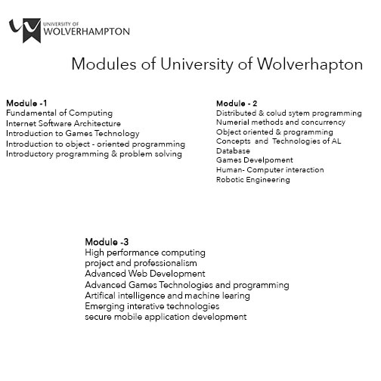

*Figure 3 module*

In This figure there are 3 years modules of Wolverhampton University. The module is divided into 3 parts. Each module has different course.



*Figure 4 HCK*

## 1.3 HCK

Herald College Kathmandu (HCK) offers the most cost-effective higher education in the UK. In partnership with the University of Wolverhampton in the UK, it provides Bachelor's degrees in IT and business. Its curriculum is designed to provide a comprehensive knowledge base, with a focus on business and information technology.

Herald College Kathmandu delivers BSc (Hons) in computer science and international business management from the University of Wolverhampton. With its top-notch academic and social facilities, the college aims to provide students with the best education experience. The faculty uses their expertise to apply textbook theories to real-world scenarios. Students receive training in cutting-edge computer languages, tools, techniques, and methodologies to improve their programming, architecture, artificial intelligence, and cloud computing skills. The college offers a range of modules, some of which have been updated, as depicted in figure 1 there are many modules, but some are changed in all semsters.

Every year, the Herald College in Kathmandu holds a tournament where students can win scholarships to the University of Wolverhampton's 15-day Summer Camp. (college, 2020).

# University

First of all, the education in Nepal there are two type Nepal University and foreign University. There are several scholarships and financial aid options available for students who want to do good for the future. Overall, the cost of studying is quite reasonable, and there are many different options available to help students. Likewise, Nepal university provides 4-year of course in reasonable price according to

my research. To apply on Nepal university, we must do CMAT (Central Management Admission Test).

Now day we can see that international education is being popular now days. Also, Past decade students have an opportunity to get foreign degree within Nepal itself. Foreign University provide the international degree. An international degree will broaden the possibilities to complete in international job market. Foreign University provide 3-years course. To apply for it we must complete some Entry requirements. Also, it is expensive than Nepal University.

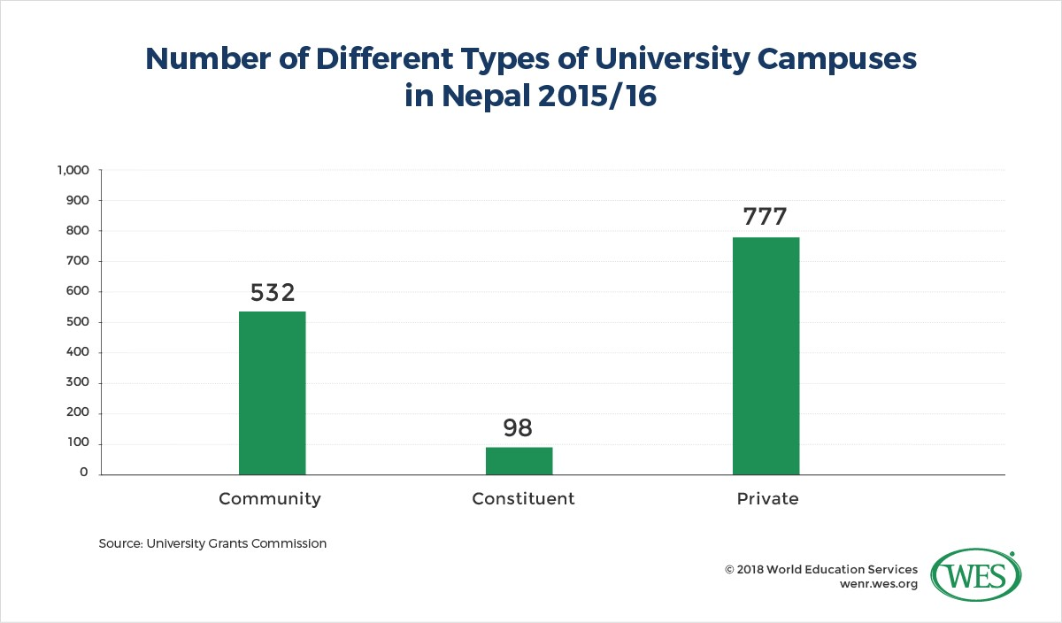

*Figure 5 difference*

In this figure it is shown that student prefer to join private rather than Community and constituent. Private provide many facilities and education which number is more.

## Critical Analysis

On 1st paragraph I have discussed SOFTNEP yearly they have 15+ online creativity, 500+ happy clients, 1000+ projects delivered and 100+ professionals engaged. The project they have done are on Travels, Radios, Mobile Apps, News portals, Websites, Software. They have mainly focus on web app development. For the opportunity’s education, skills and knowledge should be need. SOFTNEP works are on app development in which java, python and C++ knowledge should be required. Our university also provide these modules which area required for the job.

Yearly they are looking few Marketing expert, Web Designer, React Native

Developer, Software Engineering, and other candidate experience and five efforts for the better upgrade for the company. They hire few candidates for their job.

## Future Relationship

Education is an invaluable tool that plays a significant role in our daily lives. It sets us apart from other forms of life on earth and helps us discover our passions and develop the skills we need to feel confident in our abilities. The standard of education continues to improve annually. To excel in any position, one must be educated, proficient, and experienced. University students study programming languages such as Python, C++, and Java. There are numerous universities offering diverse programs, teaching methods, and course options, ensuring that there is a wide range of subjects available at each institution.

Graduates are trained to work both independently and as part of a team, which is essential in the workplace. During my observation, I noted that proficiency in programming and Java are the key requirements for positions at the company.

# Conclusion

The aim of this research was to determine efficient methods for addressing repetitive motions. With the fast-paced advancements and shifts in the information technology sector, it is crucial for graduates to stay updated in order to succeed in their careers. The study recommends that graduates possess strong skills and problem-solving capabilities to effectively tackle the challenges the company may face in the future. The university provides a solid educational foundation and relevant skills that will benefit the company.

Working collaboratively is a critical aspect in the company, and the university prepares graduates to be both independent and team oriented. They bring a progressive and forward-thinking mindset, with a focus on improving the company and achieving future aspirations and goals.

# References

college, 2020. *colleges nepal.* [Online]

Available at: https://www.collegesnepal.com/foreign-university-affiliated-colleges-andcourses-in-nepal/ COLLEGE, H., n.d. [Online]

Available at: https://heraldcollege.edu.np

QS, 1994. *TOPUNIVERSITIES.* [Online]

Available at: https://www.topuniversities.com/universities/university-wolverhampton [Accessed 2023].

THE, 2023. *Times Higher Education.* [Online]

Available at: https://www.timeshighereducation.com/world-university-rankings/universitywolverhampton