Writeup / README of SFND 3D Object Tracking
This is the final project of the camera course. By completing all the lessons, we have acquired a solid understanding of keypoint detectors, descriptors, and methods to match them between successive images. Also, we learned how to detect objects in an image using the YOLO deep-learning framework. And finally, how to associate regions in a camera image with Lidar points in 3D space. Below is our program schematic which shows what we already have accomplished and what's still missing.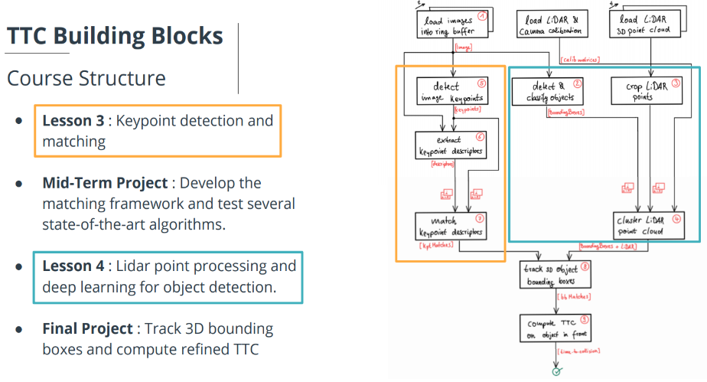
In this final project, we implemented the missing parts in the schematic by completing four major tasks:
- First, we developed a way to match 3D objects over time by using keypoint correspondences. Here the "matchBoundingBoxes" method, which takes as input both the previous and the current data frames and provides as output the ids of the matched regions of interest (i.e. the boxID property)“ was implemented.
- Second, the TTC based on Lidar measurements was computed, using information from Lesson 3 of the course: Engineering a Collision Detection System. In the implementation of the method – computeTTCLidar, a KdTree was used to eliminate outliers.
- As with the second task, camera based TTC was computed, which requires to first associate keypoint matches to regions of interest and then to compute the TTC based on those matches. To handle outliers, a robust mean of all the Euclidean distances between keypoint matches was computed using a mechanism that compares the Euclidean distance deviations to the standard deviation.
- And lastly, various tests were conducted with the goal of identifying the most suitable detector/descriptor combination for TTC estimation and also, to search for problems that can lead to faulty measurements by the camera or Lidar sensor. In the last course of this Nanodegree, we will learn about the Kalman filter, which is a great way to combine the two independent TTC measurements into an improved version which is much more reliable than a single sensor alone can be.

