Lab assessment
- Write a Python program that instructs the user to provide 10 numbers and sorts them in ascending and descending order.
Solution,
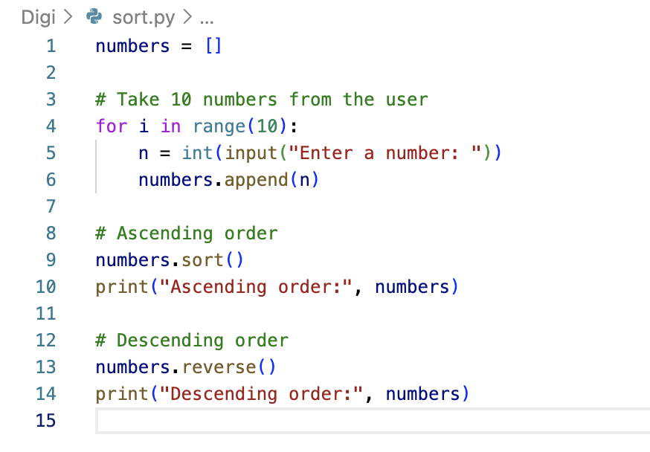
Output
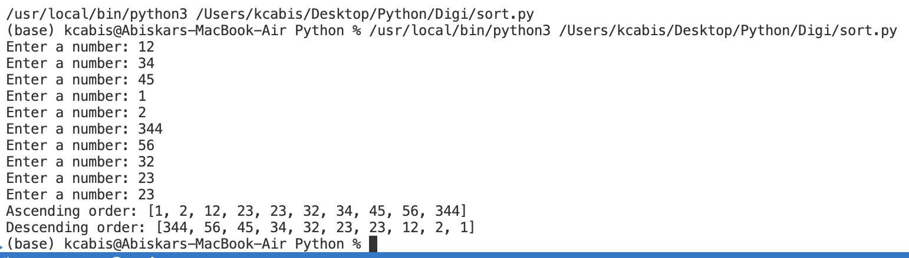

- Write a Python program that asks the user to enter a number and uses a while loop to display the multiplication table of that number up to 10.Show the result in a clear format (e,g, 5 x 1 = 5).
Solution
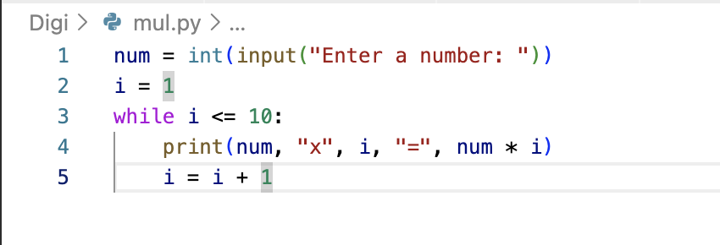

Output
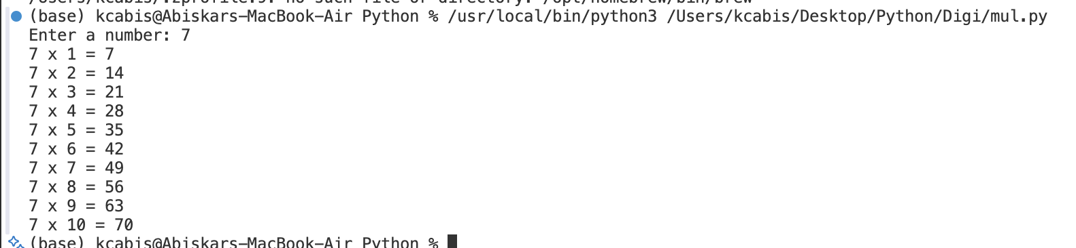

- Write a Python program that asks the user to enter their name and age and uses an if–else statement to check whether the user is eligible to vote and print a suitable message based on the result.
Solution,
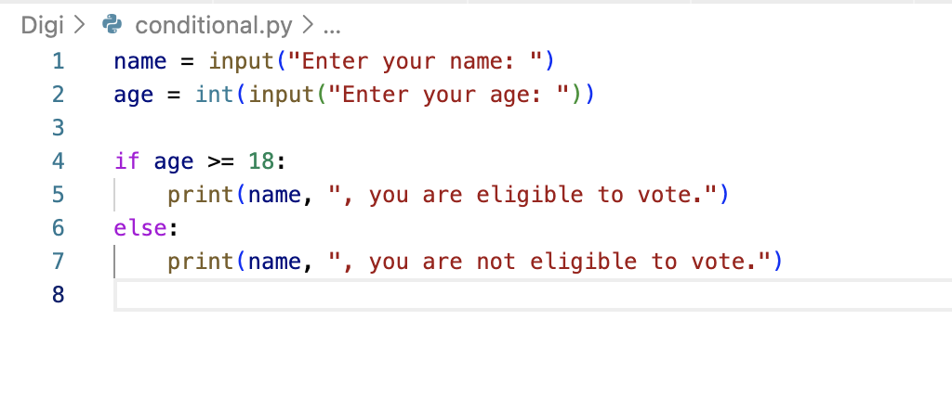
Output

