Rapport RT-qPCR

Jérémie SUDOL

2023-11-02

# Tables

## row column Sample.Name Detector Task Ct StdDev.Ct Qty Mean.Qty  
## 1 A 1 RNAi1-1 18S Unknown 15.2104 5.84 NA NA  
## 2 A 2 RNAi1-2 18S Unknown 15.2286 5.84 NA NA  
## 3 A 3 RNAi1-3 18S Unknown 15.4853 5.84 NA NA  
## 4 A 4 RNAi2-1 18S Unknown 15.3587 5.84 NA NA  
## 5 A 5 RNAi2-2 18S Unknown 15.2092 5.84 NA NA  
## 6 A 6 RNAi2-3 18S Unknown 15.1074 5.84 NA NA  
## StdDev.Qty Filtered Tm Rn User.Defined..2 User.Defined..3 primers  
## 1 NA 85.6 NA NA NA HK  
## 2 NA 85.6 NA NA NA HK  
## 3 NA 85.6 NA NA NA HK  
## 4 NA 85.6 NA NA NA HK  
## 5 NA 85.6 NA NA NA HK  
## 6 NA 85.6 NA NA NA HK

## Well Sample.Name Detector Task Ct StdDev.Ct Qty Mean.Qty StdDev.Qty  
## 1 A1 RNAi1-1 18S Unknown 15.2104 5.84 NA NA NA  
## 2 A2 RNAi1-2 18S Unknown 15.2286 5.84 NA NA NA  
## 3 A3 RNAi1-3 18S Unknown 15.4853 5.84 NA NA NA  
## 4 A4 RNAi2-1 18S Unknown 15.3587 5.84 NA NA NA  
## 5 A5 RNAi2-2 18S Unknown 15.2092 5.84 NA NA NA  
## 6 A6 RNAi2-3 18S Unknown 15.1074 5.84 NA NA NA  
## Filtered Tm Rn User.Defined..2 User.Defined..3  
## 1 85.6 NA NA NA  
## 2 85.6 NA NA NA  
## 3 85.6 NA NA NA  
## 4 85.6 NA NA NA  
## 5 85.6 NA NA NA  
## 6 85.6 NA NA NA

## # A tibble: 6 × 3  
## # Groups: Sample.Name [3]  
## Sample.Name primers mean_Ct  
## <fct> <chr> <dbl>  
## 1 Control-1 HK 30   
## 2 Control-1 test 48   
## 3 Control-2 HK 25   
## 4 Control-2 test 43.3  
## 5 Control-3 HK 26   
## 6 Control-3 test 43.7

# Plots

You can also embed plots, for example:

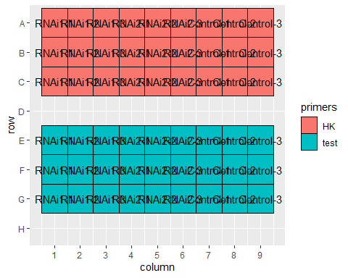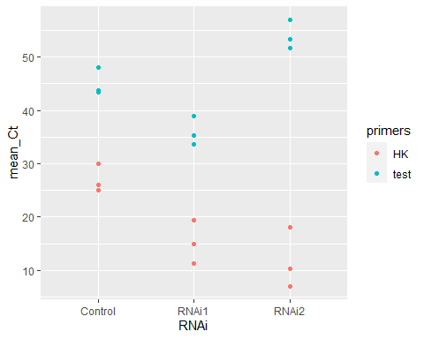

Le Ct des RNAi 1 et 2 comparés au contrôle.

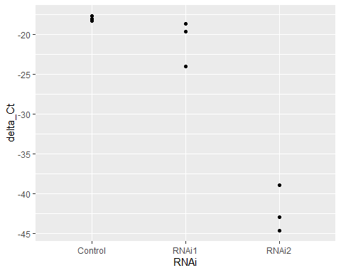

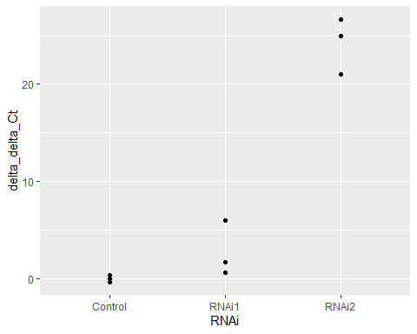

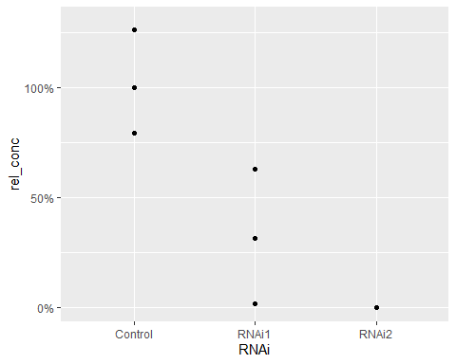

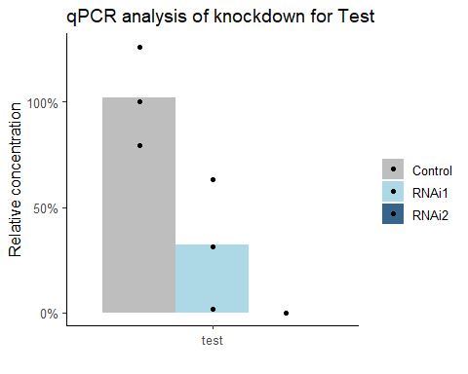

Note that the echo = FALSE parameter was added to the code chunk to prevent printing of the R code that generated the plot.