Markdown Slides [EN]

Adolfo Sanz De Diego

September 2016

Table of Contents

# About

## What is it?

* **MarkdownSlides** is a Reveal.js, Deck.js and PDF **slides** generator **from MARKDOWN files**, that also generate HTML, EPUB and DOCX documents.
* The idea is that **from a same MARKDOWN file we can get slides and books** without worrying about style, just worrying about content.

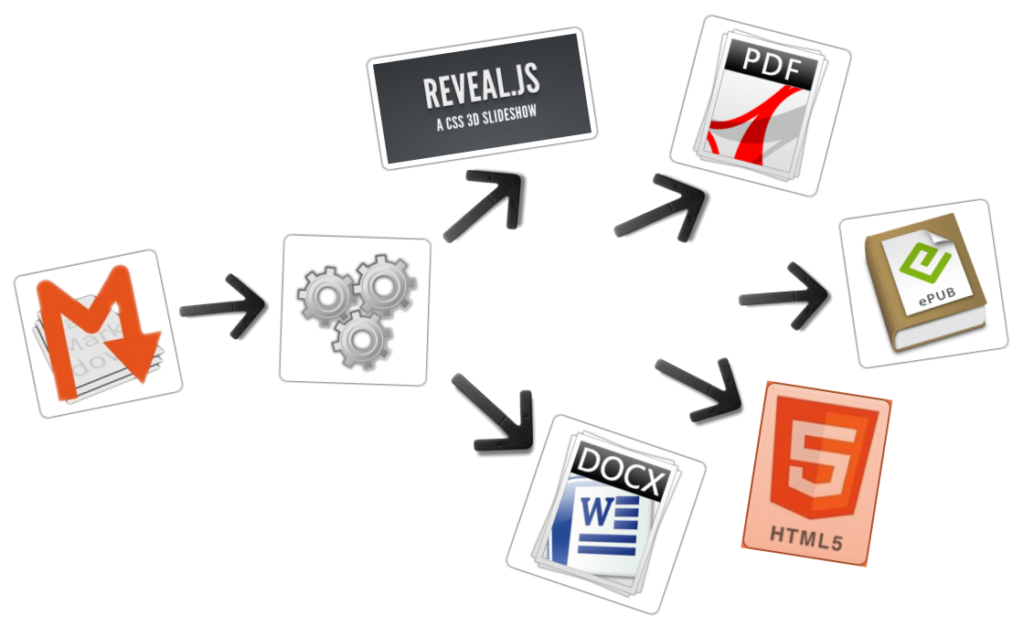

## Samples

* From a [MARKDOWN](https://raw.github.com/asanzdiego/markdownslides/master/doc/md/readme.md) file generate:
  + [reveal-slides](http://asanzdiego.github.io/markdownslides/doc/export/readme-reveal-slides.html)
  + [reveal-slides-pdf](http://asanzdiego.github.io/markdownslides/doc/export/readme-reveal-slides.pdf)
  + [reveal-slides-online](http://asanzdiego.github.io/markdownslides/doc/export/readme-reveal-slides-online.html)
  + [reveal-slides-alternative](http://asanzdiego.github.io/markdownslides/doc/export/readme-reveal-slides-alternative.html)
  + [reveal-slides-alternative-pdf](http://asanzdiego.github.io/markdownslides/doc/export/readme-reveal-slides-alternative.pdf)
  + [reveal-slides-alternative-online](http://asanzdiego.github.io/markdownslides/doc/export/readme-reveal-slides-online-alternative.html)
  + [epub-book](http://asanzdiego.github.io/markdownslides/doc/export/readme-book.epub)
  + [html-book](http://asanzdiego.github.io/markdownslides/doc/export/readme-book.html)
  + [docx-book](http://asanzdiego.github.io/markdownslides/doc/export/readme-book.docx)

## Licence

* **This work is licensed under a:**
  + [Creative Commons Attribution 3.0](http://creativecommons.org/licenses/by-sa/3.0//)
* **The program source code are licensed under a:**
  + [GPL 3.0](http://www.gnu.org/licenses/gpl.html)

# Instalation and how to use

## Dependencies

* [Pandoc](http://johnmacfarlane.net/pandoc/) (needs to be installed)
* [Phantom.js](http://phantomjs.org) (needs to be installed)
* [Reveal.js](http://lab.hakim.se/reveal-js/#/) (automaticaly downloaded)
* [Deck.js](http://imakewebthings.com/deck.js/) (automaticaly downloaded)
* Now, only works in Linux (may be on MacOS)
* It can works with Docker, but is in beta.

## Download

* <https://github.com/asanzdiego/markdownslides/archive/master.zip>

## Docker (Under testing)!

$ docker build -t asanzdiego/markdownslides .

* Process to launch container
  + Need the directory template doc, or your personalized directory to generate your md files and to receive the exports as usual
* Launch the container, product generated will be as **min** configuration

docker run -it -v ${PWD}/doc:/home/markdownslides/doc asanzdiego/markdownslides

* Changing to **med** configuration

docker run -it -v ${PWD}/doc:/home/markdownslides/doc asanzdiego/markdownslides ./build.sh med doc

* Changing to **max** configuation

docker run -it -v ${PWD}/doc:/home/markdownslides/doc asanzdiego/markdownslides ./build.sh max doc

## Creation

* First **copy the doc folder and rename it as you like**. This is not necessary but helps you organize your documents.
* **Create the md files** that you want to generate in the **md folder**. The md files are [Markdown](http://en.wikipedia.org/wiki/Markdown) files which are nothing more than plain text files with extension md, and a lightweight markup (we should know it but it is very simple).

## Configuration

* We can configure the files that we want to generate from the file **build.properties**

BUILD_REVEAL_SLIDES='min'  
BUILD_REVEAL_SLIDES_PDF='med'  
BUILD_REVEAL_SLIDES_ONLINE='med'  
BUILD_REVEAL_SLIDES_ALTERNATIVE='max'  
BUILD_REVEAL_SLIDES_ALTERNATIVE_PDF='max'  
BUILD_REVEAL_SLIDES_ALTERNATIVE_ONLINE='max'  
  
BUILD_HTML_BOOK='min'  
BUILD_DOCX_BOOK='med'  
BUILD_ODT_BOOK='max'  
BUILD_EPUB_BOOK='max'

## Build

* In the root folder you have to execute:

./build.sh [clean] [mode] [folder]

* If you add [**cleaN**] the folder **lib** will be cleaned and the dependencies will be downloaded again.
* [**mode**] can take the next values: **min, med o máx**.
* [**folder**] is the name of the folder wher to find the md files. If no folder name, it will convert all md files of all the folders.

# Author

## Adolfo Sanz De Diego

* **Old JEE web developer**.
* Now I'm **Tecnical Teacher Advaisor** in the TIC service of the General Direction of Infrastructure and Services of the Ministry of Education, Youth and Sports of the Community of Madrid.
* In addition I work as **trainer specialized in development technologies**.

## Algunos proyectos

* **Hackathon Lovers** <http://hackathonlovers.com>: a group created for entrepreneurs and developers who loves hackathones.
* **Password Manager Generator** <http://pasmangen.github.io>: an online password manager.
* **MarkdownSlides** <https://github.com/asanzdiego/markdownslides>: a script to create slides from MD files.

## Where to find me?

* Mi nick: **asanzdiego**
  + AboutMe: <http://about.me/asanzdiego>
  + GitHub: <http://github.com/asanzdiego>
  + Twitter: <http://twitter.com/asanzdiego>
  + Blog: <http://asanzdiego.blogspot.com.es>
  + LinkedIn: <http://www.linkedin.com/in/asanzdiego>
  + SlideShare: <http://www.slideshare.net/asanzdiego/>
  + Google+: <http://plus.google.com/+AdolfoSanzDeDiego>