Markdown Slides

Adolfo Sanz De Diego

January 2014

# About

## What is it?

* **MarkdownSlides** is a Reveal.js, Deck.js and PDF **slides** generator **from MARKDOWN files**, that also generate HTML, ODT and DOCX documents.

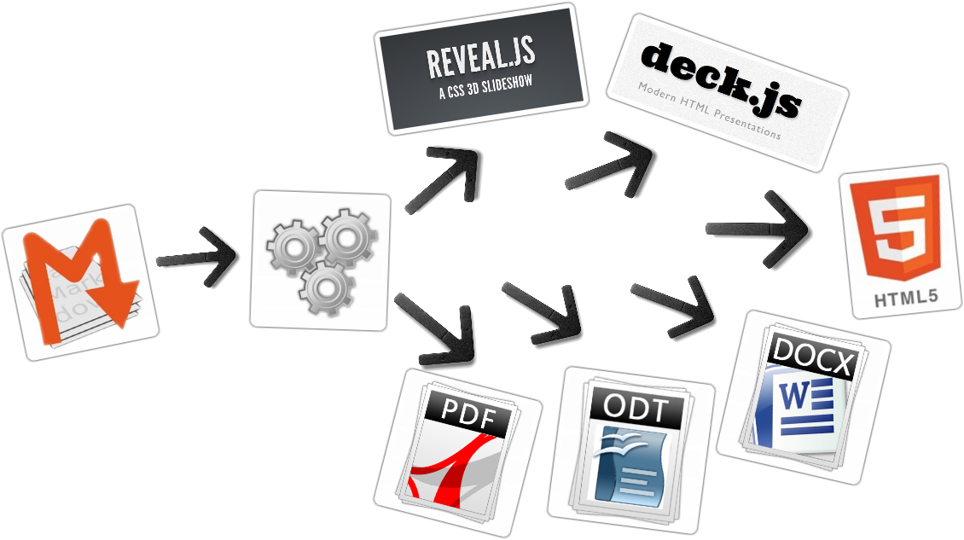

## Samples

* From a [MARKDOWN](https://raw.github.com/asanzdiego/markdownslides/master/doc/md/readme.md) file generate:
  + [reveal-slides](http://asanzdiego.github.io/markdownslides/doc/export/readme-reveal-slides.html)
  + [reveal-slides-alternative](http://asanzdiego.github.io/markdownslides/doc/export/readme-reveal-slides-alternative.html)
  + [reveal-pdf-slides](http://asanzdiego.github.io/markdownslides/doc/export/readme-reveal-slides.pdf)
  + [reveal-pdf-slides-alternative](http://asanzdiego.github.io/markdownslides/doc/export/readme-reveal-slides-alternative.pdf)
  + [deck-slides](http://asanzdiego.github.io/markdownslides/doc/export/readme-deck-slides.html)
  + [deck-slides-alternative](http://asanzdiego.github.io/markdownslides/doc/export/readme-deck-slides-alternative.html)
  + [pdf-beamer](http://asanzdiego.github.io/markdownslides/doc/export/readme-beamer.pdf)
  + [pdf](http://asanzdiego.github.io/markdownslides/doc/export/readme.pdf)
  + [html](http://asanzdiego.github.io/markdownslides/doc/export/readme.html)
  + [docx](http://asanzdiego.github.io/markdownslides/doc/export/readme.docx)
  + [odt](http://asanzdiego.github.io/markdownslides/doc/export/readme.odt)

## Licence

* **This work is licensed under a:**
  + [Creative Commons Attribution 3.0](http://creativecommons.org/licenses/by-sa/3.0//)
* **The program source code are licensed under a:**
  + [GPL 3.0](http://www.gnu.org/licenses/gpl.html)

# Instalation and how to use

## Dependencies

* [Pandoc](http://johnmacfarlane.net/pandoc/) (needs to be installed)
* [Phantom.js](http://phantomjs.org) (needs to be installed)
* [Reveal.js](http://lab.hakim.se/reveal-js/#/) (automaticaly downloaded)
* [Deck.js](http://imakewebthings.com/deck.js/) (automaticaly downloaded)

## Creation

* First **copy the doc folder and rename it as you like**. This is not necessary but helps you organize your documents.
* **Create the md files** that you want to generate in the **md folder**. The md files are [Markdown](http://en.wikipedia.org/wiki/Markdown) files which are nothing more than plain text files with extension md, and a lightweight markup (we should know it but it is very simple).
* Once created the md files, **we can generate with an script**.
  + reveal-slides
  + reveal-pdf-slides
  + deck-slides
  + pdf-beamer
  + pdf
  + html
  + docx
  + odt

## Build

* To **convert all md files of all the folders** go to the root folder and execute:

./build.sh

* To **convert all md files of one folder** go to the root folder and execute:

./build.sh [folder_name]

# Author

## Adolfo Sanz De Diego



### My Resume

* **Old JEE web developer**
* Today:
  + **Computer teacher**:
    - Hardware, Operating Systems
    - Networking, Programming
  + **Freelance Trainer**:
    - Java, Android
    - JavaScript, jQuery
    - JSF, Spring, Hibernate
    - Groovy & Grails
  + **I like to develop**

### Hackalover



* **For hackathons lovers**
  + **Meetup**: <http://www.meetup.com/Hackathon-Lovers/>
  + **Twitter**: <http://twitter.com/HackathonLovers>
  + **Blog**: <http://hackathonlovers.tumblr.com/>
  + **LinkedIn**: <http://www.linkedin.com/groups/Hackathon-Lovers-6510465>
  + **YouTube**: <http://www.youtube.com/channel/UCRwSe7jK-y62BMvIiNBV1qw>

### Tweets Sentiment



* Is a **tweets analyzer** which extracts semantic information to know if the general tweets feeling about a topic is positive or negative.
  + **Web**: <http://tweetssentiment.com/>
  + **Twitter**: <http://twitter.com/TweetsSentiment>

### Where to find me?

* My nick: **asanzdiego**
  + AboutMe: <http://about.me/asanzdiego>
  + GitHub: <http://github.com/asanzdiego>
  + Twitter: <http://twitter.com/asanzdiego>
  + Blog: <http://asanzdiego.blogspot.com.es>
  + LinkedIn: <http://www.linkedin.com/in/asanzdiego>
  + Google+: <http://plus.google.com/+AdolfoSanzDeDiego>