

School of Electrical Engineering, Computing and Mathematical Sciences

Department of Mathematics and Statistics

ASSIGNMENT COVER SHEET

UNIT NAME: ANAYLYTICS FOR EXPERIMENTAL AND SIMULATED DATA

TUTORIAL TIME: Thursdays 4pm

 | Student  Name | Student  Number | Percent contribution
1 | Samantha Clements | 22209847 | 50%
2 | Kafula Chewe | 21387933 | 50%
3
4
Total should add to 100

DECLARATION
I(we) have read and understood Curtin’s policy on plagiarism, and, except where indicated, this assignment is my own work and has not been submitted for assessment in another unit or course. I have retained a copy of the assignment for my own records.



_
[Signature of all group members]

STAT2003: Assignment 1: Comparison of Machine Learning Algorithms

QUESTION 1: Machine Learning Algorithms Comparison

Experimental Design
A randomised block design (RBD) experiment is conducted to compare four machine learning algorithms for predicting credit card default using the Default dataset from the ISLR package (James et al. 2013). The experimental factor is algorithm type, with four levels: Logistic Regression (LR), Random Forest (RF), Naive Bayes (NB), and Support Vector Machine (SVM), as illustrated in the DOE Diagram (Figure 1).
The primary response is AUC-ROC. The Default dataset reveals a large class-imbalance leading to misleading overall accuracy. Models predicting non-defaulters for all observations achieve 97% accuracy yet have no discriminatory value. AUC-ROC measures each model’s ability to distinguish defaulters from non-defaulters, where higher values indicate better discrimination, and is robust to class imbalance, making it the most appropriate metric (James et al. 2013).
The experiment is subject to three principles of experimental design (Montgomery 2020). Randomisation is conducted through random observation assignment to cross-validation (CV) folds with set.seed(123). Replication is achieved via repeated 10-fold CV with 5 repeats, producing 50 resamples, each serving as an experimental unit. Blocking treats each resample as a block; all algorithms are evaluated under identical splits, controlling fold-to-fold variation . Residual diagnostics are conducted prior to formal RBD ANOVA interpretation.
(197 words)
## default student balance income
## 1 No No 729.5265 44361.625
## 2 No Yes 817.1804 12106.135
## 3 No No 1073.5492 31767.139
## 4 No No 529.2506 35704.494
## 5 No No 785.6559 38463.496
## 6 No Yes 919.5885 7491.559
##
## No Yes
## 9667 333
a04943a732f52b70d23efbb765f19d06209d7726 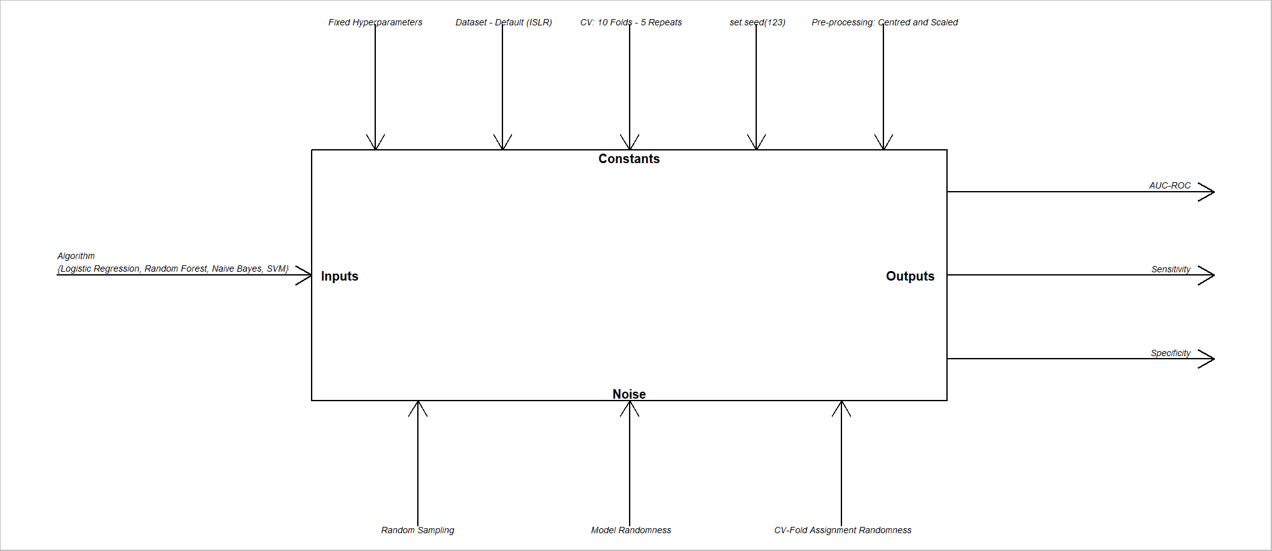

Machine Learning Algorithms Comparison

QUESTION 2: Experimental Design
A randomized block ANOVA was performed with algorithm as the treatment factor and resamples as the block factor. The results results that there was a statistical difference in the ROC means across algorithms at a the 5% significance level (p < 0.001), which means not all algorithms performed equally. Turkey HSD pairwise comparisons showed that Logistic Regression significantly outperformed Random Forrest and SVM (p < 0.001) but that it was not significantly different from Naive Bayes (p = 0.248). This suggests that Logistic Regression are statistically comparable in terms of performance. All other pairwise comparisons were significant at 5% level.
The estimated marginals means further justify this as they show that Logistic Regression had the highest ROC mean (0.949) and Naive Bayes had quite similar result (0.942) while Random Forrest and SVM performed worse, 0.896 and 0.926 respectively.
Assumption checks shows that normality of residuals was satisfied; however, homogeneity of variance was violated as seen in the Bartlett and Levene tests. Inspite of this, ANOVA is known to be relatively robust to these violations in cases where there is large number of replications. To support these findings, a non-parametric Friedman test was also conducted which confirmed a significant difference between algorithms (p < 0.001) which helped justify the conclusions drawn from ANOVA.
Overall, the results suggest that Logistic Regression and Naive Bayes as the best performing algorithms while Random forrest and SVM perform less effectively under this experimental design.
(239 words)
set.seed(123)
ctrl <- trainControl(method = "repeatedcv",
number = 10,
repeats = 5,
summaryFunction = twoClassSummary,
classProbs = TRUE,
savePredictions = TRUE)
## note: only 2 unique complexity parameters in default grid. Truncating the grid to 2 .
##
## Call:
## summary.resamples(object = res)
##
## Models: LogisticRegression, RandomForest, NaiveBayes, SVM
## Number of resamples: 50
##
## ROC
## Min. 1st Qu. Median Mean 3rd Qu. Max.
## LogisticRegression 0.9193068 0.9435696 0.9495785 0.9491588 0.9566296 0.9810097
## RandomForest 0.8374589 0.8744026 0.8940430 0.8964833 0.9179341 0.9487499
## NaiveBayes 0.9043903 0.9251208 0.9426542 0.9416489 0.9559826 0.9746534
## SVM 0.8707656 0.9105552 0.9251687 0.9257537 0.9390234 0.9727500
## NA's
## LogisticRegression 0
## RandomForest 0
## NaiveBayes 0
## SVM 0
##
## Sens
## Min. 1st Qu. Median Mean 3rd Qu. Max.
## LogisticRegression 0.9917184 0.9948240 0.9958635 0.9957379 0.9968976 1.0000000
## RandomForest 0.9793175 0.9875905 0.9896587 0.9896146 0.9917270 0.9958635
## NaiveBayes 0.9927536 0.9968976 0.9979317 0.9978277 0.9989648 1.0000000
## SVM 1.0000000 1.0000000 1.0000000 1.0000000 1.0000000 1.0000000
## NA's
## LogisticRegression 0
## RandomForest 0
## NaiveBayes 0
## SVM 0
##
## Spec
## Min. 1st Qu. Median Mean 3rd Qu. Max.
## LogisticRegression 0.20588235 0.2727273 0.3030303 0.3195900 0.3609626 0.4848485
## RandomForest 0.20588235 0.2727273 0.3235294 0.3216043 0.3636364 0.4705882
## NaiveBayes 0.06060606 0.1212121 0.1791444 0.1686453 0.2058824 0.3030303
## SVM 0.00000000 0.0000000 0.0000000 0.0000000 0.0000000 0.0000000
## NA's
## LogisticRegression 0
## RandomForest 0
## NaiveBayes 0
## SVM 0
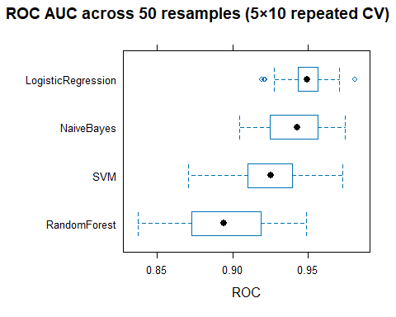
res_df <- as.data.frame(res)
# head(res_df)
res_long <- pivot_longer(res_df,
cols = -Resample,
names_to = "Model", values_to = "ROC")
res_long |>
ggplot() +
aes(x = ROC, y = Model) +
geom_boxplot() +
geom_point(aes(colour = Resample), size = 0.6, show.legend = FALSE) +
labs(y = "Models",
x = "AUC-ROC",
title = "Figure 2: AUC-ROC across 50 resamples (5×10 repeated CV)") +
theme_bw()
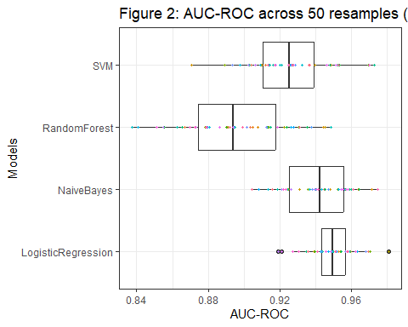
library(car)
res_aov <- aov(ROC ~ Model + Resample, data = res_long)
# visual checks
plot(res_aov)
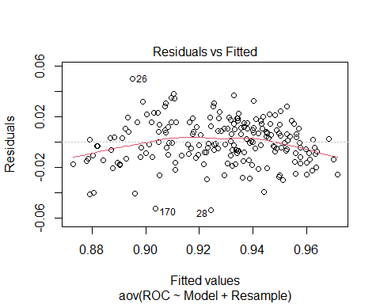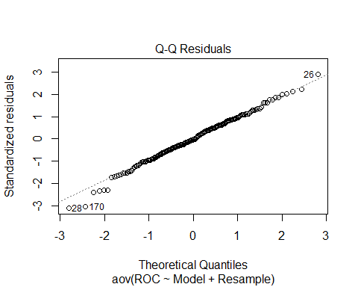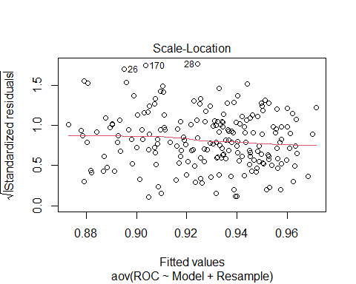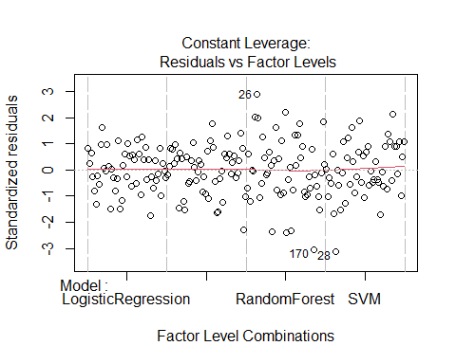
#head(res_aov)
# normality test on residuals
shapiro.test(residuals(res_aov))
##
## Shapiro-Wilk normality test
##
## data: residuals(res_aov)
## W = 0.99398, p-value = 0.5984
# homogeneity of variance test
bartlett.test(ROC ~ Model, data = res_aov$model)
##
## Bartlett test of homogeneity of variances
##
## data: ROC by Model
## Bartlett's K-squared = 34.734, df = 3, p-value = 1.387e-07
leveneTest(ROC ~ Model, data = res_long)
## Warning in leveneTest.default(y = y, group = group, ...): group coerced to
## factor.
## Levene's Test for Homogeneity of Variance (center = median)
## Df F value Pr(>F)
## group 3 12.538 1.558e-07 ***
## 196
## ---
## Signif. codes: 0 '***' 0.001 '**' 0.01 '*' 0.05 '.' 0.1 ' ' 1
# : p > 0.05, do not reject H0, normality is satisfied
# Bartlett: p < 0.05, reject H0, equal variance is not satisfied
hist(residuals(res_aov))
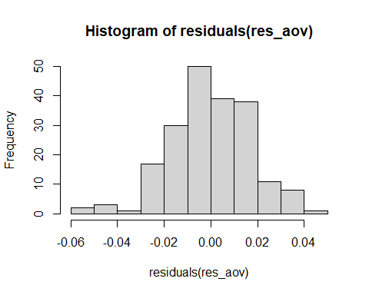
# log transform, H0 = equal medians / equal geometric means
y <- log(res_long$ROC)
res_log_aov <- aov(y ~ Model + Resample, data = res_long)
plot(res_log_aov)
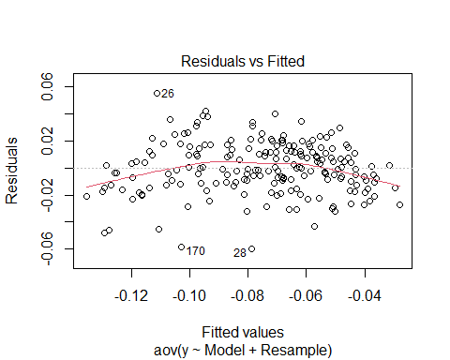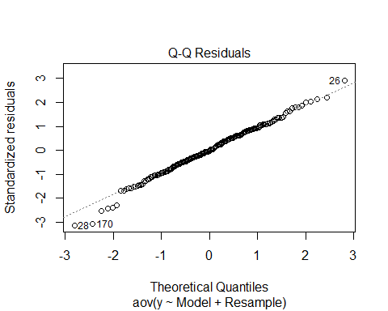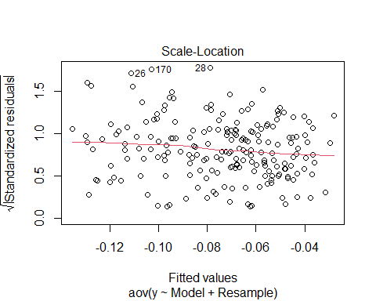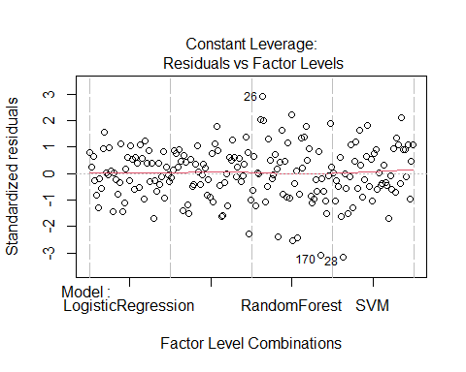
shapiro.test(residuals(res_log_aov))
##
## Shapiro-Wilk normality test
##
## data: residuals(res_log_aov)
## W = 0.99256, p-value = 0.4054
bartlett.test(y ~ Model, data = res_log_aov$model)
##
## Bartlett test of homogeneity of variances
##
## data: y by Model
## Bartlett's K-squared = 39.728, df = 3, p-value = 1.217e-08
leveneTest(y ~ Model, data = res_long)
## Warning in leveneTest.default(y = y, group = group, ...): group coerced to
## factor.
## Levene's Test for Homogeneity of Variance (center = median)
## Df F value Pr(>F)
## group 3 14.181 2.111e-08 ***
## 196
## ---
## Signif. codes: 0 '***' 0.001 '**' 0.01 '*' 0.05 '.' 0.1 ' ' 1
hist(residuals(res_log_aov))
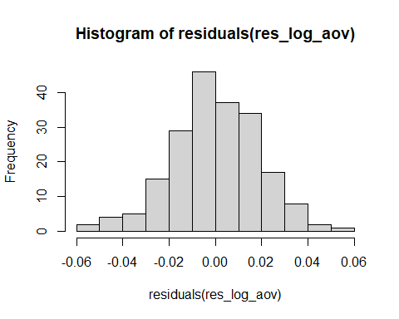
# The log transformation makes the model worse. Proceed with initial model
anova(res_aov)
## Analysis of Variance Table
##
## Response: ROC
## Df Sum Sq Mean Sq F value Pr(>F)
## Model 3 0.081603 0.0272010 67.0219 <2e-16 ***
## Resample 49 0.026458 0.0005400 1.3304 0.099 .
## Residuals 147 0.059660 0.0004059
## ---
## Signif. codes: 0 '***' 0.001 '**' 0.01 '*' 0.05 '.' 0.1 ' ' 1
# p < 0.001 indicates significant difference among algorithms.
friedman.test(ROC ~ Model | Resample, data = res_long)
##
## Friedman rank sum test
##
## data: ROC and Model and Resample
## Friedman chi-squared = 74.112, df = 3, p-value = 5.616e-16
tukey_res <- TukeyHSD(res_aov, which = "Model")
tukey_res
## Tukey multiple comparisons of means
## 95% family-wise confidence level
##
## Fit: aov(formula = ROC ~ Model + Resample, data = res_long)
##
## $Model
## diff lwr upr p adj
## NaiveBayes-LogisticRegression -0.007509974 -0.01798039 0.002960443 0.2481740
## RandomForest-LogisticRegression -0.052675496 -0.06314591 -0.042205080 0.0000000
## SVM-LogisticRegression -0.023405152 -0.03387557 -0.012934736 0.0000002
## RandomForest-NaiveBayes -0.045165522 -0.05563594 -0.034695106 0.0000000
## SVM-NaiveBayes -0.015895179 -0.02636560 -0.005424762 0.0007052
## SVM-RandomForest 0.029270344 0.01879993 0.039740760 0.0000000
library(emmeans)
emmeans(res_aov, ~ Model)
## Model emmean SE df lower.CL upper.CL
## LogisticRegression 0.949 0.00285 147 0.944 0.955
## NaiveBayes 0.942 0.00285 147 0.936 0.947
## RandomForest 0.896 0.00285 147 0.891 0.902
## SVM 0.926 0.00285 147 0.920 0.931
##
## Results are averaged over the levels of: Resample
## Confidence level used: 0.95
QUESTION 3: Algorithm Recommendation
Based on the experimental results, Logistic Regression is recommended for predicting credit card default. It had the highest point estimate ROC and showed consistency across resamples (blocks), demonstrating strong discrimination and stability. Though Naive Bayes was not significantly worse, Logistic Regression also provided a much higher specificity making it more effective for identifying default cases.
A limitation of this recommendation is that it is based on a singular dataset and the chosen resampling design, therefore, the results may differ when presented with new data. (84 words)

References
Kleijnen, Jack P. C. 2008. Design and Analysis of Simulation Experiments. 1st ed. New York: Springer-Verlag.
James, Gareth, Daniela Witten, Trevor Hastie, and Robert Tibshirani. 2013. An Introduction to Statistical Learning. Vol. 112. New York: Springer.
Montgomery, Douglas C. 2020. Design and Analysis of Experiments. 1st ed. Hoboken, NJ: Wiley.

