Issue: Mismatching steiner tree values
Kruskal: 72.25483399593904
primal-dual 67.25483399593905 (due to incorrectly picking next node to expand from frontier)

line 147: break when sel_node == (14,0) or when it is closed
Currently this happens with terminal (14,14), index 0

line 157: break when the same node is closed more than once
indicates closed set has “touched”, and merging is required

checked the frontier priority for each terminal. Currently (14,0) has the minimum g, but (15,0) from (14,-14) or terminal (1) gets picked over this...why?

Identified problem: Each component has a nominated node; however during merging when a component is touching multiple other components, one of the midpoints is considered closed...so is ignored

(see 14,0)
bottom right terminal is touching both blue and pink components, but it’s currently merging with the pink. Aftewards (14,0) doesn’t get selected again because it’s in the closed list.
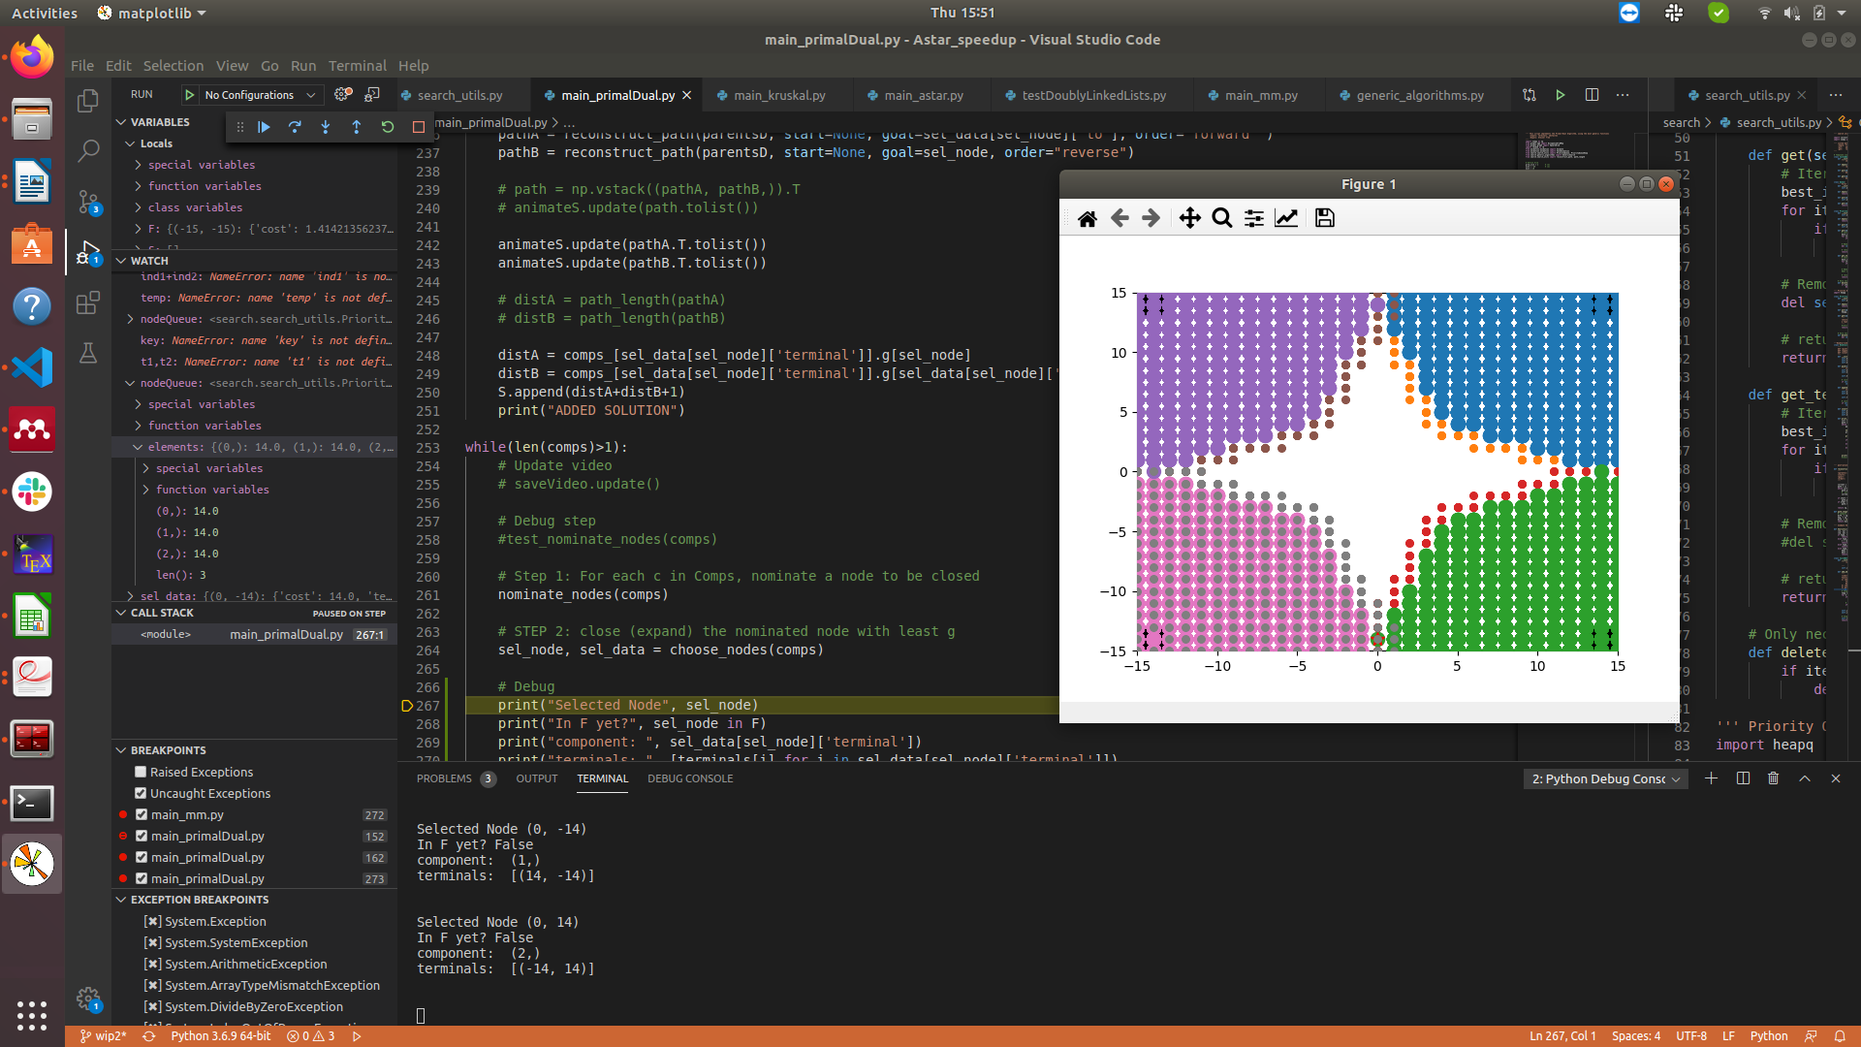
Solved by explicity passing current node to nodeQueue instead of just component index, and also adding an if case to ensure component doesn’t nominate if it already exists inside the nodeQueue

cls vs. self
cls := class method (thinnk @staticmethod)
self := instance method

https://docs.python.org/3/library/typing.html

def greeting(name: str) -> str:
return 'Hello ' + name
https://medium.com/@mrfksiv/python-design-patterns-03-the-factory-86cb351c68b0

https://www.uml-diagrams.org/design-pattern-abstract-factory-uml-class-diagram-example.html

https://docs.pytest.org/en/latest/goodpractices.html
You can then install your package in “editable” mode by running from the same directory:
pip install -e .
which lets you change your source code (both tests and application) and rerun tests at will. This is similar to running python setup.py develop or conda develop in that it installs your package using a symlink to your development code.

terminals: [-8 14] [-8 15]
terminals: [-3 -4] [-3 -3]
terminals: [ 14 -13] [ 13 -13]
terminals: [-1 -9] [-2 -8]
terminals: [-13 -2] [-14 -1]
terminals: [13 -7] [13 -6]
terminals: [-1 -3] [-1 -2]
terminals: [11 10] [10 11]
terminals: [-14 12] [-15 12]
terminals: [ 1 -1] [0 0]
terminals: [ 4 13] [ 3 13]
terminals: [-5 4] [-5 5]
terminals: [10 -9] [ 9 -9]
terminals: [-12 -8] [-13 -8]
terminals: [-2 3] [-3 3]
terminals: [-9 11] [-10 12]
terminals: [-7 11] [-8 11]
terminals: [-1 13] [-2 14]
terminals: [-15 -2] [-14 -1]
terminals: [ -2 -15] [ -1 -14]
terminals: [15 6] [14 5]
terminals: [ 4 -7] [ 5 -6]
terminals: [ 3 -12] [ 4 -12]
terminals: [14 -5] [13 -6]
terminals: [ 6 -10] [ 7 -9]
terminals: [-13 -10] [-12 -10]
terminals: [-4 -4] [-3 -4]
terminals: [15 -6] [14 -5]
terminals: [-6 12] [-7 11]
terminals: [-8 11] [-9 11]
terminals: [ 3 -10] [ 4 -9]
terminals: [-14 14] [-14 12]
terminals: [ 13 -15] [ 13 -13]
terminals: [-6 15] [-8 15]
terminals: [-14 10] [-14 12]
terminals: [ 4 -12] [ 4 -14]
terminals: [14 -5] [14 -3]
terminals: [0 5] [0 7]
terminals: [-13 -8] [-13 -10]
terminals: [ 3 -10] [ 3 -12]
terminals: [2 6] [0 7]
terminals: [11 0] [11 2]
terminals: [ 5 -1] [4 1]
terminals: [ 2 -7] [ 0 -7]
terminals: [3 4] [2 6]
terminals: [ 6 12] [ 4 13]
terminals: [-5 4] [-7 3]
terminals: [-13 -8] [-15 -9]
terminals: [-4 -4] [-6 -4]
terminals: [ 4 -7] [ 2 -7]
terminals: [ 7 -9] [ 9 -9]
terminals: [ 6 -10] [ 4 -9]
terminals: [ 15 -11] [ 14 -13]
terminals: [ -8 -15] [ -6 -14]
terminals: [11 2] [12 4]
terminals: [ 8 -3] [ 9 -1]
terminals: [2 6] [4 7]
terminals: [ 9 -11] [ 9 -9]
terminals: [-3 -3] [-1 -3]
terminals: [-2 -8] [ 0 -7]
terminals: [0 0] [2 1]
terminals: [ 6 15] [ 4 13]
terminals: [ 7 -14] [ 4 -14]
terminals: [ 1 -10] [ 3 -10]
terminals: [-7 6] [-5 5]
terminals: [-3 3] [-5 4]
terminals: [0 0] [-1 -2]
terminals: [-8 14] [-10 12]
terminals: [14 5] [12 4]
terminals: [4 1] [6 2]
terminals: [2 1] [4 1]
terminals: [11 0] [ 9 -1]
terminals: [ 4 -9] [ 4 -7]
terminals: [-11 -4] [-13 -2]
terminals: [11 -3] [ 9 -1]
terminals: [-13 -8] [-15 -5]
terminals: [-15 5] [-12 6]
terminals: [14 9] [15 6]
terminals: [13 -7] [10 -9]
terminals: [ -5 -10] [-2 -8]
terminals: [10 7] [12 4]
terminals: [7 6] [10 7]
terminals: [4 7] [7 6]
terminals: [-2 3] [0 5]
terminals: [-15 -2] [-15 -5]
terminals: [3 4] [4 1]
terminals: [-9 -8] [-12 -8]
terminals: [11 10] [14 9]
terminals: [14 -3] [11 -3]
terminals: [15 1] [12 4]
terminals: [ -2 -15] [ -6 -14]
terminals: [ 3 13] [-1 13]
terminals: [-14 12] [-10 12]
terminals: [ -6 -14] [ -5 -10]
terminals: [ 6 12] [10 11]
terminals: [ 13 -13] [ 9 -11]
terminals: [-6 15] [-2 14]
terminals: [-12 6] [-14 10]
terminals: [-9 -8] [ -5 -10]

[(1, -10), (3, -10), (0, 7), (15, 1), (-8, 14), (-6, 12), (-5, -10), (-2, 14), (10, 7), (4, -14), (7, 6), (13, -13), (-8, 11), (-14, 10), (-3, -4), (2, 6), (-10, 12), (-6, -4), (9, -9), (11, 0), (4, -9), (-14, -1), (14, -13), (-1, -9), (4, -7), (4, -12), (-13, -2), (13, -7), (15, -11), (2, 1), (-1, -3), (-5, 5), (-6, -14), (11, 10), (14, 5), (-15, -2), (-8, 15), (-1, -2), (-7, 3), (4, 1), (5, -1), (3, -12), (-13, -8), (0, 5), (-15, 12), (7, -9), (12, 4), (-15, -9), (14, -3), (-14, 12), (6, 2), (8, -3), (2, -7), (-3, 3), (14, 9), (1, -1), (-15, 5), (4, 13), (-2, -15), (5, -6), (-5, 4), (10, -9), (6, 15), (-12, -10), (-8, -15), (14, -5), (-12, 6), (6, -10), (-1, -14), (-9, -8), (-12, -8), (-2, 3), (13, -15), (15, 6), (3, 4), (-2, -8), (-6, 15), (4, 7), (10, 11), (9, -11), (11, 2), (-11, -4), (-9, 11), (-13, -10), (-15, -5), (-7, 11), (-3, -3), (-4, -4), (15, -6), (0, 0), (3, 13), (-14, 14), (-7, 6), (11, -3), (9, -1), (6, 12), (0, -7), (13, -6), (7, -14), (-1, 13)]

\begin{algorithm}[h!]
\SetAlgoLined
\textbf{Input:} \\
$G=(V,E)$, $T\subseteq V$ \\
$\bar{h}_t(u)$ \tcp{Lower bound on a shortest path from $u$ to $t\in T$} \\
$c(u,v)$ \tcp{cost of traveling between $u\in V$ and $v\in V$. Note $c(u,v)=\infty$ if $(u,v)\notin E$.} \\
\textbf{Output:}\\
$S_T$ \tcp{A Steiner tree spanning the terminals in T}\\
\textbf{Initialization:}\\
$C_t := \{t\}$ \tcp{Closed set of nodes connected to $t\in T$} \\
$O_t:= \{u: (u,v)\in E,u\notin C_t, v\in C_t\}$ \tcp{Open set of nodes adjacent to nodes in $C_t$} \\
$D_t := T\setminus \{t\}$ \tcp{Subset of terminals not connected to $t$ in $C_t$} \\
$h(u,S) := \min\{\bar{h}_t(u): t\in T, t\in S\}$ \tcp{Lower bound on a shortest path to any terminal in S} \\
$g_t(u):=c(t,u) ~\forall u\in V, t\in T$ \tcp{Upper bound on the shortest path cost from $t$ to $u$} \\
$f_t(u):=g_t(u)+h(u,D_t),~\forall u\in V,t\in T $ \tcp{Lower bound on the shortest path cost from $u$ to any terminal in $D_t$}\\
$Q=\emptyset$ \tcp{Set of paths between any two terminals that could be potentially added to $S_T$} \\
$S_T=\emptyset$\\
\vspace{.3cm}
{\bf Main Loop:} \\
\While{$S_T$ doesn't contain all the terminals in T}
{
$u_t:= \arg\min_{u\in O_t} f_t(u) ~\forall t\in T$ \tcp{Each terminal $t$ nominates a node from its open set}
$t^* = \arg \min \{f_t(u_t): t\in T\}$ \tcp{Choose the terminal which nominates the node with the least $f$ cost}
$C_{t^*}:=C_{t^*}\cup \{u_{t^*}\}$ \tcp{Update the closed set of $t$}\\
$O_{t^*}:=O_{t^*}\setminus \{u_{t^*}\}$ \tcp{Update the open set of $t$} \\
\For{$v\in \{v: (v,u_{t^*})\in E, v\notin C_{t^*} \}$}
{ $O_{t^*}:=O_{t^*}\cup \{v\}$ \\
$g_{t^*}(v):= \min(g_{t^*}(v),g_{t^*}(u_{t^*})+c(u_{t^*},v))$ \tcp{Update the $g$ cost of the nodes in $C_t$} \\
} \\
\If{$u_{t^*}\in D_{t^*}$}{
$D_{t^*}:= T\setminus (D_{t^*}\cup D_{u_{t^*}})$ \tcp{The subset of terminals not connected to both $t^*$ and $u_{t^*}$ must be updated}\\
$D_{u_{t*}}:=D_{t^*}$ \\
\tcp{Let $PATH_t^*(u_t^*)$ denote the path corresponding to $g_{t^*}(u_{t^*})$}
$Q:=Q\cup PATH_{t^*}(u_{t^*})$ \\
$f_{u_{t^*}}(v):= g_{u_{t^*}}(v) + h(v,D_{u_{t^*}}),$ $\forall v\in O_{u_{t^*}}$
\tcp{Update the $f$ cost of the nodes in $O_{u_{t^*}}$} \\
}
$f_{t^*}(v):= g_{t^*}(v) + h(v,D_{t^*}),$ $\forall v\in O_{t^*}$ \tcp{Update the $f$ cost of the nodes in $O_{t^*}$} \\
$S_T:=UpdateSteinerTree(S_T,Q,f)$
}
\textbf{return }$T_s$
\caption{S* Unmerged}
\label{Alg:Framework}
\end{algorithm}

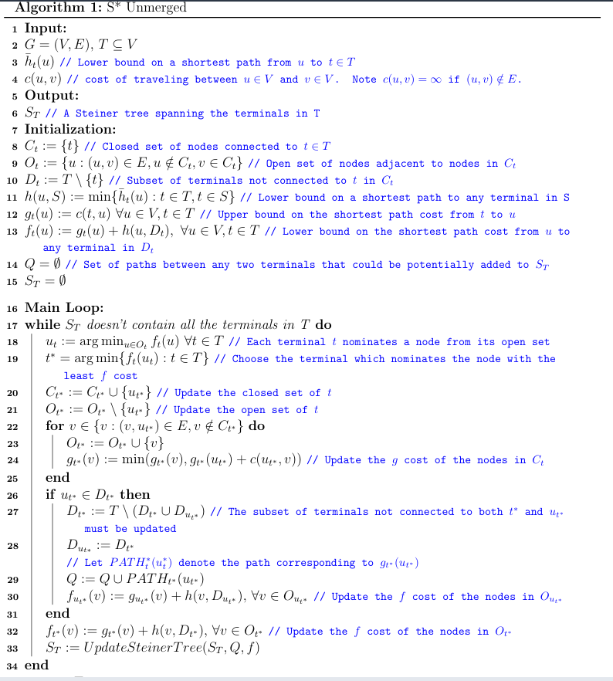

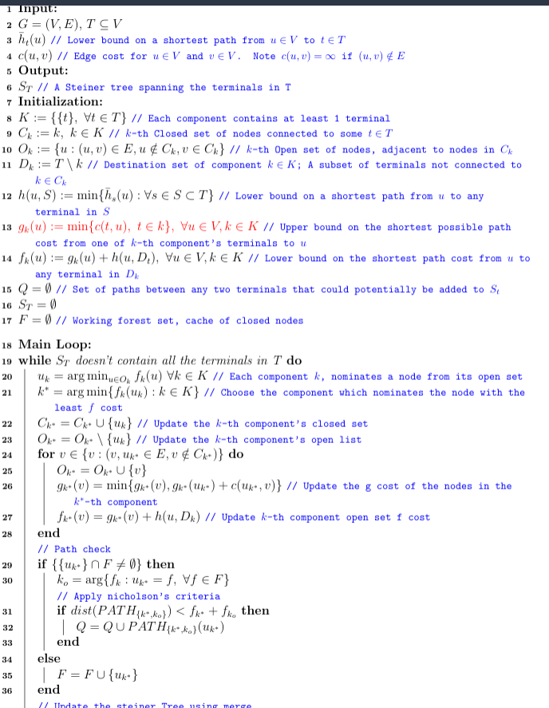

merged alogrithm
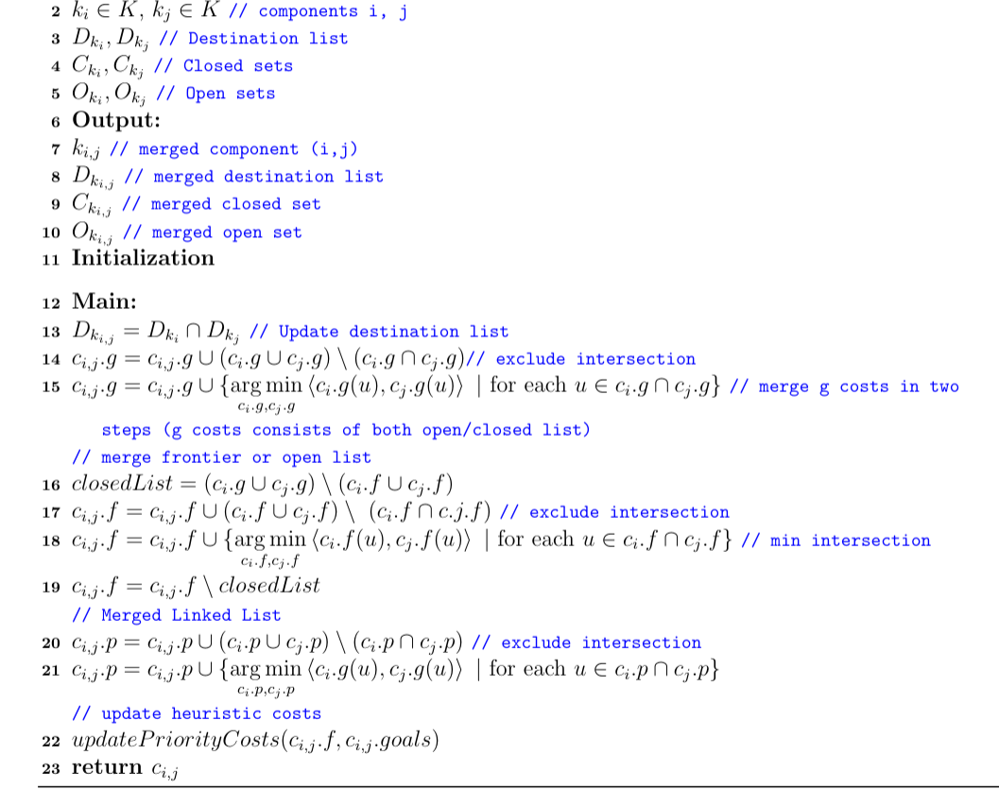
$D_{k_{i,j}} = D_{k_i}\cap D_{k_j}$ \tcp{Update destination list}
$c_{i,j}.g=c_{i,j}.g \cup \left(c_i.g \cup c_j.g \right)\setminus \left(c_i.g \cap c_j.g \right)$\tcp{exclude intersection}
$c_{i,j}.g=c_{i,j}.g \cup \{\underset{c_i.g, c_j.g}{\arg\min}\left<c_i.g(u), c_j.g(u)\right>~ | ~\text{for each}~ u \in c_i.g \cap c_j.g \}$ \tcp{merge g costs in two steps (g costs consists of both open/closed list)}
\tcp{merge frontier or open list}
$closedList = (c_i.g\cup c_j.g)\setminus (c_i.f \cup c_j.f) $ \\
$c_{i,j}.f=c_{i,j}.f \cup \left(c_i.f \cup c_j.f \right)\setminus \ \left( c_i.f\cap c.j.f \right)$ \tcp{exclude intersection}
$c_{i,j}.f=c_{i,j}.f \cup \{\underset{c_i.f, c_j.f}{\arg\min}\left<c_i.f(u), c_j.f(u)\right>~ | ~\text{for each}~ u \in c_i.f \cap c_j.f \}$ \tcp{min intersection}
$c_{i,j}.f = c_{i,j}.f \setminus closedList$\\
\tcp{Merged Linked List}
$c_{i,j}.p = c_{i,j}.p \cup \left(c_i.p \cup c_j.p \right) \setminus \left(c_i.p \cap c_j.p \right) $ \tcp{exclude intersection}
$c_{i,j}.p = c_{i,j}.p \cup \{\underset{c_i.p, c_j.p}{\arg\min}\left<c_i.g(u), c_j.g(u)\right> ~ | ~\text{for each}~ u \in c_i.p \cap c_j.p \}$\\
\tcp{update heuristic costs}
$updatePriorityCosts(c_{i,j}.f, c_{i,j}.goals)$\\
\textbf{return }$c_{i,j}$

\caption{Pseudocode for $C-$merging}
\label{Alg:Framework}

# Misc Notes
- Make sure to unset `PYTHONPATH` before creating a virtual environment test
```
$ Unset PYTHONPATH
$ python3 -m venv test_venv
$ source test_venv/bin/activate
```

Note that this will only affect the current shell and is not permanent!
- After building docs, we can start an http server and open `index.html`

```
$ python -m http.server
```

Then in the browser open, whatever ip address is displayed in the shell

- Build docs with `sphinx` command
```
$ cd docs
$ sphinx-quickstart # not necessary for us
$ make html
```
- git-lfs tutorial: [link](https://github.com/git-lfs/git-lfs/wiki/Tutorial)
- To use git-lfs for the first time after a large file has been previously committed [link](https://github.com/git-lfs/git-lfs/issues/1328)
- back up current branch
- use `git reset {sha}` to find last parent without issues
- track large files with `git-lfs` using `.gitattributes`
- commit and push
- To ignore lfs file downloads globally: `git lfs install --skip-smudge`

## Optional

There is also support for large files (i.e. results_*.pkl) using [git-lfs](https://github.com/git-lfs/git-lfs/wiki/Installation). Large files are kept in a separate server, while the repo contains only pointers to them.

If git-lfs is installed and you DO NOT wish to download any large files, run
`GIT_LFS_SKIP_SMUDGE=1 git clone SERVER-REPOSITORY`

