Question 1:

How many pennies could you put on the Golden Gate Bridge without any of them overlapping? Please write out each step of your thought process.

I started by taking a look at the a 3d model of the Golden Gate Bridge provided by Google 3D Warehouse.

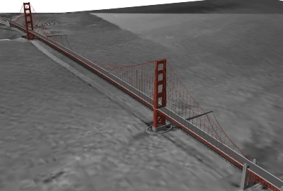

Once I got a sense of how big the bridge was including the sidewalks and roadway, I decided to find the bridges total surface area. I found all the needed information and statistics for the bridge at (http://www.goldengatebridge.org/research/factsGGBDesign.php).

The next step was to find the diameter of a penny, with a simple google search I came up with a diameter of 19.05mm.

The information provided by goldengatebridge.org said the length of the bridge is 9,150ft. This measurement included approaches from abutment to abutment plus the distance to the toll plaza.

Converting the distance of 9,150 ft into mm (finding that 1 foot = 304.8 mm) I came up with the following:

9,150 x 304.8 = 2,788,920 mm long
2,788,920 mm/19.05 mm = 146,400 pennies in length

The bridge is 90ft wide so:
90 x 304.8 = 27,432 mm wide
27,432 mm/19.05 mm = 1440 pennies in width

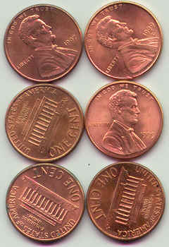
With the bridge being 146,400 pennies in length and 1440 pennies in width I could determine the approximate amount of pennies.

146,400 x 1440 = 210,816,000 Pennies

You could put 210,816,000 Pennies on the Golden Gate Bridge without any of them overlapping.

