Assignment -7

Qsn 1. write a query that counts all orders for october 3.

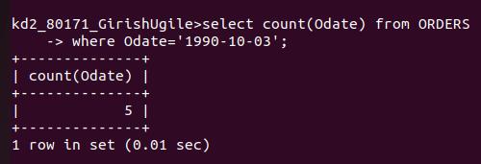

Qsn 2. write a query that counts the number of different
non-null city values in the Customers table.

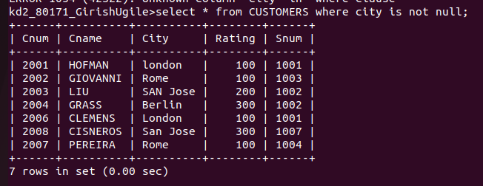

Qsn 3. write query that selects each customers smallest
order.

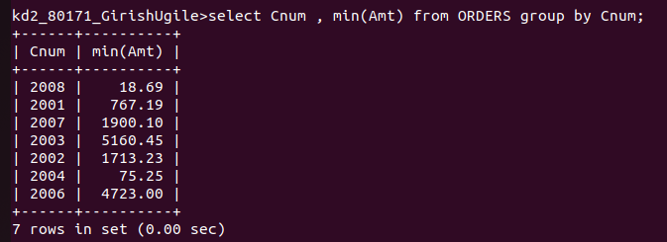

Qsn 4. write a query that selects the first customer in
alphabetical order , whose name begins with G.

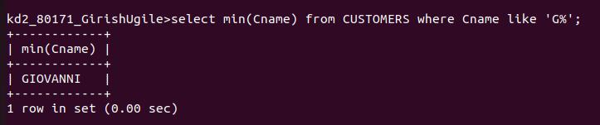

Qsn 5. write query that selects the highest rating in each
city.

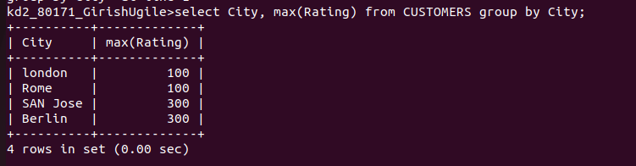

Qsn 6. Write query that counts the number of salespeople
registering orders for each day .

