Assignment-13

1. Create a union of two queries two shows the names, cities, and ratings of all
customers. Those with rating of 200 or greater will also have the words “High
Rating” while the others will have the words “Low Rating”.
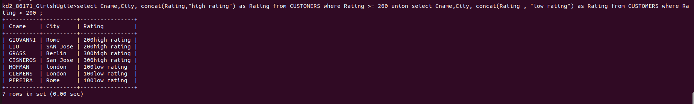

2. Write a command that produces the name and number of each salesperson
and each customer with more than one current order. Put the results in
alphabetical order.

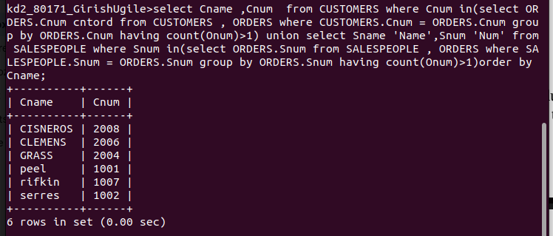

3. Form a union of three queries. Have the first select the snums of all
salespeople in San Jose; the second, the cnums of all customers in San Jose;
and the third the onums of all orders on October 3. Retain duplicates between
the last two queries but eliminate any redundancies between either of them and
first.(Note: in the sample table as given, there would be no such redundancy.
This is besides the point.)

