Assignment – 10

Qsn-1 1) Write a query that produces all pairs of salespeople who are living in the same city. Exclude combinations of salespeople withn themselves as well as duplicate rows with the order reversed.

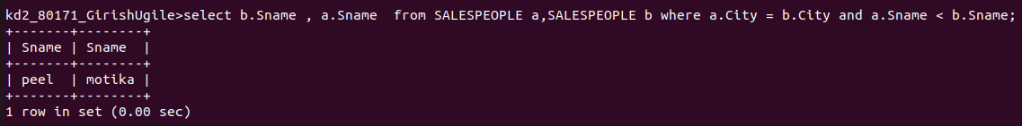

Qsn -2Write a query that produces the name and cities of all customers with the same rating as Hoffman

