ASSIGNMENT -1

QSN-1 CREATE TABLE SALESPEOPLE(SNUM INT(4),SNAME VARCHAR(10),CITY VARCHAR(10),COMM FLOAT(3,2));

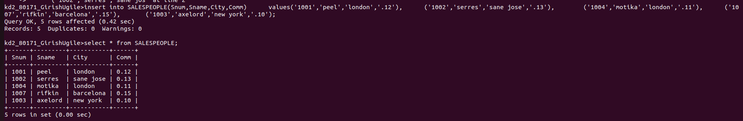

QSN NO-2. INSERT INTO CUSTOMERS(CNUM,CNAME,CITY,RATING,SNUM)
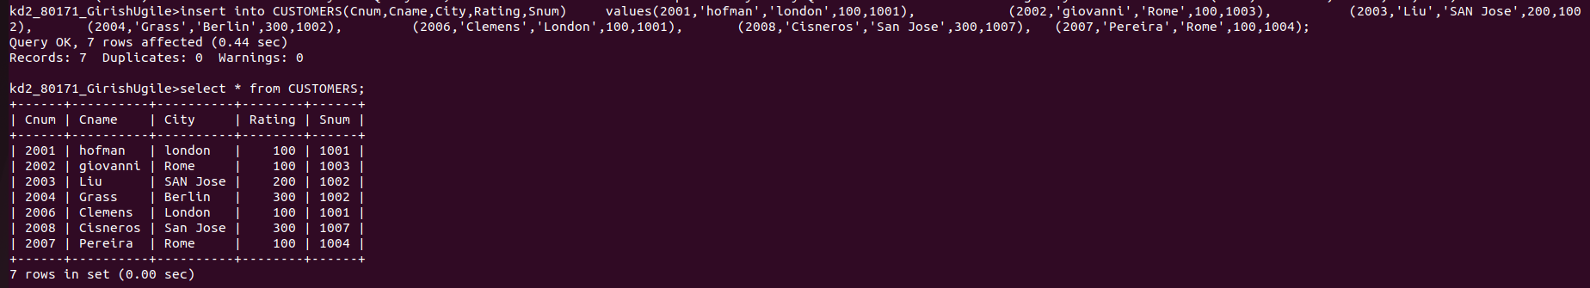

QSN no-3 INSERT INTO ORDERS(ONUM,AMT,ODATE,CNUM,SNUM)

