Assignment-8

Qsn 1.Assume each salesperson has a 12% write
a query on the orders table that will
produce the order number, the salesperson,
and the amount of the salesperson
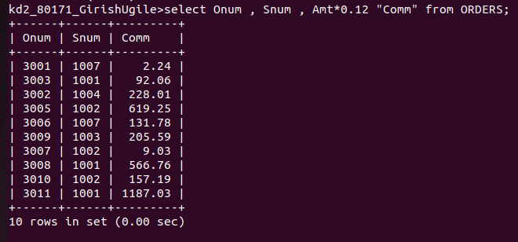
commission for that order.

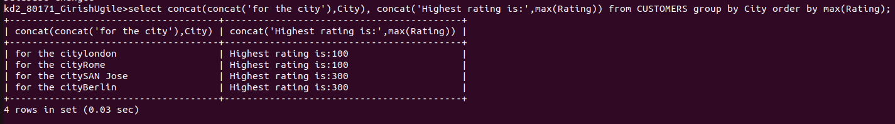
Qsn 2. write a query on the customers table that
will find the highest rating in each city .

Qsn 3. write a query that lists customers in
descending order of rating. Output the
rating field first , followed by the
customers name and number.

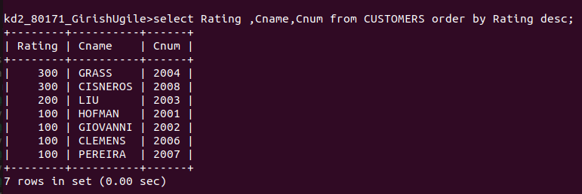

Qsn 4. write a query that totals the orders for
each day and places the results in
descending order.
