Assignment-6

QSN 1. write two different queries that would produce
all orders taken on october 3rd or 4th ,1990;

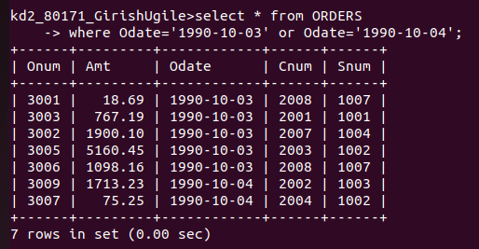
QSN 2. write a query that selects all of the customers
serviced by peel or motika.
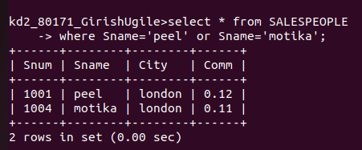

QSN 3.write query that will produce all the
customers whose names begin with a letter
‘A’ to ‘G’.

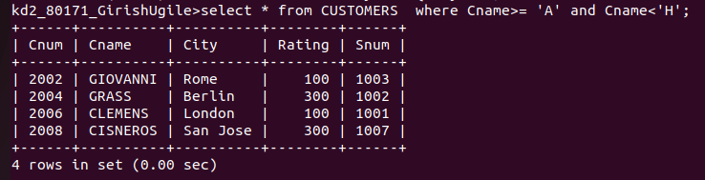

QSN 4. write a query that selects all customers whose
names begin with the letter ‘C’.
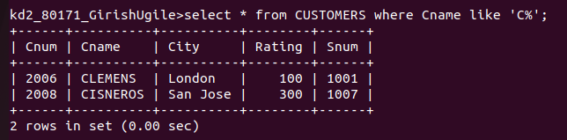

QSN 5. write query that selects all orders except those
with zeroes or nulls in the amt field.

