Assignment-14

1)Write a command that puts the following values, is their given order, into the salespeople
table: city San Jose, name - Blanco, comm - NULL, cnum -1100.
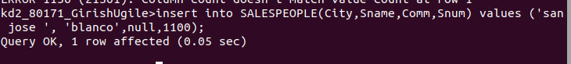

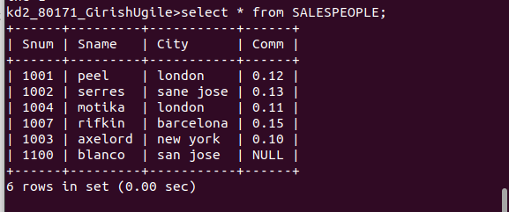

2) Write a command that removes all orders from customer Clemens from the Orders
table.

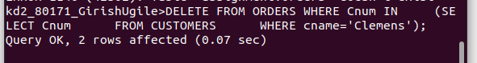
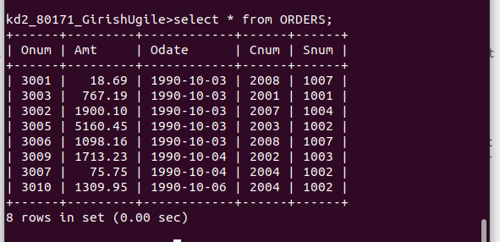

3) Write a command that increases the rating of all customers in Rome by 100.

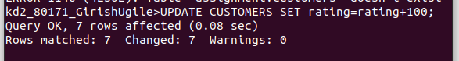

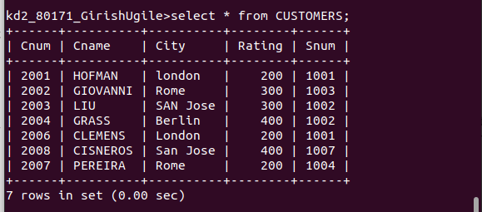

4) Salesperson Serres has left the company. Assign her customers to Motika.

