Assignment-12

Qsn-1. Write a query that selects all customers whose rating are equal to or greater
than any of ‘Serres’.

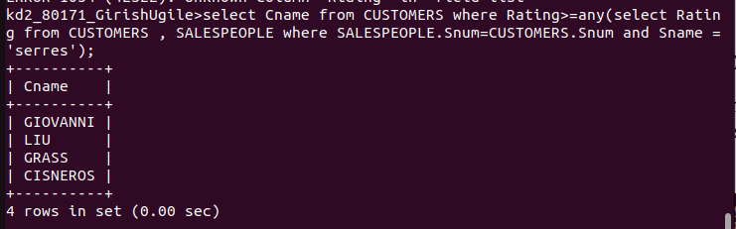

Qsn-2.Write a query using any or all that will find all salespeople who have no
customers located in their city.

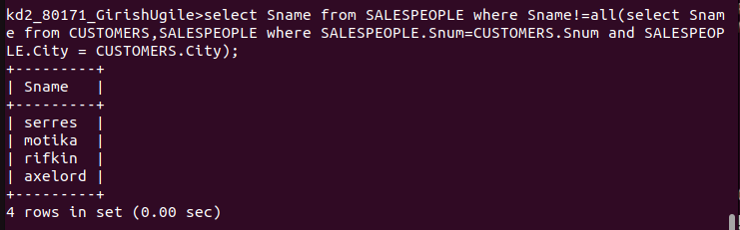

Qsn-3.Write a query that selects all orders for amount greater than any for the
customers in London.

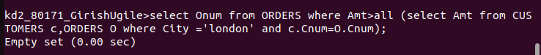

Qsn-4. Write the above query using min or max.

