ASSIGNMENT-4

QSN NO-1 -Write a select command that produces the order number, amount, and date for all rows in the Orders table.
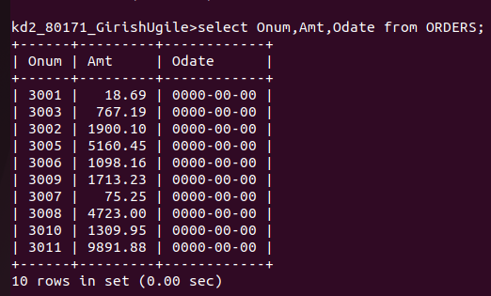

QSN NO-2 Write a query that produces all rows from the Customers table for which the salesperson's number IS 1001.
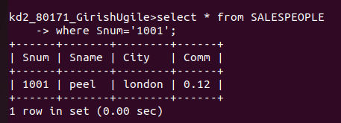
QSN NO -3 Write a query that displays the Salespeople table with the columns in the following order: city, sname, snum, comm.
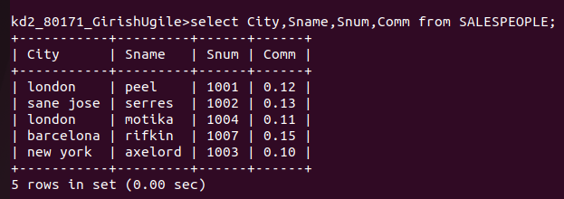

QSN NO-4 Write a select command that produces the rating followed by the name of each customer in San Jose.

