Assignment-15

1) Assume there is a table called Multicust, with all of the same column definitions as
Salespeople. Write a command that inserts all salespeople with more than one customer
into this table.
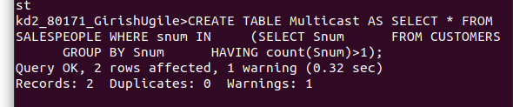

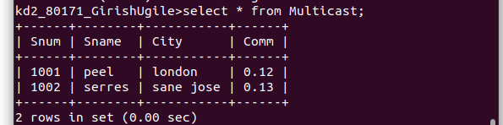

2) Write a command that deletes all customers with no current orders.

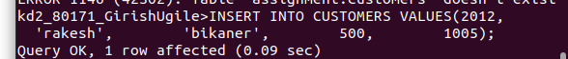
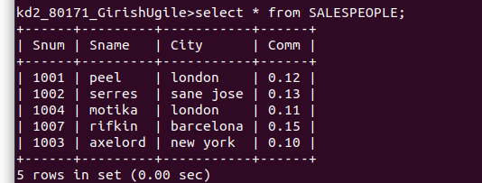
3) Write a command that increases by twenty percent the commissions of all salespeople
with total orders above Rs. 3,000.

