Assignment -5

QSN-1 Write a query that will give you all orders for more than Rs. 1,000.

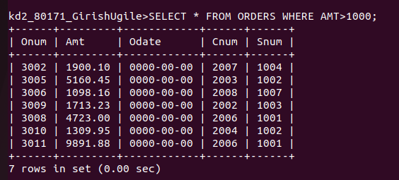

QSN 2.Write a query that will give you the names and cities of all salespeople in London with a commission above .10

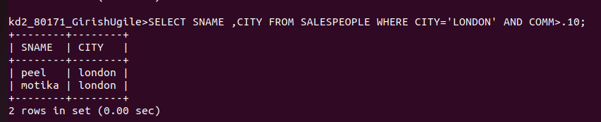

QSN 3.Write a query on the Customers table whose output will exclude all customers with a rating <= 100, unless they are located in Rome.

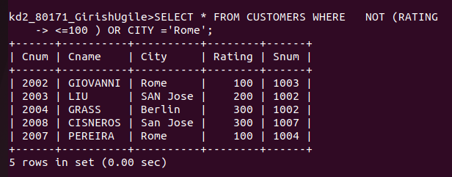

QSN 4.What will be the output from the following query?

Select * from Orders where (amt < 1000 OR

NOT (odate = 1990-10-03'

AND cnum > 2003));

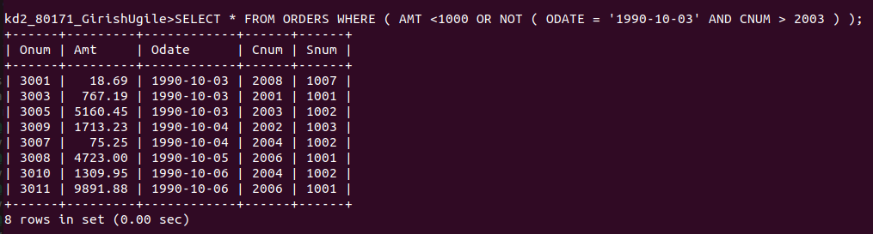
QSN 5.What will be the output of the following query?

Select * from Orders where NOT ((odate = 1990-10-03' OR snum

>1006) AND amt >= 1500);

What is a simpler way to write this query?

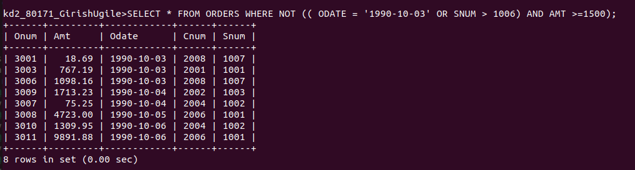

QSN 6. What is a simpler way to write this query?

Select snum, sname, city, comm From Salespeople (comm>.12 OR comm <.14);

