Assignment – 16

Creating Tables and Indexes

1. Write a command that will enable a user to pull orders grouped by date out of the Orders table quickly.

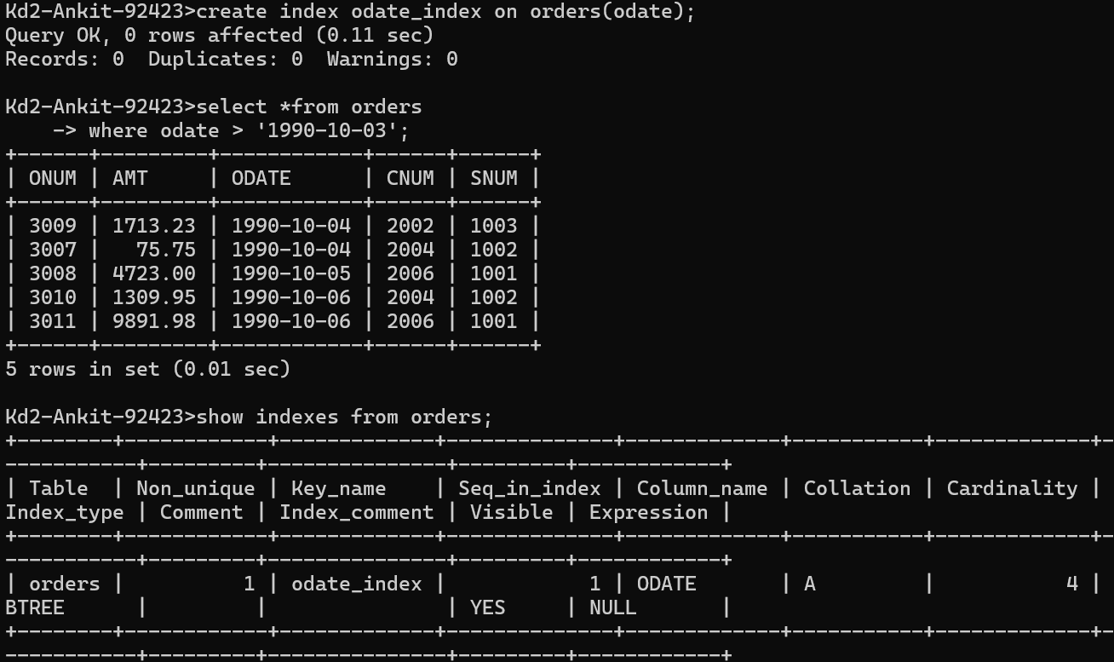

1. If the Orders table has already been created, how can you force the onum field to be unique (assume all current values are unique)?

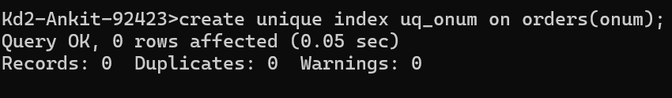

1. Create an index that would permit each salesperson to retrieve his or her orders grouped by date quickly.

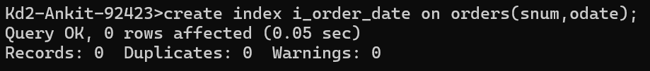

1. Let us assume that each salesperson is to have only one customer of a given rating, and that this is currently the case. Enter a command that enforces it.



