1) Write two different queries that would produce all orders taken on October 3rd or 4th, 1990.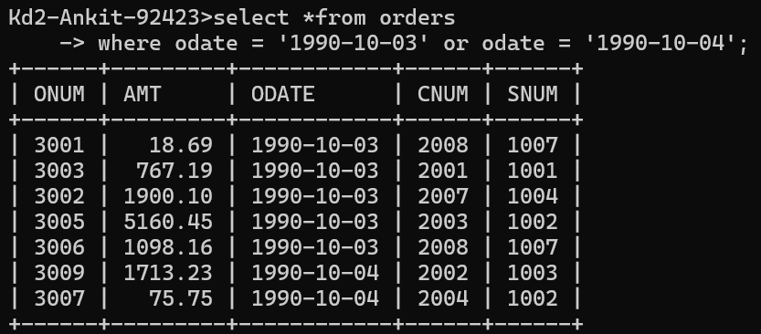

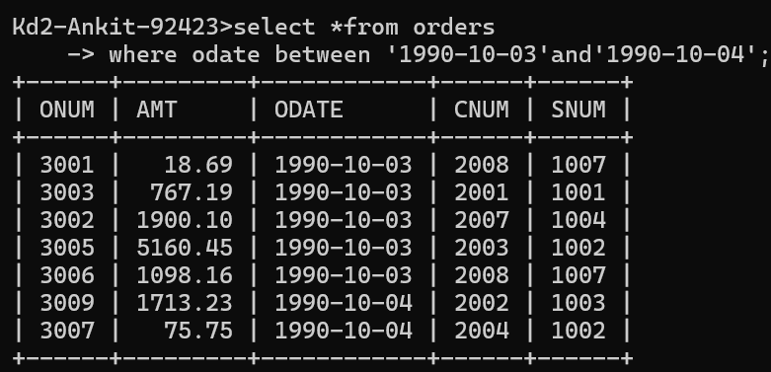

3) Write a query that will produce all the customers whose names begin with a letter from ‘A’ to ‘G’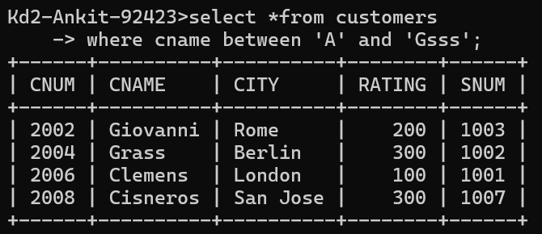

4) Write a query that selects all customers whose names begin with the letter ‘C’. 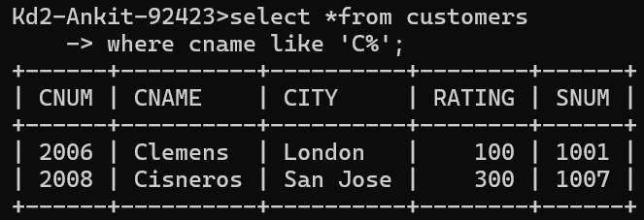

5) Write a query that selects all orders except those with zeroes or NULLs in the amt field.

