Assignment –7

Summarizing Data with Aggregate Functions

1. **Write a query that counts all orders for October 3.** 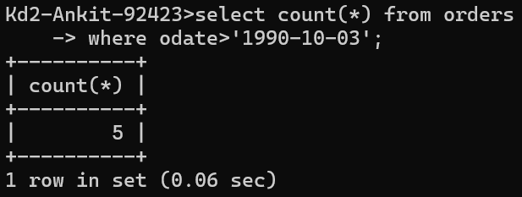
2. **Write a query that counts the number of different non-NULL city values in the Customers table.**

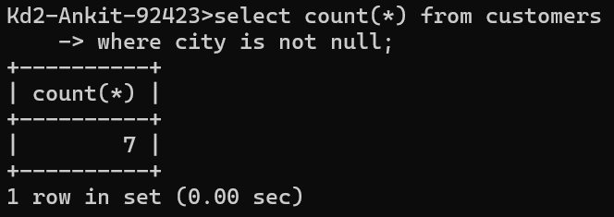

1. **Write a query that selects each customer’s smallest order.**

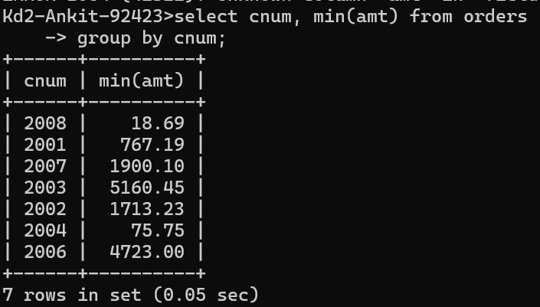

1. **Write a query that selects the first customer, in alphabetical order, whose name begins with G.**

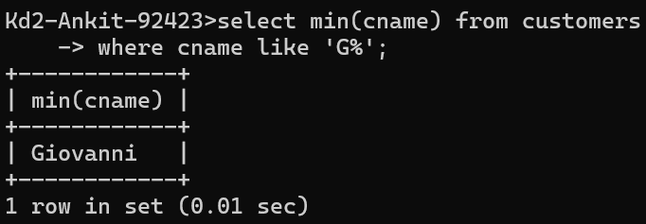

1. **Write a query that selects the highest rating in each city.**

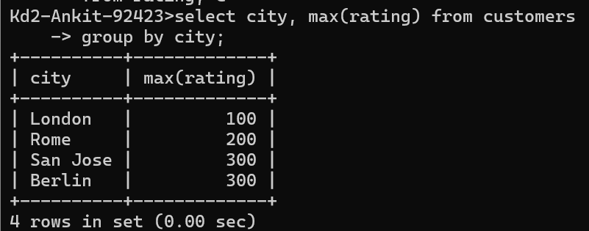

1. **Write a query that counts the number of salespeople registering orders for each day. (If a salesperson has more than one order on a given day, he or she should be counted only once.).**

