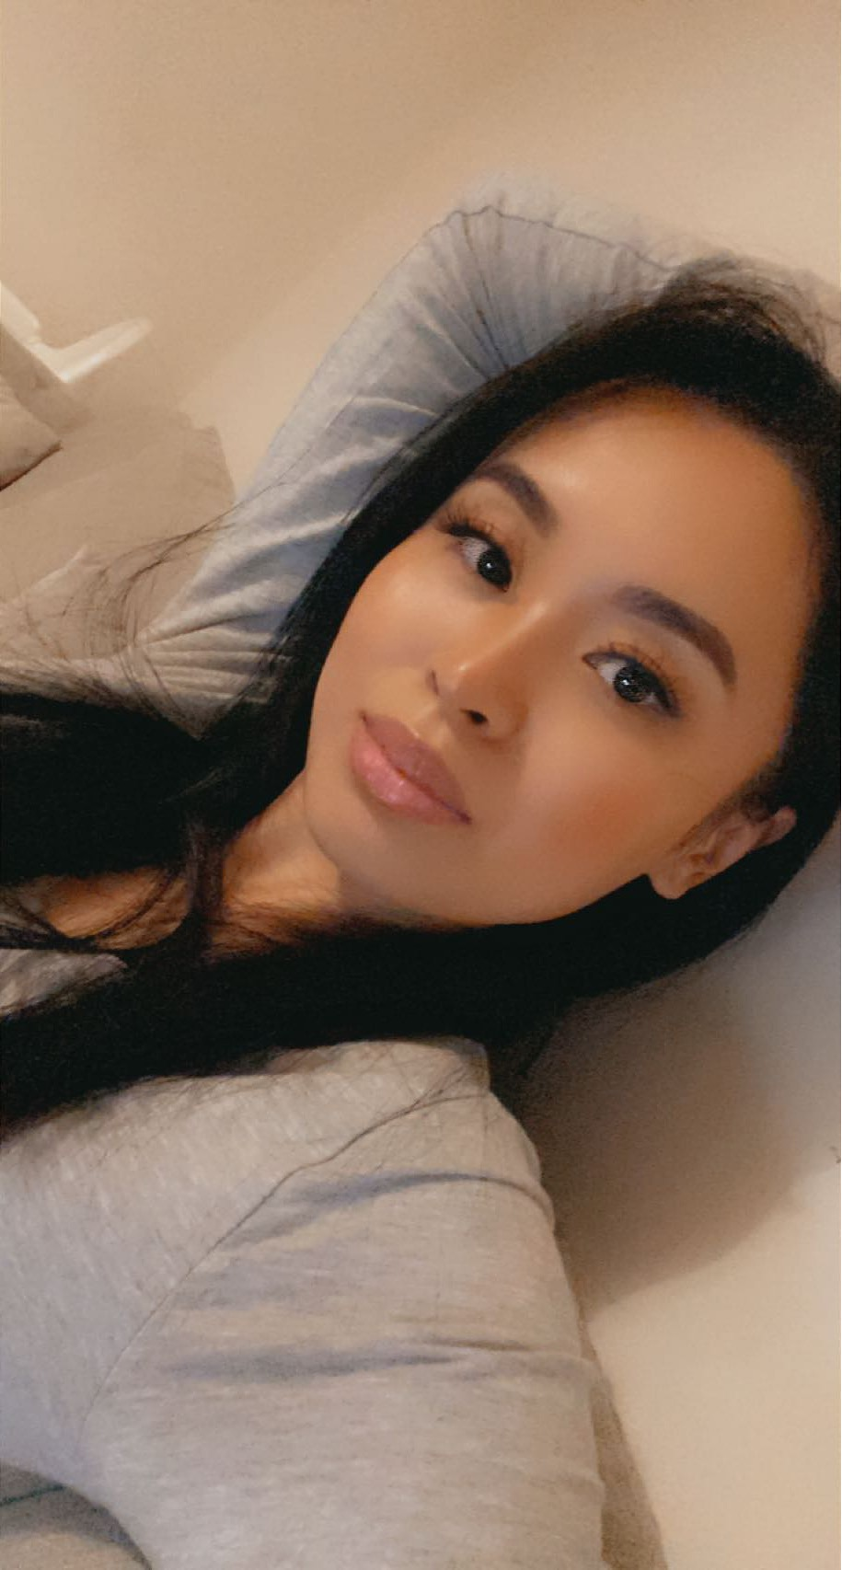

Kimberly | 07523053549| msnhile@gmail.com

# About me

Single mother of two. I love coding

# Work Experience

**Nails 2U** 2015-2019  
Sales and Marketing manager

**The Kicking Krab** 2018-2020-  
Founder CEO

# Skills

* Python coder