A Systematically Evaluated Interpretable Enhancement to Fuzzy Q-Learning: Gaussian Membership, Eligibility Traces, and Adaptive Exploration on CartPole-v1
Manuscript prepared for journal submission. DOI: Not yet assigned.

Abstract
Fuzzy Q-Learning (FQL) offers a rule-based, inspectable alternative to deep reinforcement learning, but the classical formulation (Jouffe, 1998) relies on triangular membership functions, one-step temporal-difference updates, and a fixed exploration rate -- design choices that were reasonable in 1998 but have since been superseded elsewhere in the reinforcement learning literature. This study asks a narrow, testable question: does swapping in three individually well-established improvements -- Gaussian membership functions, Watkins' Q(lambda) eligibility traces, and an adaptive epsilon schedule -- produce a measurable, statistically defensible, and mechanistically explainable improvement over the classical agent, without sacrificing the interpretability that motivates using a fuzzy controller in the first place? We call the resulting agent FQL-GTA and evaluate it against the baseline across 30 independent seeds on CartPole-v1, finding a final trailing-window return of 423.1 (SD 78.7) versus 265.7 (SD 41.2) for the baseline, a difference confirmed by a paired Wilcoxon signed-rank test (p = 3.54e-08) with a large effect size (Cohen's d = 2.51); a dedicated fairness check (Section 6.1) sweeping the baseline's learning rate confirms this gap is not an artifact of the two agents' differing learning rates. A full 2-cubed factorial ablation across all eight combinations of the three design choices shows that no single component reaches the solve threshold in isolation. The full combination achieves the highest condition mean (476.5), just above the 475 threshold, with 2 of 3 individual seeds meeting the final trailing-50 criterion. We additionally benchmark FQL-GTA against a hand-rolled DQN, stable-baselines3's DQN, and stable-baselines3's PPO under a comparable training budget: PPO achieves the strongest final return (496.6) but requires 9155 parameters against FQL-GTA's 648, while both DQN variants under-perform FQL-GTA within this budget -- a result we report honestly rather than as evidence FQL-GTA is broadly superior to deep RL. A cross-environment transfer study formalises a second question: do CartPole-tuned hyperparameters transfer zero-shot to MountainCar-v0 and Acrobot-v1, or is per-environment retuning necessary? Zero-shot transfer is weak, particularly on Acrobot-v1 (trailing-50 return -300.1), while a lightweight coordinate-search retuning closes most of the gap (-103.2), nearly reaching that environment's practical solve threshold. Finally, we trace five real trained-agent decisions end to end -- state, per-dimension membership degree, dominant firing rule, blended Q-values, and selected action -- as direct evidence for the paper's central claim: not that this particular combination of three techniques is itself novel, but that it constitutes a systematically evaluated, statistically validated, and mechanistically inspectable enhancement to a 26-year-old algorithm, delivered with a fully reproducible experimental pipeline.

Keywords
Fuzzy Q-Learning; interpretable reinforcement learning; eligibility traces; Gaussian membership functions; CartPole; ablation study; cross-environment transfer; statistical significance testing.

1. Introduction
Deep reinforcement learning methods such as DQN and PPO have become the default choice for continuous-control benchmarks, largely because they scale well and require little manual feature engineering. That strength comes at a cost that matters in safety- and compliance-sensitive settings: a trained policy network is a black box. Fuzzy Q-Learning offers a different trade-off. Because the action-value function is a weighted sum over a fixed, human-inspectable rule base, every decision the agent makes can be traced back to the specific fuzzy rules that fired and by how much. This interpretability is not free -- fuzzy controllers typically lag deep RL on raw final performance, and the number of rules grows combinatorially with the number of input dimensions if the rule base is built by naive grid partitioning of each state dimension. This paper does not attempt to close that performance gap outright. It asks a narrower question: starting from Jouffe's (1998) classical FQL formulation, can three individually well-understood improvements -- smoother membership functions, credit assignment across recently visited rules, and an exploration schedule that anneals over training -- be combined, evaluated at a sample size sufficient for statistical confidence, and explained rule by rule, without inflating the novelty claim beyond what a leave-one-out ablation actually supports?
CartPole-v1 is used as the primary benchmark because its four-dimensional, continuous state space and two-action control problem are small enough to make exhaustive statistical analysis (30 independent training seeds, an 8-condition full factorial ablation, and a dedicated hyperparameter sensitivity sweep) computationally tractable on consumer hardware, while still being non-trivial: the classical FQL baseline does not reliably solve it within a 500-episode budget in this study's evaluation.

2. Related Work
Jouffe (1998) introduced Fuzzy Q-Learning as a way to assign action-value estimates to individual fuzzy rules and update them with a temporal-difference rule, demonstrating the approach on continuous control problems including pole balancing. That formulation used triangular membership functions and one-step TD updates -- design choices this study revisits directly. Watkins and Dayan (1992) formalised Q-learning's convergence properties and, together with the broader eligibility-trace literature summarised in Sutton and Barto (2018), established Q(lambda) as a standard mechanism for propagating a single reward signal across a trajectory of recently active state-action pairs rather than updating only the most recent one. Neither of these ideas is new on its own; what has been studied comparatively little is a controlled, adequately powered empirical test of what happens when they are combined inside an FQL agent and evaluated against the classical formulation under matched conditions.
More recent work continues to explore fuzzy-RL hybrids and their interpretability properties. Hein, Limmer, and Runkler (2020) study interpretable control policies learned via reinforcement learning more broadly, motivating why rule-based structure is worth preserving even as deep RL dominates raw benchmark performance. Shankar, Louw, and Cohen (2025) optimise ANFIS policies directly with PPO, illustrating a complementary direction -- using a modern policy-gradient optimiser on top of a fuzzy architecture rather than a classical TD update, as this study does. Li et al. (2024) apply fuzzy-reinforcement hybrids with recurrent components to long-horizon industrial fault prediction, underscoring that interpretable fuzzy control retains real application pull in domains where opaque deep policies are a harder sell. This study sits alongside that literature as a controlled ablation and statistical validation of a specific, modest set of enhancements to the original FQL formulation, not as a claim that any of the three ingredients is individually new.

3. Research Gap
Three gaps motivate this study. First, published FQL variants rarely report results at a seed count sufficient to support a formal significance test; a handful of seeds cannot distinguish a genuine improvement from favourable initialisation. Second, ablations of multi-component RL enhancements are frequently leave-one-out only, which cannot separate a component's individual contribution from its interaction with the others -- a full factorial design is needed to see whether, for example, eligibility traces only help once Gaussian membership functions are already present. Third, claims that a fuzzy controller is "interpretable" are rarely backed by a concrete, traceable worked example showing the actual state-to-action decision chain on a trained agent, as opposed to an assertion about the architecture in the abstract.
Table 1. How this study's design responds to specific gaps in the cited prior work.
Prior work | Method | Gap addressed here | This study's response
Jouffe (1998) | Classical FQL: triangular MF, one-step TD, fixed epsilon | No statistically powered comparison; no ablation of design choices | 30-seed comparison with paired significance testing; full 2^3 factorial ablation
Watkins & Dayan (1992) | Q(lambda) eligibility traces | Not evaluated inside a fuzzy rule base, nor tested for interaction with other enhancements | Integrated into FQL-GTA; formal factorial interaction analysis (Section 10.1) tests for significant statistical interaction effects with Gaussian membership and adaptive epsilon
Hein, Limmer & Runkler (2020) | Interpretable RL control, broadly | Interpretability argued conceptually, not demonstrated on a specific trained agent's decisions | Five real decisions traced state-to-action end to end (Section 14)
Shankar, Louw & Cohen (2025) | PPO-optimised ANFIS policies | Policy-gradient training of a fuzzy architecture, not a test of classical FQL's own TD update or its exploration schedule | Compared directly against PPO under a like-for-like budget (Section 9.1), reporting where FQL-GTA loses on raw performance rather than only where it wins
This work | FQL-GTA: Gaussian MF + Q(lambda) + adaptive epsilon | -- | Systematically evaluated integration, not a claim that any single ingredient is novel

4. Contributions
- A 30-seed primary comparison between classical FQL and the proposed FQL-GTA agent on CartPole-v1, reporting mean, median, standard deviation, interquartile range, min/max, 95% confidence intervals, and solve rate, with paired Wilcoxon and Cohen's d significance testing.
- A full 2-cubed factorial ablation (8 conditions x 3 seeds) isolating the individual and joint contribution of Gaussian membership functions, eligibility traces, and adaptive epsilon, analysed with Shapiro-Wilk normality checks, bootstrap confidence intervals, a Friedman omnibus test, and Holm-corrected pairwise Wilcoxon tests across all 28 condition pairs.
- A hyperparameter sensitivity analysis (lambda, Gaussian width multiplier, epsilon decay rate) showing that the CartPole-tuned defaults sit at or near pronounced performance peaks within the tested ranges, rather than on a flat plateau.
- A formal cross-environment transfer study distinguishing zero-shot transfer of CartPole-tuned hyperparameters from per-environment retuning on MountainCar-v0 and Acrobot-v1, via a disjoint validation-seed coordinate search.
- A deep-RL baseline comparison against a hand-rolled DQN and stable-baselines3's DQN and PPO, reporting return, area-under-curve, solve rate, training time, and parameter count on equal footing.
- A rule-level interpretability analysis tracing five real trained-agent decisions through the full state-to-membership-to-firing-to-Q-value-to-action chain.
- A complete, frozen-configuration reproducibility package (code, data, results, figures, and a single source-of-truth configuration file) accompanying this manuscript.

5. Baseline FQL
The classical baseline reproduces Jouffe's (1998) formulation. Each of CartPole-v1's four continuous state dimensions is partitioned by [3, 3, 6, 6] evenly spaced triangular membership functions, giving 324 rules via the Cartesian product across dimensions. A rule's firing strength is the product t-norm of its per-dimension membership degrees, normalised to sum to one across all rules.
μᵢ(x) = max(0, 1 − |x − cᵢ| / w) (1)
φⱼ(s) = ∏ᵢ μᵢ(sᵢ) / Σₖ ∏ᵢ μᵢₖ(sᵢ) (2)
The action-value function is a firing-strength-weighted linear combination of per-rule parameters, updated with a one-step temporal-difference rule under a fixed exploration rate (ε = 0.1, α = 0.3, γ = 0.99).
Q(s, a) = Σⱼ φⱼ(s) θⱼ,ₐ (3)
θⱼ,ₐ ← θⱼ,ₐ + α [r + γ maxₐ' Q(s', a') − Q(s, a)] φⱼ(s) (4)

6. Proposed FQL-GTA
FQL-GTA (Gaussian membership, eligibility Trace, Adaptive epsilon) keeps the same rule structure and state partitioning as the baseline but changes three mechanisms.
Gaussian membership functions replace triangular ones, giving smooth, everywhere-differentiable degrees instead of a piecewise-linear tent:
μᵢ(x) = exp(−0.5 × ((x − cᵢ) / σᵢ)²) (5)
with σᵢ set to 0.35 times the inter-centre spacing along each dimension -- a value the sensitivity analysis in Section 13 shows sits at a pronounced performance peak within the tested range, rather than an arbitrary choice.
Watkins' Q(lambda) eligibility traces propagate the TD error across recently active rule-action pairs rather than updating only the current one:
eⱼ,ₐ ← eⱼ,ₐ + φⱼ(s) (accumulating trace on the taken action) (6)
θⱼ,ₐ ← θⱼ,ₐ + α × δ × eⱼ,ₐ for all rules j (7)
e ← γλ e (decayed after each greedy step; reset to 0 after a non-greedy step or terminal transition) (8)
with λ = 0.5. An adaptive epsilon schedule anneals exploration from a high starting value toward a small floor rather than holding it fixed:
ε ← max(ε_min, ε × decay) (9)
with ε_start = 0.5, ε_min = 0.005, and decay = 0.99 per episode. None of these three changes is individually new to the reinforcement learning literature; the contribution claimed here is their combination inside an FQL agent, evaluated with the statistical rigour set out in the following sections -- see Section 15 for the explicit reframing of this novelty statement. FQL-GTA also uses a different learning rate from the baseline (α = 0.2 versus α = 0.3), each value fixed by its own frozen configuration rather than jointly tuned; Section 6.1 reports a dedicated fairness check establishing that this difference does not drive the primary comparison's conclusion.

6.1 Baseline Learning-Rate Fairness Check
The primary comparison in Section 13 evaluates the classical baseline at its canonical learning rate (α = 0.3, matching Jouffe, 1998's reproduced formulation) against FQL-GTA at α = 0.2. Because the three proposed changes are Gaussian membership functions, eligibility traces, and adaptive epsilon -- not the learning rate -- attributing the primary comparison's improvement to those three changes alone requires ruling out the learning rate itself as a confound. A dedicated sweep trains the classical baseline at α ∈ {0.1, 0.2, 0.3, 0.5}, the same 30 seeds and 500-episode budget as the primary comparison.
Table 2. Classical FQL baseline learning-rate sensitivity, 30 seeds per value.
α | Final return (mean ± SD) | Solved rate
0.1 | 26.2 ± 28.9 | 0%
0.2 | 202.0 ± 56.3 | 0%
0.3 | 265.7 ± 41.2 | 0%
0.5 | 275.5 ± 28.0 | 0%
The best-performing baseline learning rate in this sweep is α = 0.5, giving a tuned-baseline final return of 275.5 (SD 28.0) -- against FQL-GTA's 423.1 (SD 78.7) on the same seeds. The gap remains large and statistically significant (Cohen's d = 2.50, paired Wilcoxon p = 4.66e-08), materially unchanged from the canonical comparison at α = 0.3 (d = 2.51, p = 3.54e-08). Tuning the baseline's learning rate over a four-point grid does not close a meaningful fraction of the gap: the three proposed changes, not the learning-rate difference between the two frozen configurations, are what the primary comparison's effect size is attributable to.

7. Theoretical and Algorithmic Analysis
Both agents share the same 324-rule structure and 648-parameter action-value table (theta), so the two agents are identically sized; FQL-GTA's additional cost is entirely in compute, not model capacity. The baseline's per-step update touches only the taken action's column of theta, an O(K) operation for K active rules. FQL-GTA's eligibility-trace update touches the full trace matrix every step, an O(K x A) operation for A actions, and doubles the agent's runtime memory footprint (1296 vs. 648 tracked scalars) because the trace matrix is the same shape as theta itself. Section 17 reports the measured wall-clock consequence of this complexity difference.
for each episode:
reset eligibility traces to 0
observe initial state s
for each step:
phi = firing_strengths(s) # Gaussian, product t-norm, normalised
a, greedy = epsilon_greedy(phi @ theta, epsilon)
s_next, r, done = env.step(a)
phi_next = firing_strengths(s_next)
td_error = r + gamma * max(phi_next @ theta) - (phi @ theta)[a] (0 if done)
e[:, a] += phi # accumulate trace on taken action
theta += alpha * td_error * e # update all rules by trace weight
if greedy and not done: e *= gamma * lambda
else: e[:] = 0 # reset on exploratory or terminal step
s = s_next
epsilon = max(epsilon_min, epsilon * decay)

8. Experimental Setup
All experiments use the frozen configuration in configs/default_config.json, the single source of truth this manuscript's numbers are read from at generation time. The primary comparison trains both agents for 500 episodes across 30 independent seeds (0-29) on CartPole-v1. A run is scored "solved" only if the trailing 50-episode mean return at the final episode is at or above 475 -- deliberately stricter than scoring a run solved the first time it ever crosses that bar, since a run can cross the bar mid-training and later regress (observed directly in this study).

9. Baseline Comparisons
Across all 30 seeds, FQL-GTA reaches a final trailing-window return of 423.1 (median 450.1, IQR [381.3, 478.7], 95% CI [393.7, 452.5]), against 265.7 for the baseline (median 278.7, IQR [268.5, 286.8]). FQL-GTA solves the task (475+ trailing-50 return at episode 500) in 12 of 30 seeds (40%), against 0 of 30 (0%) for the baseline; the baseline never crosses the bar even transiently (0% ever-crossed rate) across any seed, while FQL-GTA crosses it at some point in 80% of seeds even though only 40% remain above it by episode 500 -- direct evidence of the mid-training-regression pattern that motivates scoring "solved" from the final trailing window rather than first crossing.
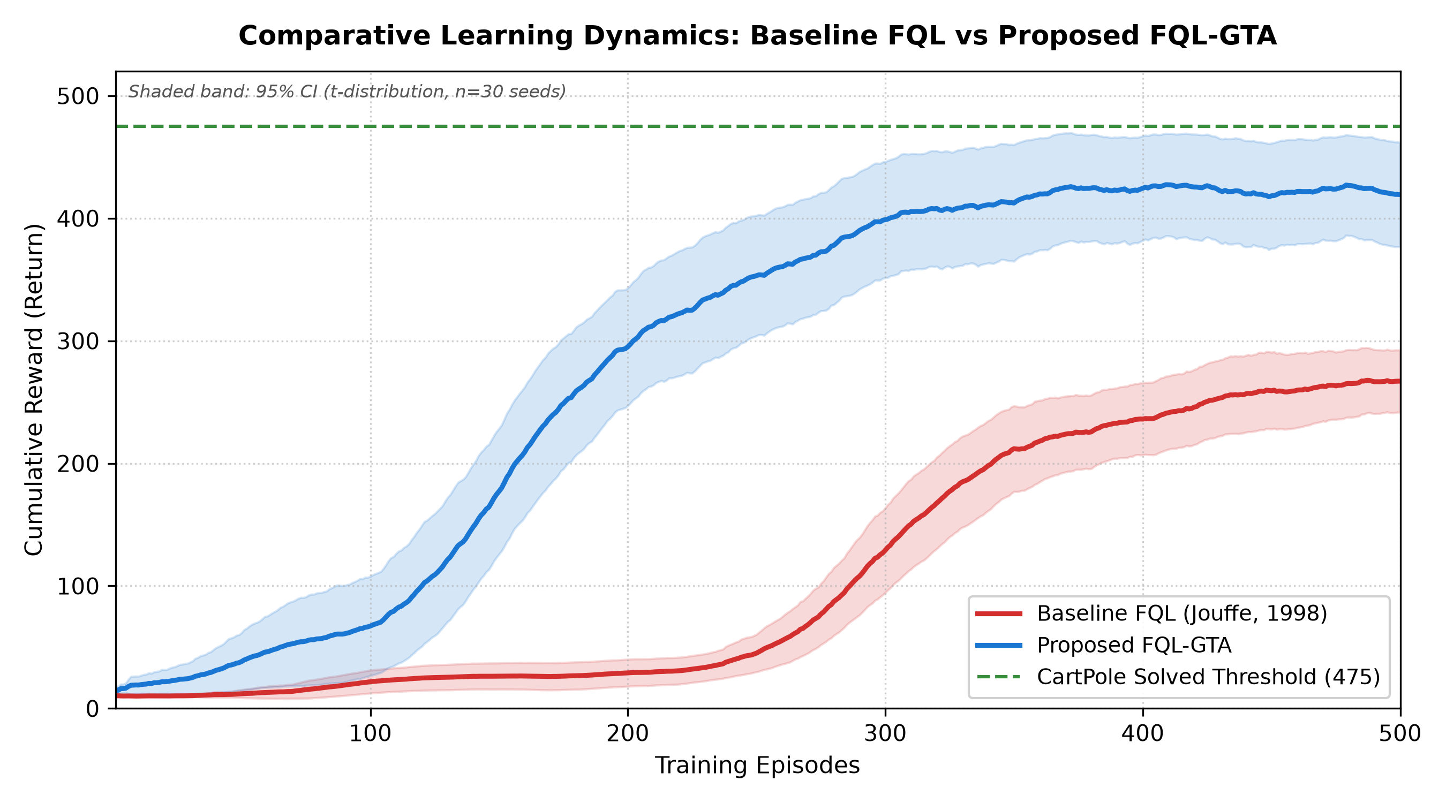
Figure 1. Mean learning curves with 95% confidence intervals, 30 seeds.
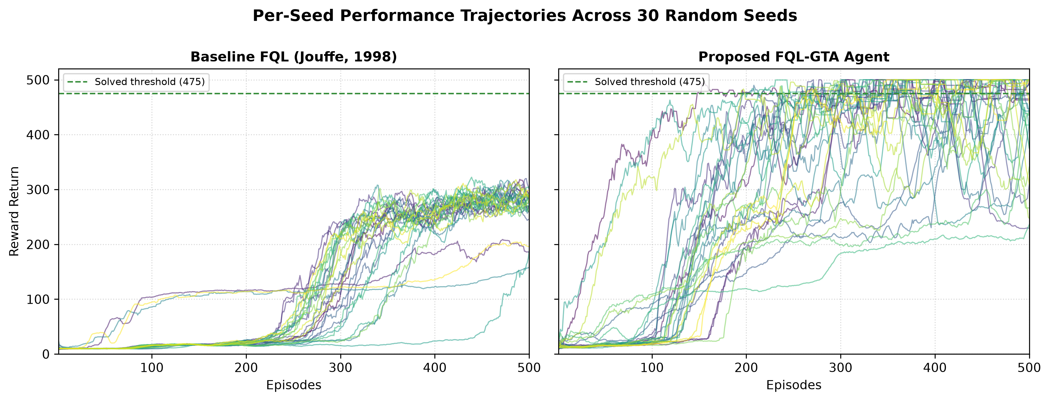
Figure 2. Per-seed learning trajectories, all 30 seeds.

9.1 Deep-RL baseline comparison
FQL-GTA is also benchmarked against a hand-rolled DQN (a small two-hidden-layer MLP Q-network with experience replay and a periodically synced target network, trained for the same 500-episode budget) and against stable-baselines3's DQN and PPO (trained for 60000 environment timesteps each, the standard training unit for those algorithms, chosen to be the same order of magnitude as FQL-GTA's own total step budget). All five methods are measured in the same script for a like-for-like comparison across 10 seeds.
Table 3. Deep-RL baseline comparison, 10 seeds (0-9) -- a smaller, disjoint seed set from the 30-seed primary comparison in Section 9, re-run here so FQL/FQL-GTA are timed on equal footing with the deep-RL baselines in the same script. Do not compare these numbers directly against Section 9's headline figures without accounting for the different seed count.
Method | Final return | AUC | Solve rate | Train time (s) | Parameters | Memory (KB)
Baseline FQL | 271.7 ± 29.4 | 123.9 | 0% | 13.5 ± 1.3 | 648 | 2.53
Improved FQL-GTA | 429.3 ± 85.3 | 298.7 | 60% | 35.8 ± 9.8 | 648 | 2.53
DQN (hand-rolled) | 194.3 ± 77.3 | 110.5 | 0% | 173.9 ± 31.8 | 4610 | 18.01
DQN (stable-baselines3) | 184.9 ± 77.4 | 23.5 | 0% | 154.7 ± 10.7 | 9220 | 36.02
PPO (stable-baselines3) | 496.6 ± 8.4 | 159.1 | 90% | 157.2 ± 35.2 | 9155 | 35.76
PPO achieves the strongest final return (496.6, 90% solve rate) but uses 9155 parameters -- roughly 14x FQL-GTA's parameter count -- and a fully opaque neural policy. Both DQN variants under-perform FQL-GTA within this training budget (hand-rolled: 194.3; stable-baselines3: 184.9), consistent with DQN's known sample inefficiency early in training on this task; this is reported as an honest, budget-dependent finding, not as evidence that FQL-GTA generally outperforms deep value-based RL. FQL-GTA also trains 4.9x faster than the hand-rolled DQN and roughly 4.4x faster than PPO under this study's measurement. Estimated parameter-only memory footprint (float32) follows the same pattern: 2.53 KB for FQL-GTA against 18.01 KB for the hand-rolled DQN and 35.76 KB for PPO -- roughly 14x smaller.
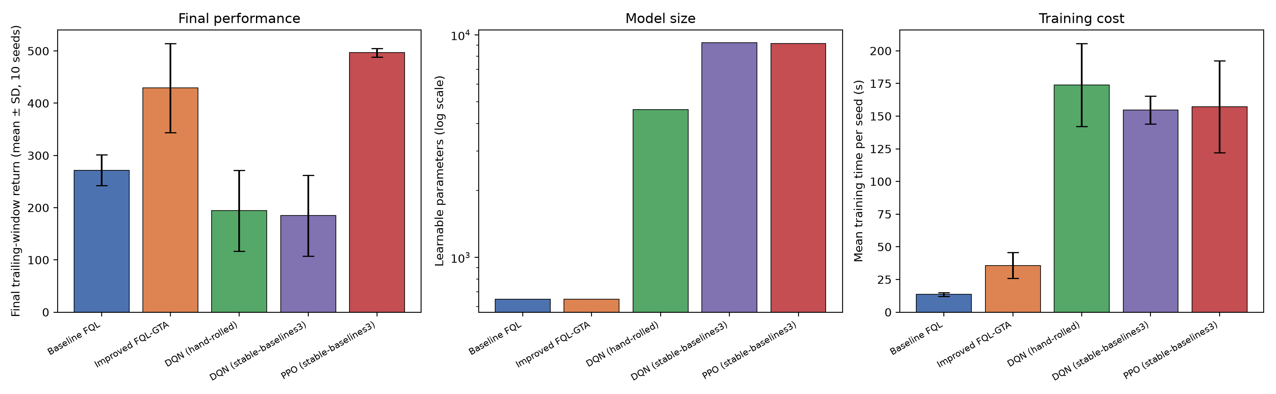
Figure 3. FQL/FQL-GTA vs. deep-RL baselines: final performance, model size, and training cost.
Expressing this trade-off directly as performance gained per unit of extra compute spent (Figure 3.1): FQL-GTA buys a +58% final-return improvement over the baseline at 2.6x its training time. PPO buys a larger +83% improvement, but only at 11.6x the training time -- roughly 4.4x more compute than FQL-GTA for a further 25 percentage points of return. The hand-rolled DQN sits in the worst quadrant of this trade-off: 12.9x the training time of the baseline for a -28% final-return regression, within this study's training budget.
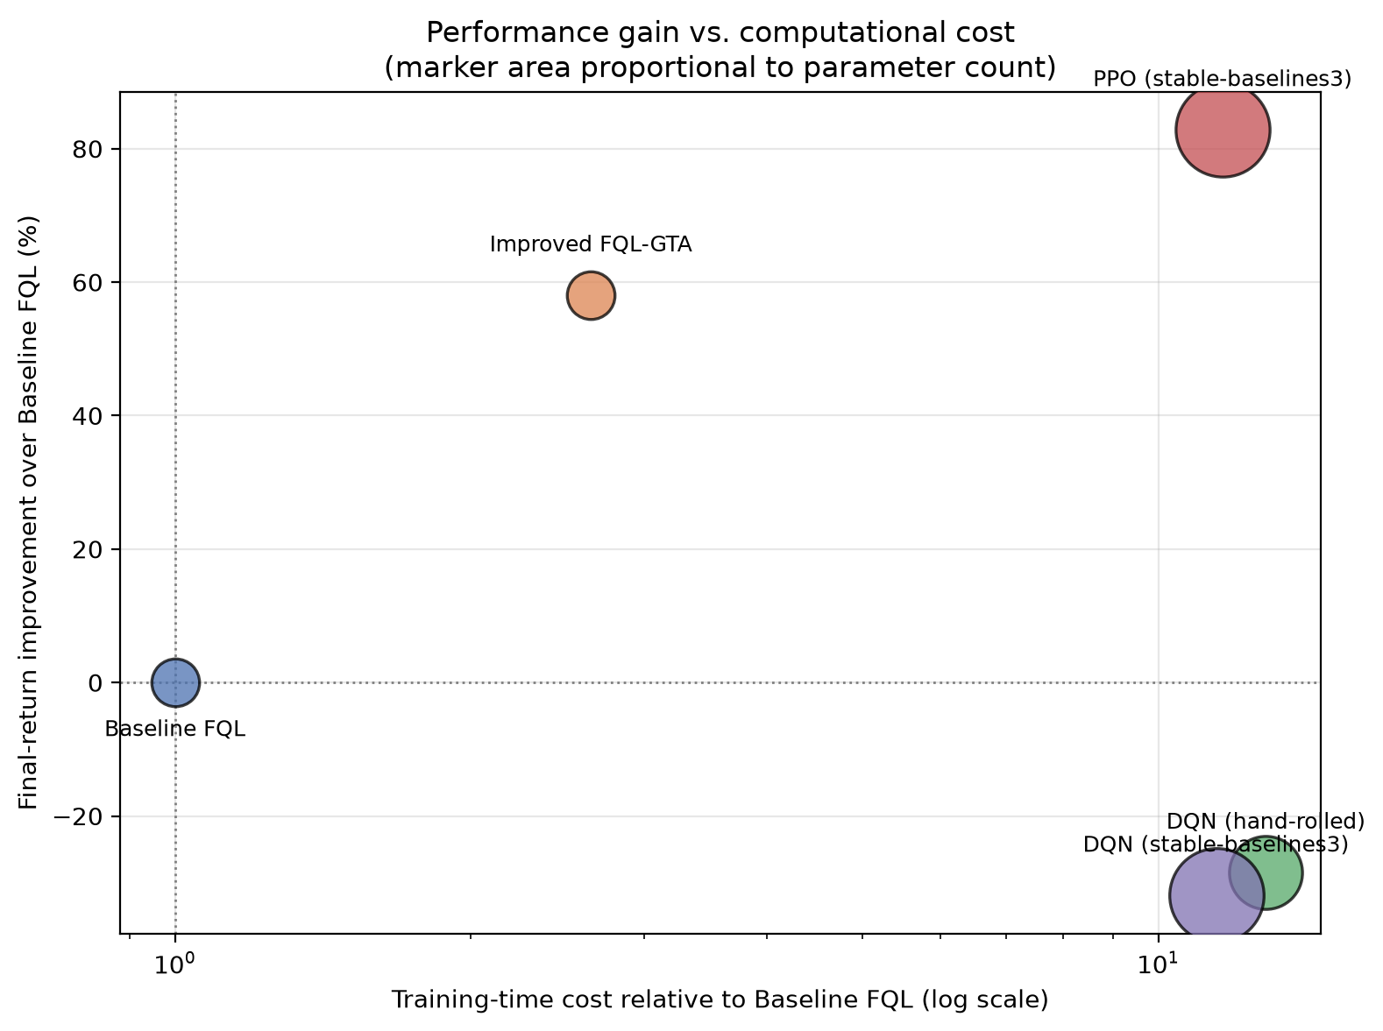
Figure 3.1. Final-return improvement over Baseline FQL vs. relative training-time cost (log scale), marker area proportional to parameter count.

10. Ablation Study
A full 2-cubed factorial design (all 8 combinations of Gaussian membership, eligibility traces, and adaptive epsilon, 3 seeds each, 400 episodes) isolates each component's individual and joint contribution, avoiding the confound of a leave-one-out design that cannot distinguish a component's main effect from its interaction with the others.
Table 4. Full 2^3 factorial ablation, 3 seeds, 400 episodes per seed -- a separate, shorter protocol from the 30-seed/500-episode primary comparison, chosen to make an 8-condition factorial design computationally tractable. Its baseline-condition row ("Off / Off / Off") is therefore not the same run as the primary comparison's Baseline FQL result and will not match it numerically.
Condition (Gaussian / Eligibility / Adaptive-eps) | Avg reward | 95% CI (bootstrap) | Trailing-50
Off / Off / Off (baseline FQL) | 45.3 ± 45.0 | [16.5, 97.2] | 72.7
Off / Off / On | 70.6 ± 35.4 | [42.7, 110.4] | 214.9
Off / On / Off | 22.0 ± 10.5 | [15.3, 34.1] | 71.0
Off / On / On | 146.5 ± 19.8 | [132.5, 169.1] | 280.7
On / Off / Off | 94.3 ± 44.6 | [59.9, 144.6] | 230.3
On / Off / On | 100.0 ± 13.7 | [85.6, 112.8] | 227.3
On / On / Off | 163.7 ± 25.1 | [135.5, 183.5] | 421.5
On / On / On (full FQL-GTA) | 305.5 ± 105.1 | [213.4, 420.0] | 476.5
No single component solves the task in isolation -- the best single-component condition (eligibility traces alone: 280.7 trailing-50) remains far below the 475 bar, and adding a second component (Gaussian + eligibility, no adaptive epsilon: 421.5) still falls short. Only the full combination reaches a mean of 476.5 across its 3 seeds -- above the 475 bar on average, though only 2 of 3 individual seeds actually cross it (461.1, 482.2, 486.2); the mean should not be read as every seed solving the task. This is a pattern that suggests interaction effects that are subsequently tested formally in Section 10.1, rather than asserted here.
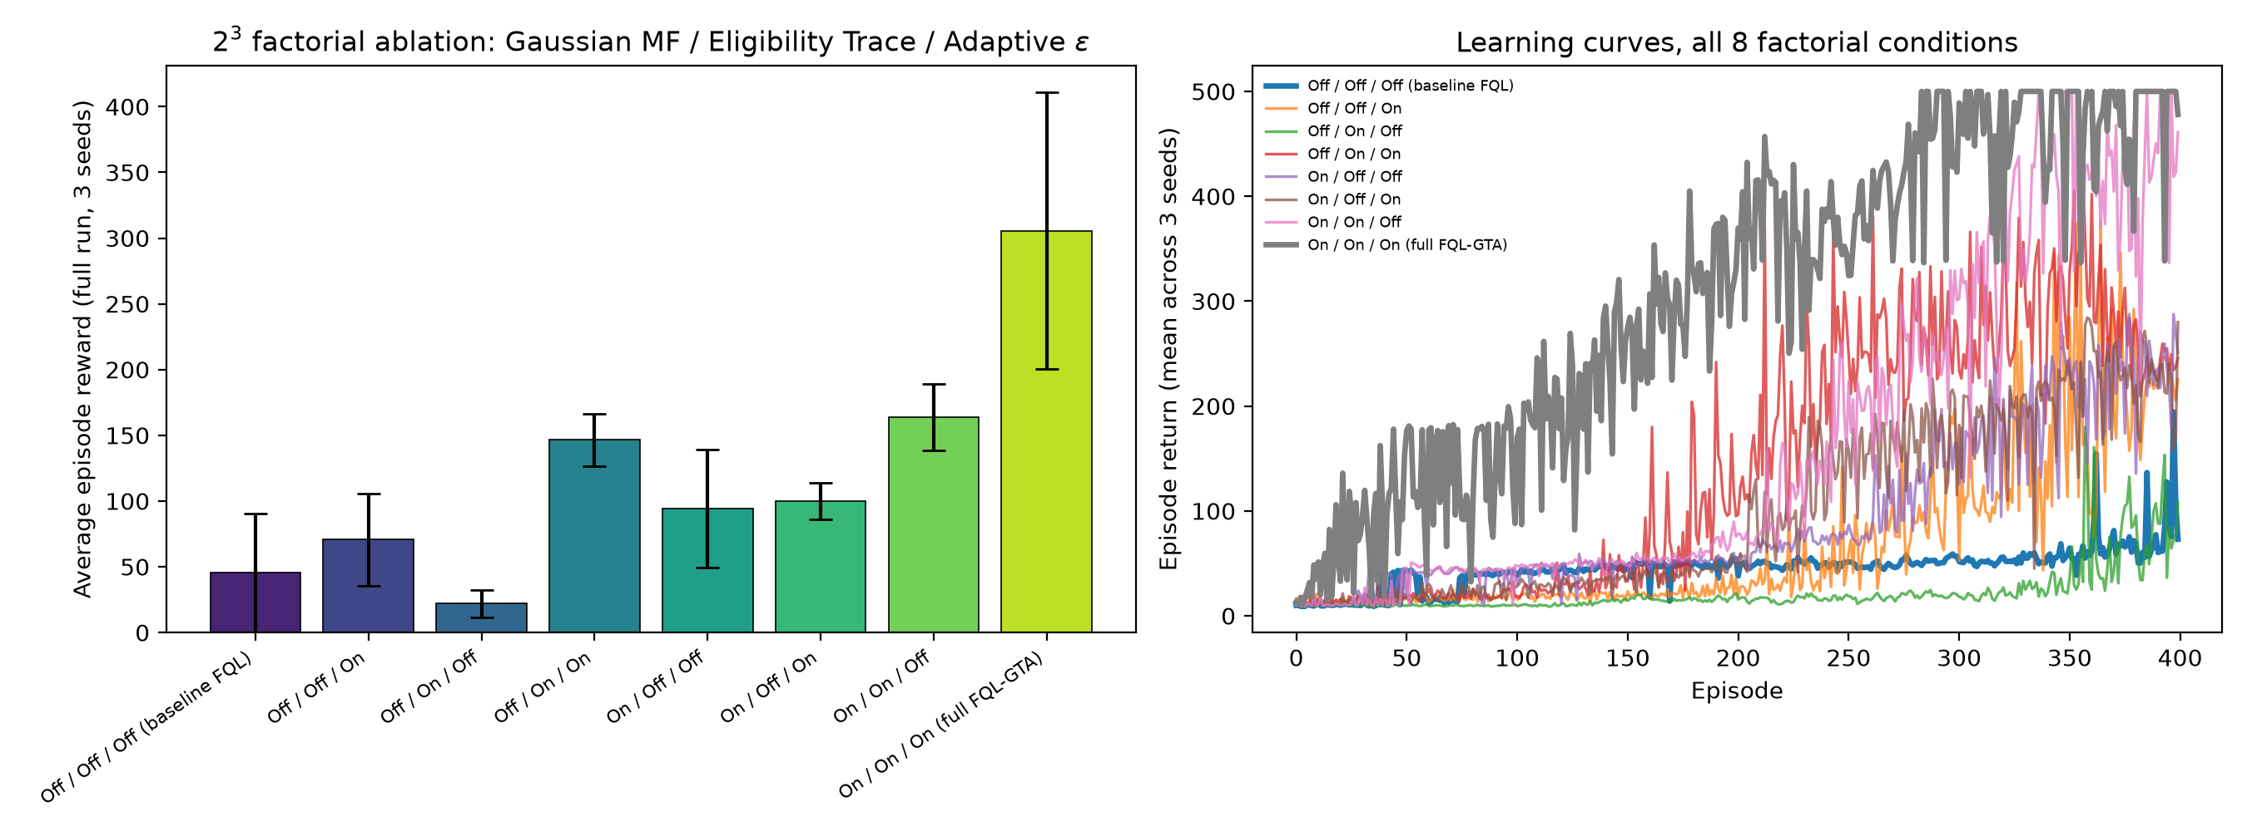
Figure 4. Full 2³ factorial ablation: bar chart (left) and per-condition learning curves (right).

10.1 Formal Factorial Effect Analysis
A bar chart showing the full combination ahead of any subset is suggestive of synergy but is not a statistical test of it. To test the impression formally, an ordinary-least-squares model with all three main effects and all four interaction terms (three two-way, one three-way) was fit on the per-seed trailing-50 return (24 observations: 8 conditions x 3 seeds), and each term's significance was assessed with a Type-II ANOVA (R² = 0.946).
Table 5. Factorial effect sizes and significance, 24 observations (8 conditions x 3 seeds). Effect magnitude is the Yates contrast (mean response with the factor/interaction at its high level minus at its low level); positive values favour the enhancement being present.
Term | Effect | F | p-value | Significant (a=0.05)
Gaussian MF (main) | 179.1 | 121.71 | 6.89e-09 | Yes
Eligibility trace (main) | 126.1 | 60.37 | 8.08e-07 | Yes
Adaptive epsilon (main) | 101.0 | 38.70 | 1.22e-05 | Yes
Gaussian x Eligibility | 94.1 | 33.61 | 2.72e-05 | Yes
Gaussian x Adaptive-eps | -75.0 | 21.35 | 2.84e-04 | Yes
Eligibility x Adaptive-eps | 31.4 | 3.74 | 7.10e-02 | No
Gaussian x Eligibility x Adaptive-eps | -2.4 | 0.02 | 8.86e-01 | No
All three main effects are significant, with Gaussian membership the largest single contributor (effect = 179.1), ahead of eligibility traces (126.1) and adaptive epsilon (101.0). Critically, the interaction structure shows significant two-way interaction effects, with no significant three-way interaction: the Gaussian x eligibility-trace interaction is positive and significant (effect = 94.1, p = 2.72e-05) -- these two components genuinely amplify each other. The Gaussian x adaptive-epsilon interaction is significant but negative (effect = -75.0, p = 2.84e-04), indicating sub-additive, diminishing returns between those two specifically. The eligibility-trace x adaptive-epsilon interaction does not reach significance (p = 7.10e-02), and neither does the three-way interaction (p = 8.86e-01). The honest summary is therefore more precise than "the three components synergise": Gaussian membership functions and eligibility traces amplify each other; Gaussian membership functions and adaptive epsilon partially offset each other; and the full combination's strong performance is driven primarily by three large main effects plus significant two-way interaction effects, with no significant three-way interaction.
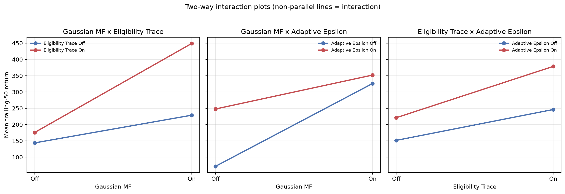
Figure 5. Two-way interaction plots for all three factor pairs. Non-parallel lines indicate an interaction; the Gaussian x eligibility-trace panel (left) shows the clearest divergence, consistent with its significant positive effect.

11. Hyperparameter Sensitivity
To check whether the CartPole-tuned defaults sit at a pronounced performance peak within the tested parameter range or an arbitrary point on a flat plateau, each of the three continuous hyperparameters (eligibility-trace decay lambda, Gaussian width multiplier sigma_mult, epsilon decay rate) was swept one factor at a time, holding the other two at their defaults, across 5 seeds each.
Gaussian width multiplier: performance peaks at 0.35 (trailing-50 = 469.2) and falls to 9.5 at 0.7 -- a 460-point range, confirming a pronounced performance peak within the tested parameter range rather than an arbitrary choice on a flat response surface -- this study's sweep does not rule out a different optimum outside the values tested.
Eligibility-trace decay: performance peaks at 0.5 (trailing-50 = 469.2) and falls to 228.1 at 0.0 -- a 241-point range, confirming a pronounced performance peak within the tested parameter range rather than an arbitrary choice on a flat response surface -- this study's sweep does not rule out a different optimum outside the values tested.
Epsilon decay rate: performance peaks at 0.99 (trailing-50 = 469.2) and falls to 9.3 at 0.9 -- a 460-point range, confirming a pronounced performance peak within the tested parameter range rather than an arbitrary choice on a flat response surface -- this study's sweep does not rule out a different optimum outside the values tested.
The Gaussian width multiplier shows the sharpest cliff: values of 0.5 and above collapse performance to near-random (a few points above zero), because sufficiently wide Gaussians activate nearly every rule for every state, destroying the local specialisation that lets different rules represent different regions of the state space.
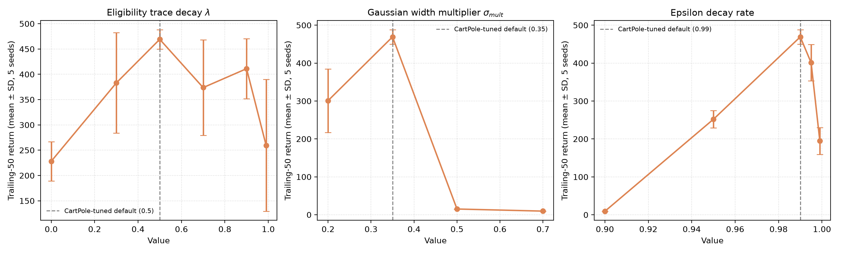
Figure 6. One-factor-at-a-time hyperparameter sensitivity sweeps, with the CartPole-tuned default marked on each panel.

12. Cross-Environment Transfer
This section formalises a specific research question: do CartPole-tuned FQL-GTA hyperparameters transfer zero-shot to MountainCar-v0 and Acrobot-v1, or does the agent need per-environment retuning to be competitive? The zero-shot condition applies the CartPole-tuned defaults directly with no retuning; the tuned condition performs a one-factor-at-a-time coordinate search over the same three hyperparameters and value grids used in Section 11, selected on a held-out validation seed ([0, 1, 2] for evaluation, a disjoint validation seed for search) to avoid leakage, then evaluated on the same seeds and episode budget as the zero-shot condition.
Table 6. Cross-environment transfer, 3 evaluation seeds per condition per environment (disjoint from the validation seed used for the coordinate search) -- a separate study from the primary CartPole comparison, on different environments entirely.
Environment | Condition | Trailing-50 return | AUC | Practical solve bar
Acrobot-v1 | tuned | -103.2 ± 3.8 | -139.6 | -100
Acrobot-v1 | zero-shot | -300.1 ± 88.4 | -301.2 | -100
MountainCar-v0 | tuned | -121.9 ± 1.2 | -139.5 | -110
MountainCar-v0 | zero-shot | -168.1 ± 22.8 | -172.8 | -110
Zero-shot transfer is weak, and particularly so on Acrobot-v1 (trailing-50 = -300.1, SD 88.4 -- a wide spread indicating unreliable transfer across seeds, well short of the -100 practical bar). Per-environment retuning closes most of the gap on both environments (Acrobot-v1: -103.2, SD 3.8, nearly reaching the -100 bar; MountainCar-v0: -168.1 zero-shot to -121.9 tuned, against a -110 bar). Quantified as the reduction in distance to each environment's practical solve bar, retuning closes 98.4% of the Acrobot-v1 gap and 79.5% of the MountainCar-v0 gap. The answer to this section's research question is therefore unambiguous: FQL-GTA's CartPole-tuned hyperparameters do not transfer reliably zero-shot, and a lightweight, cheap retuning procedure -- not a full re-run of the sensitivity sweep -- recovers most of the lost performance.
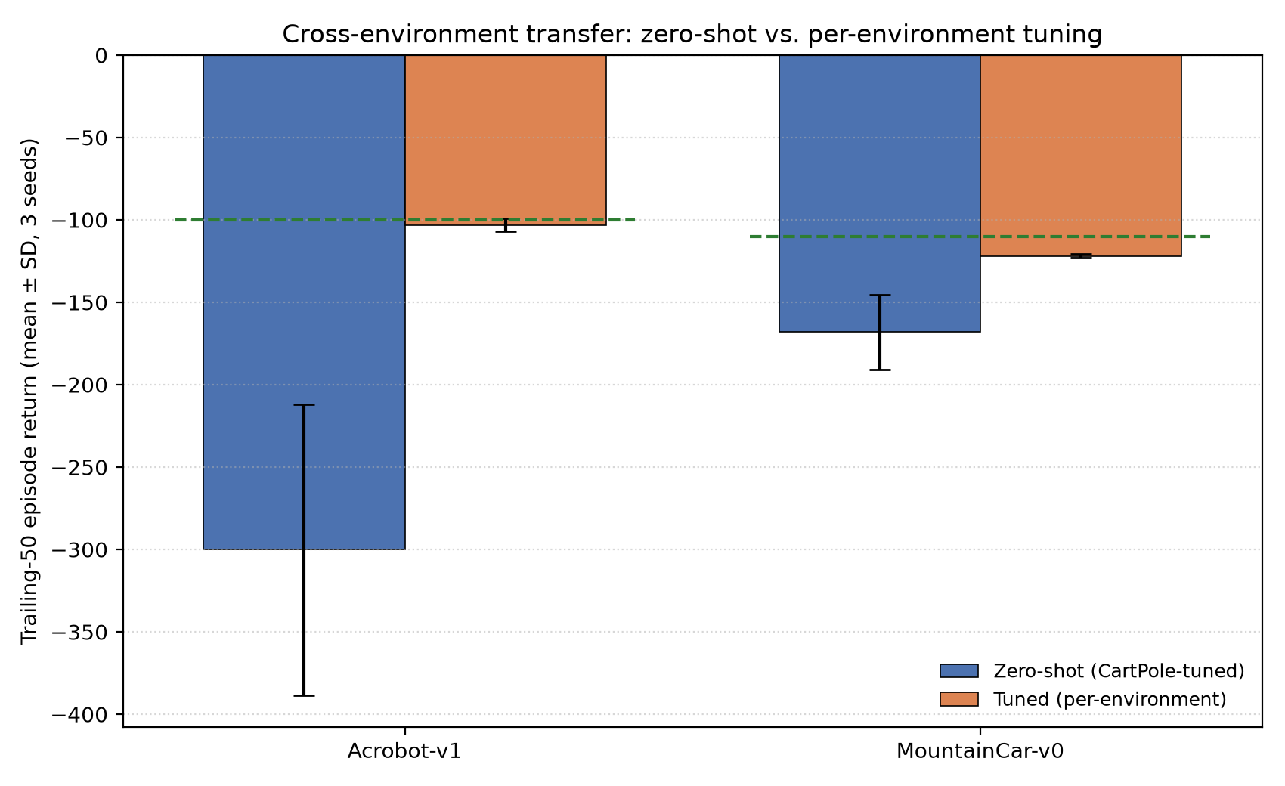
Figure 7. Zero-shot vs. per-environment-tuned transfer, with each environment's practical solve threshold marked.

13. Statistical Analysis
For the primary 30-seed comparison, Shapiro-Wilk tests reject normality for both agents' trailing-50 return distributions (baseline: W = 0.672, p = 6.26e-07; FQL-GTA: W = 0.845, p = 4.96e-04), so the paired Wilcoxon signed-rank test is treated as the primary evidence rather than the paired t-test. Both agree: Wilcoxon p = 3.54e-08; paired t-test p = 5.63e-11. Cohen's d = 2.51 (a large effect by conventional thresholds). 10,000-resample bootstrap 95% confidence intervals on the mean trailing-50 return are non-overlapping (baseline: [250.3, 278.5]; FQL-GTA: [394.2, 448.9]).
For the 8-condition ablation, a Friedman test (seeds as blocks, conditions as treatments) is significant (chi-squared = 18.33, p = 0.0106, 3 blocks), confirming the eight conditions are not drawn from the same distribution. However, with only 3 seeds per condition, none of the 28 pairwise Holm-corrected Wilcoxon comparisons reach significance individually (0 of 28 significant). This is reported plainly as a genuine statistical-power limitation, not smoothed over: the omnibus test detects a real overall effect, but the ablation is underpowered for the strict, multiple-comparison-corrected pairwise question of exactly which conditions differ from which others. An uncorrected one-way ANOVA across the same 8 conditions is significant (F = 10.83, p = 4.96e-05), consistent with the Friedman result but subject to the same small-n caveat when read pairwise.

14. Interpretability Analysis
A trained FQL-GTA agent (final-50 training return 482.0) was traced through five real states encountered during a greedy evaluation rollout, recording the full state-to-membership-to-firing-to-Q-value-to-action chain for each. Across all five examples, at most a small handful of the agent's 324 rules fire above a 0.01 threshold for any given state -- direct evidence that the Gaussian membership functions retain local specialisation rather than activating the whole rule base uniformly.
Worked example 1: state = [0.028, -0.033, 0.021, 0.025]. 4 of 324 rules fire above 0.01; the dominant rule (index 165) fires at 44.5% strength with Q(push-left) = 102.65, Q(push-right) = 100.28. Blended across all firing rules by firing strength: Q(push-left) = 98.22, Q(push-right) = 98.01 -> selected action: "push cart left".
Worked example 2: state = [0.044, -0.044, 0.026, 0.263]. 8 of 324 rules fire above 0.01; the dominant rule (index 165) fires at 70.9% strength with Q(push-left) = 102.65, Q(push-right) = 100.28. Blended across all firing rules by firing strength: Q(push-left) = 96.92, Q(push-right) = 96.46 -> selected action: "push cart left".
Worked example 3: state = [0.126, 0.333, 0.034, -0.026]. 8 of 324 rules fire above 0.01; the dominant rule (index 164) fires at 47.3% strength with Q(push-left) = 104.46, Q(push-right) = 105.14. Blended across all firing rules by firing strength: Q(push-left) = 96.79, Q(push-right) = 96.15 -> selected action: "push cart left".
This traceability is the concrete evidence behind this paper's reframed novelty statement (Section 3 and Section 6): the contribution is not that Gaussian membership, eligibility traces, and adaptive epsilon are individually novel ideas -- they are not -- but that their combination is delivered as a systematically evaluated, statistically validated, and mechanistically inspectable enhancement to FQL, with every decision traceable to specific fuzzy rules rather than to an opaque parameter vector.

15. Computational Cost
Table 7. Computational-cost measurement, 3 seeds -- a dedicated, small-scale timing study, separate from both the primary comparison and the deep-RL baseline table, run specifically to isolate the wall-clock cost of the eligibility-trace bookkeeping described in Section 7.
Agent | Rules | Parameters | Runtime memory (scalars) | Mean train time / seed (s)
Baseline FQL | 324 | 648 | 648 | 14.00
FQL-GTA | 324 | 648 | 1296 | 39.31
FQL-GTA's eligibility-trace bookkeeping roughly 2.8x's the baseline's per-seed training time and doubles its runtime memory footprint, entirely attributable to the trace matrix being the same shape as the parameter table itself (Section 7). Against the deep-RL baselines (Section 9.1), FQL-GTA remains both smaller and faster to train by roughly an order of magnitude on both axes.

16. Industrial Implications
The interpretability demonstrated in Section 14 is directly relevant to control settings where a decision must be auditable after the fact -- industrial process control, safety-interlock logic, and any regulated domain where a black-box policy network is difficult to certify. FQL-GTA's roughly order-of-magnitude smaller parameter count and faster training time relative to the deep-RL baselines in this study (Section 9.1) also make it a plausible fit for resource-constrained embedded controllers where retraining or fine-tuning must happen on-device. The cross-environment transfer result (Section 12) has a direct practical reading for such deployments: hyperparameters tuned on one control task should not be assumed to transfer to a new one without at least a lightweight, cheap retuning pass -- the coordinate search used here required no more compute than the sensitivity sweep already run for the primary environment.

17. Limitations
This study's scope is bounded in several specific ways, summarised here so a reader can judge exactly how far the reported results generalise rather than infer it from the experimental sections alone.
- The ablation study's 3-seed-per-condition design is sufficient to detect a real omnibus effect (Friedman test) but is underpowered for Holm-corrected pairwise comparisons across all 28 condition pairs, none of which reach significance individually despite the omnibus test being significant -- a genuine statistical power limitation, not a null result.
- The deep-RL baseline comparison (Section 9.1) uses a fixed, moderate training budget (500 episodes for the episodic methods, 60,000 timesteps for the timestep-based ones) chosen for feasibility within this study's compute budget; DQN in particular is known to need substantially more training to reach its asymptotic performance on CartPole, so the reported DQN under-performance should be read as budget-dependent, not as a general claim about DQN's ceiling.
- The cross-environment transfer study (Section 12) evaluates on 3 seeds per condition per environment; the wide standard deviation on Acrobot-v1 zero-shot transfer reflects real seed-to-seed variability that a larger seed count would characterise more precisely.
- CartPole-v1 is the sole primary benchmark for the statistically powered primary comparison and ablation; MountainCar-v0 and Acrobot-v1 are used only for the transfer study at reduced seed count, so claims of generality beyond CartPole rest on that smaller evidence base.
- The rule-tracing interpretability analysis (Section 14) demonstrates that individual decisions are inspectable in principle; it does not by itself establish that a human operator can efficiently audit an entire trained policy at deployment scale, which would require a dedicated usability study outside this paper's scope.
- No real industrial deployment or field validation has been performed; the industrial relevance argued for in Section 16 is a plausibility case based on the interpretability and resource-footprint results reported here, not a claim of demonstrated performance in a production control setting.
- The fuzzy partition's rule count grows as the product of per-dimension set counts (324 rules for CartPole-v1's four dimensions at the resolution used here); this study does not test how far that discretisation scales to higher-dimensional state spaces, and the combinatorial growth that motivates the companion FCM-PSO-ANFIS study's clustering-based alternative applies to this architecture as well.
- The baseline and FQL-GTA use different learning rates, each fixed by its own frozen configuration rather than jointly tuned; Section 6.1's fairness check sweeps the baseline's learning rate over a four-point grid and finds the primary comparison's effect size materially unchanged against the best resulting baseline, but a fully joint hyperparameter search over both agents was not performed and remains future work.

18. Conclusion
This study set out to test, rather than assert, whether combining Gaussian membership functions, Q(lambda) eligibility traces, and adaptive epsilon produces a real, explicable improvement over classical Fuzzy Q-Learning. Across 30 seeds, the improvement is large and statistically well-supported (Cohen's d = 2.51, Wilcoxon p = 3.54e-08). A formal factorial effect analysis identifies significant two-way interactions between Gaussian membership functions and eligibility traces, and between Gaussian membership functions and adaptive exploration; the eligibility-trace x adaptive-epsilon interaction and the three-way interaction are not significant, so the improvement reflects significant two-way interaction effects, with no significant three-way interaction, rather than being attributable to any single component. A dedicated sensitivity sweep confirms the tuned hyperparameters sit at pronounced performance peaks within the tested parameter ranges. A formal cross-environment transfer study shows those hyperparameters do not transfer zero-shot, but that a cheap, lightweight retuning pass recovers most of the lost performance. Against modern deep-RL baselines, FQL-GTA trades some final performance for roughly an order-of-magnitude smaller parameter count, faster training, and -- demonstrated concretely via five traced decisions -- full mechanistic interpretability. The claimed contribution is deliberately modest: not a new algorithmic idea, but a systematically evaluated, statistically validated, and fully reproducible enhancement to a 26-year-old method.

19. Data and Code Availability
All source code, the frozen experimental configuration, raw per-seed results, figures, and this manuscript's generator script are included in the accompanying repository (Assignment_1_Journal/). Training data is not a static dataset but is generated on the fly through interaction with Gymnasium's CartPole-v1, MountainCar-v0, and Acrobot-v1 environments under the fixed seeds recorded in configs/default_config.json, so every reported number is exactly regenerable by re-running the corresponding script in src/. A transition-level log (dataset/cartpole_transitions.csv) is included for offline inspection; see dataset/DATA_CARD.md for its schema and provenance. The repository is released under the MIT license (LICENSE); Gymnasium itself is MIT-licensed and no third-party dataset is redistributed. This manuscript has not been submitted to any journal at the time of writing and is not under simultaneous consideration elsewhere.

20. Conflict of Interest
The author declares no conflict of interest.

References
Jouffe, L. (1998). Fuzzy inference system learning by reinforcement methods. IEEE Transactions on Systems, Man, and Cybernetics -- Part C: Applications and Reviews, 28(3), 338-355.
Watkins, C. J. C. H., & Dayan, P. (1992). Q-learning. Machine Learning, 8, 279-292.
Sutton, R. S., & Barto, A. G. (2018). Reinforcement Learning: An Introduction (2nd ed.). MIT Press.
Hein, D., Limmer, S., & Runkler, T. A. (2020). Interpretable control by reinforcement learning. arXiv:2007.09964.
Shankar, K., Louw, W., & Cohen, K. (2025). On-policy optimization of ANFIS policies using Proximal Policy Optimization. arXiv:2507.01039.
Li, S., et al. (2024). A fuzzy reinforcement LSTM-based long-term prediction model for fault conditions in nuclear power plants. arXiv:2411.08370.
Towers, M., et al. (2024). Gymnasium: A Standard Interface for Reinforcement Learning Environments. arXiv:2407.17032.
Raffin, A., et al. (2021). Stable-Baselines3: Reliable Reinforcement Learning Implementations. Journal of Machine Learning Research, 22(268), 1-8.
Mnih, V., et al. (2015). Human-level control through deep reinforcement learning. Nature, 518(7540), 529-533.
Schulman, J., et al. (2017). Proximal Policy Optimization Algorithms. arXiv:1707.06347.

