**Covid - 19 Vaccine Analysis**

|  |  |
| --- | --- |
| **Project Name** | **Covid - 19 Vaccine Analysis** |
| **Team ID** | **8934** |
| **Date** | **10/10/2023** |

**Introduction:**

In the age of information, data-driven decision-making is at the forefront of innovation across various industries. Applied Data Science, with its transformative capabilities, has emerged as a driving force for innovation, revolutionizing how organizations operate and solve complex problems**.**

The COVID-19 pandemic has made it crucial to thoroughly analyze vaccine data. This involves collecting data, exploring it, using it to make predictions, and making informed decisions. In this report, we'll discuss an innovative way to analyze COVID-19 vaccine data using Python and modern data science techniques.

Throughout this report, we'll go through each step of the process, showing how Python, advanced data visualization methods, and predictive modeling can help us make informed decisions that are vital in the global battle against COVID-19.

**Objective:**

The goal of COVID-19 vaccine analysis is to understand how effective vaccines are at preventing the virus, identify areas that need more vaccinations, and make informed decisions to protect public health.

**Architecture Diagram:**

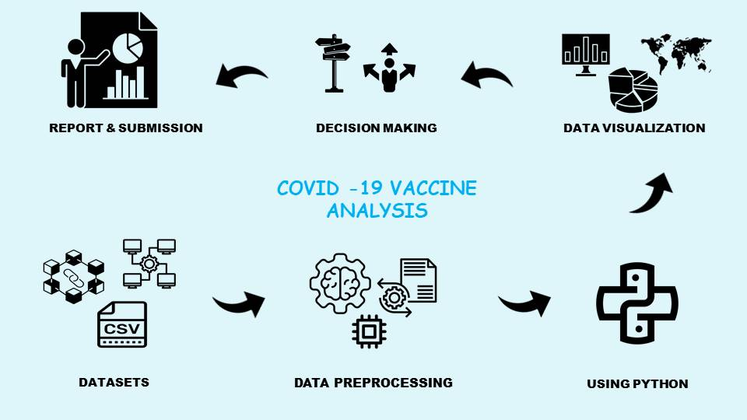

1. Data Collection: COVID-19 datasets are gathered for analysis.
2. Data Preprocessing: Data is cleaned, transformed, and prepared for analysis using Python.
3. Data Exploration (EDA): Exploratory Data Analysis is performed to understand the data's characteristics and relationships.
4. Data Visualization: Python libraries are used to create meaningful visualizations for insights.
5. Predictive Modeling: Machine learning techniques are applied to build predictive models.
6. Decision-Making: Informed strategies and decisions are made based on the analysis and model outcomes.
7. Report Generation: Insights and outcomes are summarized in a comprehensive report.
8. Report Submission: The final report is submitted to stakeholders, guiding them in their response to the COVID-19 pandemic and vaccination efforts.

This architecture outlines the flow of COVID-19 vaccine analysis, starting from data collection and preprocessing, through data exploration and visualization, to predictive modeling, decision-making, report generation, and ultimately, report submission for informed actions and strategies.

**Innovative Designing**

Innovative design in COVID-19 vaccine analysis using Python involves the creative use of data science techniques, machine learning, and cutting-edge data visualization to extract actionable insights from vaccine-related data. By harnessing the power of Python libraries and advanced algorithms, we can not only model vaccine effectiveness and distribution but also visualize these insights in engaging and informative ways, enabling data-driven decision-making and contributing to global efforts in combating the COVID-19 pandemic.

**Advanced Data Visualization in COVID-19 Vaccine Analysis:**

In COVID-19 vaccine analysis, advanced data visualization techniques in Python enable us to:

* Create interactive dashboards to explore real-time vaccination trends.
* Visualize vaccination distribution on geographic maps.
* Display temporal changes using animated charts.
* Utilize augmented reality (AR) for immersive data experiences.
* Present insights through storytelling in explanatory visualizations.

These techniques enhance our understanding of vaccination data, facilitating informed decisions in the fight against the pandemic.

**AI and Machine Learning Models:**

AI and machine learning models are invaluable tools in COVID-19 vaccine analysis. They allow us to predict vaccine efficacy, optimize distribution strategies, and gain deeper insights into vaccination trends. By leveraging these models in our analysis, we can identify high-risk populations, allocate resources efficiently, and make data-driven decisions that are critical in the global fight against the pandemic.

**AI in Healthcare:**

AI in healthcare has played a pivotal role in COVID-19 vaccine analysis. Machine learning models have been instrumental in predicting vaccine efficacy, optimizing distribution, and identifying potential adverse events. AI-driven data analysis has allowed healthcare professionals to make informed decisions regarding vaccination strategies, monitor real-world vaccine effectiveness, and prioritize vaccination for vulnerable populations, significantly contributing to the ongoing battle against the COVID-19 pandemic.

**Innovative Tools:**

* Jupyter Notebook

## NumPy

## Pandas

## Scikit-learn

## SciPy

## Matplotlib

* Plotly
* Seaborn

**Conclusion:**

In the challenging landscape of the COVID-19 pandemic, the analysis of vaccine data has proven to be an indispensable tool. It has enabled us to understand the effectiveness of vaccines, identify areas where vaccinations are needed most, and make informed decisions. With the power of data science, Python, and innovative technologies, we've gained crucial insights that guide our response to the pandemic. As we continue this journey, data-driven analysis remains a cornerstone in our collective effort to combat COVID-19 and protect public health.