SQl basic

**1.SELECT, WHERE, COUNT**

SELECT

*

FROM Customers

WHERE Country = 'Germany'

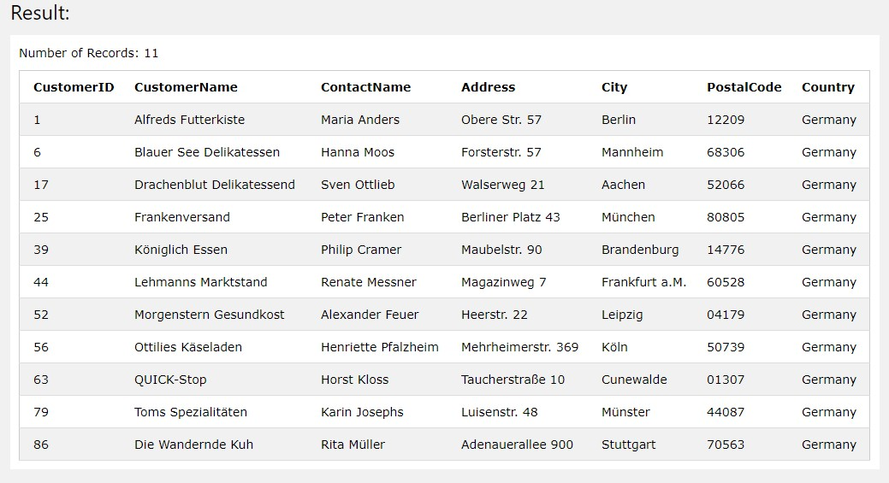

SELECT

count(*)

FROM Customers

WHERE Country = 'Germany'

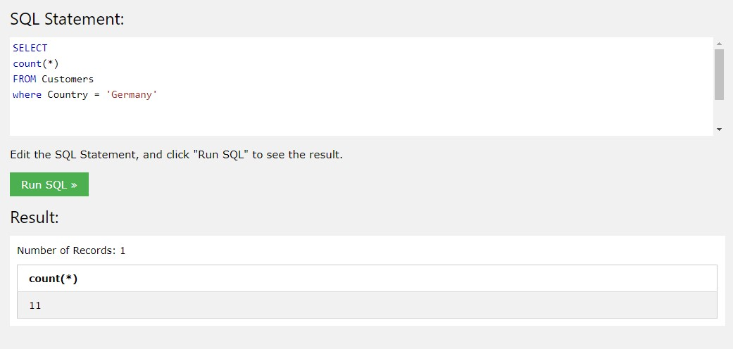

**2. LIKE**

SELECT

*

FROM Customers

WHERE CustomerName like('%e')

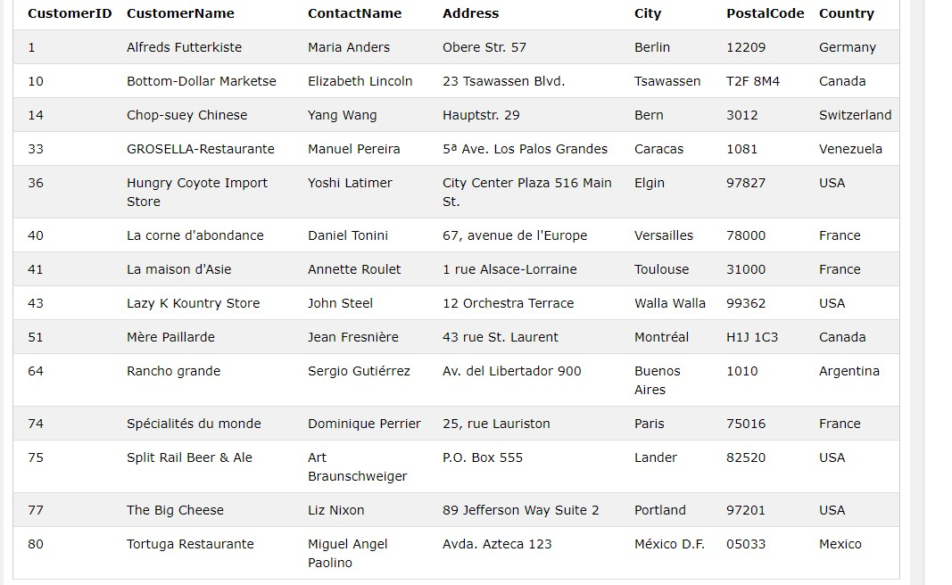



SELECT

count(*)

FROM Customers

WHERE CustomerName like('%e')

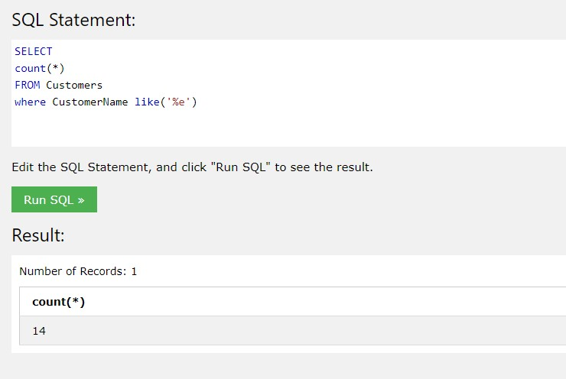

**3. INSERT, SELECT**

INSERT into Customers(CustomerName, ContactName, Address, City, PostalCode, Country)

values('Karina Dmitrieva', 'Karina Dmitrieva', 'Pushkina str.55', 'Novosibirsk', '630007', 'MotherRussia')

SELECT

*

FROM Customers

WHERE CustomerName like('Karina%')

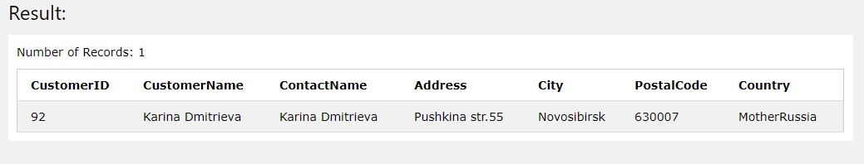

**4. UPDATE, SELECT**

UPDATE Customers

SET CustomerName = 'Nina Dmitrieva'

WHERE CustomerName like('Karina%')

and PostalCode = '630007'

SELECT

*

FROM Customers

WHERE CustomerName like('Nina%')

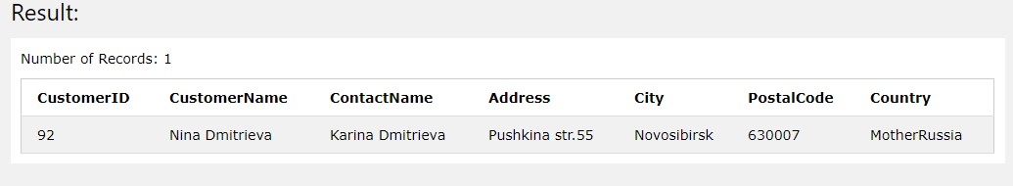

**5. DELETE**

DELETE FROM Customers WHERE City = 'Nantes'

SELECT

count(*)

FROM Customers

WHERE City = 'Nantes'

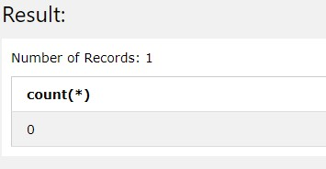

**6. INNER JOIN**

SELECT

ord.OrderID, ord.OrderDate, emp.LastName, emp.FirstName

FROM Orders ord

INNER JOIN Employees emp on emp.EmployeeID = ord.EmployeeID

WHERE emp.FirstName = 'Steven'

