Data-Driven Forecasting & Peak Demand Prediction for Afficionado Coffee Roasters

A Research Project Report

Submitted by:
Kundan Kumar Singh

Course: Data Analyst Internship

Submitted to: Unified Mentor

Table of Contents

- Abstract
- Introduction
- Problem Statement
- Objectives
- Dataset Description
- Methodology
- Exploratory Data Analysis (EDA)
- Model Evaluation
- Dashboard Implementation
- Forecasting Results
- Uncertainty Analysis
- Demand Analysis
- Business Insights
- Conclusion
- Future Work
- References
1. Abstract
This research presents a data-driven forecasting framework for Afficionado Coffee Roasters to predict sales demand and identify peak demand periods across multiple store locations. Coffee retail demand is highly volatile due to time-of-day patterns and location-specific variations. Traditional decision-making based on historical intuition leads to inefficiencies in inventory and staffing.
This study applies time-series forecasting techniques, including baseline models and Gradient Boosting regression, to predict daily revenue and hourly demand. The proposed model achieves 89.46% forecasting accuracy and 95.56% peak demand capture rate, significantly improving operational planning. The system is deployed through an interactive Streamlit dashboard to support real-time decision-making.

2. Introduction
Demand forecasting plays a crucial role in retail operations, especially in the food and beverage industry where customer behavior varies significantly across time and location. Coffee consumption patterns show strong temporal trends, including morning rush hours and fluctuating midday demand.
Afficionado Coffee Roasters currently relies on historical intuition for decision-making, resulting in overstocking, wastage, and missed sales opportunities. This project introduces a predictive analytics approach that enables accurate demand forecasting and proactive planning.

3. Problem Statement
Despite having detailed transactional data, Afficionado Coffee Roasters lacks:
- Short-term (1–7 days) and medium-term (14–30 days) demand forecasts
- Store-level predictive visibility
- Quantitative uncertainty estimates for planning
This leads to:
- Planning is reactive rather than proactive
- Decisions are uniform across stores rather than location-specific
- Operations become inefficient during demand surges

4. Objectives
Primary Objectives:
- Forecast daily and hourly sales per store
- Predict future revenue trends
- Identify peak-demand periods
Secondary Objectives:
- Reduce inventory waste
- Improve staff scheduling accuracy
- Enable location-specific decision-making

5. Dataset Description
The dataset consists of transactional-level data with the following attributes:
Feature | Description
transaction_id | Unique transaction identifier
transaction_time | Time of purchase
transaction_qty | Quantity purchased
unit_price | Price per unit
store_id | Store identifier
store_location | Store location
product_category | Product category
Target Variables
- Daily revenue per store
- Hourly transaction volume
- Category-level demand
Derived Feature:
- Revenue = transaction_qty × unit_price

6. Methodology
6.1 Time-Series Construction
- Aggregation of data at hourly and daily levels
- Creation of continuous time indices
- Handling missing intervals using zero-filling

6.2 Feature Engineering
Key predictive features include:
- Lag features (t-1, t-24, t-168)
- Rolling averages (3-day, 7-day)
- Hour-of-day indicators
- Day-of-week indicators
- Store-level categorical encoding
Revenue was calculated as:
- Revenue = transaction_qty × unit_price

6.3 Train-Test Strategy
- Time-based split (no random shuffling)
- Rolling validation approach
- Separate evaluation for each store

6.4 Model Evaluation
Baseline Model:
- Moving Average approach
- Used for comparison
Advanced Model:
- Gradient Boosting Regression
- Captures nonlinear demand patterns
Reason for selection:
- Captures non-linear patterns
- Handles complex feature interactions
- Provides higher accuracy

7. Exploratory Data Analysis (EDA)
The following visualizations provide insights into category performance, store-level revenue, and demand patterns.
Key Observations:
- Peak demand occurs during morning and evening hours
- Coffee and Tea are the highest revenue-generating categories
- Significant variation exists across store locations
- Strong hourly and daily patterns observed
Visual Analysis: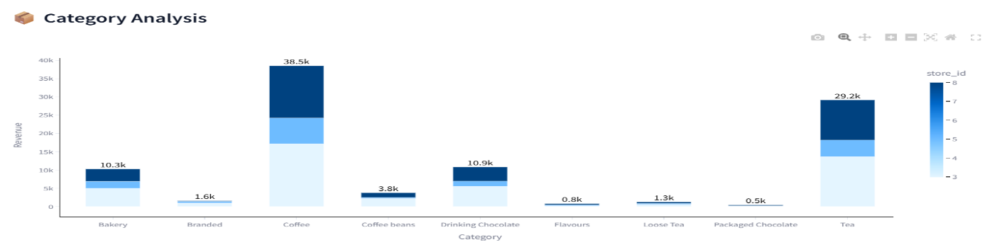
Figure 1: Category-wise Revenue Distribution
This chart shows the distribution of revenue across different product categories. It is observed that coffee and tea contribute the highest revenue, indicating strong customer preference for these products.

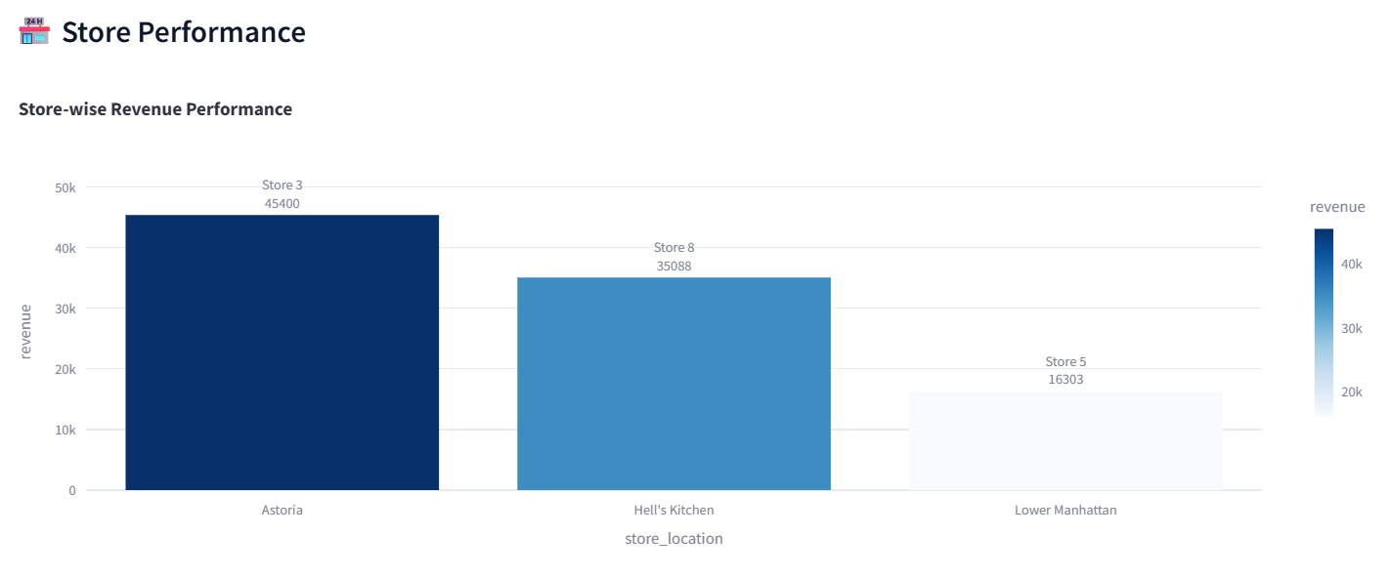
Figure 2: Store-wise Revenue Performance
This visualization compares revenue across different store locations. It highlights significant variation in store performance, indicating the need for location-specific strategies.

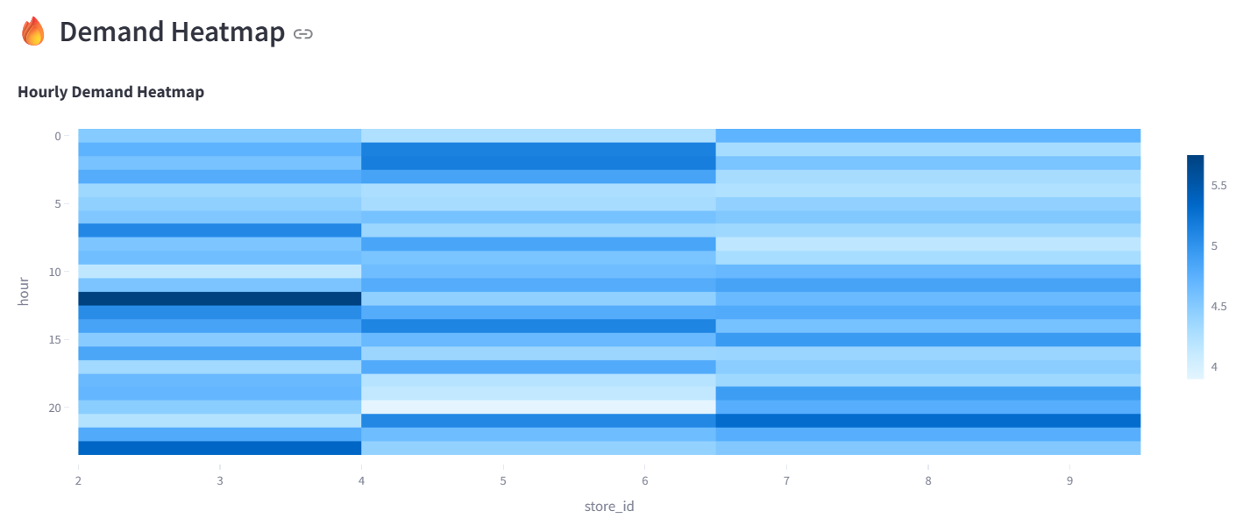
Figure 3: Hourly Demand Heatmap
The heatmap illustrates demand patterns across hours and stores. Higher intensity during morning and evening indicates peak customer activity periods.

8. Model Evaluation
The model performance was evaluated using multiple metrics:
Metric | Value
Forecast Accuracy | 89.46%
Peak Demand Capture Rate | 95.56%
Mean Absolute Error (MAE) | 215.13
Baseline MAE | 417.38
Error Reduction | 48.5%
- MAPE was used to compute forecast accuracy: [ Accuracy = 100 – MAPE]
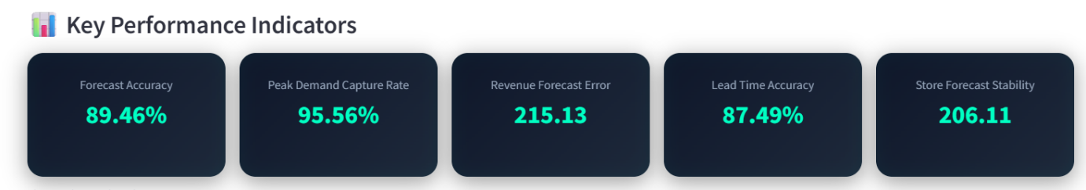
Figure 4: KPI Cards
The KPI dashboard summarizes model performance using metrics such as accuracy, MAE, and peak detection rate. It shows that the model achieves high prediction accuracy and reliability.

9. Dashboard Implementation
An interactive dashboard was developed using Streamlit.
Features:
- Store selection filter
- Forecast horizon slider
- Revenue vs Quantity toggle
- Model comparison
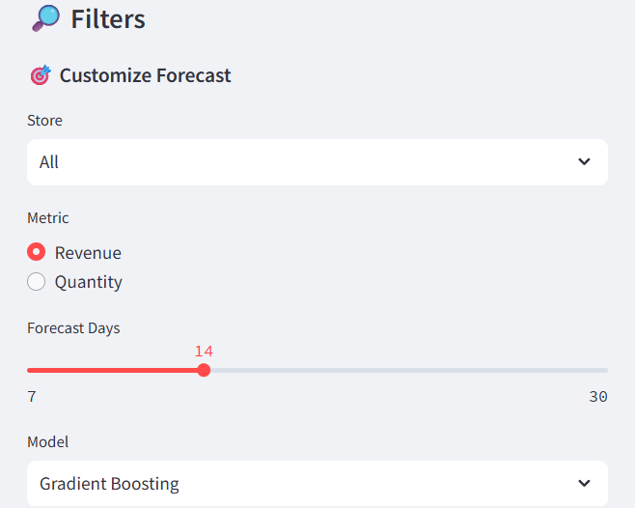
Figure 5: Forecast Customization and Filter Panel
The filter panel provides user-controlled inputs for forecasting analysis, including store selection, metric type (revenue or quantity), forecast duration, and model selection. This interactivity enhances usability by allowing decision-makers to analyze different scenarios and tailor predictions according to operational needs.
Core Modules:
- Forecast vs Actual
- Confidence Interval
- Scenario Analysis
- Demand Spike Detection
- Heatmap Visualization
- Category & Store Analysis

10. Forecasting Results
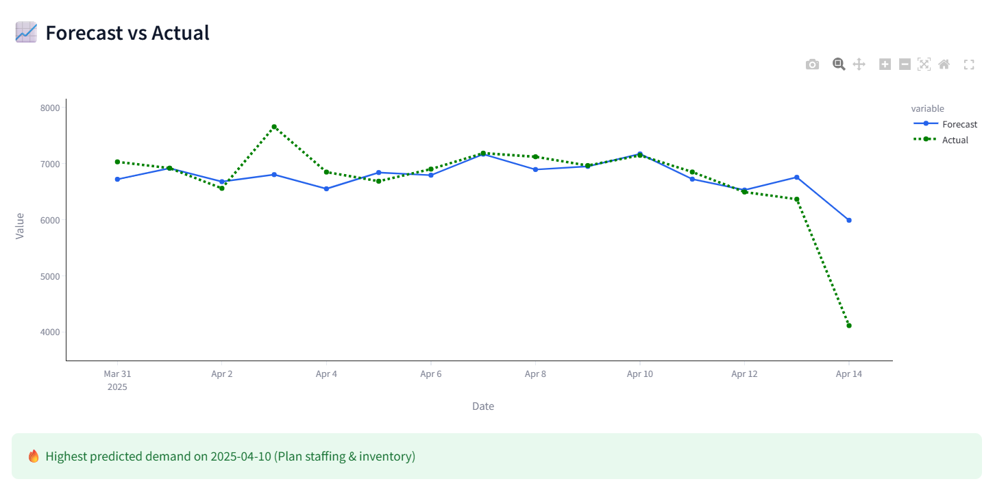
Figure 6: Forecast vs Actual Demand Comparison
This graph compares predicted values with actual demand. The close alignment between both lines indicates strong forecasting performance.

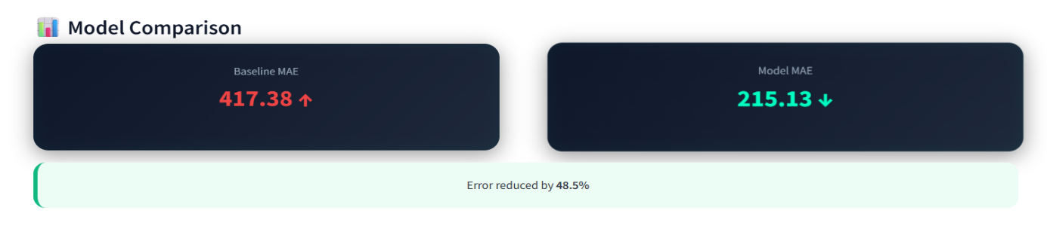
Figure 7: Model Comparison
The comparison demonstrates that the Gradient Boosting model significantly reduces error compared to the baseline model.
The model significantly outperforms the baseline, reducing error by 48.5%.

11. Uncertainty & Scenario Analysis
To improve planning reliability:
- Confidence intervals were calculated
- Best-case (+10%) and worst-case (-10%) scenarios generated
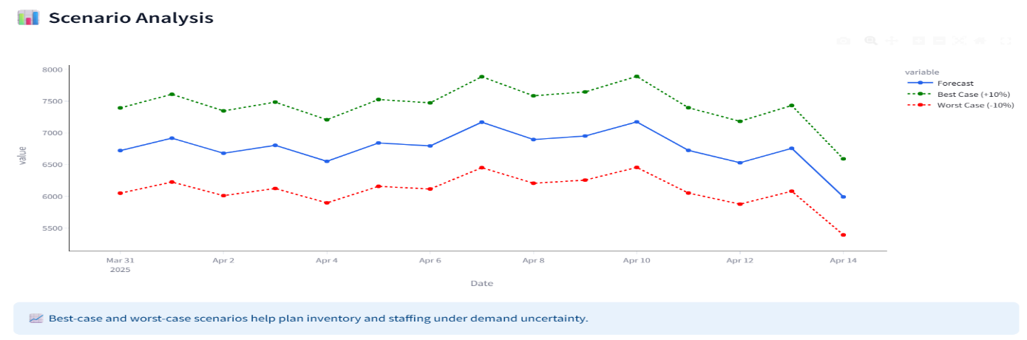
Figure 8: Scenario Analysis
This visualization presents possible demand variations under different scenarios, helping in planning inventory and staffing strategies.

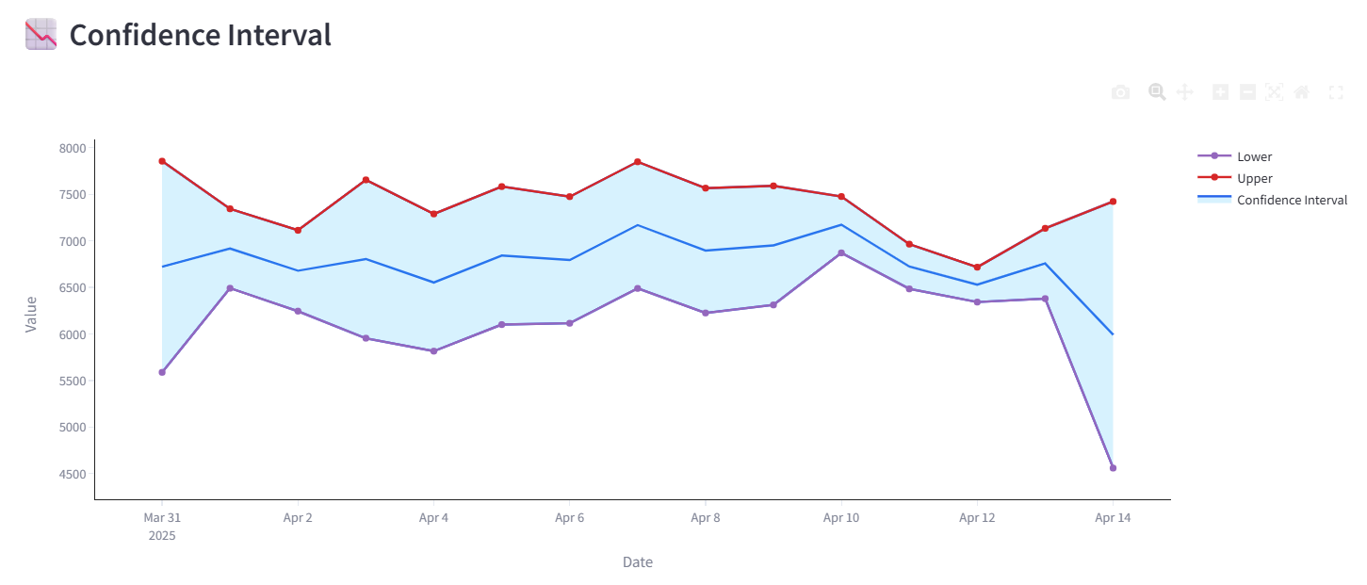
Figure 9: Confidence Interval
The shaded region represents uncertainty in predictions. It provides a range within which actual demand is expected to fall.

12. Demand Spike Analysis
- Top 10% demand values classified as spikes
- 5 spike events detected
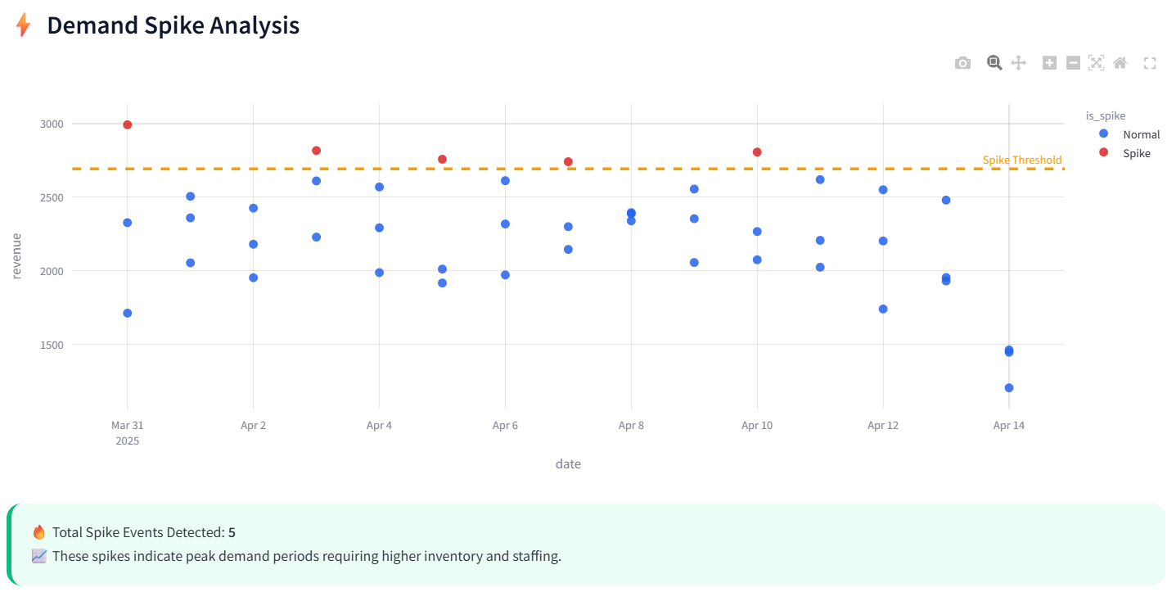
Figure 10: Demand Spike Detection
This chart identifies peak demand events using threshold-based detection. These spikes require special planning for staffing and inventory.

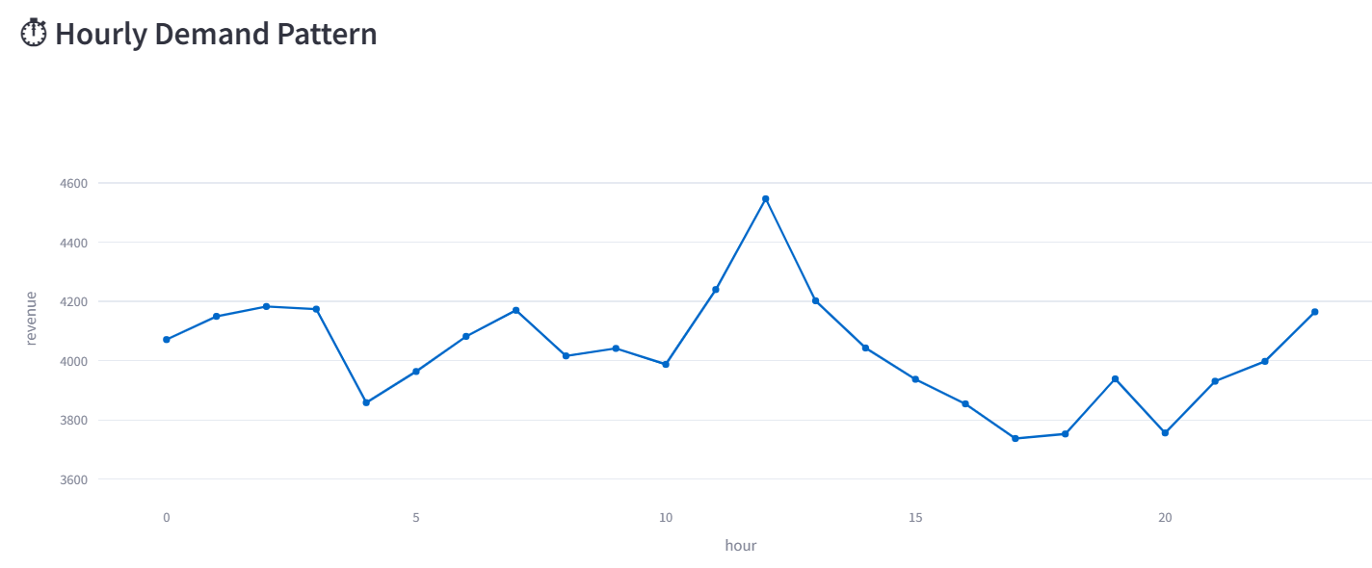
Figure 11: Hourly Demand Pattern
The line chart shows demand variation throughout the day, with clear peaks in morning and evening hours.

13. Business Insights
- Peak demand occurs in morning and evening
- Highest predicted demand observed on April 10
- Coffee and Tea dominate sales
- Store-level variation requires customized strategies
- Forecasting reduced error by 48.5%
Business Impact:
- Improved staffing decisions
- Reduced inventory wastage
- Enhanced customer satisfaction
- Data-driven operational planning

14. Conclusion
This study demonstrates the effectiveness of data-driven forecasting in retail operations. By applying machine learning and time-series techniques, accurate demand predictions and peak detection were achieved.
The implementation enables Afficionado Coffee Roasters to transition from reactive to proactive decision-making, improving efficiency, profitability, and customer experience.

15. Future Work
- Implementation of deep learning models (LSTM)
- Integration of external factors (weather, holidays)
- Real-time forecasting system
- Automated inventory optimization

16. References
- Hyndman, R.J. & Athanasopoulos, G. (Forecasting Principles and Practice)
- Scikit-learn Documentation
- Streamlit Documentation
- Python Pandas Library Documentation

