PROG2002 - Web Development II
Assignment 2: Use Case (A Dynamic Website)
Student ID: ______________________
Last Name: ______________________
First Name: ______________________
Title of the project:
Liuzhou Care - A Dynamic Charity Events Website
(Node.js + Express + MySQL RESTful API with an HTML/CSS/JavaScript client)

Table of Contents

1. Introduction / Motivation 2
2. Problem Statement 3
3. Solution 3
4. Web UX 4
5. Data Schema 6
6. API Design 7
7. Gen AI Acknowledgement and Chat Log 9

1. Introduction / Motivation
Charitable organisations depend on community events - fun runs, gala dinners, concerts, and auctions - to raise funds and awareness for their causes. Today, most people discover and sign up for such events online, so a professional, easy-to-use events website has become essential for any charity that wants to reach a wide audience.
This project builds a dynamic website called "Liuzhou Care" for a fictional charity based in Liuzhou, Guangxi, China (working together with a second fictional organisation, the Bright Futures Youth Foundation). The motivation was to design a complete client-server web application from scratch: a MySQL database that stores the events, a RESTful API built with Node.js and Express that exposes the data, and a client-side website built with plain HTML, CSS, and JavaScript that consumes the API. The site lets the public browse all current and upcoming charity events in Liuzhou, search them by date, location, and category, and view full details including ticket information (in CNY) and each event's fundraising goal versus its progress.
The project demonstrates the key concepts covered in Modules 1-4 of PROG2002: client-server communication, relational database design, RESTful API development with Express, and dynamic DOM rendering using JavaScript promises and the Fetch API.

2. Problem Statement
The case study requires a platform that connects a charitable organisation with potential attendees and handles the event viewing and registration process. The specific problems this website solves are:
- Awareness: the public needs a single place to see which charity events are currently available or coming up in their city.
- Discoverability: users need to filter events by practical criteria - when (date), where (location), and what type (category) - rather than scrolling through one long list.
- Trust and transparency: each event must show clear details - what it is for, when and where it happens, what a ticket costs, and how much of the fundraising goal has been reached - so attendees feel confident their participation genuinely supports the cause.
- Content control: the organisation must be able to suspend events that violate policy so they are immediately hidden from the public.
As this is Assessment 2, the scope is the read-only public experience: registration is represented by a placeholder. Creating, updating, and deleting data (POST/PUT/DELETE endpoints, admin side, and ticket purchase) is intentionally left for Assessment 3, as specified in the brief.

3. Solution
The solution is a two-tier dynamic web application that follows the classic client-server model:
- Data tier: a MySQL database named charityevents_db stores the organisations, event categories, and events, including ticket prices, fundraising goals, and progress.
- Server tier: a Node.js application using the Express framework exposes a RESTful API (GET endpoints) that queries the database and returns JSON.
- Client tier: three static web pages (Home, Search Events, Event Details) written in HTML, CSS, and vanilla JavaScript. They use the Fetch API and Promises to call the RESTful endpoints and then render the returned JSON into the page with DOM manipulation.
This separation reflects the client-server communication concept: the browser (client) sends an HTTP request to the API server; the server queries MySQL, formats the result as JSON in the response body; and the client's JavaScript parses that response and updates the DOM - all without the page reloading. For example, when the Home page loads, home.js calls GET /api/events; the server joins the event, category, and organisation tables and computes whether each event is "past" or "upcoming" by comparing its date with the current date; the client then builds one card per event.
Only GET endpoints are provided in this assessment, matching the read-only scope, and all queries are parameterised to prevent SQL injection. Suspended events are filtered out at the database query level, so they never reach the client.

4. Web UX
The website was designed to feel like a professional charity events platform, using fundraising event sites (walks, runs, and galas) as reference for how information is structured. Several decisions were made to keep the application intuitive and easy to use:
- Wireframing first: before coding, each page was sketched as a simple wireframe (header/navigation, content region, footer) to fix the layout and information hierarchy early. All three pages share the same structure, so users always know where they are.
- Consistent navigation: a sticky menu (Home, Search Events, About Us, Contact) appears at the top of every page, with the current page highlighted, so users can move around the site in one click.
- Summary-to-detail flow: the Home and Search pages show compact event cards (image, name, category and past/upcoming badge, date, location) with a single clear "View Details & Register" action, which leads to the full detail page. Colour-coded badges (green = Upcoming, grey = Past) communicate status at a glance.
- Forgiving search form: the search page uses input controls matched to the data types - a date picker for the event date, a free-text field for location, and a dropdown for category (loaded from the API). Users may combine criteria or use just one, and a "Clear Filters" button resets the whole form instantly.
- Feedback and validation: the site always tells the user what is happening - a loading message while data is fetched, a friendly message when no events match, a validation message if the search form is submitted empty, and an error message if the API is unreachable.
- Visual design: a calm teal-and-coral palette, generous white space, cards with subtle shadows, and a progress bar for each event's fundraising goal make the content scannable and engaging on both desktop and mobile screens (responsive grid layout).
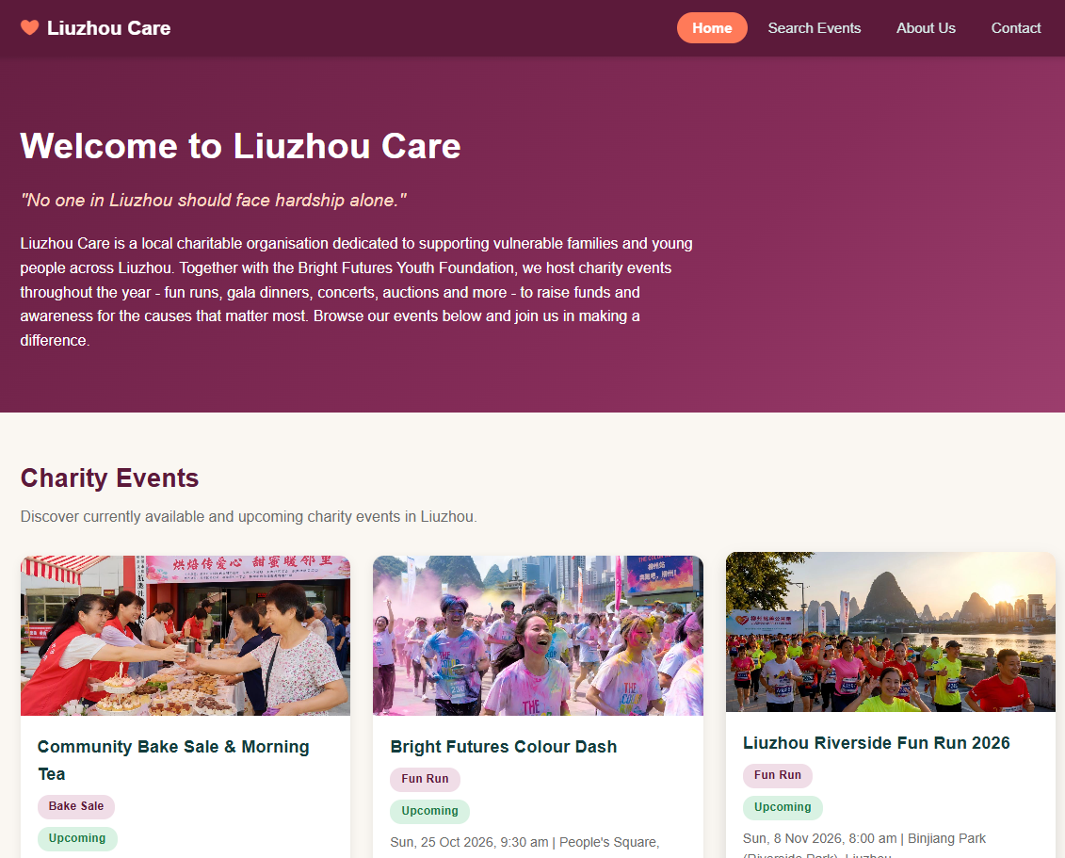
Figure 1: Home page - organisation banner and dynamic event listing with past/upcoming badges.
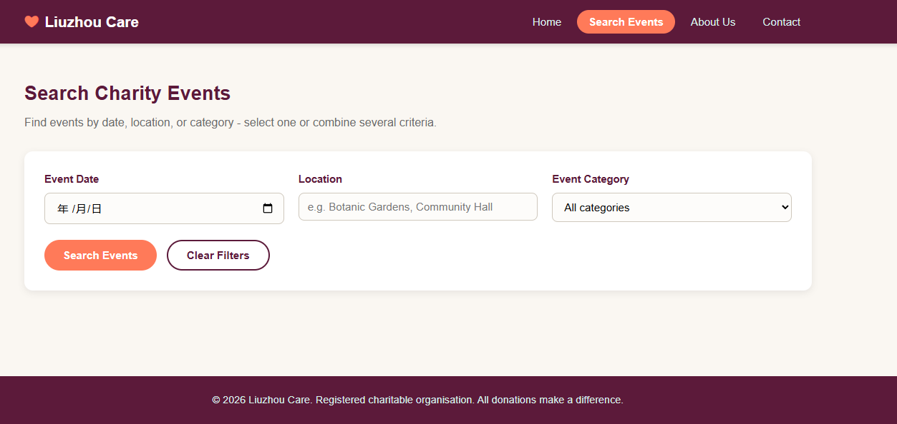
Figure 2: Search Events page - filter form (date, location, category) with Search and Clear Filters buttons.
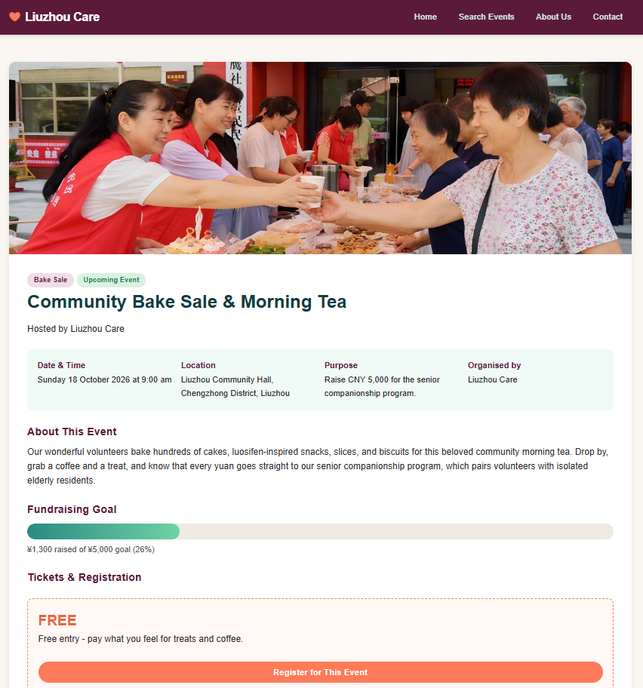
Figure 3: Event Details page - full description, fundraising goal progress bar, ticket information (CNY), and the Register button (placeholder).

5. Data Schema
The database charityevents_db uses three related tables. The design goal was to avoid repeating data: organisations and categories are stored once and referenced by each event through foreign keys.
- organisation - the charitable organisations that host events. Stores name, description, mission statement, contact email/phone, and address. Primary key: organisation_id.
- category - the event types used for filtering (e.g. Fun Run, Gala Dinner, Concert, Silent Auction, Charity Walk, Bake Sale). Primary key: category_id.
- event - the core table. Holds the event name, short and full descriptions, purpose, date/time, location and city, ticket price and ticket information, fundraising goal and funds raised, an image URL, a status flag, and foreign keys to organisation and category. Primary key: event_id.
Relationships: one organisation can host many events (1:N), and one category can classify many events (1:N), implemented with FOREIGN KEY constraints on organisation_id and category_id. The status column ('active' or 'suspended') lets the organisation hide policy-violating events; whether an event is "past" or "upcoming" is not stored but derived at query time by comparing event_date with the current date, which keeps the data always correct. The schema is populated with 8 active sample events set at real Liuzhou venues (Binjiang Park, Dalongtan Park, Yaobu Ancient Town, People's Square, Liuzhou Museum, the Diwang International Tower, and more) with a mix of past and upcoming dates, plus 1 deliberately suspended event to prove the hiding behaviour works.
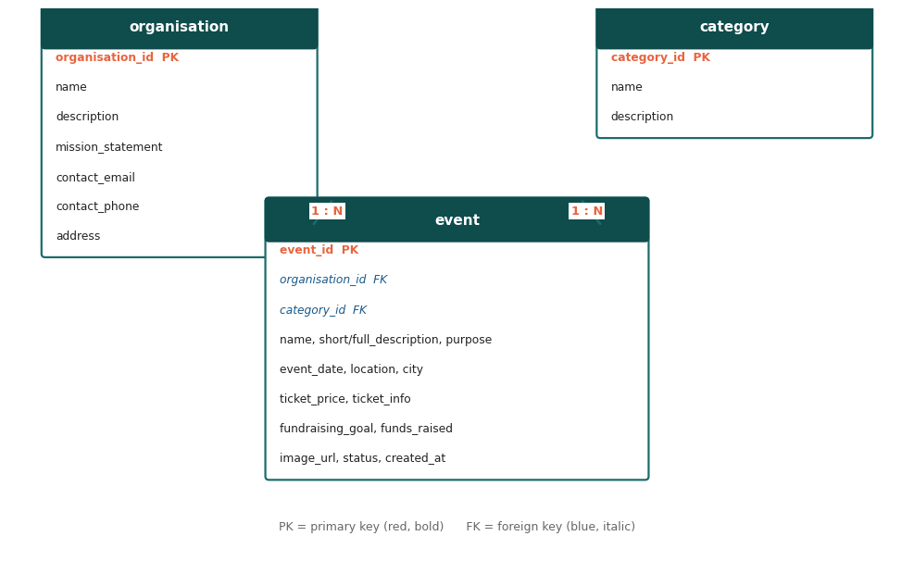
Figure 4: Entity-relationship diagram of the charityevents_db schema (1:N relationships).

6. API Design
The API was designed around the three website pages, following RESTful principles: endpoints are named after the resources they return (events, categories), they use the plural resource name in the URL, support content negotiation through JSON responses, and remain stateless. All endpoints are read-only GET requests because data modification is out of scope for this assessment.
Endpoint | Purpose
GET /api/events | Returns all active events (upcoming first, then past) with category and organisation names - powers the Home page.
GET /api/events/search | Searches active events by the criteria date, location, and/or category (query string parameters). Powers the Search page.
GET /api/events/:id | Returns the full details of one event (description, purpose, tickets, goal vs progress) - powers the Event Details page. Returns 404 if the event does not exist or is suspended.
GET /api/categories | Returns all event categories so the Search page can build its category dropdown filter.

6.1 Example: GET /api/events/search
Purpose: allow the website's Search page to discover active charity events matching one or more criteria. The criteria arrive as URL query string parameters, so the endpoint follows REST conventions and stays bookmarkable. Empty criteria are simply omitted by the client and ignored by the server, which keeps a single endpoint flexible enough for single-criterion and combined searches (the server combines criteria with AND logic).
Request (no request body is used, as is standard for safe retrieval):
GET /api/events/search?date=2026-11-08&location=&category=1
The parameterised SQL behind this request is equivalent to:
SELECT ... FROM event e JOIN category c ON e.category_id = c.category_id WHERE e.status = 'active' AND DATE(e.event_date) = ? AND e.category_id = ? ORDER BY e.event_date ASC;
Example response body (JSON array, truncated to one event):
[{"event_id":1,"name":"Liuzhou Riverside Fun Run 2026","short_description":"A 10 km fun run along the scenic Liu River promenade.","event_date":"2026-11-08T08:00:00","location":"Binjiang Park (Riverside Park), Liuzhou","city":"Liuzhou","ticket_price":"35.00","fundraising_goal":"40000.00","funds_raised":"26500.00","image_url":"images/fun-run.jpg","category":"Fun Run","organisation":"Liuzhou Care","event_status":"upcoming"}]

6.2 Choice of HTTP Methods
Every endpoint uses GET because the operations are safe, read-only retrievals of resources - the client asks for data without changing any state on the server. According to HTTP semantics, GET requests should not have side effects, which makes them cacheable and safe to trigger from a browser address bar or link. POST, PUT, and DELETE were deliberately not implemented: they will be introduced in Assessment 3 together with registration/ticket purchase and the admin side, exactly as scoped in the brief. Error handling follows HTTP conventions: 404 Not Found for a missing or suspended event id, and 500 with a JSON error message for unexpected database failures, so the client can always show a meaningful message.

7. Gen AI Acknowledgement and Chat Log
I acknowledge that I have used GenAI tools to complete this assessment. I used Kimi (Moonshot AI) to assist with drafting the initial project structure, generating sample event data and event images, suggesting code for parts of the Express API and client-side JavaScript, and proofreading sections of this report, within the parameters outlined in the Assessment Brief and by the Unit Assessor. All generated output was reviewed, tested, and adapted by me; I ran the full website end-to-end and can explain every part of the code, the database schema, and the API design.
Summary of the main interactions with the GenAI tool:
Prompt (mine) | AI response (summary)
Here is my assessment brief. Help me plan the database schema for the charity events case study. | Proposed three tables (organisation, category, event) with primary/foreign keys, a status flag for suspended events, and derived past/upcoming logic, then wrote charityevents_db.sql with 8+ sample events.
Write the Express API for the three pages: home listing, search by date/location/category, and event details. | Implemented server.js with GET /api/events, GET /api/events/search, GET /api/events/:id and GET /api/categories, using parameterised mysql2 queries and JSON responses, plus event_db.js for the connection pool.
Build the client-side pages in plain HTML/CSS/JavaScript only (no frameworks). | Delivered index.html, search.html, event.html with a shared stylesheet, a fetch/promise helper, DOM card rendering, clear-filters behaviour, error messages, a goal-vs-progress bar, and an under-construction modal for the Register button.
I am based in Liuzhou, China - localise the sample data to my city. | Updated the database, web pages and report so the charity is set in Liuzhou with local venues, addresses and CNY pricing.
The images still look foreign - regenerate them to match Liuzhou. | Regenerated all eight event photos with Chinese participants and Liuzhou scenery (Liu River, karst peaks, Yaobu Ancient Town, Dalongtan Park).
Help me fill in the project report sections (motivation, problem, solution, UX, schema, API design). | Drafted the report content based on the actual implementation, which I then reviewed and edited.

