HW9
Kayla Dyer
2025-11-06

1. Read Lecture7data.csv into R. Call it mpg. This is the same data set we have used in the notes for the last two weeks. Load the tidyverse package.
setwd("~/Desktop/STA 503/Week 7")
library(tidyverse)
## ── Attaching core tidyverse packages ──────────────────────── tidyverse 2.0.0 ──
## ✔ dplyr 1.1.4 ✔ readr 2.1.5
## ✔ forcats 1.0.1 ✔ stringr 1.5.1
## ✔ ggplot2 4.0.0 ✔ tibble 3.3.0
## ✔ lubridate 1.9.4 ✔ tidyr 1.3.1
## ✔ purrr 1.1.0
## ── Conflicts ────────────────────────────────────────── tidyverse_conflicts() ──
## ✖ dplyr::filter() masks stats::filter()
## ✖ dplyr::lag() masks stats::lag()
## ℹ Use the conflicted package (<http://conflicted.r-lib.org/>) to force all conflicts to become errors
mpg <- read.csv(file = "Lecture7data.csv")
names(mpg)
## [1] "manufacturer" "model" "displ" "year" "cyl"
## [6] "trans" "drv" "cty" "hwy" "fl"
## [11] "class"

2. Use the ggplot2 package to re-create the R Code necessary to generate the six graphs on the next page. The three variables used are displ, hwy, and drv. You will create each graph separately.You do NOT need them all within the same figure.
ggplot(mpg, aes(displ, hwy)) +
geom_point() +
geom_smooth(se = FALSE)
## `geom_smooth()` using method = 'loess' and formula = 'y ~ x'
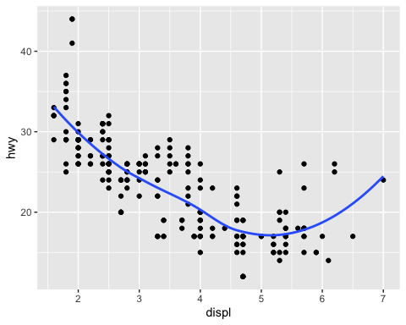
ggplot(mpg, aes(displ, hwy)) +
geom_point() +
geom_smooth(aes(group = drv), se = FALSE)
## `geom_smooth()` using method = 'loess' and formula = 'y ~ x'
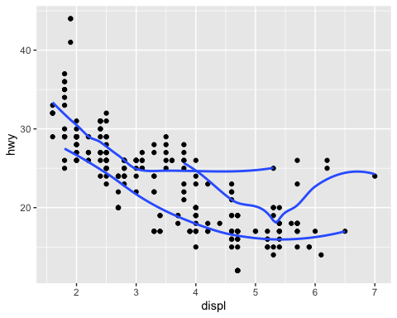
ggplot(mpg, aes(displ, hwy, color = drv)) +
geom_point() +
geom_smooth(se = FALSE)
## `geom_smooth()` using method = 'loess' and formula = 'y ~ x'
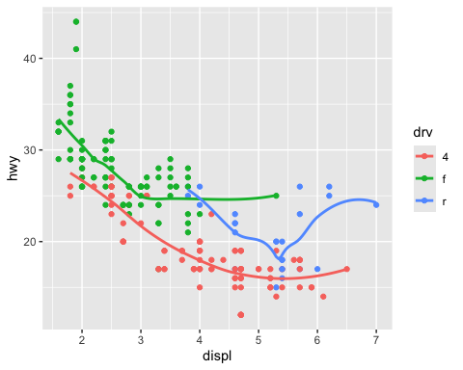
ggplot(mpg, aes(displ, hwy)) +
geom_point(aes(color = drv)) +
geom_smooth(se = FALSE)
## `geom_smooth()` using method = 'loess' and formula = 'y ~ x'
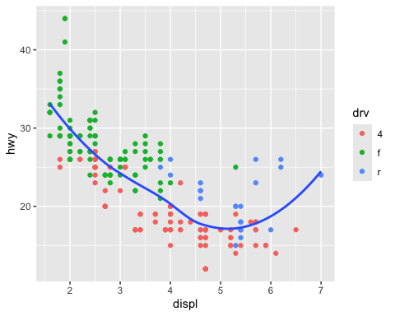
ggplot(mpg, aes(displ, hwy)) +
geom_point(aes(color = drv)) +
geom_smooth(aes(linetype = drv), se = FALSE)
## `geom_smooth()` using method = 'loess' and formula = 'y ~ x'
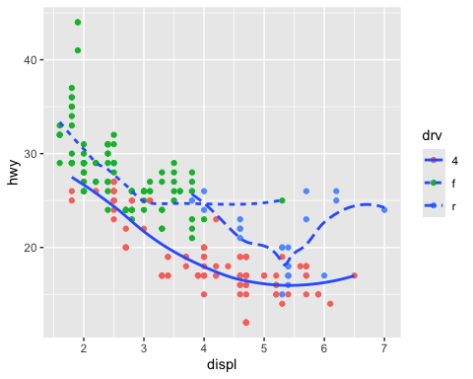
ggplot(mpg, aes(displ, hwy, color = drv)) +
geom_point()
