HW6
Kayla Dyer
2025-10-07

1. Read in the data set called HW6data.csv. Do not print the data set. Print the structure of the data set. How many observations do we have? How many variables?
setwd("~/Desktop/STA 503/Week 6")
data <- read.csv(file = "HW6data.csv")
str(data)
## 'data.frame': 20 obs. of 4 variables:
## $ var.1: num 3.33 3.86 4.86 6.54 3.01 ...
## $ var.2: num -7.71 NA -15.52 NA -7.34 ...
## $ var.3: chr "Yes" "No" "No" "No" ...
## $ var.4: chr "B" "C" "C" NA ...

The dataset has 20 observations and 4 variables.

2. Print a summary of the variables. Do we have any missing values? If so, how many in each variable?
summary(data)
## var.1 var.2 var.3 var.4
## Min. :2.309 Min. :-20.194 Length:20 Length:20
## 1st Qu.:3.727 1st Qu.:-16.618 Class :character Class :character
## Median :5.005 Median :-14.496 Mode :character Mode :character
## Mean :4.776 Mean :-13.400
## 3rd Qu.:5.859 3rd Qu.: -7.715
## Max. :6.960 Max. : -6.036
## NA's :3
colSums(is.na(data))
## var.1 var.2 var.3 var.4
## 0 3 0 3

Yes there are missing values. There are 3 missing values in variable 2 and 3 missing values in variable 4.

3. Print the mean and standard deviation of variables var.1 and var.2.

var.1
mean(data$var.1, na.rm = TRUE)
## [1] 4.775836
sd(data$var.1, na.rm = TRUE)
## [1] 1.43059
##var.2
mean(data$var.2, na.rm = TRUE)
## [1] -13.39974
sd(data$var.2, na.rm = TRUE)
## [1] 4.528701

4. Print the distribution (the table) of relative frequencies for variable var.3
table(data$var.3)
##
## No Yes
## 13 7
prop.table(table(data$var.3))
##
## No Yes
## 0.65 0.35

5.Print the two-way table of frequencies with var.3 as the rows and var.4 as the columns. Explain why all the numbers don’t add up to 20 (the number of observations).
table(data$var.3, data$var.4)
##
## A B C
## No 7 1 3
## Yes 2 2 2

The numbers don’t add up to 20 because 3 observations in the dataset have missing values.

6. Make a scatterplot with var.1 as your explanatory variable and var.2 as your response variable. Add the OLS regression line to this scatterplot.
plot(data$var.1, data$var.2)
lm.fit <- lm(var.2 ~ var.1, data = data)
abline(lm.fit)
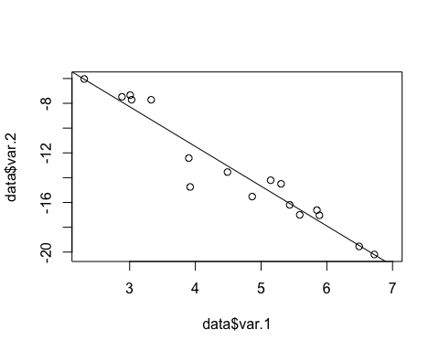

7. Using the kable function and inline code, print the coefficient table from the lm( ) function. In other words, your output document should have a table outside of the code chunk and no R code should be included.
Coefficient Table for Linear Model: var.2 ~ var.1
 | Estimate | Std. Error | t value | Pr(>|t|)
(Intercept) | 1.3485 | 1.0955 | 1.2310 | 0.2373
var.1 | -3.2080 | 0.2290 | -14.0069 | 0.0000

8. Make side-by-side horizontal boxplots of var.1 across the different levels of var.3
boxplot(var.1 ~ var.3, data = data,
horizontal = TRUE,
main = "Boxplots of var.1 by var.3",
xlab = "var.1",
ylab = "var.3")
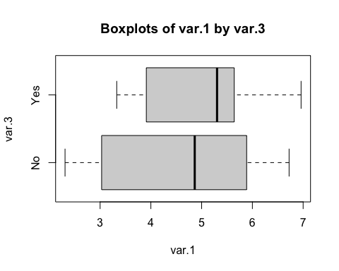 ## 9. Recreate the plot on the following page in R. Here, the A, B, and C come from var.4. The Yes,and No come from variable var.3
counts.2 <- table(data$var.3, data$var.4)
barplot(height = counts.2,
beside = TRUE,
legend = rownames(counts.2),
main = "Bar Plot of var.3 by var.4",
xlab = "var.3",
ylab = "Frequency")
