HW10
Kayla Dyer
2025-11-21

1a.Load the tidyverse package. Type str(mtcars). This data set contains 32 observations and 11 variables. The variable we are going to use is called mpg. Also, type row.names(mtcars). Each observation is a type of car and the row names are the name of the car.
library(tidyverse)
## ── Attaching core tidyverse packages ──────────────────────── tidyverse 2.0.0 ──
## ✔ dplyr 1.1.4 ✔ readr 2.1.5
## ✔ forcats 1.0.1 ✔ stringr 1.5.1
## ✔ ggplot2 4.0.0 ✔ tibble 3.3.0
## ✔ lubridate 1.9.4 ✔ tidyr 1.3.1
## ✔ purrr 1.1.0
## ── Conflicts ────────────────────────────────────────── tidyverse_conflicts() ──
## ✖ dplyr::filter() masks stats::filter()
## ✖ dplyr::lag() masks stats::lag()
## ℹ Use the conflicted package (<http://conflicted.r-lib.org/>) to force all conflicts to become errors
str(mtcars)
## 'data.frame': 32 obs. of 11 variables:
## $ mpg : num 21 21 22.8 21.4 18.7 18.1 14.3 24.4 22.8 19.2 ...
## $ cyl : num 6 6 4 6 8 6 8 4 4 6 ...
## $ disp: num 160 160 108 258 360 ...
## $ hp : num 110 110 93 110 175 105 245 62 95 123 ...
## $ drat: num 3.9 3.9 3.85 3.08 3.15 2.76 3.21 3.69 3.92 3.92 ...
## $ wt : num 2.62 2.88 2.32 3.21 3.44 ...
## $ qsec: num 16.5 17 18.6 19.4 17 ...
## $ vs : num 0 0 1 1 0 1 0 1 1 1 ...
## $ am : num 1 1 1 0 0 0 0 0 0 0 ...
## $ gear: num 4 4 4 3 3 3 3 4 4 4 ...
## $ carb: num 4 4 1 1 2 1 4 2 2 4 ...
row.names(mtcars)
## [1] "Mazda RX4" "Mazda RX4 Wag" "Datsun 710"
## [4] "Hornet 4 Drive" "Hornet Sportabout" "Valiant"
## [7] "Duster 360" "Merc 240D" "Merc 230"
## [10] "Merc 280" "Merc 280C" "Merc 450SE"
## [13] "Merc 450SL" "Merc 450SLC" "Cadillac Fleetwood"
## [16] "Lincoln Continental" "Chrysler Imperial" "Fiat 128"
## [19] "Honda Civic" "Toyota Corolla" "Toyota Corona"
## [22] "Dodge Challenger" "AMC Javelin" "Camaro Z28"
## [25] "Pontiac Firebird" "Fiat X1-9" "Porsche 914-2"
## [28] "Lotus Europa" "Ford Pantera L" "Ferrari Dino"
## [31] "Maserati Bora" "Volvo 142E"

1b. Type: mtcars$car.name <- row.names(mtcars). This creates a new variable called car.name. We have to do this because we will lose the row names in the next step.
mtcars$car.name <- row.names(mtcars)

1c. Next, we are going to do is add a column to mtcars which is the standardized score of mpg for each car, rounded to two decimal places. Recall from STA 503 that we can use the mutate( ) function to add a column that is a function of already existing columns. Type: mtcars <- mutate(mtcars, mpg.z = round((mpg - mean(mpg))/sd(mpg), 2)). Now, if you type str(mtcars) you will have 13 variables. The last variable is called mpg.z
mtcars <- mutate(mtcars, mpg.z = round((mpg - mean(mpg))/sd(mpg), 2))
str(mtcars)
## 'data.frame': 32 obs. of 13 variables:
## $ mpg : num 21 21 22.8 21.4 18.7 18.1 14.3 24.4 22.8 19.2 ...
## $ cyl : num 6 6 4 6 8 6 8 4 4 6 ...
## $ disp : num 160 160 108 258 360 ...
## $ hp : num 110 110 93 110 175 105 245 62 95 123 ...
## $ drat : num 3.9 3.9 3.85 3.08 3.15 2.76 3.21 3.69 3.92 3.92 ...
## $ wt : num 2.62 2.88 2.32 3.21 3.44 ...
## $ qsec : num 16.5 17 18.6 19.4 17 ...
## $ vs : num 0 0 1 1 0 1 0 1 1 1 ...
## $ am : num 1 1 1 0 0 0 0 0 0 0 ...
## $ gear : num 4 4 4 3 3 3 3 4 4 4 ...
## $ carb : num 4 4 1 1 2 1 4 2 2 4 ...
## $ car.name: chr "Mazda RX4" "Mazda RX4 Wag" "Datsun 710" "Hornet 4 Drive" ...
## $ mpg.z : num 0.15 0.15 0.45 0.22 -0.23 -0.33 -0.96 0.72 0.45 -0.15 ...

1d. Next, we will create another variable called mpg.type which has value below if the z-score computed from the previous step is less than 0 (i.e. that car gets less than average mpg) and above otherwise. Type: mtcars <- mutate(mtcars, mpg.type = ifelse(mpg.z < 0, “below”, “above”)). Now we have 14 variables!
mtcars <- mutate(mtcars, mpg.type = ifelse(mpg.z < 0, "below", "above"))
str(mtcars)
## 'data.frame': 32 obs. of 14 variables:
## $ mpg : num 21 21 22.8 21.4 18.7 18.1 14.3 24.4 22.8 19.2 ...
## $ cyl : num 6 6 4 6 8 6 8 4 4 6 ...
## $ disp : num 160 160 108 258 360 ...
## $ hp : num 110 110 93 110 175 105 245 62 95 123 ...
## $ drat : num 3.9 3.9 3.85 3.08 3.15 2.76 3.21 3.69 3.92 3.92 ...
## $ wt : num 2.62 2.88 2.32 3.21 3.44 ...
## $ qsec : num 16.5 17 18.6 19.4 17 ...
## $ vs : num 0 0 1 1 0 1 0 1 1 1 ...
## $ am : num 1 1 1 0 0 0 0 0 0 0 ...
## $ gear : num 4 4 4 3 3 3 3 4 4 4 ...
## $ carb : num 4 4 1 1 2 1 4 2 2 4 ...
## $ car.name: chr "Mazda RX4" "Mazda RX4 Wag" "Datsun 710" "Hornet 4 Drive" ...
## $ mpg.z : num 0.15 0.15 0.45 0.22 -0.23 -0.33 -0.96 0.72 0.45 -0.15 ...
## $ mpg.type: chr "above" "above" "above" "above" ...

1e. Now, let’s sort the 32 cars based on their value of mpg.z. Type: mtcars <- mtcars[order(mtcars$mpg.z), ]. Type head(mtcars) and tail(mtcars). Notice that it sorted them observations from smallest to biggest!
mtcars <- mtcars[order(mtcars$mpg.z), ]
head(mtcars)
## mpg cyl disp hp drat wt qsec vs am gear carb
## Cadillac Fleetwood 10.4 8 472 205 2.93 5.250 17.98 0 0 3 4
## Lincoln Continental 10.4 8 460 215 3.00 5.424 17.82 0 0 3 4
## Camaro Z28 13.3 8 350 245 3.73 3.840 15.41 0 0 3 4
## Duster 360 14.3 8 360 245 3.21 3.570 15.84 0 0 3 4
## Chrysler Imperial 14.7 8 440 230 3.23 5.345 17.42 0 0 3 4
## Maserati Bora 15.0 8 301 335 3.54 3.570 14.60 0 1 5 8
## car.name mpg.z mpg.type
## Cadillac Fleetwood Cadillac Fleetwood -1.61 below
## Lincoln Continental Lincoln Continental -1.61 below
## Camaro Z28 Camaro Z28 -1.13 below
## Duster 360 Duster 360 -0.96 below
## Chrysler Imperial Chrysler Imperial -0.89 below
## Maserati Bora Maserati Bora -0.84 below
tail(mtcars)
## mpg cyl disp hp drat wt qsec vs am gear carb
## Porsche 914-2 26.0 4 120.3 91 4.43 2.140 16.70 0 1 5 2
## Fiat X1-9 27.3 4 79.0 66 4.08 1.935 18.90 1 1 4 1
## Honda Civic 30.4 4 75.7 52 4.93 1.615 18.52 1 1 4 2
## Lotus Europa 30.4 4 95.1 113 3.77 1.513 16.90 1 1 5 2
## Fiat 128 32.4 4 78.7 66 4.08 2.200 19.47 1 1 4 1
## Toyota Corolla 33.9 4 71.1 65 4.22 1.835 19.90 1 1 4 1
## car.name mpg.z mpg.type
## Porsche 914-2 Porsche 914-2 0.98 above
## Fiat X1-9 Fiat X1-9 1.20 above
## Honda Civic Honda Civic 1.71 above
## Lotus Europa Lotus Europa 1.71 above
## Fiat 128 Fiat 128 2.04 above
## Toyota Corolla Toyota Corolla 2.29 above

1f. Finally, type the following: mtcars$car.name<−factor(mtcars$car.name, levels = mtcars$car.name). The reason we had to do this is because we would have lost the ordering from the previous step because R will sort character values (what our car.name was before this step) alphabetically.
mtcars$car.name <- factor(mtcars$car.name, levels = mtcars$car.name)

1g. Type the following in to R:
ggplot(mtcars, aes(x = car.name, y = mpg.z, label = mpg.z)) + # set up the plot with car name on x, mpg.z on y, labels as mpg.z
geom_point(aes(col = mpg.type), size = 6) + # make large points colored by mpg.type (above/below)
scale_color_manual(name = "Mileage", # customize the legend title
labels = c("Above Average", "Below Average"), # names for the two groups
values = c("green", "red")) + # manually assign colors to above/below
geom_text(color = "black", size = 2) + # add black text labels showing z-scores
labs(title = "Diverging Dot Plot", # main plot title
subtitle = "Standardized Miles Per Gallon", # subtitle
x = "Car Name", # x-axis label
y = "Z-score") + # y-axis label
coord_flip() # flip the axes so car names are easier to read
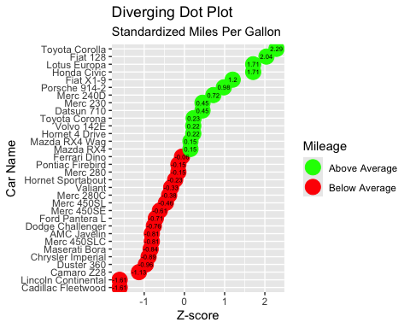

2. On the next page there are four plots. Write R code that re-creates each of the four plots. You do NOT need to include them all in one plotting window. Type the following into R. states <- data.frame(state.abb, state.center, state.region, state.division, state.x77) str(states)
library(ggplot2)
states <- data.frame(state.abb, state.center, state.region, state.division, state.x77)
str(states)
## 'data.frame': 50 obs. of 13 variables:
## $ state.abb : chr "AL" "AK" "AZ" "AR" ...
## $ x : num -86.8 -127.2 -111.6 -92.3 -119.8 ...
## $ y : num 32.6 49.2 34.2 34.7 36.5 ...
## $ state.region : Factor w/ 4 levels "Northeast","South",..: 2 4 4 2 4 4 1 2 2 2 ...
## $ state.division: Factor w/ 9 levels "New England",..: 4 9 8 5 9 8 1 3 3 3 ...
## $ Population : num 3615 365 2212 2110 21198 ...
## $ Income : num 3624 6315 4530 3378 5114 ...
## $ Illiteracy : num 2.1 1.5 1.8 1.9 1.1 0.7 1.1 0.9 1.3 2 ...
## $ Life.Exp : num 69 69.3 70.5 70.7 71.7 ...
## $ Murder : num 15.1 11.3 7.8 10.1 10.3 6.8 3.1 6.2 10.7 13.9 ...
## $ HS.Grad : num 41.3 66.7 58.1 39.9 62.6 63.9 56 54.6 52.6 40.6 ...
## $ Frost : num 20 152 15 65 20 166 139 103 11 60 ...
## $ Area : num 50708 566432 113417 51945 156361 ...

Plot A
ggplot(states, aes(x = x, y = y)) +
geom_point(aes(size = Population, color = state.region), alpha = 0.7) +
geom_text(aes(label = state.abb), vjust = -0.5) +
geom_smooth(aes(color = state.region), method = "lm", se = FALSE, size = 1) +
scale_size(range = c(2, 8), name = "Population") +
labs(x = "Latitude", y = "", color = "state.region")
## Warning: Using `size` aesthetic for lines was deprecated in ggplot2 3.4.0.
## ℹ Please use `linewidth` instead.
## This warning is displayed once every 8 hours.
## Call `lifecycle::last_lifecycle_warnings()` to see where this warning was
## generated.
## `geom_smooth()` using formula = 'y ~ x'
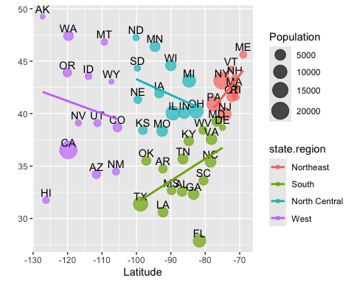

Plot B
meanFrost <- mean(states$Frost)
sdFrost <- sd(states$Frost)
ggplot(states, aes(x = Frost)) +
geom_histogram(aes(y = ..density..),
bins = 7, fill = "grey80", color = "red", alpha = 0.6) +
geom_density(size = 1) +
geom_rect(aes(xmin = meanFrost - sdFrost,
xmax = meanFrost + sdFrost,
ymin = 0, ymax = Inf),
fill = "blue", alpha = 0.5, inherit.aes = FALSE) +
labs(x = "Number of Days with Frost", y = "Density")
## Warning: The dot-dot notation (`..density..`) was deprecated in ggplot2 3.4.0.
## ℹ Please use `after_stat(density)` instead.
## This warning is displayed once every 8 hours.
## Call `lifecycle::last_lifecycle_warnings()` to see where this warning was
## generated.
## Warning in geom_rect(aes(xmin = meanFrost - sdFrost, xmax = meanFrost + : All aesthetics have length 1, but the data has 50 rows.
## ℹ Please consider using `annotate()` or provide this layer with data containing
## a single row.
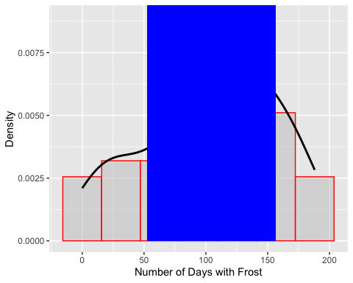

Plot C
ggplot(states, aes(x = Frost, y = state.region)) +
geom_boxplot(fill = "white") +
geom_jitter(height = 0.1, color = "grey40", alpha = 0.7) +
stat_summary(fun = mean, geom = "point", color = "red", size = 3) +
labs(x = "Number of Days with Frost", y = "State Region")
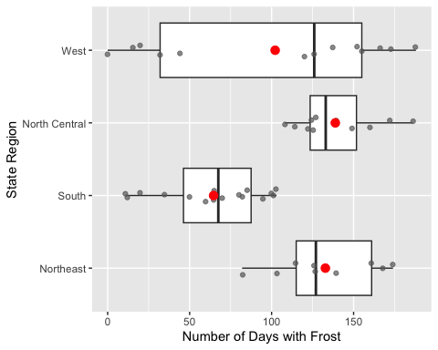

Plot D
ggplot(states, aes(x = state.region, fill = state.division)) +
geom_bar() +
labs(title = "Number of States in Each Division per Region",
x = "State Region", y = "count") +
theme(axis.text.x = element_text(angle = 45, hjust = 1))
