Kayla Dyer
Professor McClintock
STA 512
7 February 2026
Homework 1
Question A.
A.
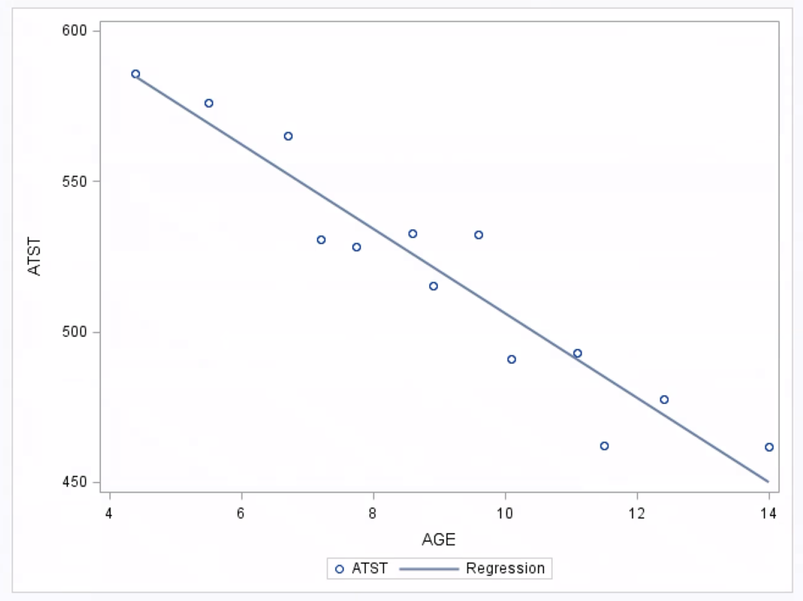
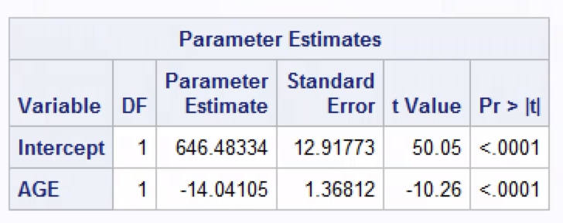
A scatterplot of average total sleep time (ATST) versus age shows a clear negative linear relationship, indicating that average sleep time tends to decrease as age increases.
From the regression output, the least-squares estimates are an intercept of 646.48 and a slope of −14.04. The estimated regression line for predicting ATST from AGE is
$$\hat{ATST}=646.48-14.04(\text{AGE})$$
The slope indicates that average total sleep time decreases by approximately 14 minutes per day for each additional year of age. The intercept represents the predicted ATST at age zero; although age zero is not meaningful in this context, the intercept is necessary to define the regression line.

The fitted line drawn on the scatterplot shows a negative linear trend, and the data points are located reasonably close to the line with no obvious curvature or extreme outliers, suggesting that a straight-line model provides a good fit.
C.
Hypotheses:
$H_{0}:β_{1}=0$ (AGE has no linear relationship with ATST)
$H_{a}:β_{1}≠0$ (AGE has a linear relationship with ATST)
Test statistic:

From the Parameter Estimates table for AGE, $t=-10.26$ with $df=n-2=13-2=11.$
Critical value (two-sided, $α=0.05):$
**using a t Table I got the value 2.2009.
$$t_{0.025,11}=2.201$$
p-value and interpretation:
The p-value is less than 0.0001, which means that if age truly had no linear effect on average total sleep time, observing a slope as extreme as the one in this sample (t = −10.26) would be extremely unlikely. This indicates that the observed relationship is not due to random chance.
Decision in context:
Because the observed test statistic has magnitude 10.26, which exceeds the critical value of 2.201, and the p-value is less than 0.05, the result is statistically significant, and we reject the null hypothesis. There is strong evidence that the true slope is not 0, so age is linearly related to average total sleep time. The estimated slope value of -14.04 shows that total sleep time decreases on average as people get older.
D.

$$β_{1}=-14.04105$$
$$SE\left(β_{1}\right)=1.36812$$
$$df=11$$
$$t_{0.025,11}=2.201$$
$$ME=t∙SE\left(β_{1}\right)=2.201∙1.36812\sim 3.01$$
$$CI=β_{1}∓ME=-14.04105∓3.01$$
Lower bound:
$$-14.04105-3.01\sim -17.05$$
Upper bound:
$$-14.04105+3.01\sim -11.03$$
$$(-17.05,-11.03)$$
We are 95% confident that the true slope of the regression line lies between −17.05 and −11.03. This means that for each additional year of age, average total sleep time is estimated to decrease by between 11 and 17 minutes per day.
E.

The 95% confidence interval for the slope is $\left(-17.05, -11.03\right)$, and 0 is not contained in this interval. Therefore, we reject the null hypothesis $H_{0}:β_{1}=0$at the 0.05 significance level. The results show that age is significantly related to average total sleep time, and the straight-line regression model is useful for predicting ATST.

Question B.

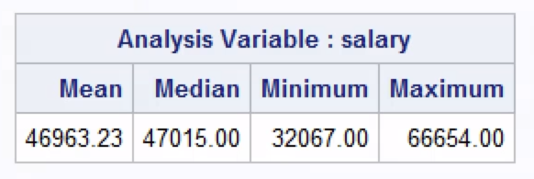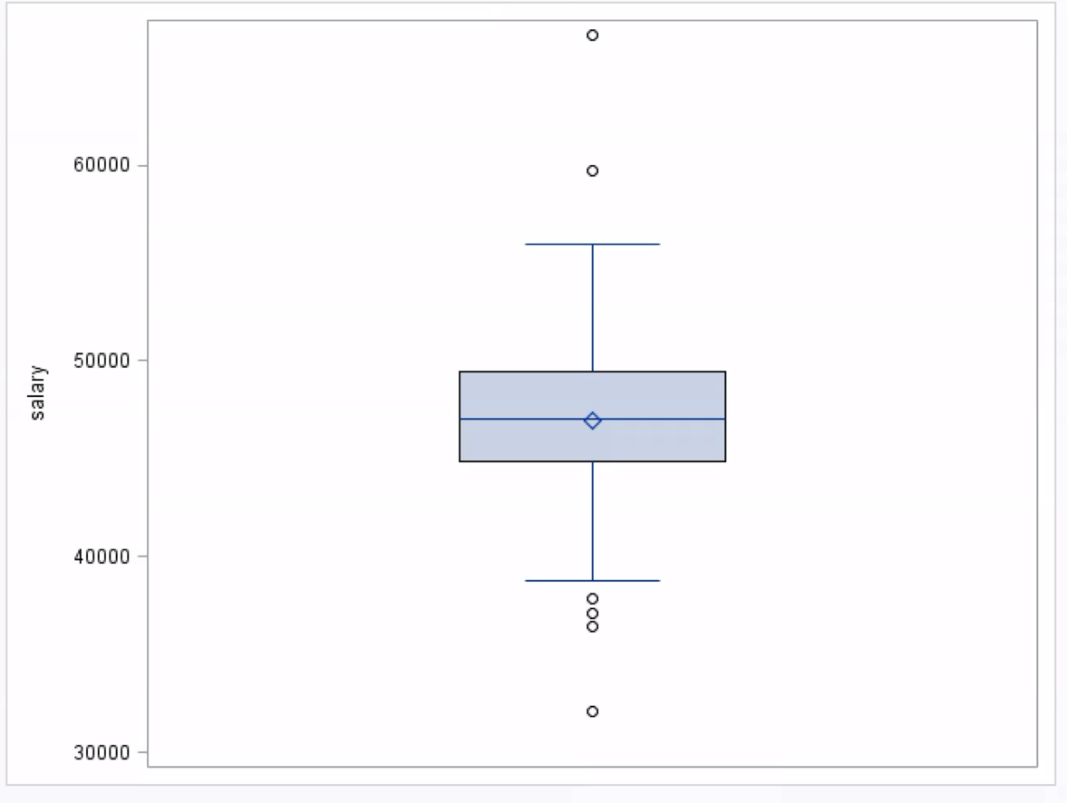
The variable SALARY represents teacher salaries across the schools in the dataset. The average teacher salary amounts to $46,963 while the middle salary value reaches $47,015 which shows that most teachers earn approximately $47,000 annually. Salaries range from $32,067 to $66,654. The boxplot demonstrates that most schools distribute their salaries throughout this range, but several institutions have salaries which differ substantially from the average. The salary data show that teachers receive salaries which vary at a moderate level between different schools while most institutions maintain salaries that match the average amount.

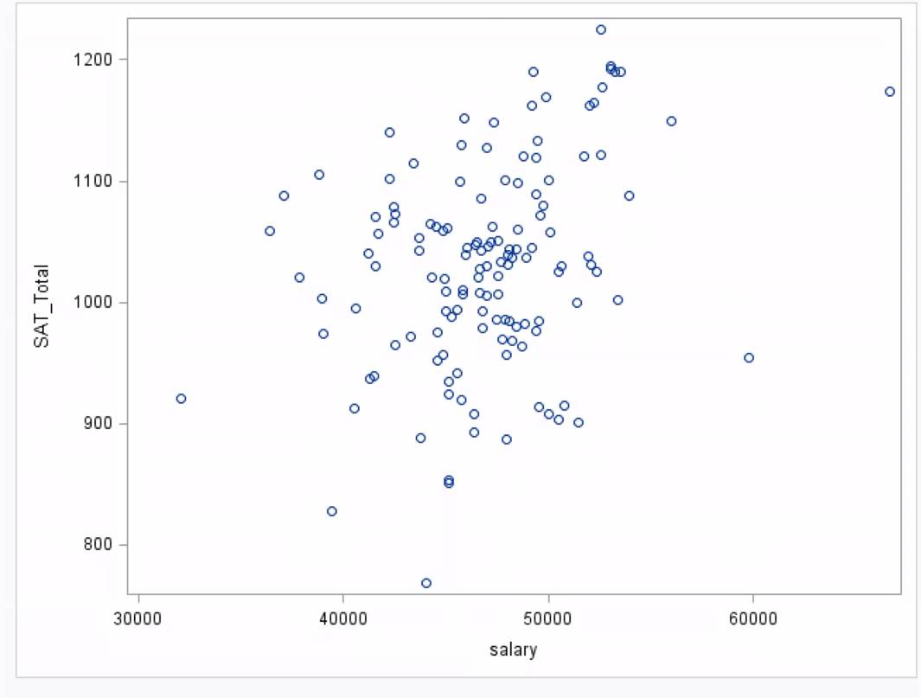
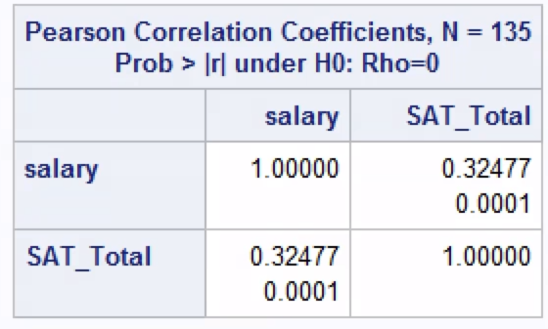
The scatterplot of SAT_TOTAL verses SALARY shows a weak positive linear relationship, indicating that schools with higher teacher salaries tend to have slightly higher SAT scores. Since, there is lots of variability in the SAT scores across all salary levels this suggests that salary alone does not strongly predict SAT performance.
The correlation coefficient between SALARY and SAT_TOTAL is $r=0.325$, which indicates a weak positive linear relationship. This correlation does support the pattern observed in the scatterplot.

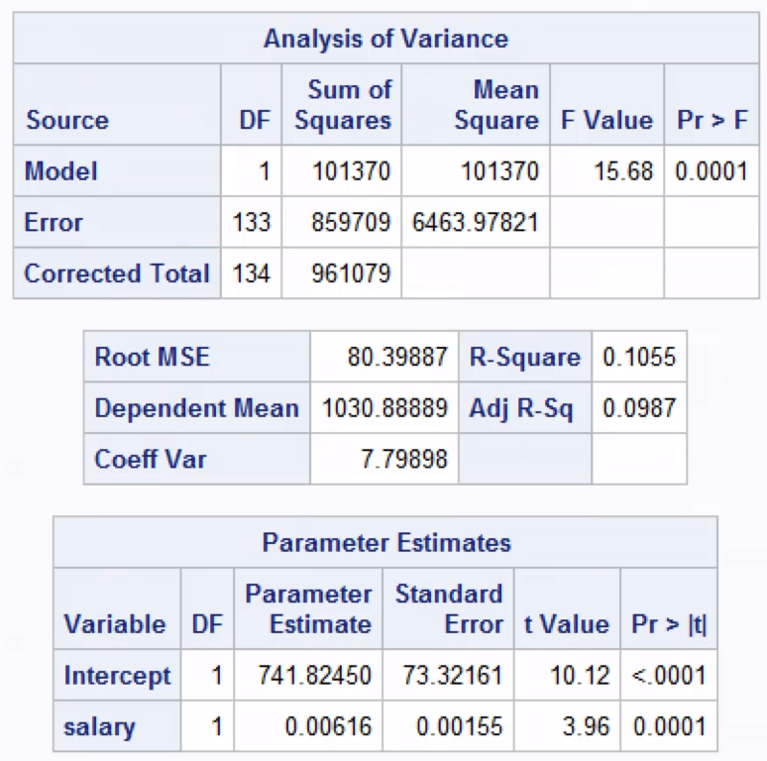
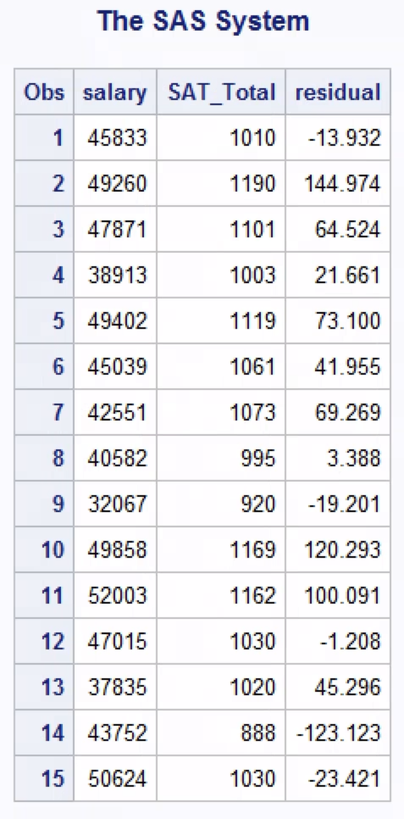

Based on the Parameter Estimates table above, the slope for the SALARY is 0.00616. This means that for every $1 increase in teacher salary, the predicted average SAT_TOTAL score would increase by approximately 0.00616 points.

Based on the Parameter Estimates table above, the y-intercept is 741.8245. This indicates that when the average teacher salary is $0 the predicted SAT_TOTAL score is approximately 742 points. The y-intercept is needed to define the regression line, but it not a practical because an average teacher salary of $0 is not realistic.

Hypotheses:
$H_{0}:β_{1}=0$ (SALARY has no linear relationship with SAT_TOTAL)
$H_{a}:β_{1}≠0$ (SALARY has a linear relationship with SAT_TOTAL)
Test statistic:


From the Parameter Estimates table for SALARY, $t=3.96$ with $df=n-2=135-2=133$
Critical value (two-sided, $α=0.05):$
** The t-table does not have row for 133, so using the closest df row (100) I got the value 1.984.
$$t_{0.025,133}=1.984$$
p-value and interpretation:
The p-value is 0.0001, which means that if SALARY truly had no linear effect on SAT_TOTAL, observing a slope as extreme as the one in this sample (t = 3.96) would be very unlikely. This indicates that the observed relationship is not due to random chance.
Decision in context:
Because the observed test statistic has magnitude 3.96, which exceeds the critical value of 1.98, and the p-value is less than 0.05, the result is statistically significant, and we reject the null hypothesis. There is strong evidence that the true slope is not 0, so SALARY is linearly related to SAT_TOTAL. The estimated slope value of 0.00616 shows that SAT_TOTAL increases on average as teacher salary increases, however the effect is small.

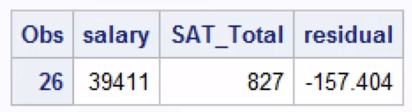
Observation (School) #26 has a residual of approximately −157, meaning that its actual SAT_TOTAL score is about 157 points lower than the value predicted by the regression model based on its average teacher salary. This indicates that teacher salary alone does not fully explain SAT scores for this school.


From the regression output, the least-squares estimates are an intercept of 741.82450 and a slope of 0.00616. The estimated regression line for predicting SAT_TOTAL from SALARY is
$$\hat{SAT_TOTAL}=741.82450+0.00616(SALARY)$$

$$\hat{SAT_TOTAL}=741.82450+0.00616\left(45,106\right)=741.82450+277.85296\sim 1019.7$$

$$SAT_TOTAL\sim 1019.7$$
$$\hat{SAT_TOTAL}=741.82450+0.00616\left(80,000\right)=741.82450+492.8\sim 1,234.6$$
According to the regression equation, the predicted SAT_TOTAL score for a school with an average teacher salary of $45,106 is approximately 1,020. A school with an average teacher salary of $80,000 is predicted to have an SAT_TOTAL score of approximately 1,235.

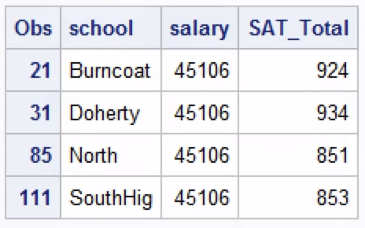
There are four schools in the dataset with an average teacher salary of $45,106. The actual SAT scores at these schools are 924, 934, 851 and 853. Based on the predicted SAT score of approximately 1,020 from Question 8, the actual scores are lower than predicted but not surprising. Because the linear relationship between teacher salary and SAT_TOTAL is weak, we are not surprised that the predicted SAT scores do not closely match the actual scores.

