Kayla Dyer
Professor McClintock
STA512
23 March 2026
Homework 4
The variable sex was recoded such that sex = 0 for male bears and sex = 1 for female bears.
Question 1.

To compare the linear relationship between weight and length for male and female bears, I used the model:
$$weight=β_{0}+β_{1}\left(length\right)+β_{2}\left(sex\right)+β_{3}\left(length∙sex\right)$$
$$sex=\left\{\begin{aligned}0, if the bear is male \\ 1, if the bear is female\end{aligned}\right.$$
The parameter estimates for this model are shown below from the SAS output.
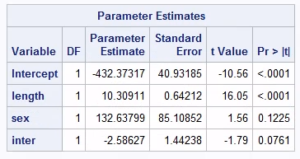
$$\hat{weight}= -432.37317+10.30911\left(length\right)+132.63799\left(sex\right)-2.58627(length∙sex)$$

$$Male \left(sex=0\right):$$
$$\hat{weight}= -432.37317+10.30911\left(length\right)+132.63799\left(0\right)-2.58627(length∙0)$$
$$\hat{weight}= -432.37317+10.30911\left(length\right)$$

$$Female \left(sex=1\right):$$
$$\hat{weight}= -432.37317+10.30911\left(length\right)+132.63799\left(1\right)-2.58627(length∙1)$$
$$\hat{weight}= -432.37317+132.63799+(10.30911-2.58627)(length)$$
$$\hat{weight}=-299.73518+7.722884(length)$$
Thus, the regression equations relating weight to length differ between male and female bears in both intercept and slope.

Hypotheses:
$H_{0}:β_{3}=0$ (The slope relating length to weight is the same for male and female bears.)
$H_{a}:β_{3}≠0$ (The slope relating length to weight is different for male and female bears.)

Full Model:
$$weight=β_{0}+β_{1}\left(length\right)+β_{2}\left(sex\right)+β_{3}\left(length∙sex\right)$$
where sex = 0 for male bears and sex = 1 for female bears.
p-value:
The p-value for interaction is 0.0761.
Decision in context:
Since the p-value is greater than 0.05, we fail to reject $H_{0}$. There is not enough evidence to conclude that the slope relating length to weight differs between male and female bears. This suggests that increases in length are associated with similar increases in weight for both male and female bears

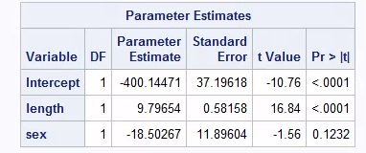
Hypotheses:
$H_{0}:β_{2}=0$ (The intercept is the same for male and female bears.)
$H_{a}:β_{2}≠0$ (The intercept is different for male and female bears.)
Full Model:
$$weight=β_{0}+β_{1}\left(length\right)+β_{2}\left(sex\right)$$
where sex = 0 for male bears and sex = 1 for female bears.
p-value:
The p-value for the sex variable is 0.1232.
Decision in context:
The p-value is larger than 0.05, so we fail to reject $H_{0}$. Therefore, there is not sufficient evidence to claim that the intercept in the length vs. weight equation is different between males and females. This means when length is held fixed in this reduced model, male and female bears do not have significantly different intercepts.

