Kayla Dyer
Professor McClintock
STA512
17 February 2026
Homework 3
Question 1.
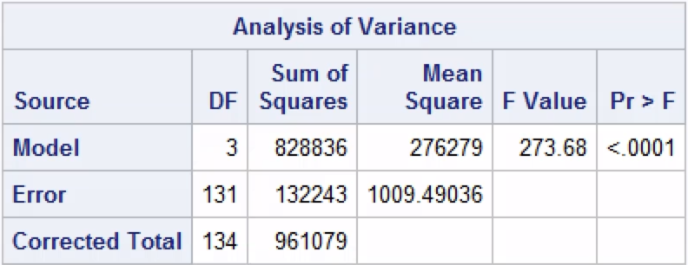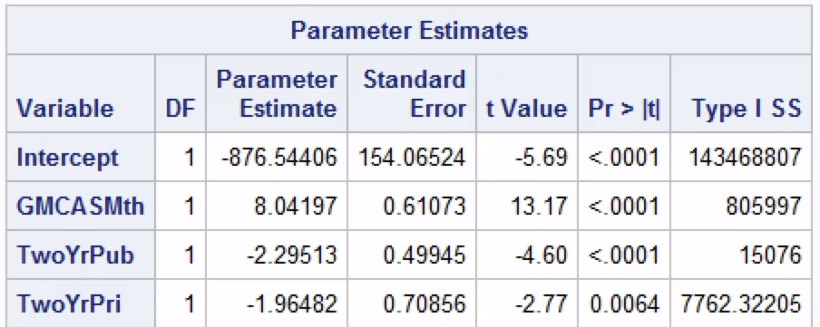
Test 1 – GMCASMth
Hypotheses:
$H_{0}:β_{GMCASMth}=0$ (GMCASMth has no linear relationship with SAT_TOTAL)
$H_{a}:β_{GMCASMth}≠0$ (GMCASMth has a linear relationship with SAT_TOTAL)
Test statistic:
From the Type I test in SAS for GMCASMth, $t=13.17$
$$F=t^{2}={(13.17)}^{2}\sim 173.45$$
with $df_{error}=n-p=135-4=131$
$$F\left(1,131\right)=173.45, p<0.0001$$

Critical Value:
**No critical value needed.**
p-value and interpretation:
The p-value is less than 0.0001, which indicates that GMCASMth adds significantly to the model when entered first. This provides strong statistical evidence that the average 10th grade MCAS Math score is linearly related to total SAT scores.
Decision in context:
Since the p-value is less than 0.05, we reject the null hypothesis. There is strong evidence that the average 10th grade MCAS Math score contributes significantly to explaining variation in total SAT scores when entered first in the model.
Test 2 – TwoYrPub
Hypotheses:
$H_{0}:β_{TwoYrPub}=0$ (TwoYrPub has no linear relationship with SAT_TOTAL after GMCASMth is in the model.)
$H_{a}:β_{TwoYrPub}≠0$ (TwoYrPub has a linear relationship with SAT_TOTAL after GMCASMth is in the model.)
Test statistic:
From the Type I test in SAS for TwoYrPub, $t=-4.60$
$$F=t^{2}={(-4.60)}^{2}=21.16$$
with $df_{error}=n-p=135-4=131$
$$F\left(1,131\right)=21.16, p<0.0001$$
Critical Value:
**No critical value needed.**
p-value and interpretation:
The p-value is less than 0.0001, which indicates that TwoYrPub adds significantly to the model when entered second (after GMCASMth). This provides strong statistical evidence that the percentage of students attending two-year public colleges is linearly related to total SAT scores after accounting for the average 10th grade MCAS Math score.
Decision in context:
Since the p-value is less than 0.05, we reject the null hypothesis. There is strong evidence that the percentage of students attending two-year public colleges contributes significantly to explaining variation in total SAT scores after GMCASMth is included in the model.
Test 3 – TwoYrPri
Hypotheses:
$H_{0}:β_{TwoYrPri}=0$ (TwoYrPri has no linear relationship with SAT_TOTAL after GMCASMth and TwoYrPub are in the model.)
$H_{a}:β_{TwoYrPri}≠0$ (TwoYrPri has a linear relationship with SAT_TOTAL after GMCASMth and TwoYrPub are in the model.)
Test statistic:
From the Type I test in SAS for TwoYrPri, $t=-2.77$
$$F=t^{2}={(-2.77)}^{2}=7.67$$
with $df_{error}=n-p=135-4=131$
$$F\left(1,131\right)\sim 7.67, p<0.0064$$
Critical Value:
**No critical value needed.**
p-value and interpretation:
The p-value is 0.0064, which indicates that TwoYrPri adds significantly to the model when entered third (after GMCASMth and TwoYrPub). This provides strong statistical evidence that the percentage of students attending two-year private colleges is linearly related to total SAT scores after accounting for the other two predictors already in the model.
Decision in context:
Since the p-value is less than 0.05, we reject the null hypothesis. There is strong evidence that the percentage of students attending two-year private colleges contributes significantly to explaining variation in total SAT scores after GMCASMth and TwoYrPub are included in the model.
Question 2.
Hypotheses:
$H_{0}:β_{TwoYrPub}=0$ (TwoYrPub adds nothing to predicting SAT_TOTAL after GMCASMth and TwoYrPri are in the model.)
$H_{a}:β_{TwoYrPub}≠0$ (TwoYrPub adds to predicting SAT_TOTAL after GMCASMth and TwoYrPri are in the model.)
Test statistic:
From SAS, TwoYrPub has $t=-4.60$
$$F=t^{2}={(-4.60)}^{2}=21.16$$
with $df_{error}=n-p=135-4=131$
$$F\left(1,131\right)=21.16, p<0.0001$$
Critical Value:
**No critical value needed.**
p-value and interpretation:
The p-value is less than 0.0001, indicating that TwoYrPub contributes significantly to predicting total SAT scores above and beyond GMCASMth and TwoYrPri.
Decision in context:
Since the p-value is less than 0.05, we reject the null hypothesis. There is strong evidence that the percentage attending two-year public colleges adds significant explanatory power after accounting for GMCASMth and TwoYrPri.
Question 3.
Hypotheses:
$H_{0}:β_{GMCASMth}=0$ (GMCASMth adds nothing to predicting SAT_TOTAL after TwoYrPub and TwoYrPri are in the model.)
$H_{a}:β_{GMCASMth}≠0$ (GMCASMth adds to predicting SAT_TOTAL after TwoYrPub and TwoYrPri are in the model.)
Test statistic:
From SAS for GMCASMth, $t=13.17$
$$F=t^{2}={(13.17)}^{2}\sim 173.45$$
with $df_{error}=n-p=135-4=131$
$$F\left(1,131\right)=173.45, p<0.0001$$

Critical Value:
**No critical value needed.**
p-value and interpretation:
The p-value is less than 0.0001, which indicates that GMCASMth adds significantly to the model above and beyond TwoYrPub and TwoYrPri. This provides strong statistical evidence that the average 10th grade MCAS Math score is related to total SAT scores even after accounting for the percentages of students attending two-year public and two-year private colleges.
Decision in context:
Since the p-value is less than 0.05, we reject the null hypothesis. There is strong evidence that GMCASMth contributes significantly to explaining variation in total SAT scores above and beyond TwoYrPub and TwoYrPri.

