Kayla Dyer
Professor McClintock
STA512
13 April 2026
Analysis of Dating Preferences
Introduction
This study examines data collected for a new online dating platform, PIZZAZ.COM, which aims to use statistical methods to optimally match couples. The dataset has 276 observations, where each observation represents one interaction between a male and a female who were randomly paired during a speed dating event. After each date, participants rated their partner on characteristics such as attractiveness, sincerity, intelligence, fun, ambitiousness, and shared interests on a 1 to 10 scale. They also reported an overall liking score, their decision to see the partner again, and demographic information including age and race. The main problem being studied is whether a participant’s liking score can be predicted using these characteristics, and whether factors such as being the same race, being close in age within two years, and differences between males and females influence attraction. This is important because the entrepreneur aims to build a dating platform that uses statistical insights to improve matching, helping users find more compatible partners and increasing the success of the platform.
Descriptive Statistics
The dataset contains 276 observations. There are some missing values in the dataset, so fewer observations can be used in the regression models. However, the data is still usable and no major errors are detected. Looking at race, there are 121 couples of the same race and 155 couples of different races. This means that 43.84% of couples are the same race, while 56.16% are different races. Overall, most couples are of different races. In terms of age, close in age is defined as couples within 2 years of each other. There are 119 couples who are close in age and 157 couples who are not close in age. This means that 43.12% of couples are close in age, while 56.88% are not. Overall, most couples are not close in age.
Model Selection/Analysis
Multiple linear regression was used because the response variable, Like, is continuous and measured on a 1 to 10 scale. Since several partner characteristics may influence liking, this method allows all variables to be evaluated simultaneously while holding the others constant. Separate models were used for males and females to account for potential differences in preferences between the two groups. The final models include all six partner characteristics: attractiveness, sincerity, intelligence, fun, ambitiousness, and shared interests, as specified in the study. Separate models were constructed for males and females, resulting in the following estimated equations obtained from SAS output.
Male Model
$$\hat{LikeM}=3.6248-0.0507\left(AttractiveF\right)+0.1349\left(SincereF\right)+0.0267\left(IntelligentF\right)+0.0431\left(FunF\right)+0.0793\left(AmbitiousF\right)+0.0166(SharedInterestsF)$$
Female Model
$$\hat{LikeF}=3.5384-0.0029\left(AttractiveM\right)+0.1618\left(SincereM\right)+0.1495\left(IntelligentM\right)-0.1003\left(FunM\right)+0.1206\left(AmbitiousM\right)+0.0466\left(SharedInterestsM\right)$$
The overall usefulness of each model was assessed using the F-test and its corresponding p-value from the regression output. Individual predictors were evaluated using their p-values to determine which characteristics have a meaningful effect on liking. Model fit was assessed using the R-squared value, which indicates how much variation in the Like score is explained by the predictors. Alternative models, such as removing non-significant variables, could have been considered. However, the full model was retained to match the study objectives and evaluate all characteristics provided. Variables such as SameRace and CloseAge were analyzed separately using t-tests rather than being included in the regression models.
Diagnostics
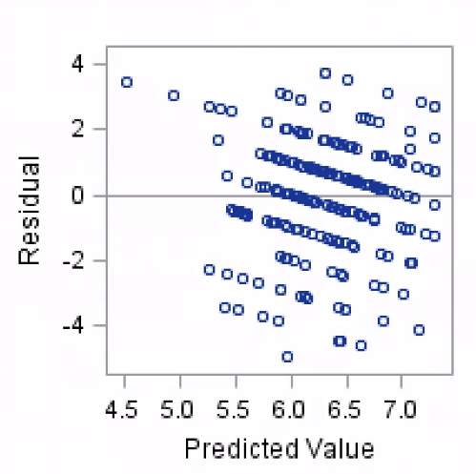
Figure 1: Residuals vs. Predicted Values for Female Like Model
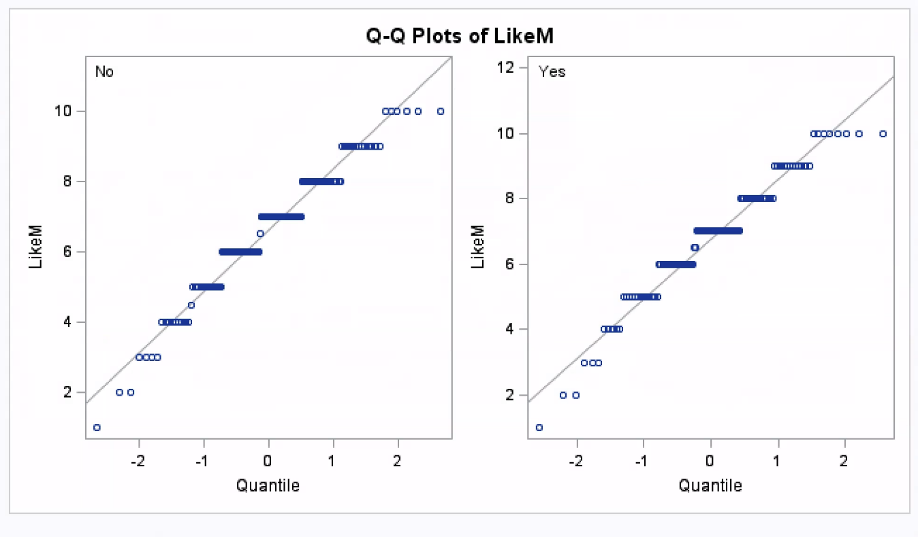
Figure 2: Normal Q-Q Plot of Like Scores for Males by Same Race Status
Diagnostic plots from the regression output were examined to assess whether the assumptions of linear regression were reasonably satisfied. As shown in Figure 1, the residuals appear to be centered around zero with no clear patterns, suggesting that the assumption of linearity is appropriate. The spread of the residuals is fairly consistent, indicating that the constant variance assumption is reasonably met. The normal probability plot in Figure 2 shows slight deviations from normality, but not to a degree that would significantly impact the results. Additionally, Cook’s D values are small, indicating that there are no highly influential outliers, so overall the model assumptions appear to be reasonably satisfied.
Summary of Findings
The dataset appears to have been mostly imported correctly because the total number of observations was 276, which matches the expected sample size, but there was a mismatch in the number of variables, since only 18 variables were present instead of the expected 22. This suggests that some variables may not have exported correctly, but the main variables needed for the analysis were still available, so the dataset was usable overall.
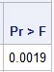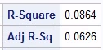
Table 1: Regression model summary for predicting Like score for males.

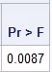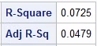
Table 2: Regression model summary for predicting Like score for females.
Tables 1 and 2 summarize the regression results for the male and female models. The regression models do not predict a dater’s Like score very well because the R² values are only 0.0864 for males and 0.0725 for females, so less than 10% of the variation in liking is explained. Even though both models are statistically significant overall, with p-values of 0.0019 and 0.0087, the relationships are still weak, and the models are not strong predictors.
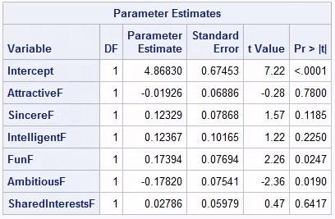
Table 3: Parameter estimates for predicting male Like score based on female characteristics.
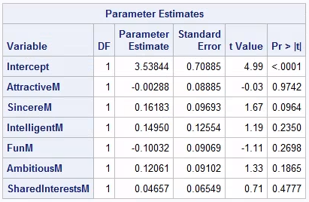
Table 4: Parameter estimates for predicting female Like score based on male characteristics.
The parameter estimates for the male and female models are shown in Tables 3 and 4. When we examine the male model first, Fun has a positive effect on liking with a p-value of 0.0247, and Ambitious has a negative effect with a p-value of 0.0190, so both of these are statistically significant. However, the female model none of the variables are statistically significant since all of the p-values are greater than 0.05, which suggests that these characteristics are not clearly related to liking for females. Overall, the preferences may differ between males and females.
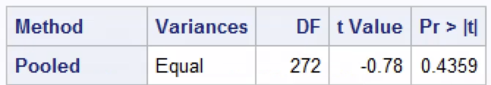
Table 5: T-test results for the effect of same race on Like score for males.
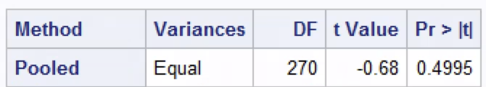
Table 6: T-test results for the effect of same race on Like score for females.
As shown in Tables 5 and 6, the t-test results indicate that there is no statistically significant difference in liking between same-race and different-race couples, with p-values of 0.4359 for males and 0.4995 for females. This suggests that being the same race does not have a meaningful impact on how much people like each other.
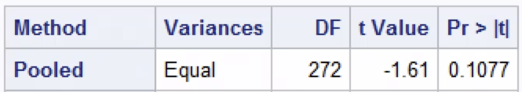
Table 7: T-test results for the effect of close age on Like score for males.
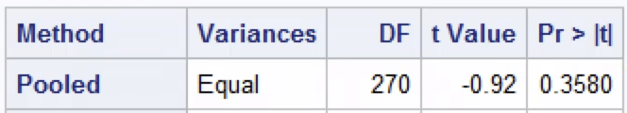
Table 8: T-test results for the effect of close age on Like score for females
As shown in Tables 7 and 8, the t-test results indicate that there is no statistically significant difference in liking between couples who are close in age and those who are not, with p-values of 0.1077 for males and 0.3580 for females. This suggests that being close in age does not have a meaningful impact on how much people like each other.
Looking at Tables 3 and 4, it seems that males and females do value partner characteristics differently. In the male model, a few variables have a noticeable effect on liking, while in the female model none of the variables show a clear effect. This suggests that males and females are likely paying attention to different traits when deciding how much they like someone.
Tables 1 and 2 show that the current models have very weak predictive power, therefore partner ratings alone are not enough to make strong matching decisions. Looking at Tables 5 through 8, there is no significant difference in liking based on whether people are the same race or close in age. Another important takeaway is that males and females tend to value different traits, which supports looking at them separately when modeling preferences. Given these results, the entrepreneur should be cautious about using these models as they are and should focus on collecting more meaningful variables, like personality and compatibility, while also improving the data collection process to avoid missing important information.

