钯片刚性封装与多体库仑动力学
  - Rigid Encapsulation and Many Body Coulomb Dynamics in Palladium
结构 原理 注释与单侧锂化合物后续方向
Structure, principles, annotations and future directions for a one-sided lithium-compound layer
本人 James Qi 更新日期 2026年10月29日
James Qi Updated 29 October 2026

本人的实验记录与机理解释
My experimental record and interpretation
本人把含氘钯片、非均匀孔槽、外封装和持续驱动作为一个相互耦合的系统研究。
I study deuterium-loaded palladium, nonuniform holes and grooves, external encapsulation, and sustained driving as one coupled system.
主要驱动结构为高速自转的多孔钯片与偏角六瓣磁阵列，磁瓣采用NNNSNS或SSSNSN非交替极序。
The main drive combines a rapidly spinning perforated palladium plate with a skewed six-lobe magnetic array whose non-alternating pole sequence is NNNSNS or SSSNSN.
首要结构重点是钯片外封装的刚性作用，即通过有限刚度的边界限制自由形变，并改变内部应力与接触响应。
The primary structural emphasis is the rigidity of the encapsulation around the palladium plate, which constrains free deformation and changes internal stress and contact responses through a boundary of finite stiffness.
本人的核心机理判断是“以多数库伦混沌效应打败局部库伦”，即利用多体环境的瞬时集体作用促进局部两氘核接近。
My central mechanistic interpretation is “overcoming local Coulomb repulsion through collective Coulomb chaos”: transient collective environmental effects promote the approach of a local deuteron pair.
本文记录本人的实验观察，并说明本人将结构、扰动、电子响应、氘分布与两核相对运动联系起来的机理解释。
This document records my experimental observations and explains how I connect structure, perturbations, electronic response, deuterium distribution, and relative nuclear motion.

个人简介
Personal profile
戚克斌 KeBin Qi James Qi
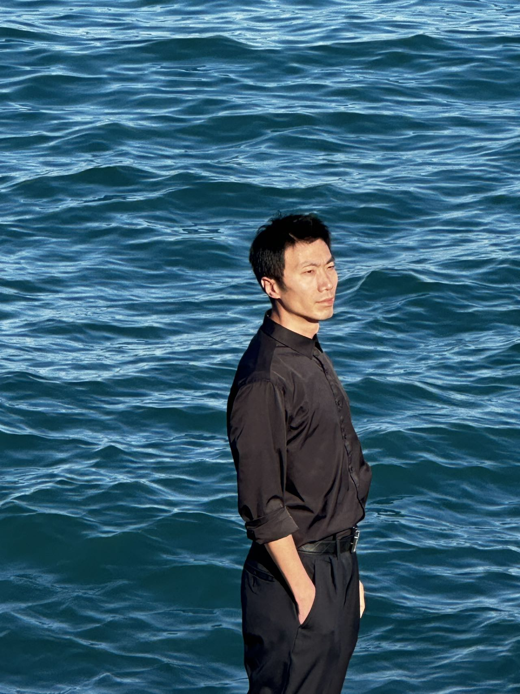
本人照片 My photographs
本人1981年6月出生于中国黑龙江省哈尔滨市，目前在美国。
I was born in June 1981 in Harbin, Heilongjiang Province, China, and I am currently based in the United States.
本人从事核物理领域的独立研究，研究方向为常温微型聚变装置。
I conduct independent research in nuclear physics, focusing on miniature room-temperature fusion devices.
本人已经做出原型机，并多次实验成功。
I have built a prototype and achieved successful results in multiple experiments.
本人研发的单个核心成本不足200美元，输入功耗仅为瓦级，输出能量大于输入能量。
Each core I developed costs less than US$200, requires only watt-scale input power, and produces more energy than it consumes.
采用阵列式结构可大幅度降低成本。
An array configuration can substantially reduce costs.
该技术由本人KeBin Qi（James Qi），中文名戚克斌，独自迭代研发，未借鉴任何人的技术，属于独创。
I, KeBin Qi (James Qi), known in Chinese as 戚克斌, independently developed and iteratively refined this original technology without drawing on anyone else’s technology.

1 结构组成与空间关系

Architecture and spatial relationships
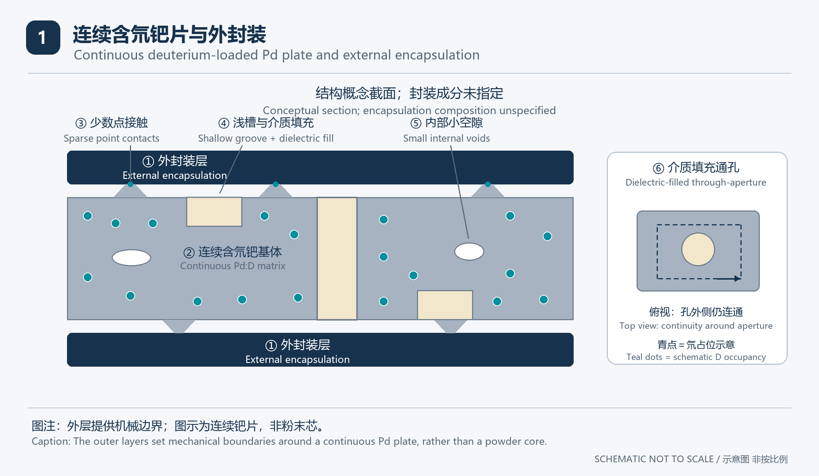
图1 含氘钯片与外封装的概念截面，图中尺寸和原子间距均不代表实际比例。
Figure 1. Conceptual section of the deuterium-loaded palladium plate and its encapsulation; dimensions and atomic spacings are not to scale.
主体是一片连续导电的含氘钯基体，氘位于其间隙、缺陷或其他材料占位环境中。
The main body is a continuous conducting palladium matrix containing deuterium in interstitial, defect-related or other material environments.
不规则浅槽、凹陷与通孔改变局部几何，孔周围保留的金属连接仍能形成连续导电路径。
Irregular shallow grooves, recesses and through-holes change the local geometry, while the remaining metal around the holes can retain continuous conducting paths.
槽和孔中的介质、钯表面以及外封装共同构成界面体系，其电学、热学与力学作用需要分别描述。
The medium in grooves and holes, the palladium surface and the outer encapsulation form an interface system whose electrical, thermal and mechanical roles must be described separately.
外封装位于钯片之外，本文所说的“钯片外封装”不表示封装层本身必须由钯制成。
The encapsulation lies outside the palladium plate; “encapsulation around the palladium plate” does not mean that the encapsulating material must itself be palladium.
局部贴合区可以传递接触力，局部未贴合区可以形成内部小空隙，外缘是否真正密闭决定这些空隙是否通向外界。
Contact regions can transmit contact forces, noncontact regions can form internal voids, and the integrity of the outer seal determines whether those voids communicate with the surroundings.
注1 图中青色标记表示氘占位，示意位置不代表已知浓度、实际晶格占位或原子间距。
Note 1. Teal markers indicate deuterium occupancy, and their schematic positions do not represent a measured concentration, actual lattice occupancy or atomic spacing.

2 外封装的刚性作用

Mechanical role of the outer encapsulation
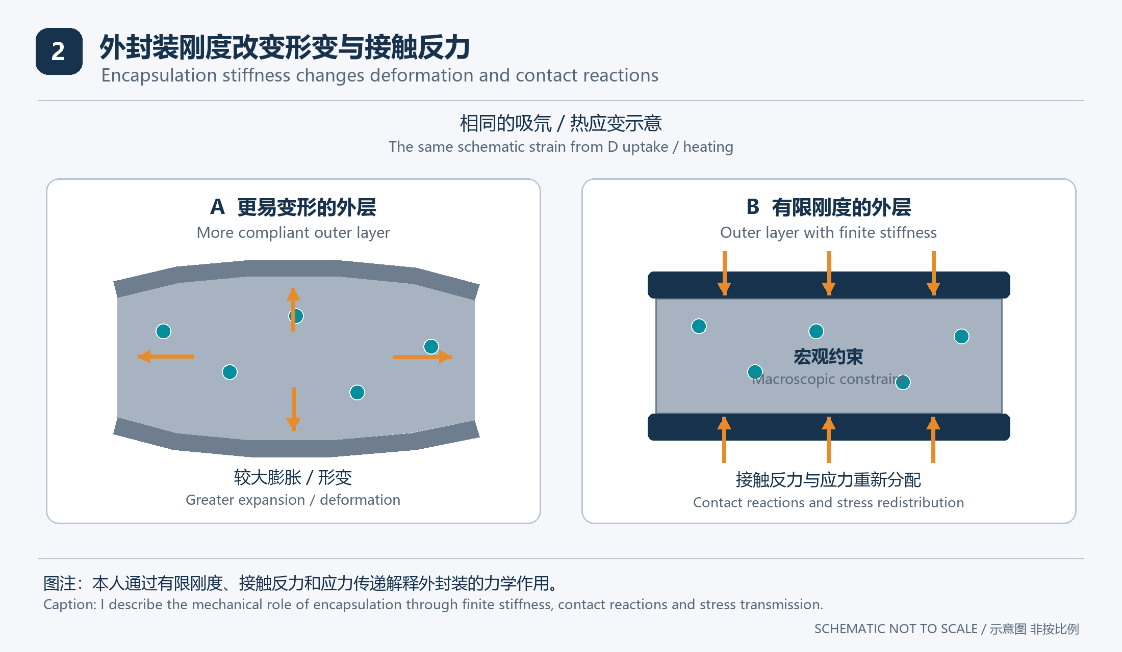
图2 较柔顺外层与有限刚度外层的力学响应比较，箭头仅表示形变和接触反力。
Figure 2. Comparison of a compliant outer layer and an outer layer of finite stiffness; arrows indicate deformation and contact reactions only.
外封装是机械边界，不能仅按“防漏涂层”理解，它会参与整个钯片的形变与受力。
The encapsulation is a mechanical boundary whose role extends beyond sealing, because it participates in the deformation and loading of the entire palladium plate.
当吸氘、温度变化或相变倾向于改变钯的尺寸时，外部约束可使部分自由形变转化为应力。[R1]
When deuterium uptake, temperature changes or phase transformations tend to change the dimensions of palladium, external constraint can convert part of the free deformation into stress. [R1]
本人把较强的接触约束理解为减少局部通过整体外鼓释放形变的自由度，并改变相邻区域之间的扰动传递。
I interpret stronger contact constraint as reducing the freedom to accommodate local deformation through outward bulging and changing disturbance transmission between neighboring regions.
本人据此分析边界作用对局部应力、应变、接触状态、缺陷演化及氘占位环境的影响。
I use this boundary description to analyze local stress, strain, contact conditions, defect evolution, and deuterium occupancy environments.
刚性并不意味着绝对不动，实际约束能力取决于材料、形状、支撑、接触面积、黏接与温度。
Rigidity does not imply zero motion, because the actual constraint depends on material properties, shape, support, contact area, bonding and temperature.
注2 本节说明外封装的材料力学作用；本人将核尺度的作用另列为机理解释。
Note 2. This section describes the materials-mechanics role of the encapsulation; I discuss nuclear-scale effects separately as my mechanistic interpretation.

3 刚性 密封与保氘的分工

Distinct roles of stiffness, sealing and deuterium retention
外封装的刚度、气密性与热接触是不同属性，改善其中一项不保证其他属性同时改善。
Encapsulation stiffness, gas tightness and thermal contact are distinct properties, and improving one does not ensure improvement in the others.
$$σ = C : (ε − ε_{free})$$
力学注释 在线性小变形弹性近似下，C为弹性刚度，实际应变ε偏离自由应变ε_free时产生应力σ。
Mechanical annotation. In a linear small-strain elastic approximation, C is the elastic stiffness, and stress σ arises when actual strain ε differs from free strain ε_free.
属性  Property | 在本构想中的作用  Role in this concept | 需要区分的限制  Necessary distinction
刚度  Stiffness | 限制形变并传递反力  Constrains deformation and transmits reactions | 整体支撑与界面接触决定有效约束  Support and interface contact determine effective constraint
气密性  Gas tightness | 减少氘向整个封装外逸出  Reduces deuterium loss from the enclosure | 不等于钯晶格装载恒定  Does not ensure constant lattice loading
界面贴合  Interface contact | 影响载荷与热量传递  Affects load and heat transfer | 小空隙不等于贯通漏道  A small void is not necessarily a leak path
热接触  Thermal contact | 改变温差与散热路径  Changes gradients and heat-removal paths | 温升变化不等于新增能量  A changed temperature rise is not extra energy

若外缘真正气密，局部空隙内的氘分压可能随解吸而升高，从而抑制继续净解吸并趋向新的平衡。
If the outer boundary is gas-tight, deuterium desorption can raise its partial pressure in an internal void, suppressing further net desorption as a new equilibrium is approached.
$$N_{D,total} = N_{D,Pd} + N_{D,void} + N_{D,other}$$
式1 这是封装内氘原子库存的分项记账，只有在无泄漏且无核转化的近似下总库存才保持不变。
Equation 1. This partitions the deuterium-atom inventory inside the enclosure; total inventory remains constant only under the approximation of no leakage and no nuclear conversion.
整体保住氘与保持原有钯内装载率不是同一个条件，因为温度、压力、应力及相态仍可重新分配库存。
Retaining deuterium in the enclosure and retaining the original palladium loading are different conditions, because temperature, pressure, stress and phase state can redistribute the inventory.
胶层可能通过蠕变或黏弹性松弛改变约束，陶瓷层则需考虑脆性开裂与热膨胀失配，两者应在真实边界条件下比较。
An adhesive may change constraint through creep or viscoelastic relaxation, whereas a ceramic requires consideration of brittle cracking and thermal-expansion mismatch, so both must be compared under actual boundary conditions.
注3 密闭空隙中的气体回压与固体接触产生的机械反力是两条不同路径，不能在模型中混为一个“挤压力”。
Note 3. Gas back pressure in a sealed void and mechanical reaction from solid contact are different pathways and should not be merged into a single unspecified “squeezing force.”

4 驱动如何进入内部体系

How driving couples into the internal system
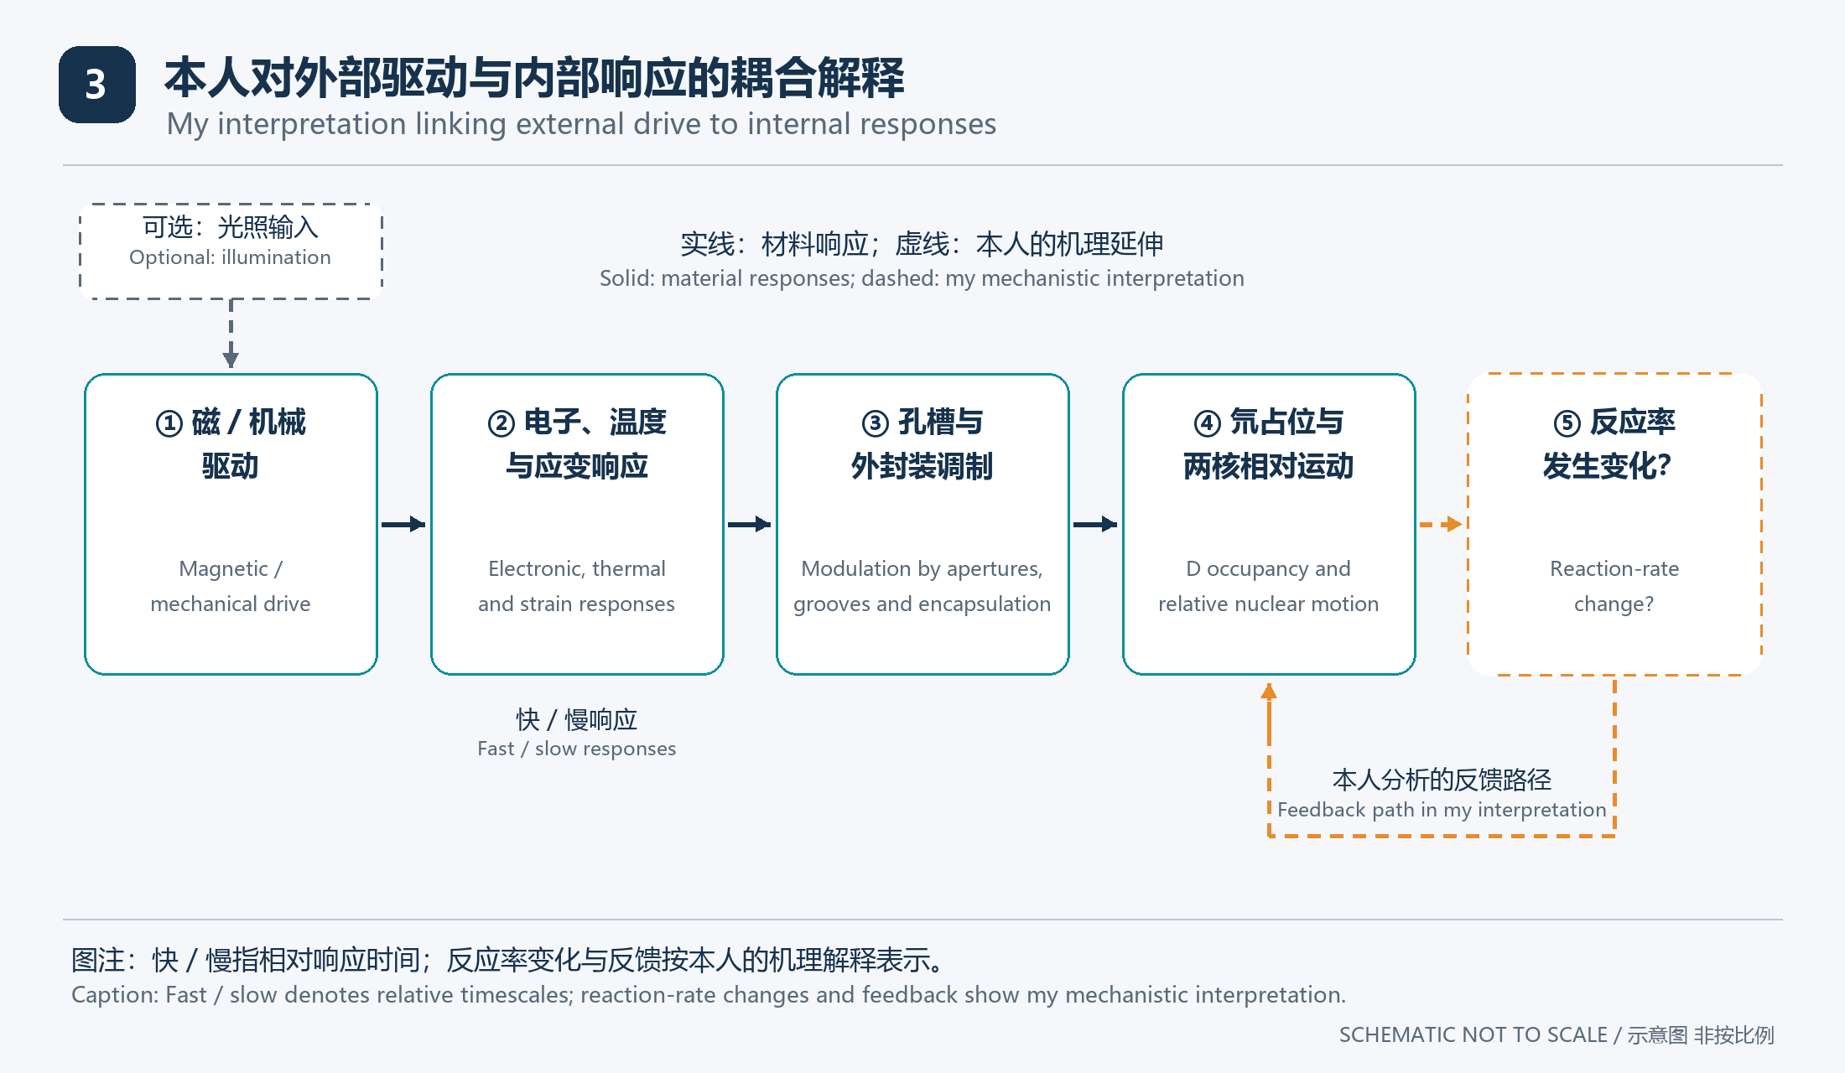
图3 本人采用的外部驱动与内部响应耦合路径，虚线表示本人对反应率变化及反馈的机理解释。
Figure 3. The coupling paths I use between external driving and internal responses; dashed links show my mechanistic interpretation of reaction-rate changes and feedback.
钯片在偏角六瓣非交替极性磁阵列前自转，孔槽参与决定局部动生电流及电、热、力学响应。
The palladium plate spins opposite a skewed six-lobe array with non-alternating polarity, while holes and grooves shape local motional currents and electrical, thermal and mechanical responses.
闭合导电路径提供电流可经过的路线，但驱动电流仍需要实际的电动势或其他能量输入。
A closed conducting path provides a route for current, while an actual electromotive force or another energy input is still required to drive that current.
本人把移动光斑列为辅助扰动的后续方案，用于研究非均匀表面与界面的局部状态变化。
I include a moving light pattern as a future auxiliary-perturbation scheme for studying local changes at nonuniform surfaces and interfaces.
电子响应、局部温度、应变和氘占位具有不同时间尺度，因此前一次扰动可能通过较慢状态影响下一次响应。
Electronic response, local temperature, strain and deuterium occupancy have different timescales, so a perturbation may influence the next response through slower material states.
本人用从输入、局域环境到两氘相对运动的传递关系解释装置响应，并把电流和温升作为其中的观察量。
I interpret the device response through the transfer from input to the local environment and then to relative deuterium motion, using current and temperature rise as observable quantities within that account.
注4 电流密度增大、电子被激发和局部电子数密度增加是不同现象，本文不将三者互相替代。
Note 4. Increased current density, electronic excitation and increased local electron number density are distinct phenomena and are not used interchangeably here.

5 偏角六瓣磁阵列与高速多孔钯片

Skewed six-lobe magnetic array and rapidly spinning perforated palladium
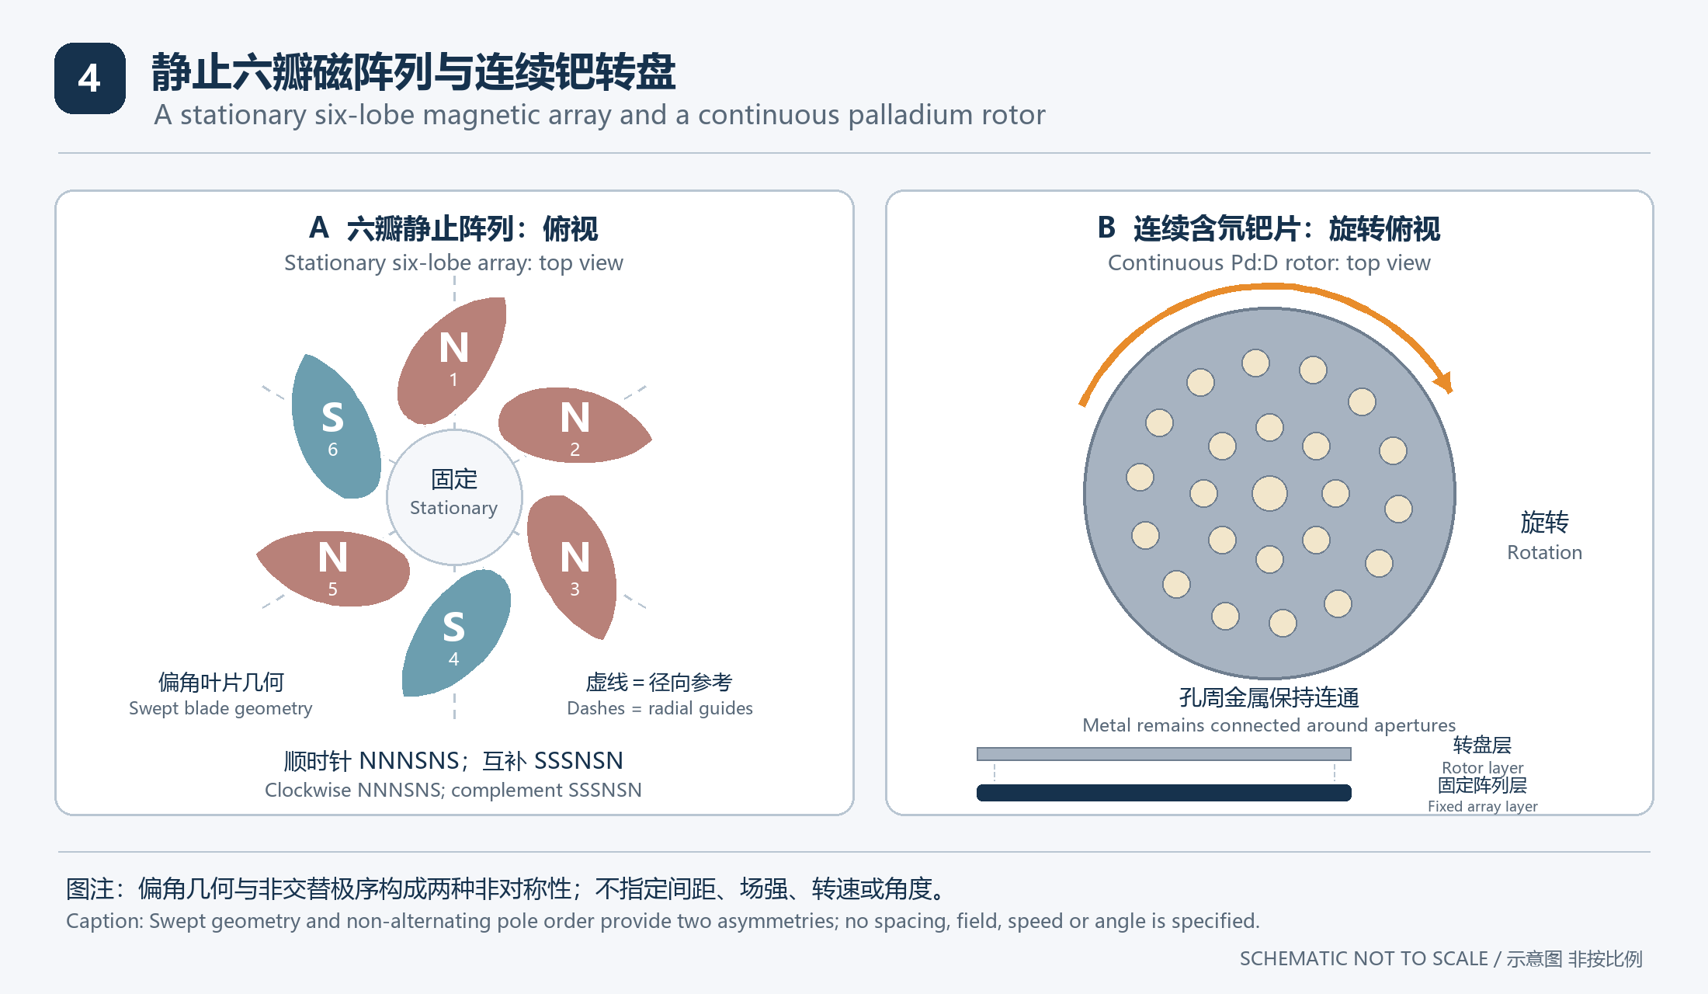
图4 六瓣磁阵列与多孔钯转盘的概念布局，瓣形表示偏角极区的几何意图，灰虚线为径向参考。
Figure 4. Conceptual layout of the six-lobe array and perforated Pd rotor; blade shapes express skewed pole regions, and gray dashes are radial guides.
六个磁瓣像涡轮叶片一样相对径向带有偏角，偏角几何与非交替极序共同形成双重非对称性。
The six magnetic lobes are skewed relative to the radial direction like turbine blades, with the skewed geometry and non-alternating pole sequence providing two forms of asymmetry.
按图示同一观察方向顺时针读取，六瓣依次为NNNSNS，整体反转极性后为SSSNSN。
Read clockwise from the single viewing direction shown, the six lobes follow NNNSNS, with SSSNSN obtained by reversing every polarity.
这保留了本人强调的同极相邻与非均等极性过渡，而不是将六瓣简化成径向对齐的NSNSNS交替阵列。
This preserves my emphasis on adjacent like poles and unequal polarity transitions, rather than reducing the array to radially aligned alternating NSNSNS poles.
多孔钯片在阵列前持续自转，使不同孔缘、金属连接和材料区域依次经过不同磁场区域。
Sustained rotation carries different aperture rims, metal connections and material regions of the perforated plate successively through different field regions.
重要实物说明 本人使用细木制绝缘支撑杆，支撑并带动钯片自转。
Important physical detail. I used a thin wooden, electrically insulating support rod to support and rotate the palladium plate.
瓣形、N与S标签用于描述构型，实际磁场的方向和强度分布仍由完整磁化结构、空间位置及导体响应共同决定。
Lobe shapes and N/S labels describe the configuration, while actual field directions and strengths depend on the complete magnetization structure, spatial positions and conductor response.

实物照片 钯片样品
Photographs of the palladium sample
下面两张照片展示本人多孔钯片的整体外观与近景，作为同一样品的图像组阅读。
The following two photographs show the overall appearance and a closer view of my perforated palladium plate and are presented as views of the same sample.
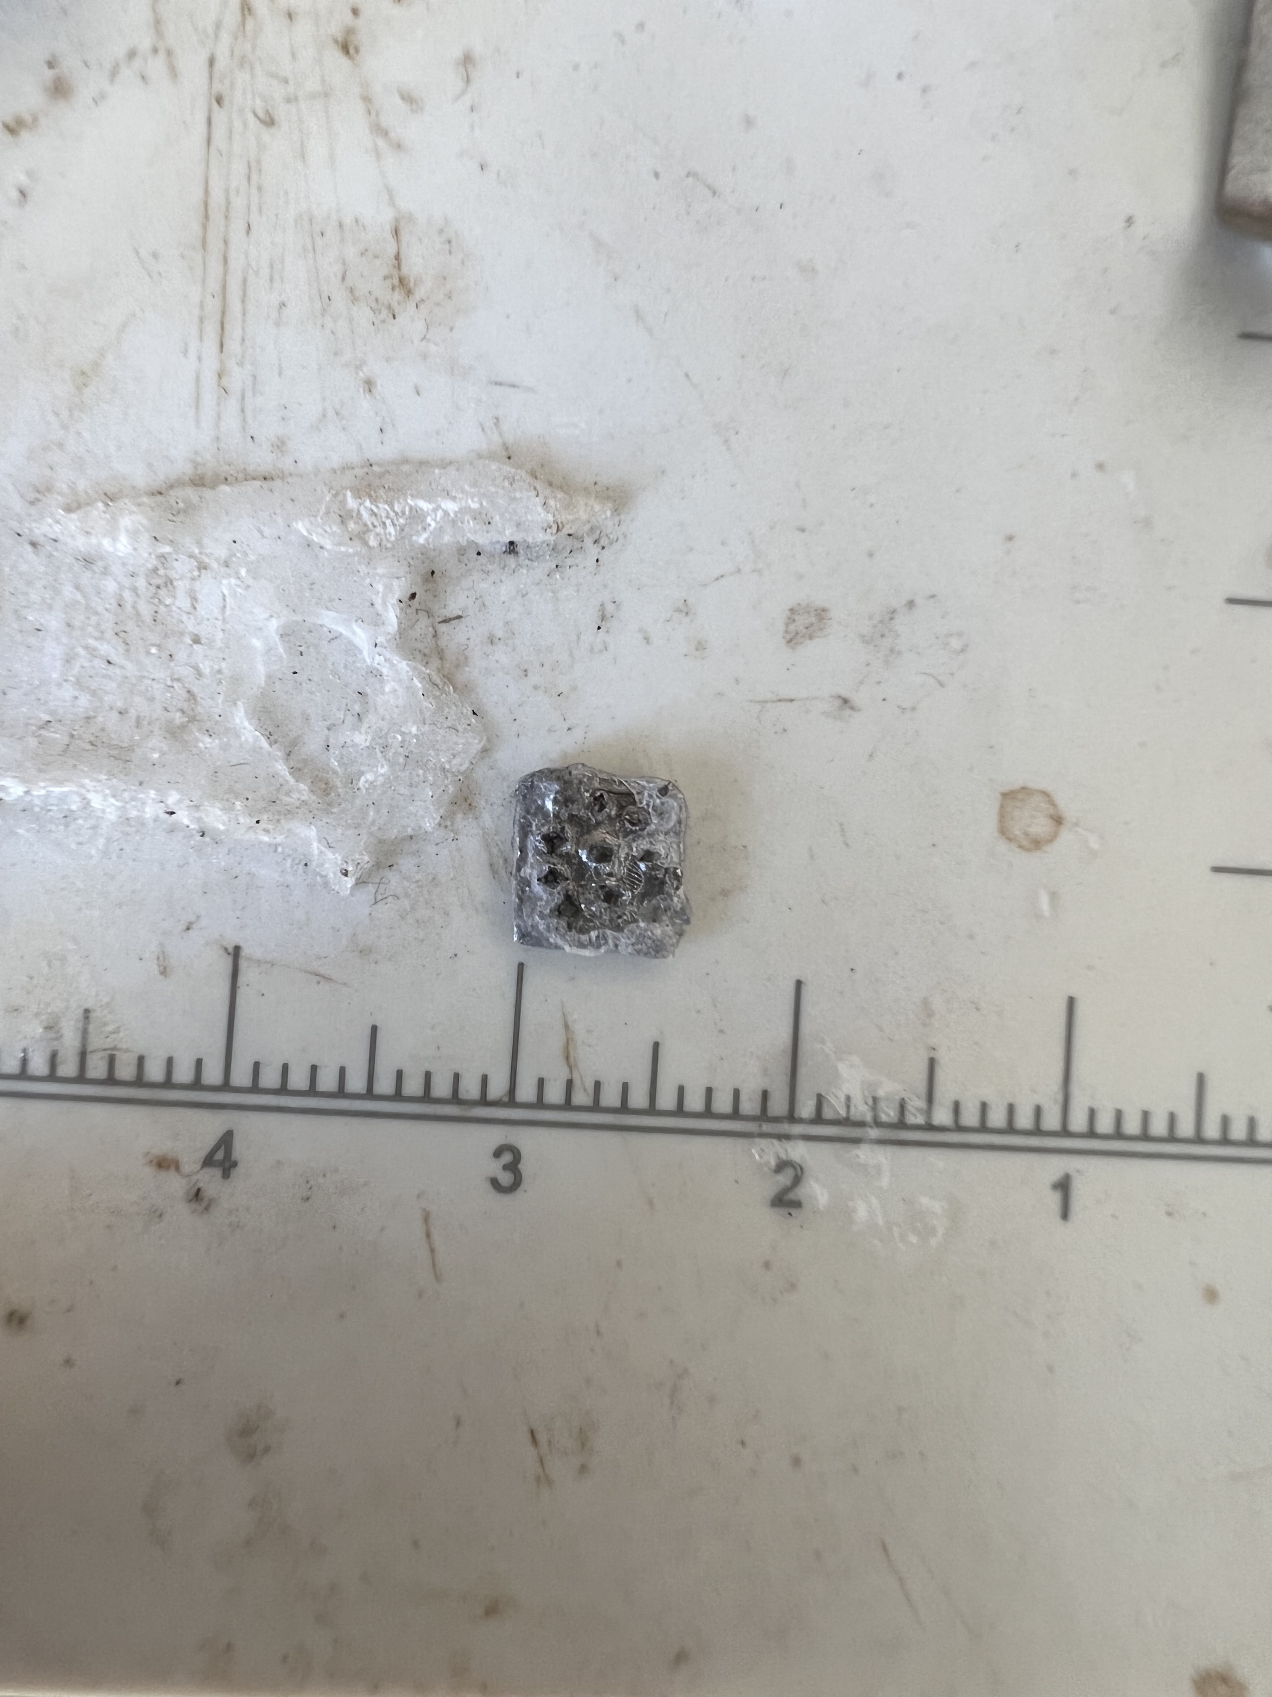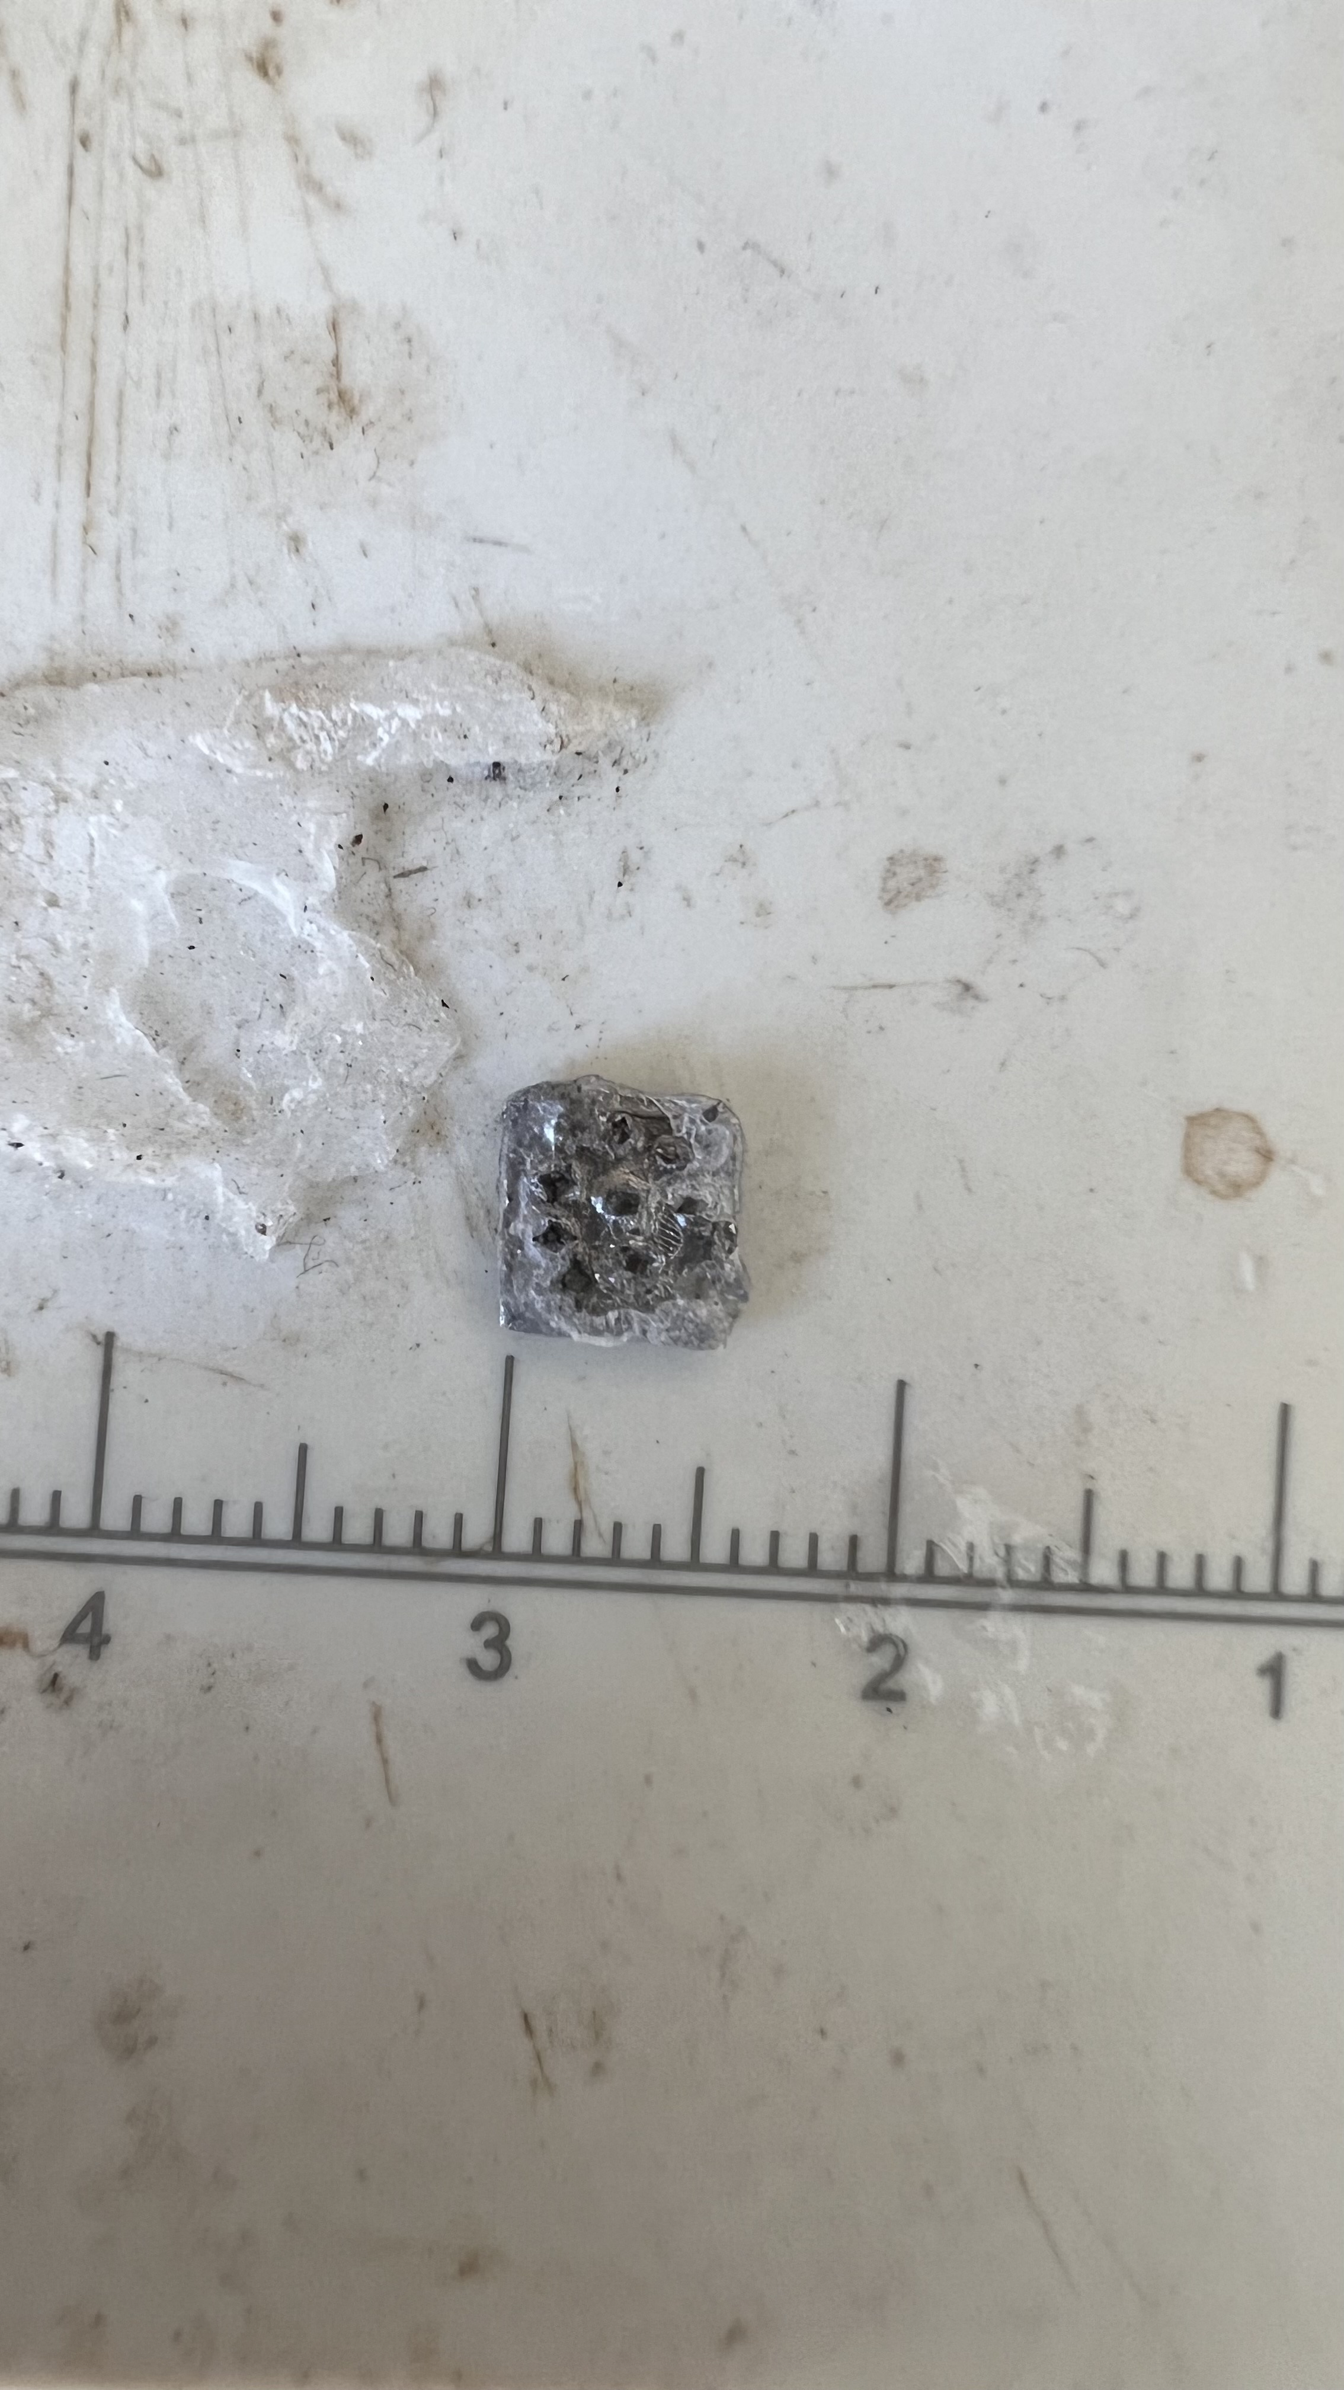
实物照片 A1 左侧为样品与背景刻度，可见片状外形、表面孔状结构及不规则边缘。
Photograph A1. Left: the sample beside a background scale, showing its plate-like outline, hole-like surface features and irregular edges.
实物照片 A2 右侧为较近视图，补充显示孔状结构、表面形貌和边缘细节。
Photograph A2. Right: a closer view providing additional detail of the hole-like features, surface appearance and edges.
本人使用的样品材料为钯，支撑杆用于带动自转；本组照片记录样品外观。
I used palladium for the sample and a support rod to transmit rotation; this group of photographs records the sample appearance.

实物照片 磁阵列与亚克力中心
Magnetic assembly and its acrylic central support
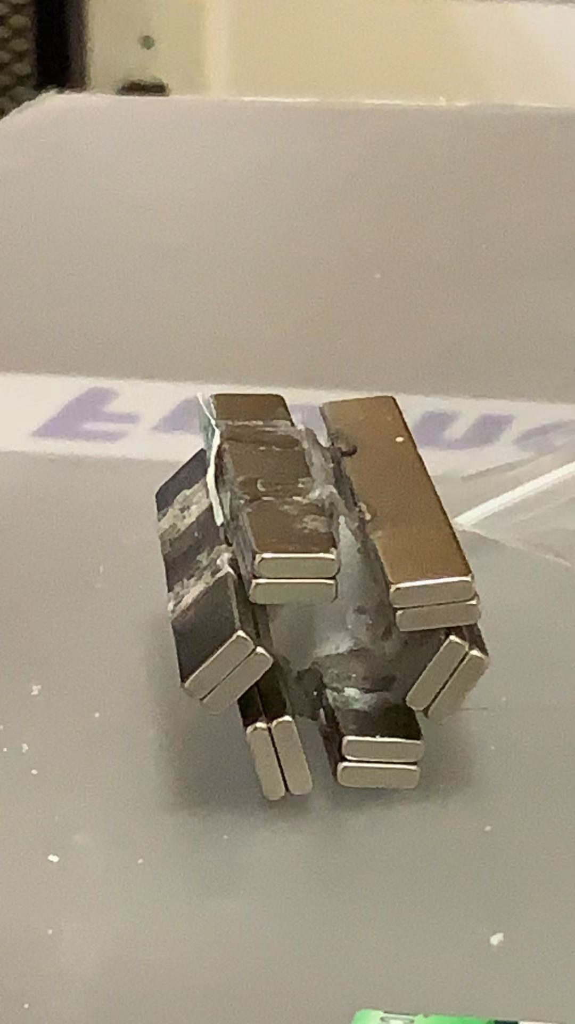
实物照片 A3 磁阵列实物，可见围绕中央支承体布置的多组矩形磁体及黏接痕迹。
Photograph A3. The magnetic assembly, showing groups of rectangular magnets arranged around a central support and visible adhesive.
材料重点 磁铁中央的支承体为亚克力材料，本人使用的是聚甲基丙烯酸甲酯 PMMA；它是含氢聚合物，属于本人解释伽马读数时考虑的周边材料。[R6]
Material emphasis. The central support inside the magnets is acrylic; I used polymethyl methacrylate, PMMA, a hydrogen-containing polymer that I include among the surrounding materials when interpreting gamma readings. [R6]
伽马读数增益问题 本人把亚克力对读数增强的贡献纳入机理解释：在存在入射中子的条件下，含氢材料中的散射慢化及后续辐射俘获形成次级伽马贡献。[R7]
Enhancement of gamma readings. My interpretation includes a contribution from the acrylic: where incident neutrons are present, scattering and moderation in hydrogen-containing material, followed by radiative capture, contribute secondary gamma radiation. [R7]
这里的“增益”指辐射计数的附加贡献，与探测器电子学增益分开表述；本人对中子及聚变的判断属于机理解释。
Here, “enhancement” means an additional contribution to radiation counts and is described separately from detector electronic gain; my attribution to neutrons and fusion is a mechanistic interpretation.

6 动生电流与局部电子环境

Motional currents and the local electronic environment
钯片相对非均匀磁阵列运动，为局部电荷重新分布和环流提供动生电磁驱动，孔槽则改变电流可通过的路径。
Motion relative to the nonuniform array provides a motional electromagnetic drive for local charge redistribution and circulation, while apertures and grooves alter the available conducting paths.
$$j = σ(E + u × B) ; u = Ω × r$$
电磁式E1 在非相对论、局域线性且近似各向同性的欧姆模型中，j为相对晶格的传导电流密度，u为晶格速度。[E1]
Electromagnetic relation E1. In a nonrelativistic, local, linear and approximately isotropic Ohmic model, j is conduction-current density relative to the lattice and u is lattice velocity. [E1]
E必须包含电荷重排建立的电场，并与孔壁、封装界面和电荷连续性共同求解，因此不能只取σu×B来认定实际电流。
E must include the field established by charge redistribution and be solved with aperture-wall boundaries, encapsulation interfaces and charge continuity, so actual current cannot be identified from σu×B alone.
$${EMF}_{C} = ∮(E + u × B) · dℓ = −dΦ/dt$$
电磁式E2 对随材料运动的闭合回路C，Φ为穿过其随动曲面的总磁通，此式表达电场和动生项共同决定的回路电动势。[E1]
Electromagnetic relation E2. For a closed material loop C, Φ is total flux through its moving spanning surface, and the loop electromotive force includes both the electric and motional terms. [E1]
孔周剩余金属使电流绕行并可能出现空间集中的路径，但集中位置、方向与幅度需要由实际场和边界确定。
Metal remaining around apertures makes current detour and may create spatially concentrated paths, whose locations, directions and amplitudes depend on the actual fields and boundaries.
$$j_{e} = −e n_{e} v_{d}$$
电磁式E3 n_e为传导电子数密度，v_d为电子相对晶格的漂移速度，电流变化可以来自其中不同因素。[E2]
Electromagnetic relation E3. Here n_e is conduction-electron number density and v_d is electron drift velocity relative to the lattice, so different factors can account for current changes. [E2]
本人用“高速变换的局部高密度电子云”解释局部电子环境，并把电子数密度与电流密度作为不同的物理量。
I use “rapidly changing local high-density electron clouds” to interpret the local electronic environment, while treating electron number density and current density as different physical quantities.
若局部电势、屏蔽或应变随驱动改变，它们就可能为氘的占位和跃迁提供时变环境，这一联系需要保留在整体模型中。
If local potentials, screening or strain change with the drive, they can provide a time-dependent environment for deuterium occupancy and hopping, a link that should remain in the coupled model.

7 材料参考系中的扫场与多体重排

Field sweeping and many-body rearrangement in the material frame
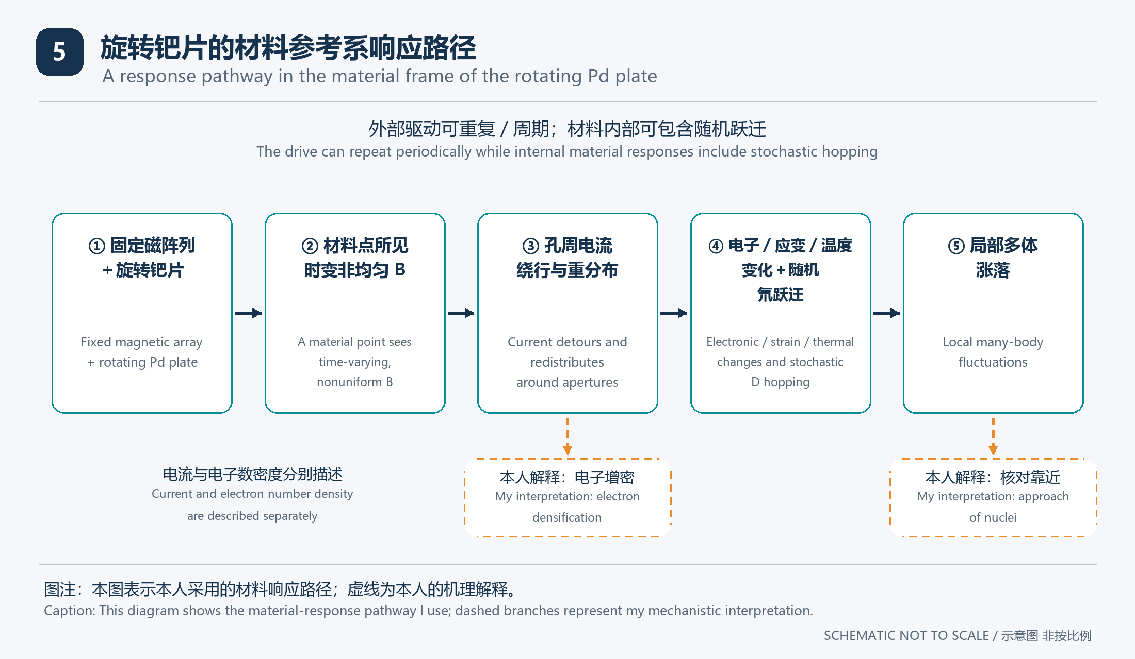
图5 固定磁阵列在旋转材料参考系中相对扫过；实线表示材料响应路径，虚线表示本人对电子增密和核对接近的机理解释。
Figure 5. The fixed array sweeps past in the rotating material frame; solid arrows show material-response paths, while dashed branches show my interpretation of electron densification and nuclear-pair approach.
从随钯片转动的材料点看，固定的偏角六瓣场相对移动，使该点所见磁场及其方向投影随时间变化。
For a material point rotating with the plate, the fixed skewed six-lobe field moves relative to it, making the sampled field and its directional components change with time.
不同孔缘和相邻金属连接具有不同位置和路径约束，因此局部电流与电势的响应不必在整个钯片上同时相同。
Different aperture rims and metal connections have different positions and path constraints, so local current and potential responses need not be identical across the plate at the same time.
晶格内氘的随机位移和跃迁叠加在整体转动之上，其局部环境还受到电子响应、温度、应变及占位历史影响。
Random deuterium displacements and hopping are superposed on bulk rotation, while electronic response, temperature, strain and occupancy history also affect the local environment.
本人的核心解释是持续且空间不均匀的驱动反复重排多体环境，使局部趋近事件不必等待整个体系同时形成静态均衡。
My central interpretation is that sustained, spatially nonuniform driving repeatedly rearranges the many-body environment, allowing local approach events without requiring the whole system to reach static equilibrium simultaneously.
刚性外封装继续参与应力传递与形变约束，因此磁阵列、孔槽、电子、氘跃迁和外封装应在同一耦合链中分析。
The rigid encapsulation continues to transmit stress and constrain deformation, so the array, apertures, electrons, deuterium hopping and encapsulation should be analyzed within one coupled sequence.
本人把多体重排与两氘近距关联的联系，作为从材料响应连接到局部核对运动的机理环节。
I treat the link between many-body rearrangement and short-range deuterium-pair correlations as the mechanistic connection from material response to local nuclear-pair motion.

8 回旋类比与持续非平衡驱动

Cyclotron analogy and sustained nonequilibrium driving
本人所说的“类似回旋加速器”，用于形象表达带电体系在相对扫过的非对称电磁环境中反复受到扰动。
My phrase “similar to a cyclotron” illustrates repeated perturbation of a charged system by an asymmetric electromagnetic environment sweeping past relative to the material.
这个类比可以保留反复受驱和运动轨迹受影响的直觉，但晶格占位、散射和跃迁约束仍需保留，不能把固体氘直接当作自由回旋束流。
The analogy retains the intuition of repeated driving and altered motion, while lattice occupancy, scattering and hopping constraints remain essential, so solid-state deuterium cannot be treated directly as a freely orbiting beam.
$$F_{B} · v = q(v × B) · v = 0 ; P_{E} = qE · v$$
电磁式E4 对点电荷，磁力本身不做功，而电场可改变其动能，维持钯片转动的机械输入也必须计入能量收支。[E3]
Electromagnetic relation E4. Magnetic force does no work on a point charge, whereas an electric field can change its kinetic energy; mechanical input maintaining plate rotation must also enter the energy balance. [E3]
在理想恒转速与静态阵列下，某材料点每完整一转重新经过同一构型，因此外驱可以周期重复，转内的局部变化仍可很不均匀。
With ideal constant rotation and a static array, a material point revisits the same configuration after each revolution, so the drive can repeat periodically while varying strongly within a turn.
NNNSNS与SSSNSN不具有每瓣都相同的极性重复，实际信号可含多个空间结构对应的时间成分，不能仅从六瓣数认定单一六倍转频。
NNNSNS and SSSNSN do not repeat the same polarity at every lobe, so responses can contain temporal components from multiple spatial features rather than a single six-times-rotation frequency inferred from lobe count.
本人用持续驱动、慢氘占位、应变及界面记忆的耦合，解释复杂的非平衡响应。
I interpret complex nonequilibrium responses through the coupling of sustained driving, slow deuterium occupancy, strain, and interfacial memory.
本人用“难以全域回稳”描述内部局部状态持续重排，并将其与周期平均和统计分布分开讨论。
I use “difficulty reaching global stability” to describe continuing rearrangement of local internal states, discussing it separately from periodic averages and statistical distributions.
由此，模型需要连接外部周期扫场与内部多体涨落，再判断它们是否改变局部相对运动，而不是把驱动周期性与材料混沌当作同一件事。
The model must therefore connect periodic field sweeping to internal many-body fluctuations and assess any change in local relative motion, while distinguishing drive periodicity from chaos in the material.

9 多数库伦混沌压过局部排斥的核心思路

Collective Coulomb chaos and local repulsion
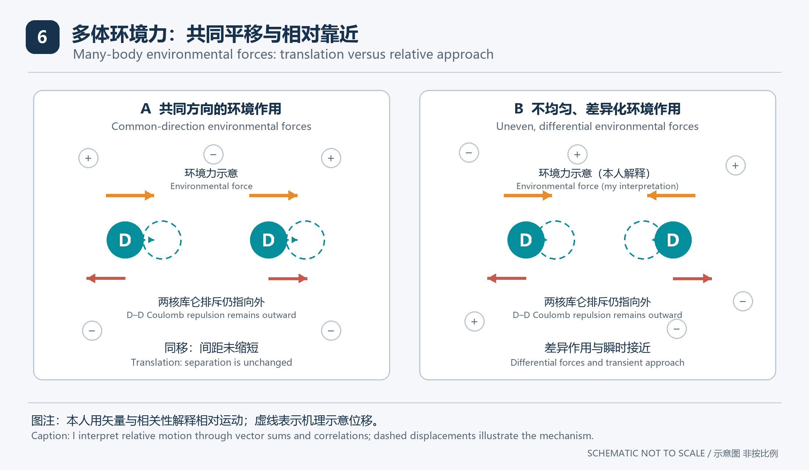
图6 共同受力主要推动整体平移，差异受力才可能改变两核相对运动，图中箭头不是实测力值。
Figure 6. Common forcing mainly drives translation, whereas differential forcing can alter relative nuclear motion; arrows are not measured force values.
本人的“以多打少”强调局部两氘并非孤立，而是持续受到周围电子、其他氘与钯晶格的共同影响。
My “many against few” intuition emphasizes that a local deuterium pair is continually influenced by surrounding electrons, other deuterium, and the palladium lattice.
本人所分析的有利事件，是周围多体作用在某个时间窗口形成相向的差异力，使核对相对运动出现趋近分量。
The favorable event in my analysis is a time window in which the many-body environment produces converging differential forces and an approaching component of relative pair motion.
若周围作用仅使两颗氘受到相同方向和大小的力，主要结果是共同移动，而不是两者间距缩小。
If the surroundings exert equal forces in the same direction on both deuterons, the main result is common motion rather than a reduction in their separation.
因此，“多数”的意义应落实为方向、空间梯度、相关性、持续时间和能量传递，而不能只按周围粒子数量判断压缩强弱。
The significance of “many” must therefore be expressed through direction, spatial gradients, correlations, duration and energy transfer, rather than inferred solely from particle count.
本人将电子屏蔽作为整体环境的一部分，将刚性边界作为改变材料响应与应力传递的条件，两者在同一耦合模型中讨论。
I include electronic screening in the overall environment and the rigid boundary among the conditions shaping material response and stress transmission, discussing both in the same coupled model.
注5 本人用“打败”表示提高有利局部事件的概率，库仑相互作用仍保留在模型中。
Note 5. I use “overcome” to mean an increased probability of favorable local events, while retaining Coulomb interactions in the model.

10 用相对运动表达本人的多体解释

Expressing my many-body interpretation through relative motion
为避免“周围压力很大”掩盖关键环节，可选取一对氘核的位置差，并把核对之间的作用与其余环境作用分开记账。
To make the key step explicit, one can select the displacement between a deuteron pair and account separately for the interaction within the pair and the forces from the remaining environment.
$$r = r₁ − r₂ ; {ΔF}_{env} = F_{env}(r₁,t) − F_{env}(r₂,t)$$
式2 r为核对相对位置，ΔF_env为两处环境力之差，所有力都需要在一致模型中定义。
Equation 2. Here r is the pair displacement and ΔF_env is the difference between environmental forces, all of which must be defined within one consistent model.
$$m_{D} d²r/dt² = 2F₁₂ + {ΔF}_{env}$$
式3 对等质量氘核的经典受力记账中，F₁₂指第二颗对第一颗的直接作用，环境项包含其余粒子与边界的间接影响。
Equation 3. In classical force bookkeeping for equal-mass deuterons, F₁₂ is the direct force of the second on the first, while the environmental term includes indirect effects of other particles and boundaries.
沿核对连线投影时，环境差异力的向内分量具有促使接近的倾向；本人用这一分量表达局部核对运动的机理。
Projected along the pair axis, an inward differential environmental force tends to promote approach; I use that component to express my interpretation of local nuclear-pair motion.
$$W_{env,rel} = ∫ ({ΔF}_{env} / 2) · dr$$
式4 在上述等质量经典模型中，这个量记录环境对相对运动所做的功，而不是对整体平移所做的功。
Equation 4. Within the equal-mass classical model above, this quantity records environmental work on relative motion rather than on translation of the pair as a whole.
本人从有利差异力的来源、持续时间、能量传递及弛豫耗散四个方面分析这一机理。
I analyze this mechanism through the origin, duration, and energy transfer of favorable differential forces and the relaxation processes that dissipate them.
注6 上述公式是辅助表达的经典框架，不能代替量子多体计算或核反应计算，采用屏蔽有效势时还须避免重复计入电子作用。
Note 6. These equations provide classical bookkeeping for explanation and do not replace quantum many-body or nuclear calculations; electronic effects must not be counted twice when a screened effective potential is used.

11 混沌 涨落与反应概率的连接

Connecting chaos, fluctuations and reaction probability
本人将复杂的非平衡多体涨落称为“库伦混沌”，用它表达本人的内部动力学解释。
I call complex nonequilibrium many-body fluctuations “Coulomb chaos” as a term for my interpretation of the internal dynamics.
几何不规则、信号噪声大与动力学混沌不是同一概念，后者需要可辨识的动力学及相应定量判据。
Geometric irregularity, noisy signals and dynamical chaos are different concepts, with the last requiring identifiable dynamics and corresponding quantitative criteria.
$$Var(Σf_{i}) = ΣVar(f_{i}) + 2Σ_{i<j} Cov(f_{i}, f_{j})$$
式5 若f_i为某方向的随机力分量，总涨落取决于各分量的方差及相互协方差，而不仅取决于数量。
Equation 5. If f_i denotes a random force component along one direction, total fluctuations depend on the component variances and their covariances, rather than on count alone.
相互抵消的作用可使大量参与者产生很小的净效应，而有相关性的局部作用也可能改变某些短暂事件的分布。
Mutual cancellation can give many contributors a small net effect, whereas correlated local interactions may change the distribution of particular transient events.
本人围绕两氘的近距关联、相对速度分布、时变有效相互作用及有利构型的占空比例分析核反应联系。
I analyze the connection to nuclear reactions through short-range deuterium-pair correlations, relative-velocity distributions, time-dependent effective interactions, and the fraction of time spent in favorable configurations.
本人把有效势和运动分布的变化作为机理解释，把可测核产物的重复出现作为对应的观察量。
I treat changes in effective potentials and motion distributions as mechanistic explanations and repeated measurable nuclear products as the corresponding observable quantities.
金属靶中的电子屏蔽实验研究材料环境对外加离子碰撞反应产额的影响；本人将其作为材料环境作用的物理参照。[R2]
Electronic-screening experiments in metal targets examine material effects on reaction yields under incident-ion collisions; I use them as a physics reference for the role of the material environment. [R2]
注7 多体涨落可以重新分配外部输入的能量，不能被单独计作新增能源，任何净输出主张都需要独立能量收支。
Note 7. Many-body fluctuations can redistribute externally supplied energy but cannot themselves be counted as an additional energy source; any net-output claim requires an independent energy balance.

12 从结构到可观察结果的完整逻辑

Complete logic from architecture to observable results

本人采用的因果链
The causal sequence I use
第一步，含氘钯提供受晶格影响的氘占位环境，较高局部装载是本人的设计目标。
First, deuterium-loaded palladium provides lattice-influenced occupancy environments, with higher local loading as my design objective.
第二步，偏角六瓣非交替极序与钯片旋转形成时变驱动，孔槽及界面进一步改变局部电、热与力学响应。
Second, the skewed six-lobe non-alternating pole sequence and plate rotation provide time-dependent driving, with holes, grooves and interfaces further shaping local electrical, thermal and mechanical responses.
第三步，在本人的解释中，外封装通过机械约束、接触及密封参与响应，改变扰动的传递、耗散和氘库存分布。
Third, in my interpretation, encapsulation participates through mechanical constraint, contact, and sealing, changing disturbance transmission, dissipation, and deuterium inventory distribution.
第四步，本人用电子快响应与氘、应变等较慢变量的耦合解释局部状态的历史依赖。
Fourth, I explain the history dependence of local states through coupling between fast electronic responses and slower variables such as deuterium occupancy and strain.
第五步，本人的机理判断是某些瞬时构型增强核对的趋近运动或改变有效相互作用，从而提高核反应概率。
Fifth, my mechanistic interpretation is that certain transient configurations enhance pair approach or change effective interactions, increasing nuclear reaction probability.
第六步，本人把核产物、时间关联与能量收支作为解释实验观察的相互对应量。
Sixth, I use reaction products, temporal correlations, and energy accounting as mutually corresponding quantities when interpreting experimental observations.

各环节的对应观察量
Observable quantities corresponding to each link
前四步涉及材料与输运，第五步涉及核尺度；本人将这两类作用分层说明。
The first four steps concern materials and transport, while the fifth concerns the nuclear scale; I describe these as separate levels of the interpretation.
局部持续变化可能最终形成稳定周期响应，因此“不断扰动”不自动等于无限积累或永不回稳。
Continual local changes may settle into a stable periodic response, so repeated perturbation does not automatically imply unlimited accumulation or an inability to reach a steady response.
本人把边界刚度与材料响应的联系作为外封装功能的观察线索，把核机理的判断另列说明。
I use the relationship between boundary stiffness and material response as an observational indicator of encapsulation function and describe my interpretation of the nuclear mechanism separately.

13 本人的实验记录与结果解释

My experimental record and interpretation of the results
本人的实验记录包括仪表照片、视频截图和多轮内部比较，构成本人整理和修订技术解释的实验资料。
My experimental record includes instrument photographs, video screenshots, and repeated internal comparisons, which I use to develop and revise my technical interpretation.
记录  Record | 平均显示值  Displayed mean | 最大显示值  Displayed maximum
2025年6月15日照片  Photograph dated 15 June 2025 | 4.64 μSv/h  4.64 μSv/h | 8.16 μSv/h  8.16 μSv/h
2025年7月2日截图  Screenshot dated 2 July 2025 | 34.33 μSv/h  34.33 μSv/h | 37.41 μSv/h  37.41 μSv/h
背景照片  Background photograph | 0.10 μSv/h  0.10 μSv/h | 0.13 μSv/h  0.13 μSv/h

表1 这里只摘录历史报告中平均值和最大值字段的显示单位，不把峰值写成连续输出，也不由读数反推中子产额。
Table 1. Only the displayed units of the mean and maximum fields are reproduced from the historical report; peaks are not treated as continuous output and readings are not converted into neutron yield.
本人还记录了状态改变后的读数回落、不同磁场下的热表现差异，以及本人称为“瓦级”的输出表现。
I also recorded readings returning toward background after state changes, differences in thermal behavior under different magnetic conditions, and output that I described as being on a “watt scale.”
本人将仪表读数与热表现作为实验记录，将反应种类、内部作用路径和净能量判断作为本人对这些记录的解释。
I record instrument readings and thermal behavior as experimental observations, and describe reaction identity, internal pathways, and net energy as my interpretation of those records.
本人用纯氘氘反应、多级反应和能量增益解释上述读数与热表现；本人也将中央亚克力的次级辐射贡献纳入伽马读数分析。
I interpret these readings and thermal behavior in terms of pure deuterium–deuterium reactions, multistage reactions, and energy gain; I also include secondary-radiation contributions from the central acrylic in my analysis of gamma readings.
关于纯氘氘反应，本人认为：含氚效果更好且更容易做成。
Regarding pure deuterium–deuterium reactions, my view is that including tritium gives better results and makes the system easier to realize.
关于普通重水，本人认为：氘氚混合的重水效果最佳。
Regarding ordinary heavy water, my view is that heavy water containing a deuterium–tritium mixture gives the best results.
注8 旧文本中的主显示单位存在抄录差异与非标准拼写，本文选用较一致的平均值及最大值字段，正式数据表仍应回到原图和校准记录核对。
Note 8. Older texts differ in transcription of the main display unit and include a nonstandard spelling; this summary uses the more consistent mean and maximum fields, while formal datasets still require checking against original images and calibration records.

14 本人的因果分析与后续比较

My causal analysis and further comparisons
本人按整体耦合关系安排后续比较，分别分析各环节与观察量之间的联系。
I organize further comparisons around the coupled system and analyze how each link relates to observable quantities.
本人采用的因果环节  Links in my causal model | 对应观察量  Corresponding observable quantities | 需要分辨的因素  Factors to distinguish
刚性边界参与内部响应  Rigid boundary affects internal response | 约束变化伴随形变或应力响应变化  Response in deformation or stress changes with constraint | 装载 温度 密封及接触差异  Loading, temperature, sealing and contact
慢状态承接快扰动  Slow states retain fast perturbations | 响应具有延迟或历史依赖  A delay or history dependence appears | 单纯热滞后与仪器响应  Thermal lag and instrument response
磁瓣与孔槽改变驱动路径  Lobes and apertures change driving paths | 局部响应随极序与位置改变  Local response changes with pole order and position | 局部磁场 散热及电流分配  Local fields, cooling and current distribution
多体作用改变核对运动  Collective effects change pair motion | 材料变量与核对相关量有一致联系  Material variables track pair-related quantities | 只有整体平移或普通扩散  Common motion or ordinary diffusion alone
核反应率确有变化  A nuclear rate actually changes | 反应特异产物可重复并与状态相关  Reaction-specific products repeat and track the state | 本底 污染 探测器及输入能量  Background, contamination, detectors and input energy

本人将各环节分别比较，用对应观察量缩小机理解释的范围。
I compare the links separately and use their corresponding observable quantities to narrow the scope of my interpretation.
如果刚度变化只改变散热而未改变其他响应，则应优先采用热学解释，而不能把温升差直接算作核效应。
If a stiffness change only alters cooling without changing other responses, a thermal explanation should be considered first instead of assigning the temperature difference directly to a nuclear effect.
本人将核产物与材料变量的对应关系用于分析刚性边界和多体涨落的因果作用。
I use the relationship between nuclear products and material variables to analyze the causal roles of rigid boundaries and many-body fluctuations.
注9 本节为本人的因果分析框架；具体实验记录列在第13节。
Note 9. This section presents my framework for causal analysis; the experimental record appears in Section 13.

15 术语与关键注释

Terminology and key annotations
中文与英文  Chinese and English | 本文的准确含义  Meaning in this document
含氘钯片  Deuterium-loaded palladium plate | 连续钯基体内含氘，不预设自由等离子体状态  A continuous Pd matrix containing D, without presuming a free-plasma state
刚性外封装  Rigid external encapsulation | 钯片之外具有有限刚度的机械边界  A mechanical boundary of finite stiffness outside the Pd plate
偏角六瓣磁阵列  Skewed six-lobe magnetic array | 磁瓣像涡轮叶片相对径向偏转的磁场构型  A field configuration with lobes skewed from the radial direction like turbine blades
非交替极序  Non-alternating pole sequence | 依次为NNNSNS或互补的SSSNSN  NNNSNS in sequence, or its complement SSSNSN
动生感应电流  Motional induction current | 导体运动与自洽电场共同决定的局部电流  Local current determined jointly by conductor motion and the self-consistent electric field
多数库伦作用  Collective Coulomb interactions | 许多带电自由度共同参与的矢量相互作用  Vector interactions involving many charged degrees of freedom
局部库伦排斥  Local Coulomb repulsion | 选定核对之间阻碍接近的电相互作用  The electrical interaction opposing approach of a selected nuclear pair
库伦混沌  Coulomb chaos | 本人对复杂非平衡多体涨落的名称  My term for complex nonequilibrium many-body fluctuations
差异力  Differential force | 两个位置所受环境力之差，与整体共同受力不同  The difference in environmental forces at two positions, distinct from common forcing
电子屏蔽  Electronic screening | 环境电子改变有效相互作用，不等于电流或激发本身  Electronic modification of effective interactions, distinct from current or excitation alone
回稳与弛豫  Return to equilibrium and relaxation | 状态向相应稳态恢复，受驱动时也可能到达周期稳态  Recovery toward a corresponding steady state, which may be periodic under driving
单侧锂化合物层  One-sided lithium-compound layer | 本文结尾列出的后续功能界面  A future functional interface discussed at the end

注10 本文的数学表达用于分析机理，不能替代对实际装置的测量。
Note 10. The mathematical expressions are used to analyze mechanisms and do not replace measurements on the actual device.

16 物理参照与适用边界

Physics references and limits of applicability
以下文献分别作为本人分析材料、电磁及核相互作用的物理参照。
I use the following sources as physics references for materials, electromagnetism, and nuclear interactions.
[R1] Burlaka等 2017 钯层吸氢相关缺陷与应力的原始研究，支持机械边界会影响膨胀及缺陷演化这一材料物理联系。
[R1] Burlaka et al. (2017), an original study of hydrogen-related defects and stress in Pd layers, supports the materials-physics link between mechanical boundaries, expansion and defect evolution.
原文题名为 Defect generation in Pd layers by ‘smart’ films with high H-affinity，研究对象为特定薄膜结构，并非本项目封装钯片。
The paper is titled “Defect generation in Pd layers by ‘smart’ films with high H-affinity” and studies a specific thin-film structure rather than this project’s encapsulated plate.
原文链接 https://www.nature.com/articles/s41598-017-09900-z
Source link https://www.nature.com/articles/s41598-017-09900-z
[R2] Raiola等 2002 氘化金属靶D–D反应的电子屏蔽实验，支持材料环境影响外加离子碰撞下的产额。
[R2] Raiola et al. (2002), an electronic-screening experiment on D–D reactions in deuterated metal targets, supports material-dependent yields under incident-ion collisions.
原文题名为 Electron screening in d(d, p)t for deuterated metals and the periodic table，采用外加离子碰撞条件。
The original title is “Electron screening in d(d, p)t for deuterated metals and the periodic table,” and the study uses incident-ion collisions.
原文标识 DOI 10.1016/S0370-2693(02)02774-0
Source identifier DOI 10.1016/S0370-2693(02)02774-0
[R3] Karahadian等 2026 亚千电子伏能区核聚变增强的原始报告，采用外加离子束及产物诊断。
[R3] Karahadian et al. (2026), an original report on enhanced nuclear fusion in the sub-keV regime, uses an external ion beam and product diagnostics.
原文链接 https://www.nature.com/articles/s41467-026-74421-1
Source link https://www.nature.com/articles/s41467-026-74421-1
[R4] Aberdam等 1990 对钯和钛吸氘后中子发射的直接检索给出所测条件下的上限，说明吸氘本身不能替代核产物证据。
[R4] Aberdam et al. (1990) directly searched for neutron emission after deuterium absorption in palladium and titanium and set limits under the tested conditions, illustrating why absorption alone cannot replace product evidence.
原文标识 DOI 10.1103/PhysRevLett.65.1196
Source identifier DOI 10.1103/PhysRevLett.65.1196
[R5] NNDC的ENDF 300官方资料收录锂6中子反应评价，作为本人讨论含锂层核相互作用的物理参照。
[R5] NNDC’s official ENDF-300 report includes an evaluated lithium-6 neutron reaction, which I use as a physics reference for nuclear interactions in a lithium-containing layer.
原文链接 https://www.nndc.bnl.gov/endfdocs/ENDF-300-1979.pdf
Source link https://www.nndc.bnl.gov/endfdocs/ENDF-300-1979.pdf

亚克力与伽马测量参照
References for acrylic and gamma measurements
[R6] NIST材料组成表列出PMMA含氢、碳和氧，支持亚克力属于含氢周边材料这一说明。
[R6] The NIST material-composition table lists hydrogen, carbon and oxygen in PMMA, supporting its identification as a hydrogen-containing surrounding material.
参照资料 NIST X-Ray Mass Attenuation Coefficients Table 2 中的 Polymethyl Methacrylate 条目。
Reference: the Polymethyl Methacrylate entry in NIST X-Ray Mass Attenuation Coefficients, Table 2.
https://physics.nist.gov/PhysRefData/XrayMassCoef/tab2.html
[R7] NIST瞬发伽马活化分析资料说明中子俘获产生伽马，以及周边含氢材料对俘获伽马本底的贡献。
[R7] NIST guidance on prompt gamma-ray activation analysis describes gamma emission following neutron capture and contributions from surrounding hydrogen-containing materials to capture-gamma background.
https://www.nist.gov/laboratories/tools-instruments/prompt-gamma-ray-activation-analysis-pgaa
补充参照 DOE材料科学手册第二卷 MS-05 第18至19页说明含氢材料的中子慢化以及俘获伽马这一通用测量背景。
Additional reference: DOE Fundamentals Handbook Material Science, Volume 2, MS-05 pages 18 to 19, describes neutron moderation in hydrogen-containing materials and capture gamma radiation as general measurement background.
https://www.energy.gov/sites/default/files/2026-04/DOE-HDBK-1017-93_VOL2.pdf

17 电磁学模型参照

References for the electromagnetic model
[E1] MIT的运动导体模型给出洛伦兹力和含运动项的欧姆关系，本文用它约束动生电流的基本记账。
[E1] MIT’s moving-conductor model gives the Lorentz force and an Ohmic relation with a motion term, used here for basic bookkeeping of motional currents.
参照位置为 Essentials of Geophysics 第3章第3.9节的式3.54与3.55，具体钯片仍需采用自身的导电性质与边界条件。
The reference is Chapter 3, Section 3.9, equations 3.54 and 3.55 of Essentials of Geophysics, while the palladium plate requires its own transport properties and boundary conditions.
原文链接 https://ocw.mit.edu/courses/12-201-essentials-of-geophysics-fall-2004/f45383d9b61f24c2c5fa474288d7158d_ch3pdf.pdf
Source link https://ocw.mit.edu/courses/12-201-essentials-of-geophysics-fall-2004/f45383d9b61f24c2c5fa474288d7158d_ch3pdf.pdf
[E2] OpenStax的金属导电模型区分载流子数密度、漂移速度和电流密度，支持将电流与“高密度电子云”分开描述。
[E2] OpenStax’s metal-conduction model distinguishes carrier number density, drift velocity and current density, supporting separate descriptions of current and a “high-density electron cloud.”
参照位置为 University Physics Volume 2 第9.2节 Model of Conduction in Metals。
The reference is University Physics Volume 2, Section 9.2, Model of Conduction in Metals.
原文链接 https://openstax.org/books/university-physics-volume-2/pages/9-2-model-of-conduction-in-metals
Source link https://openstax.org/books/university-physics-volume-2/pages/9-2-model-of-conduction-in-metals
[E3] CERN关于加速器的说明区分电场增能与磁场导向，支持本文对回旋类比和能量来源的限定。
[E3] CERN’s accelerator explanation distinguishes energy gain from electric fields and steering by magnetic fields, supporting the treatment of the cyclotron analogy and energy source here.
原文链接 https://home.cern/how-accelerator-works/
Source link https://home.cern/how-accelerator-works/

18 单侧锂化合物封装面的作用方向

Future role of a lithium-compound layer on one face
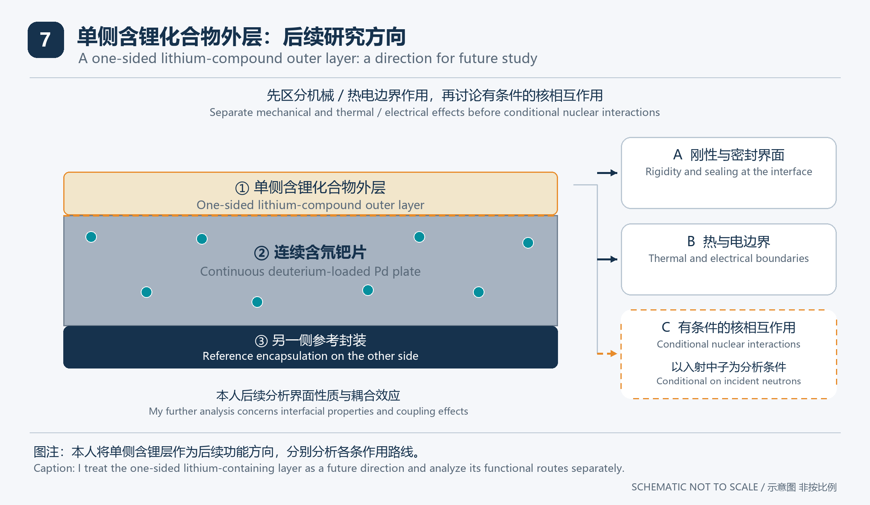
图7 本人的单侧含锂层后续方向，分别表示材料边界作用与以中子入射为条件的核相互作用。
Figure 7. My future direction for a one-sided lithium-containing layer, separating material-boundary effects from nuclear interactions conditional on incident neutrons.
本人将一侧封装面引入锂化合物列为后续方向，让这一侧兼具机械边界与功能界面的角色。
I include a lithium compound on one encapsulation face among my future directions, giving that face both a mechanical-boundary role and a functional-interface role.
第一条路线是材料与力学作用，研究含锂层如何改变接触刚度、氘保持、界面应力与温度分布。
The first route concerns materials and mechanics, examining how the lithium-containing layer changes contact stiffness, deuterium retention, interfacial stress and temperature distribution.
第二条路线是电与化学边界作用，研究具体化合物及其界面是否改变电荷转移、离子输运或局部反应环境。
The second route concerns electrical and chemical boundaries, examining whether the chosen compound and interface alter charge transfer, ionic transport or the local reaction environment.
单侧引入会产生力学与热学不对称，因此可能同时带来弯曲、热梯度和探测路径变化，不能预设所有变化都有利。
One-sided introduction creates mechanical and thermal asymmetry and may also change bending, temperature gradients and detection paths, so its effects cannot all be presumed favorable.
注11 含锂陶瓷、氘化锂及其他锂化合物的化学、电学与结构性质不同，不能只凭“含锂”将其视为可互换封装。
Note 11. Lithium ceramics, lithium deuteride and other lithium compounds differ in chemical, electrical and structural properties and are not interchangeable encapsulants merely because they contain lithium.

19 单侧含锂层的核相互作用分析

Analysis of nuclear interactions in the one-sided lithium-containing layer
第三条路线以存在入射中子为条件，分析进入含锂层的中子与材料的相互作用及产物。
The third route is conditional on incident neutrons and analyzes their interactions and products in the lithium-containing layer.
$$⁶Li + n → ⁴He + ³H$$
式6 锂6受中子作用产生氦4与氚是已知核反应，列在这里仅用于说明条件性材料功能。[R5]
Equation 6. The neutron-induced production of helium-4 and tritium from lithium-6 is an established nuclear reaction, included only to explain a conditional material function. [R5]
这一核作用与普通传热、化学变化或机械约束不同，也不能从盖革仪读数直接推算它在本装置中的贡献。
This nuclear interaction is distinct from ordinary heat transfer, chemical changes and mechanical constraint, and its contribution in this device cannot be inferred directly from a Geiger-counter reading.
生成核产物不等于已经形成后续聚变，材料中存在氚也不自动构成持续反应或自持反馈。
Production of nuclear species does not establish subsequent fusion, and tritium in a material does not automatically create sustained reactions or self-sustaining feedback.
本人把钯氘区域作为可调的初级作用核心，把外层材料作为后续能量路径的扩展模块，并分别说明各层的功能。
I treat the Pd–D region as an adjustable primary core and outer materials as modules for future energy pathways, describing each layer’s function separately.
近期最明确的研究落点，是先说明单侧含锂界面怎样改变刚性、保氘和内部响应，再判断是否需要额外核机理来解释结果。
The clearest near-term research objective is to establish how the one-sided lithium-containing interface changes stiffness, deuterium retention and internal response, then determine whether an additional nuclear mechanism is needed to explain the results.
本人在核作用分析中分别列出粒子源项、材料相互作用、核产物及可回收热量，按各项对应关系记账。
In my analysis of nuclear effects, I account separately for particle sources, material interactions, reaction products, and recoverable heat and connect the corresponding quantities.
本人将刚性外边界与内部多体动力学的联系，以及它对局部核对事件的作用，作为整体机理解释的主线。
I use the connection between the rigid outer boundary and internal many-body dynamics, and its effect on local nuclear-pair events, as the main thread of my mechanistic interpretation.
本人按单侧锂化合物层承担的具体功能评价其作用。
I evaluate the one-sided lithium-compound layer through the specific functions it performs.

