I. Introduction

das hier am ende von arbeitszeit (märz, april) ändern, bis dahin wie man es benutzt soll fertig werden (späterer teil) 12.-16.1. urlaub → 6.-10.
1. When do you need ODME?

The Open Domain Modeling Environment (ODME) is designed for projects in which complex systems need to be modeled, analyzed and shared between different departments. While many difficulties may arise with such a task, ODME is able to simplify them considerably.

Many tasks in engineering and simulation require models with numerous components, variants, and dependencies. Not only the modeling process but also the following work with it will bring several issues to overcome.

By having a standardized SES (System Entity Structure)-based modeling environment, these complex systems can be modeled coherently in a visual way. Not only does this simplify the modeling process but it also makes the comprehension of the model more accessible to all involved people.

An SES model often generates large structures with many options. To execute a specific scenario, this tree must be pruned, i.e., reduced to a unique structure.
ODME includes an interactive pruning tool that allows you to select variables, determine alternatives, and thus arrive at a pruned entity structure (PES) step by step. This allows you to quickly move from general models to executable scenarios.

To counter the duplication of effort and low interoperability, caused by different projects developing their own SES-based tools, ODME offers an application independent environment. Whether climate modeling, aerospace, software development, or data systems: with ODME, you use the same toolbox for modeling and pruning everywhere.

Models are often developed in research groups and later adopted by others. Without common formats, this is error-prone or even impossible.
ODME promotes reusable and exchangeable models by ensuring consistency thanks to the XML basis. This allows your models to be easily shared between projects and institutions.

Therefore, ODME is an efficient tool if you:

- work with complex, hierarchical systems.
- want a standardized model representation.
- work in different fields of application.
- need interactive pruning to refine models.
- want to reuse and exchange models.

2. Foundation of the concept

Using a System Entity Structure (SES), complex systems can be decomposed, representing taxonomy and the coupling of systems in Domain Modeling Mode using a set number of elements for different relationships and functionalities.

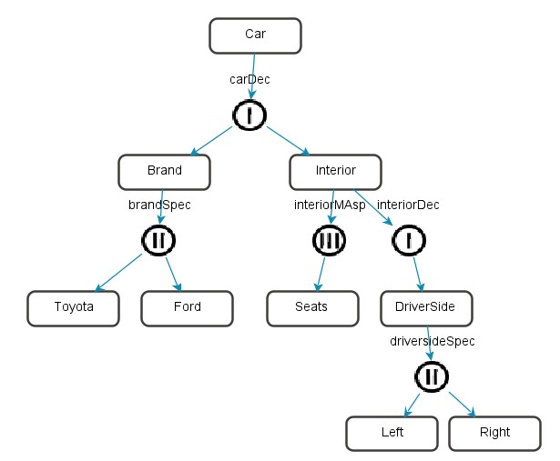

With the Interactive Pruning Tool (PES), different scenarios of a specific Domain Model can be created, whereas the different factors such as risks can be compared between each scenarios. To create these scenarios, the initial Domain Model has to be pruned to meet the specified conditions for each scenario.

While the use of two different tools with time intensive exchangeability issues was necessary before, the ODME allows you to create a Domain Model using the SES structure in Domain Modeling Mode and easily switch to the Scenario Modeling Mode (PES) with the Domain-Scenario Switch. In the Scenario Modeling Mode, the Domain Model can be pruned directly and different scenarios can be saved and compared using the Scenario Manager. In conclusion, ODME simplifies your workflow immensely by combining the SES and PES tool and ensuring compatibility and exchangeability.
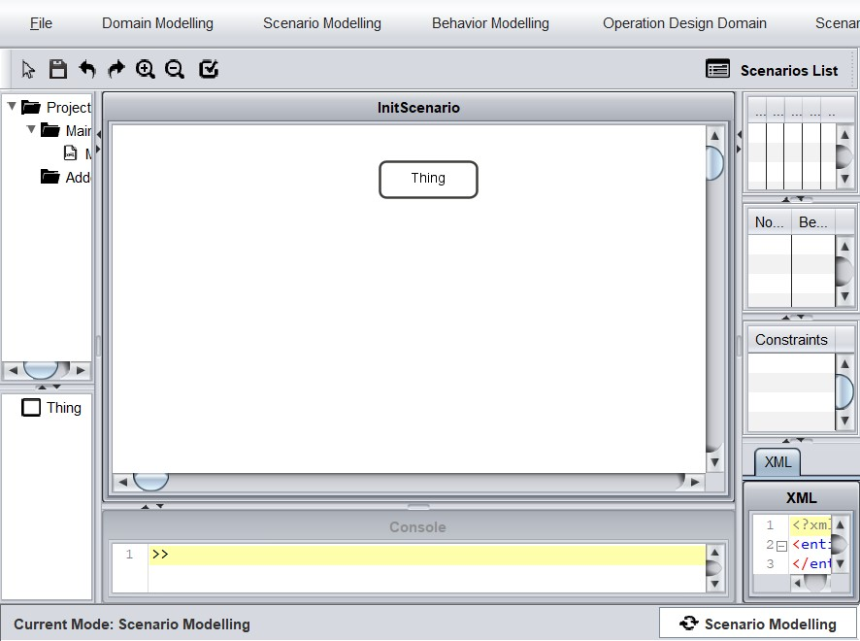

3. System overview

Besides the combined function of SES (Domain Modeling Mode) and PES (Scenario Modeling Mode), the ODME offers functions such as the Behavior Modeling Mode in which functionalities and relationships of behaviors can be specified and the possibility to create an Operational Domain (OD) and Operational Design Domain (ODD) of a specific scenario. The ODME is a powerful tool since it includes all of these functions and makes a switch between these modes possible while maintaining the project information.

4. ODME user workflow

The ODME is a tool that builds the bridge between general, human readable scenarios in natural language and executable, machine readable scenarios. Using the ODME, these simple scenarios in plain language get translated into complete and consistent machine-readable scenarios. Additionally, the ODD of the project can be saved and edited in the ODME. These machine readable scenarios that got translated using the ODME, can then be simulated using a simulator where the ODD gets tested and validated. This whole process strengthens the safety of a project by creating complete, executable and machine readable scenarios for your simple scenario idea in plain language that can then be simulated and evaluated using a suitable simulator.
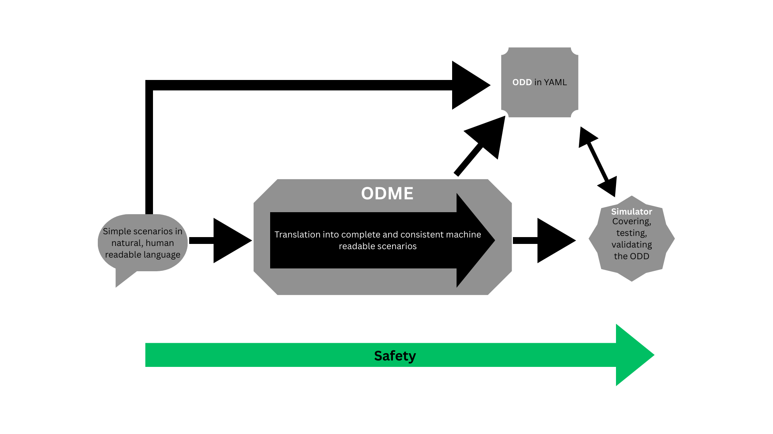
II. Installation

1. Developers

1. 1. Cloning the repository

To run the ODME as a developer, you have to “clone” it, which means that you have to download a version onto your local computer. To do that, open your Terminal (Windows: Windows + r → enter “cmd”) and copy and paste this line: “git clone https://github.com/aeronautical-informatics/ODME.git” (Make sure that you have git installed on your local computer!) . Now the current version of the ODME is installed on your computer.

1. 2. Open the project

To actually run the files that you have cloned onto your computer, you need an IDE. These can be common IDE's like IntelliJ IDE or Visual Studio Code. Once you have installed the IDE of your choice, follow these steps:

- Run the IDE
- Open the ODME folder that you have cloned onto your computer
- Make sure to open it as a Maven project

1. 3. Run the project

Once the project is opened on your IDE, you can finally run the project by following the path “src → main → java → odme → odmeeditor → Main” on the project structure on the left-hand-side. Then right-click the file “Main” and select “ Run 'Main.main()' ”. Now, the ODME will open, making it free for you to use.

2. Users

III. Domain Modeling Mode

Using the Domain Modeling Mode, the initial, human readable, scenario that is set to be translated into machine readable executable scenarios, can be modeled on a GUI, defining entities, their attributes and the relationships between them.

The interface will look like this:

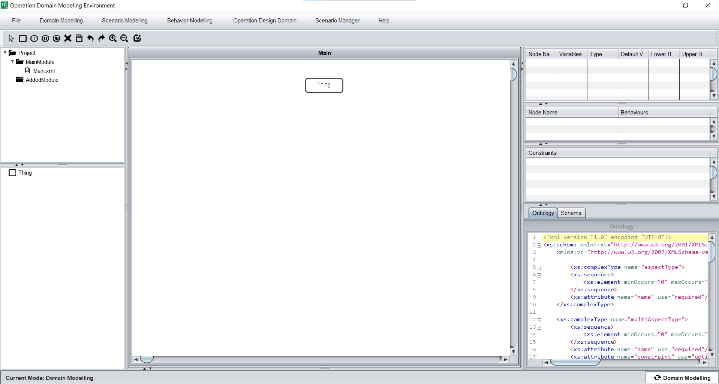
1. Starting a new project

To start a new project, “New Project” has to be selected in the “Domain Modeling” field of the menu bar. This will open a window in which the project has to be named the name of the root node (the initial name being “Thing”) and the storage location has to be selected. When selecting “Use Default Location”, the odme folder will be selected automatically.

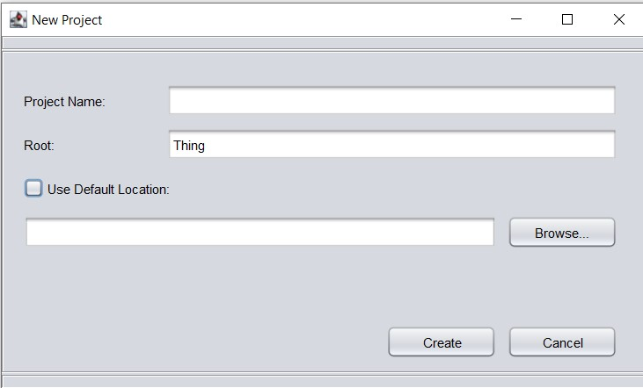

2. Definition of Domain model components

To model a System Entity structure, four specific elements can be used:

Entity: A real or artificial System component which is as object of interest that can have variables attached to it.

Aspect: Used for denoting the decomposition of an entity.

Specialization: When a specific form a thing can assume can be selected, it gets represented by Specialization.

Multi-Aspect: When multiple child nodes of the same type are required, the multiplicity is represented by Multi-Aspect.
When relationship-nodes are used (Aspect, Specialization, Multi-Aspect) it is helpful to change their default name to the name of their parent-entity in lowercase by double clicking on the node. This creates a more coherent and clear structure for later use.

3. Modeling a Domain Model

3. 1. Adding Domain model components

To add any component onto the GUI, the corresponding button on the menu bar has to be clicked , followed by a click onto the desired area on the GUI. By holding down the left mouse button, they can additionally be dragged.

3. 2. Adding attributes

Besides defining the cardinality and relationships of entities, attributes can also be added to them. By right-clicking on an entity, this pop up menu will appear:

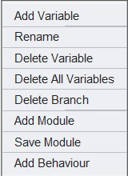
Now, “Add Variable” has to be clicked which will open a window that allows the user to specify the attribute. The type of the attribute can be boolean, int, float, double or string.

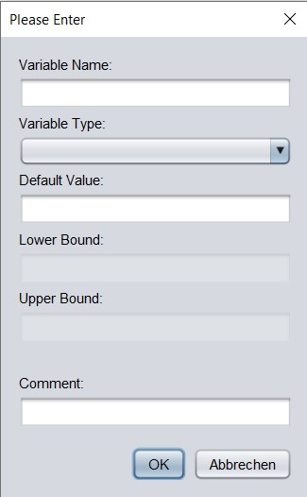
After adding attributes to an entity, they will be listed on the table on the right hand side when the corresponding entity is selected.

3. 1. Defining relationships

When hovering over a component, its edges will be highlighted green. By left-clicking and holding onto it, an arrow will appear which will connect the selected component with another one by releasing the mouse button while hovering over the second component which will then have its edges highlighted green. It is important noting that an entity cannot be directly connected to another entity. For creating logical, executable scenarios, a relationship component (Aspect, Specialization, Multi-Aspect) has to connect the entities.

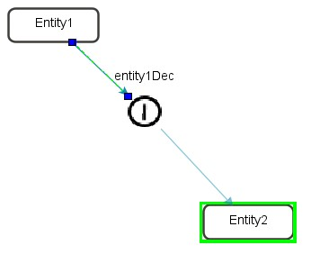
4. Import and export of Domain models

To enable a smooth exchange of projects, the Domain Modeling Mode offers the function of importing XML-files of Domain models and exporting the current Domain model.

Both functionalities can be found under the “Domain Modeling” field in the menu bar. To export the current Domain Model, “Save as Template” has to be selected. This will open a window where the XML-file that will be created has to be named. If not changed, the corresponding file will be located in the folder of the current Domain Model.

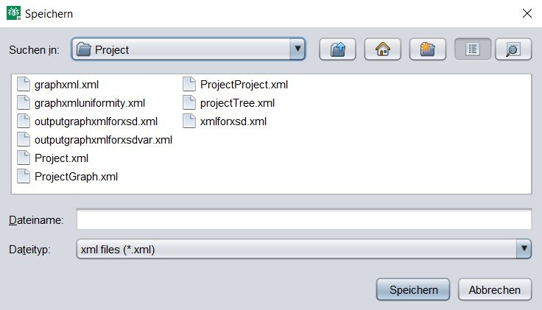

The import function is also located in the “Domain Modeling” field just above the export function as “Import Template”. To select the corresponding XML-file of the Domain model that is desired to be opened, the “Browse” button allows the user to search for and select the right file. Additionally, a Project Name has to be given since the imported project will also be saved as a new Domain Model.

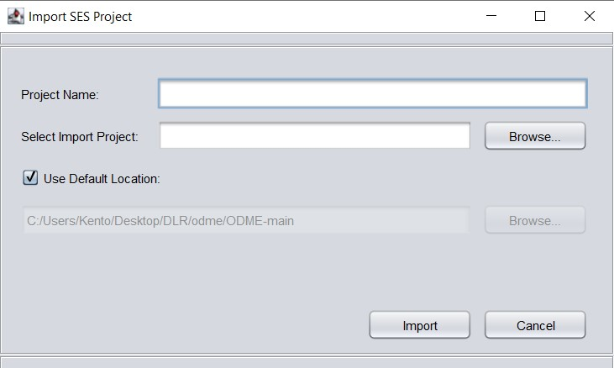

3. Behavior Modeling

3. 1 Adding behaviors

In the Domain Modeling Mode it’s possible to add behaviors to each entity of the SES. To add them, “add behavior” has to be selected after right clicking on the selected entity. Now, the new behavior has to be named using either camelCase or PascalCase. By using behaviors, a behavior that should take place during the simulation can be described. All of the added behaviors will be displayed in a table when the corresponding entity is selected.

3. 2 Behavior Modeling Tool Environment

To specify the functionalities and relationships of the behaviors, the tool “Sync Behavior” can be used which is found under “Behavior Modeling” in the menu bar. After selecting a scenario the Behavior Modeling Tool Environment will be opened as a new window.

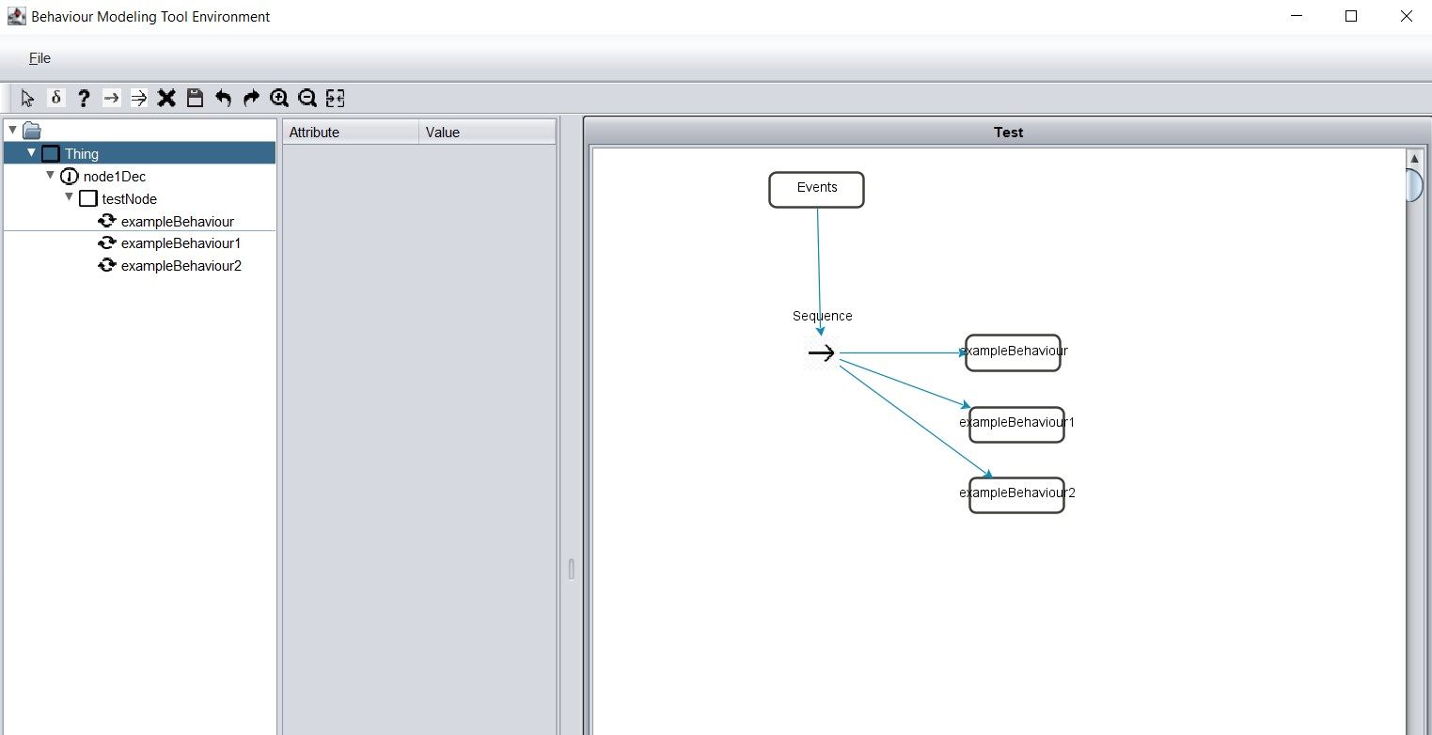

In this environment four different elements can be used to visualize the relationship and functionality of the behaviors in the form of a graph tree:

- Decorator: The Decorator node can be used to to specify a certain condition for a behavior to happen or to create a loop of this behavior. To add the condition / loop, the corresponding instructions can be added by double clicking on the Decorator node which opens a window that allows you to write down these instructions.
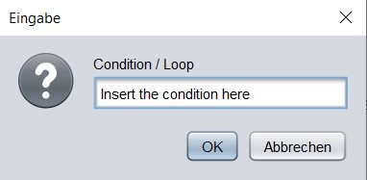

- Selector:

- Sequence: The Sequence node is used to describe a sequence of consecutive behaviors.

- Parallel: The Parallel node is used to describe parallel acting behaviors.

In the left hand column of the environment, the behaviors can be found and by clicking on its name, each behavior can be added to the graph tree.

Besides these special aspects, basic functionalities such as:

- Delete Node

- Save Graph

- Undo / Redo

- Zoom in / Zoom out

can be found in the menu bar of the environment.

Additionally, variables can be added to each behavior by left clicking the corresponding node and selecting “add behavior”. Another window will pop up to assign a name and value.
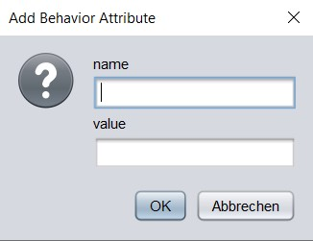
When a specific behavior is selected, the corresponding attributes with their values will be displayed on the table on the left-hand-side.
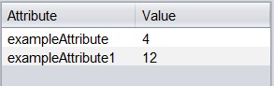

3.3 Export Behavior Tree to XML

The last element that can be found in the menu bar “Merge” will create an XML file of the Behavior Tree Graph. Before merging the file, saving it is necessary! This file can then be found in the corresponding scenario folder.

Screenshots of Tree and corresponding XML

IV. Scenario Modeling Mode & Pruning

1. Interface of the Scenario Modeling Mode

Switching from Domain Modeling Mode to Scenario Modeling Mode is easily done by clicking the Domain-Scenario Model Switch. When switching to Scenario Modeling Mode, an initial scenario gets created automatically (InitScenario).
Nodes that are eligible to be pruned will be highlighted green and can be pruned by right-clicking them and selecting “Prune it”.

2. Pruning techniques

Using ODME, three types of pruning are possible:
1. Entity Variable Pruning: specific values can be assigned to entity variables.
2. Specialization Node Pruning: one specific of several possible child nodes can be selected.
3. Multi-Aspect Node Pruning: The number of instances of the child node can be defined.

3. Pruning Workflow

1. Switch from Domain Modeling Mode to Scenario Modeling Mode.
2. Prune the highlighted Nodes.
3. Save the scenario by clicking “Scenario Modeling” in the Menu Bar and selecting “Save Scenario”. After giving the scenario a name, a scenario folder will be automatically created in the ODME-main file.

4. Scenario Manager

The Scenario Manager let’s you change between different scenarios easily. By opening the Scenario List, each scenario of your model can be opened, renamed and deleted. Additionally, risks and remarks about each scenario can be noted in the Scenario List.

V. Operational Domain and Operational Design Domain (ODD)

The “Operational Design Domain” in the menu bar offer two functions:

1. Generating an OD

When selecting “Generate OD” an Operational Domain (OD), corresponding to the SES-model will be generated.

Screenshot of example OD

In the form of a table, a clear overview of the OD is made possible. When saving the OD, a name must be assigned to the file.

2. ODD manager

After generating an OD, managing and editing the corresponding Operational Design Domains (ODD) can be easily done by selecting “ODD manager” right below the OD function.

The window that pops up now will have the same table-layout as when generating an OD but with functionalities for editing and managing the ODDs.

Screenshot of ODD window

First of all, an ODD List can be found on the left-hand side. The files that appear in this list will be the ODs that have been generated and saved before. By clicking one of them, the corresponding ODD will appear in the central table, ready to be edited.

In that table, the lower- and upper bounds of each variable can be edited, according to the desired values of the ODD. Additionally, comments for each variable can be added in the last column.

In the menu bar, the option to save an edited ODD is given by clicking “save”. Same goes for deleting an ODD by clicking “delete”. To export the ODDs, the options of exporting it as an XML and a YAML file are given. After specifying the storage location, a corresponding XML / YAML file will be found there.

Screenshot of example XML and YAML file

VI. Use case examples
…

1. example

2. …

