Name: Ke Chen, Jeremiah Asala

CS5610: Web Development Project 3

Design Document for Project 3 –

Full stack application with Node + Express + Mongo + React (hooks)

* **Project Name**

* + CS Degree Planner
* **Project description**
  + The goal is to create a degree planner for students in the Khoury Align MSCS program. The app will allow students to select specializations they may be interested in, and see a recommendation of courses to take for the entire length of the program and in what semesters to take them. They also have the option to modify the recommended degree plan to suit their preferences (perhaps after speaking with an academic advisor).
* **User Personas**
  + Ben was recently accepted to the Align MSCS program at Northeastern University. He’s transitioning from a career in Law and has no idea what courses to take for future career in tech. He needs an application that offer suggestions on what courses to take each semester depending on his desired specialization.
  + Grace just completed her first year of the Align program. She realized that she is interested in a couple of CS specializations but is undecided on what path to pursue.
  + Neil is an international student who just started his first semester of MSCS-Align program at Northeastern University. As an international student, he need to make courses plans for his internship or Co-ops arrangement.
* **User stories (use cases but with a story)**
  + Ben was recently accepted to the Align MSCS program at Northeastern University. He’s transitioning from a career in Law and has no idea what courses to take. He can use this application to make plans for what courses he will take in each semester, because this app can offer suggestions for various specializations.
  + Grace just completed her first year of the Align program. She realized that she is interested in a couple of CS specializations but is undecided on what path to pursue and what courses will best prepare her for the future. She can use this application where she can manage her degree plan(s) as she continues to explore her interests.
  + Neil is an international student who just started his first semester of MSCS-Align program at Northeastern University. As an international student, he is able to use a 12months CPT to be employed for internships or Co-ops during the entire length of the program. So, he is actively looking for next year’s internships and Co-ops. But there are strict Khoury academic and coop policies that he has to follow before CPT approval and starting Co-ops. He can use this application as a planner where he can make eligible plans for graduating on time and taking advantages of the CPT length
* **Design mockups.**

HomePage

Sign UP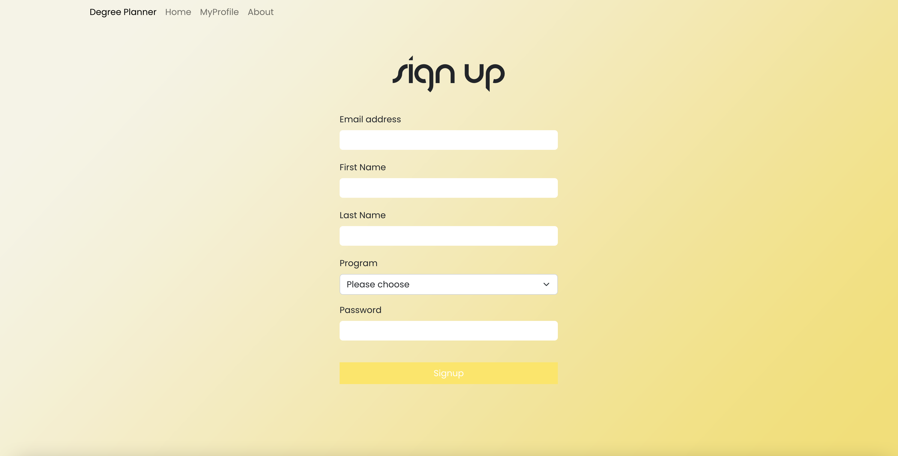

Log in

Profile

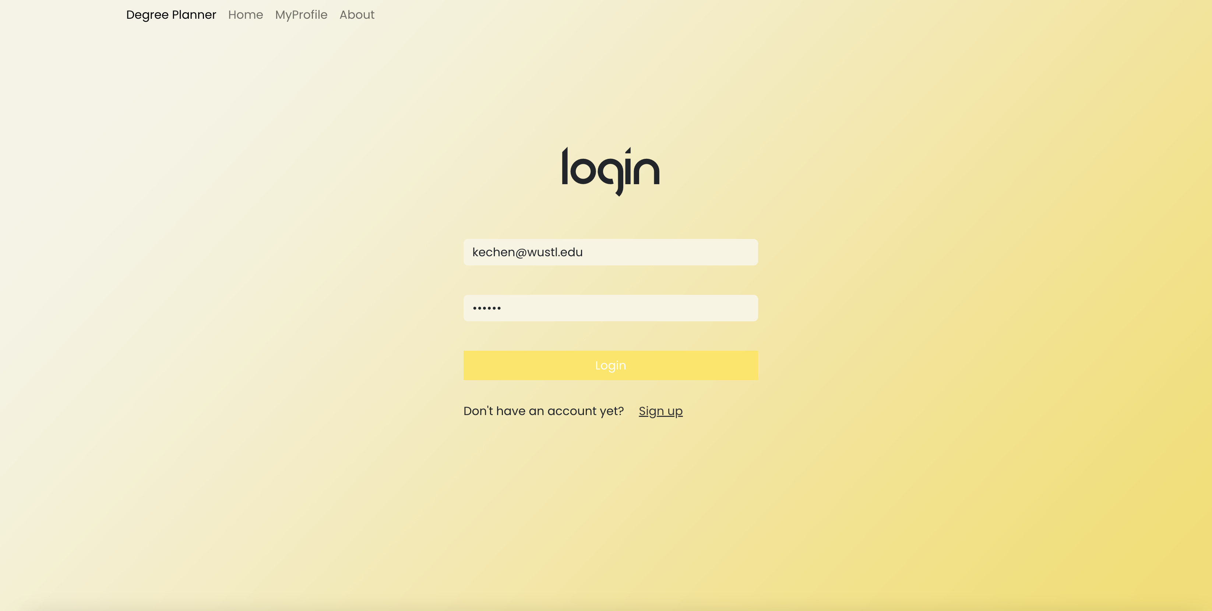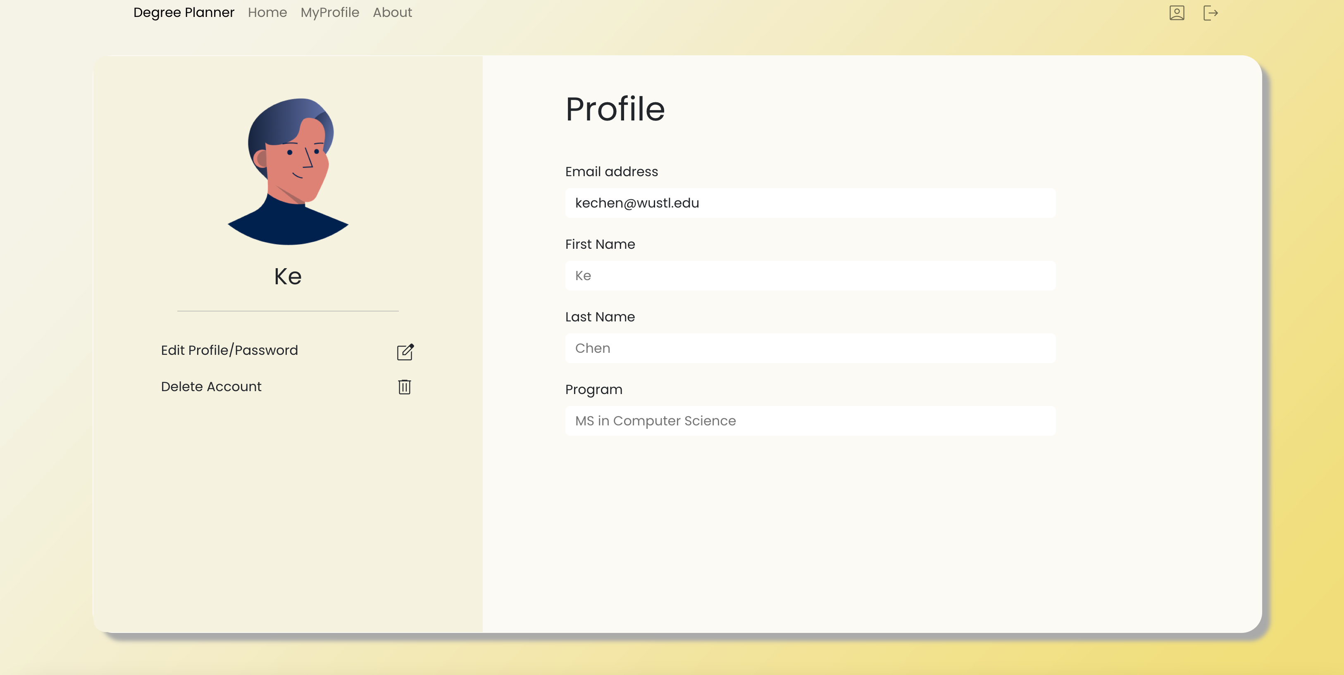

Edit Profile

