HOME PAGE (NO LOGIN)
-> Remove the paths for crop market, input market and market analytics in navbar.
FARMER SIDE
- Inside Farmer Dashboard
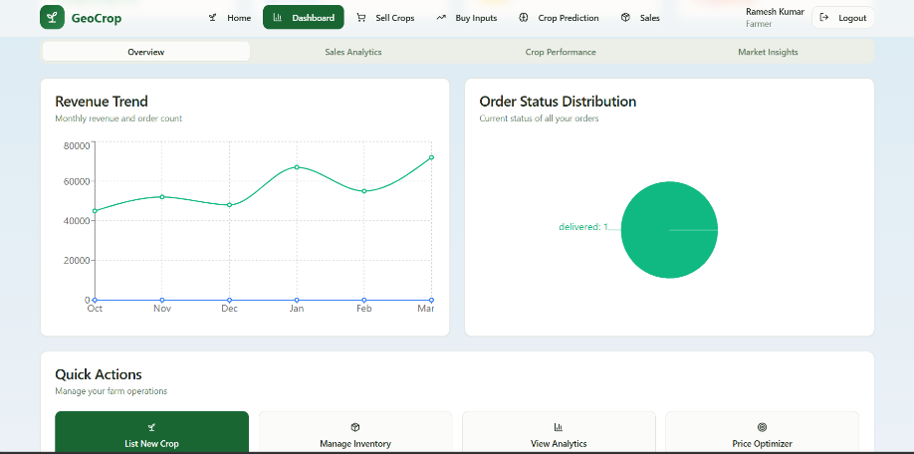
Remove the quick actions Tab
Remove market insights

- Inside Farmer selling crop section
-> Make that edit option working
-> Add a “remove crop” button for each
-> when adding new crop the form takes image url as input just convert that to jpg or jpeg like that
3) In buy Inputs section
-> add quatity to buy while ordering
-> make pop up about things we are buying and total cost to confirm order
4) in prediction page
-> keep only crop recommended, soil and weather data in result
-> include chatbot here.( Is it better to add this only in this section or like it can be available through out the site? Do whatever that is better.)
BUYER SIDE
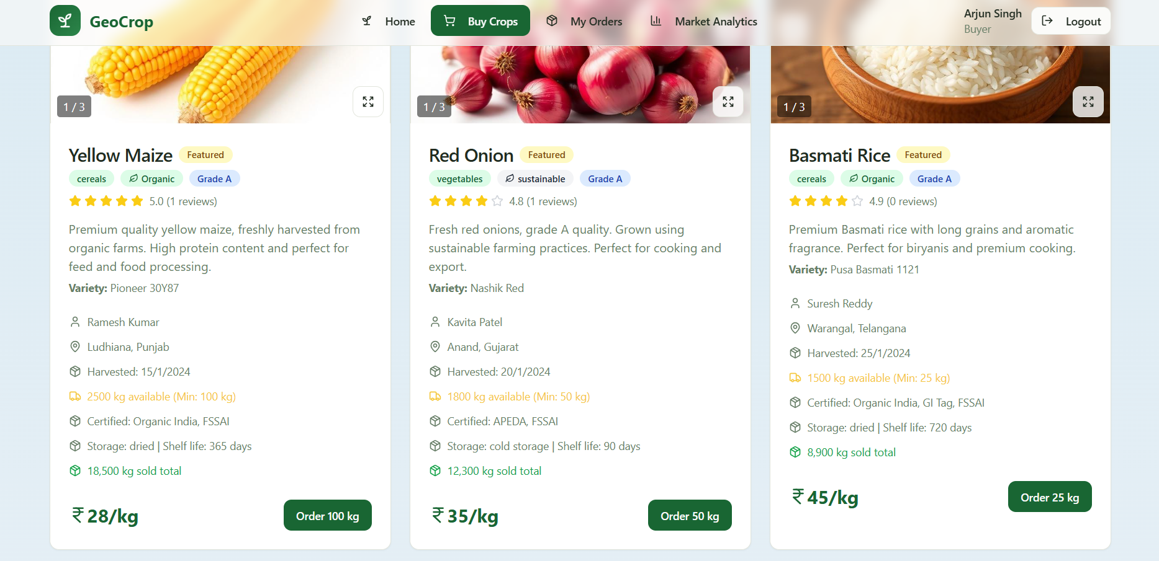
- Buy crops
-> add quatity to buy while ordering
-> make pop up about things we are buying and total cost to confirm order
2) Remove that market analytics completely
DEALER SIDE
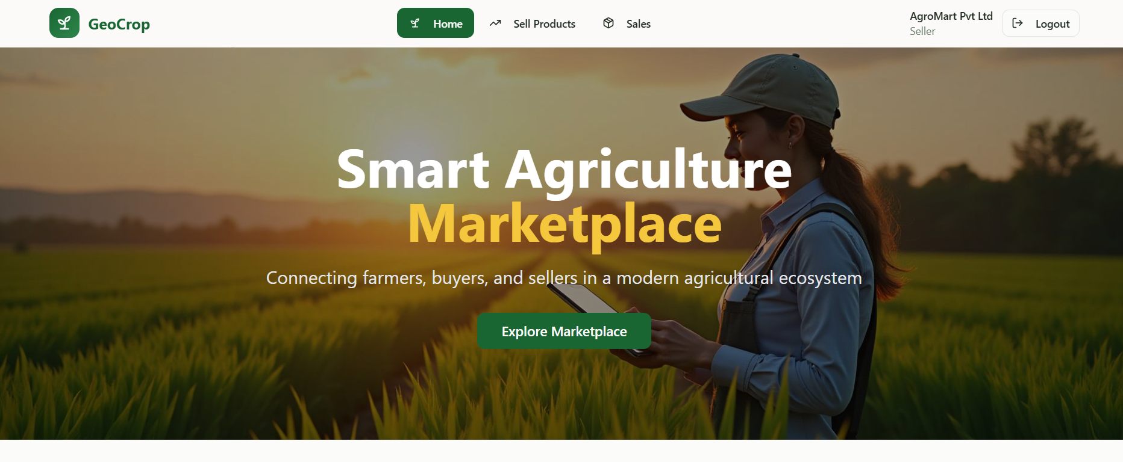
- Here map that explore marketplace to the sell products section
In sell products section
-> Make that edit option working
-> Add a “remove product ” button for each
-> when adding new product the form takes image url as input just convert that to jpg or jpeg like that.
That’s it these are the major change we have to do now.
And it’s ok to improve the functionalities in your way.
Tell me if I miss anything during the process.

