Stackoverflow Like

Project Report for StackOverflow Like web site

Report

Elysée Jonas

Rabérin Alexandre

Table des matières

I - Work to be done 2

A – Subject 2

B – Particularities 2

C – Tools Used 2

II – Conception of the Application 3

A – UML Diagram 3

B – Mock-ups 3

III – Work Done 4

A – Architecture 4

Controllers 4

Services 4

B – Work to be done 4

Conclusion 5

Annex 6

# I - Work to be done

## A – Subject

In the "Rapid Application Development" cursus, we had to develop an application based on the same concept as the website [www.StackOverflow.com](http://www.StackOverflow.com)

The Application should allow a user to ask questions on a forum; these questions will be able to be seen by all the users of the service.

A user will have to identify himself (therefore own an account) in order to ask a question, to answer a question or comment on another user's answer. Consequently, every registered user will have a profile which everyone will be able to see, and which will show information about the user such as the date at which he sign up or a summary of his activities.

A Tag system will be in place in order to organize questions around specific themes.

Questions and their answers will be able to be voted upon in order to show if the question itself is interesting or if the answer solves the problem brought up by the question. A reward system will exist in order to award users having performed certain actions.

## B – Particularities

Certain constraints are added to the subject stated previously:

* The application will have to be internationalized, which means it will have to be able to adapt the displayed features' language to the user's system's language.
* The code and its commentaries will have to be in English
* The application will have to be tested, which means unit tests will have to be put in place in order to test the different functionalities implemented.

## C – Tools Used

In order to develop this project, certain tools were made available to lighten the workload. In this cursus' scope, the web application development tool used was Grails: grails is based on the use of the programming language Groovy, used in order to code the application. IntelliJ was used as the development environment which supports the Grails framework.

# II – Conception of the Application

## A – UML Diagram

The first step of development of the project is to isolate the different entities we are going to use throughout the development and the operating phases of our application. For this reason, we have constructed the following UML Diagram which gives a general vision of our projects:

Figure: UML Diagram

We have a domain class which represents a user and all the information we have on him. A user handles posts which can be of various types: Questions, Answers or Comments. Questions can be tagged in order to be organized around similar themes. Votes are casted upon posts in order to show the interest of the community in that particular post. Finally, a user is awarded badges upon completing certain actions.

## B – Mock-ups

Knowing our application would be a web application, the graphical aspect of our project gains significant importance. The second step to take is clearly to be able to project what the final aspect of the application will be. In that event, we used Balsamiq in order to create different mock-ups of our application which allows to have a clear end goal when developing the graphical side of the application

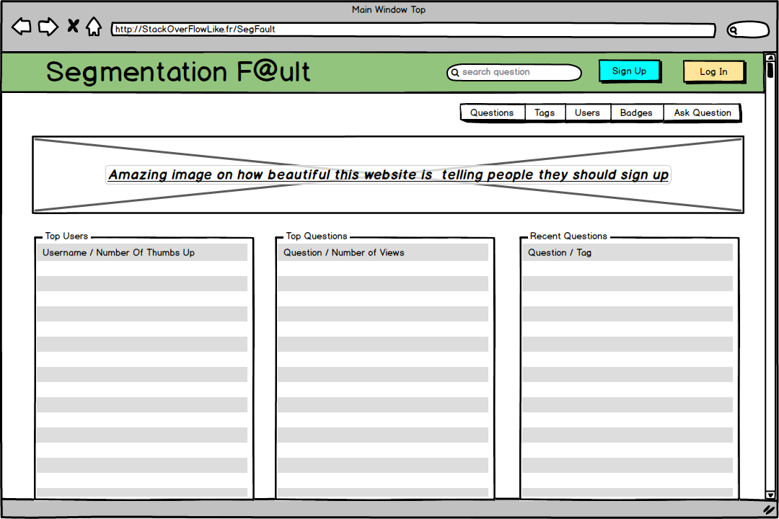

Figure: Home Window Mock-up

# III – Work Done

## A – Architecture

Different controllers are in charge of different aspects of the application. Each controller, depending on the web site's needs, calls services which in turn are in charge of more complexed procedures such as the logic behind the reputation system. This explains why different services can communicate with one another. In addition, this approach allows us to group the different business logics of our application and delegate the routing logic to the controllers.

The application relies on a privilege system which allows us to create different interfaces for the users depending on the privileges which they have been attributed. Features using this system include the ability to ask a question only if a user is logged in.

A series of test have been put in place in order to test the different domain classes and controllers we have created.

### Controllers

Controllers are in charge of four actions on the domain classes to which they are affected (see UML Diagram). These four actions, also known as CRUD actions, allow them to create a new instance of the domain class in the database, read and access an instance of the domain class in the database, update one and, finally, remove and instance from the database.

The controllers are also responsible for the redirection of pages of our website, also referred to as the internal routing system. Depending on various data, such as answers from services or requests from the user, the controller will choose the correct page to display.

### Services

## B – Work to be done

From a functional point of view, our application possesses most of the functionalities awaited for an imitation of the website StackOverflow.

However, the visual aspect of the product we are delivering requires a lot of work in order to be polished. A graphical chart for the website is needed in order for the project to be complete. The current version of the project relies on different bootstrap sources in order to be visually appealing. Nonetheless, it is clear that this solution is unacceptable for a final product but is enough presently given the allotted time.

# Conclusion

This project was an opportunity for us to discover new ways to develop web applications thanks to the Grails framework. The complexity of the project covered the necessary aspects needed for us to truly gain the knowledge to be acquired in this cursus.

However, it is clear to us that the time granted in order to fulfill this project was insufficient. Some aspects of the project, mainly the visual aspect, have been heavily affected by this.

# Annex

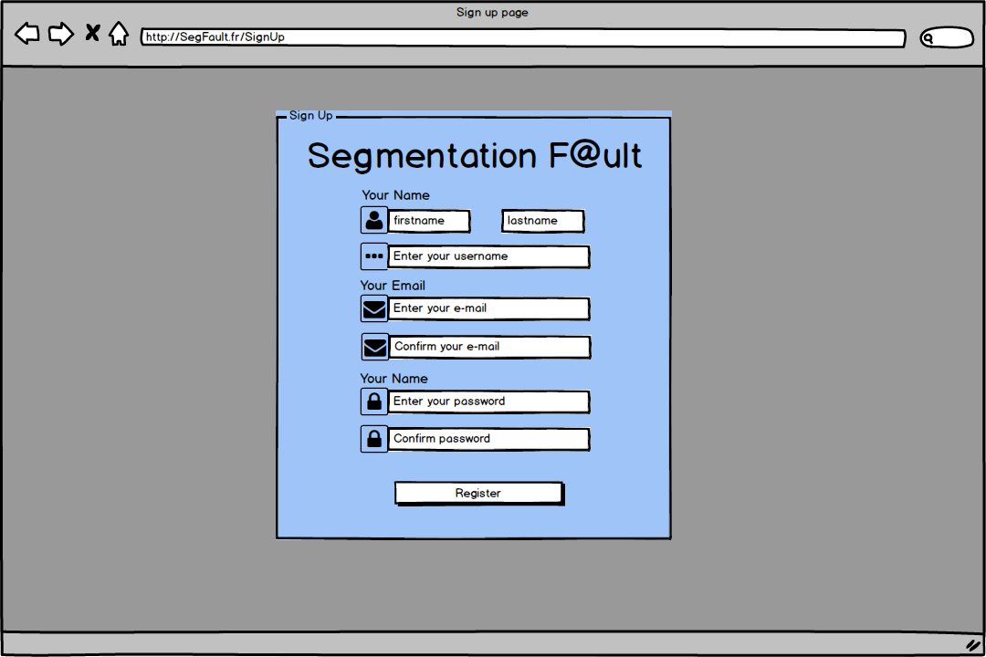

Balsamiq Mockups

Annex: Sign Up Window

Annex: Log In Window

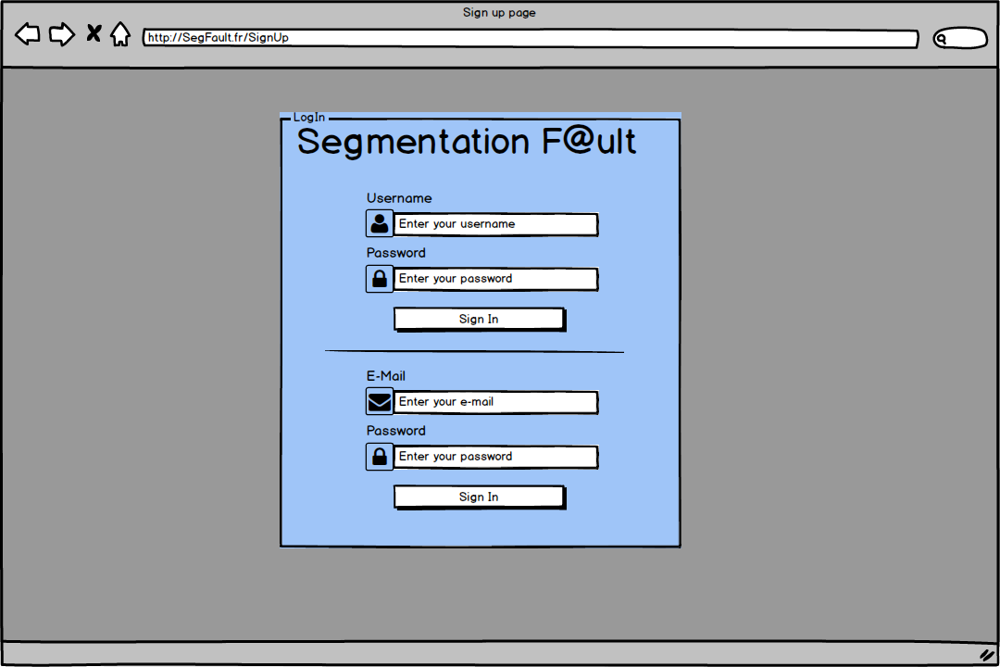

Annex: Display Question Details

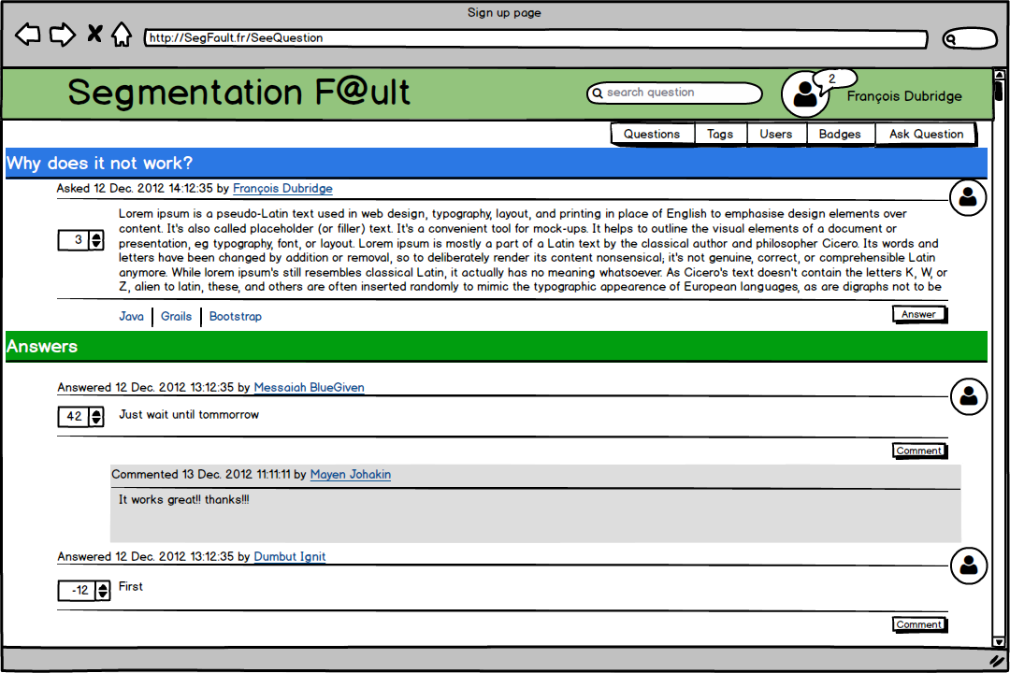

Annex: New Question Form

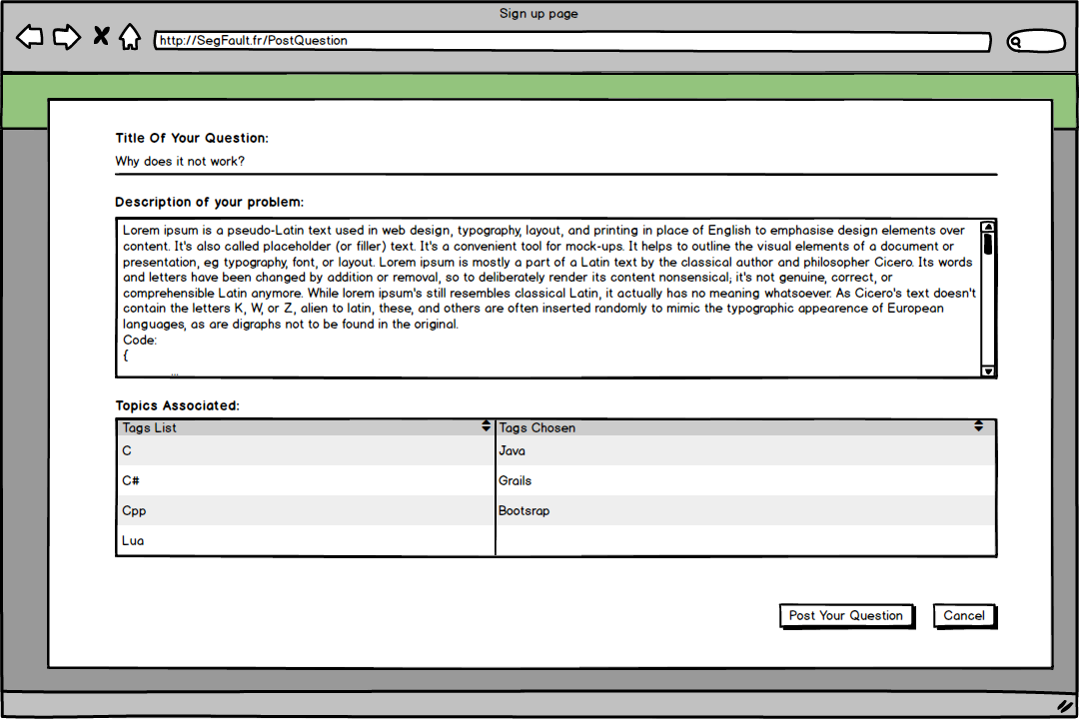

Annex: Display Item List

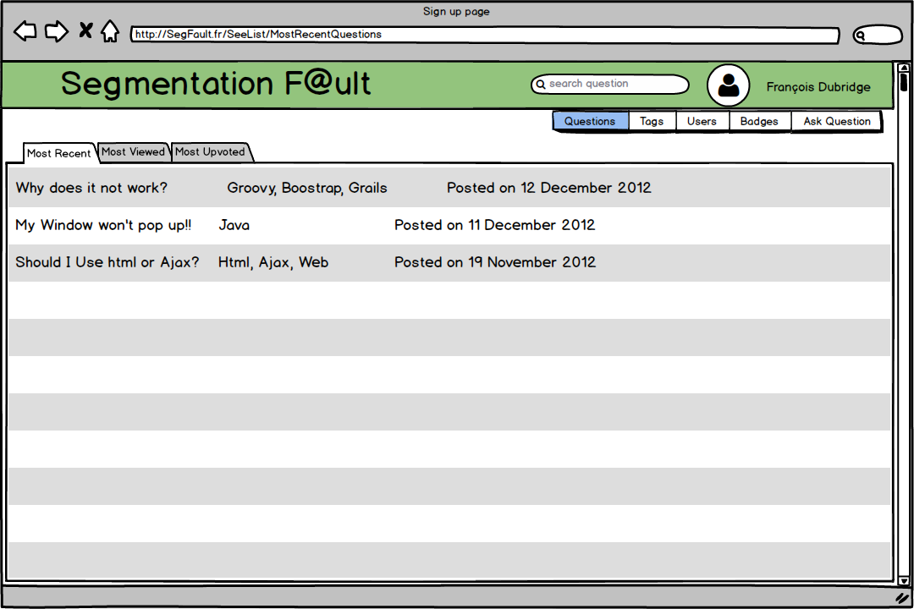

User Profile

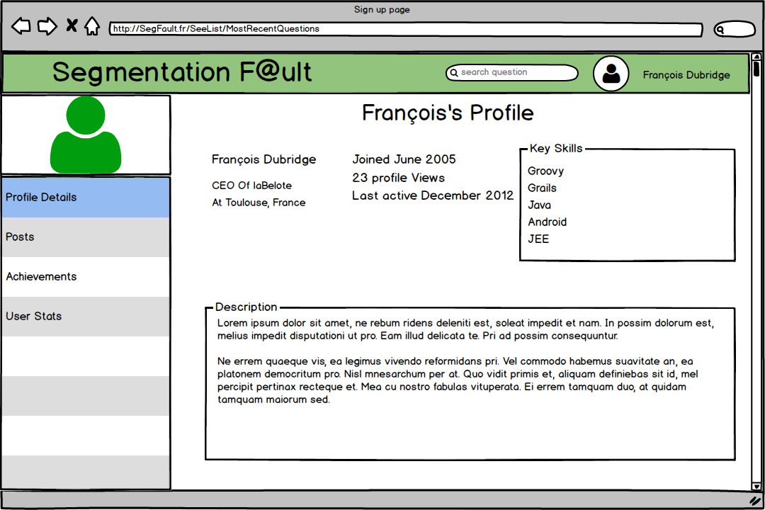

User Achievements

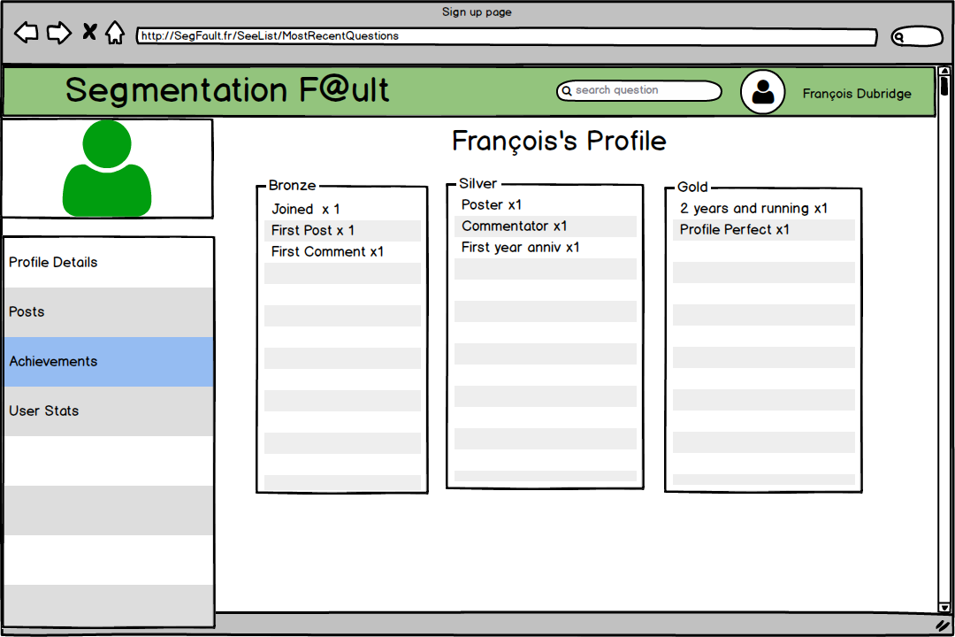

User Activity

