Recognising Human Activity from Phone Motion with a Hidden Markov Model
Machine Learning Techniques, Formative 2 · Gaju Keane · 31 October 2026
Code and data: github.com/Keaane/HMM-activity-recognition

1. Background and motivation
Phones and watches record motion all day, and fitness trackers, health monitors and smart-home systems all need to turn that motion into an activity. My use case is a phone-only activity log for a student who has no smartwatch. It should count the time spent standing, walking and exercising (jumping stands in for exercise here), and it must not count the time the phone lies on a desk as the person being active, which is the still class. The activity itself is never measured: the accelerometer and gyroscope give only noisy evidence of it, and an activity usually lasts a while before it changes. That is the structure of a Hidden Markov Model (HMM). The activity is the hidden state, a short window of sensor data is the observation, and the transition probabilities say how likely the activity is to stay the same from one second to the next.

2. Data collection and pre-processing
I recorded with Sensor Logger (iOS and Android), logging the accelerometer including gravity (in g) and the gyroscope (rad/s). Every file has a timestamp column (nanoseconds) and the six axes. Table 1 lists the phones and the sampling rate measured from each phone's timestamps.
Table 1. Phones, who recorded on them, and their native sampling rates. All are resampled to 50 Hz.
Phone | Recorded by | Used for | Native rate
iPhone 11 Pro | me | training | 99.8 Hz
iPhone 11 | friend, at school | test A (all four activities) | 100.1 Hz
iPhone 16 Pro | friend, at home | test B (jumping, still) | 99.6 Hz
Samsung SM-A235F | friend, at home | test B (standing, walking) | 102.1 Hz
Training data (26 October, iPhone 11 Pro, recorded by me). I made one long recording per activity: standing 128 s with the phone at waist level, walking 122 s and still 122 s (phone flat on a table), plus five jumping takes of 23–39 s. Each recording was trimmed by 2 s at the start and 3 s at the end, which removes the moments of starting and stopping the app, and cut into 8 s files: 15 standing, 14 walking, 14 still and 12 jumping. I also recorded one 72 s session that goes still → standing → walking → jumping. In that session the moments where I picked the phone up or changed activity are left unlabelled and skipped. Every activity has at least 109 s of training data (standing 134 s, walking 130 s, jumping 110 s, still 127 s), above the 90 s minimum. Because the 8 s files come from a few long recordings, files from the same recording are not independent, so feature choice uses blocked folds (section 3).
Unseen test data. Test A: a friend's iPhone 11 at school on the same day, three 8 s files per activity taken from the middle of separate recordings. The friend's jumping recording started at the same second as my training take jumping_2, so its first 27 s were skipped. Test B: the next day, at home, two other friends' phones, an iPhone 16 Pro (jumping, still) and a Samsung SM-A235F (standing, walking), one short file each. In total there are 72 CSV files (56 training, 16 test), each listed with its phone, date and time span in data/manifest.csv.
Pre-processing. Each file is sorted by time and duplicate timestamps are dropped; no missing values were found. Android logs m/s² with the opposite sign to iPhones, so the Samsung's accelerometer values are divided by −9.81. The phones log at 99.6–102.1 Hz with slightly uneven spacing, so every file is linearly interpolated onto an even 50 Hz grid using its own timestamps, after which all phones look the same to the model. 50 Hz is plenty: walking repeats at about 1.5 Hz and jumping at about 2 Hz, and section 6 shows that nothing is lost even at 10 Hz. The signal is then cut into 2 s windows (100 samples) that overlap by half. Two seconds holds 3–4 steps or jumps, enough for the FFT to find the rhythm, and the 1 s step lets the decoder follow a change within about a second.
Table 2. Video evidence of the data collection. All four are also in one folder: drive.google.com/drive/folders/1qP9lk4-jdwW2zVzHJfrS-97dwyjKSSTp
Activity | Video of me recording it (about 5 s, whole body and face visible)
Standing | drive.google.com/file/d/1DbuKi2fFGHKsp-Dc_dmSgkdPQfZGT58R/view
Walking | drive.google.com/file/d/1qN1bkOZjtsGW4xYbjx5tOWmzon84elF-/view
Jumping | drive.google.com/file/d/1h8uUoRtdRANqKgtrE7Bfue7nX2O2b0dp/view
Still (phone on a flat surface) | drive.google.com/file/d/1k-YQIuRrEuhhP4bo9Cw2g9SsSArijBaa/view
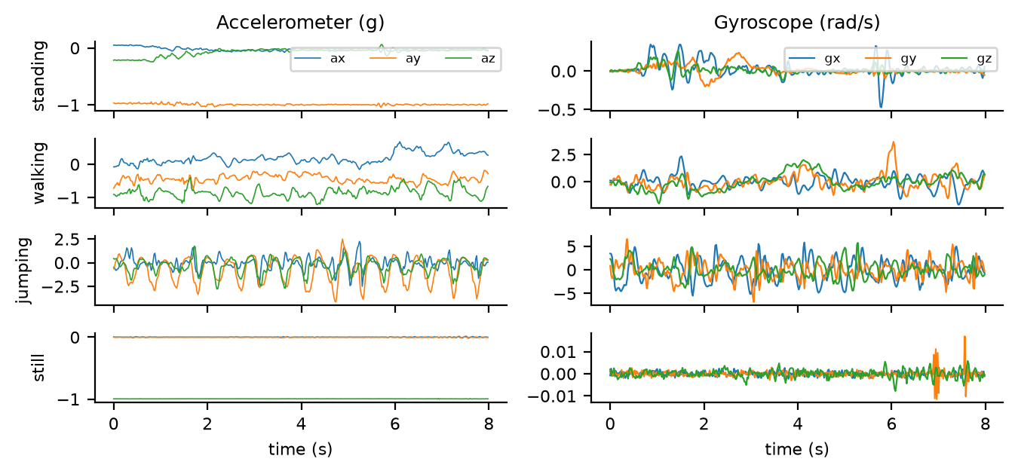
Figure 1. One 8 s training file per activity: accelerometer (left, g) and gyroscope (right, rad/s). The y-scales differ: when still, the phone rotates by less than 0.01 rad/s.

3. Feature extraction
Each window becomes 12 features: 8 from the time domain and 4 from the FFT (Table 3). They are computed on the length of the acceleration and rotation vectors, so they do not depend on how the phone is held. Spectra use a Hann window and a zero-padded 512-point FFT of the mean-removed magnitude, restricted to 0.5–10 Hz.
Table 3. The 12 features computed for every 2 s window.
Feature | Domain | Why it helps tell the activities apart
acc_mag_mean | time | Average load: about 1 g at rest, far above it during jumps.
acc_mag_logvar | time | How much the movement varies. Log, because it spans six orders of magnitude from a still phone to jumping.
acc_sma | time | Signal magnitude area: overall movement energy, moving versus not moving.
acc_corr_xy, _xz, _yz | time | Whether the axes move together: strongly coupled in jumping, weakly in walking.
gyr_mag_mean, gyr_mag_logvar | time | How much the phone rotates: arm swing when walking, hand tremor when standing, nothing when still.
acc_dom_freq | frequency | Strongest frequency: about 1.5 Hz walking, 2 Hz jumping; only noise for still and standing.
acc_spec_energy | frequency | Log power in 0.5–10 Hz: how much rhythmic movement there is.
acc_spec_entropy | frequency | Peaked spectrum (rhythm) versus flat spectrum (noise).
gyr_spec_energy | frequency | The same energy measure for rotation.
I also tried the mean of each axis, which gives the direction of gravity. It describes how the phone is held, not what the person does: standing was upright in my long recording and flat in the session. I chose features on training data only, using blocked 3-fold cross-validation over the 8 s pieces plus decoding the session with a model trained without it. Adding the orientation features dropped the session accuracy from 0.94 to 0.77, so I left them out. The four frequency features alone scored higher (0.995 in cross-validation, 1.00 on the session), but the assignment also asks for time-domain features, so I used the best set that meets that requirement.
Normalisation. The features sit on different scales (g, correlations, log-powers, Hz), and both the Gaussian emissions and the variance floor depend on scale, so every feature is z-scored, (x − mean) / std. The mean and std come from the training windows only and are reused unchanged on the test files. I chose z-score over min-max because a few extreme jumping windows would squeeze every other window into a narrow min-max range.

4. HMM setup and implementation
- Hidden states (Z): standing, walking, jumping, still.
- Observations (X): the 12 z-scored features of each 2 s window, one window every second.
- Transition probabilities (A): a 4 × 4 matrix, the chance of moving from one activity to another between consecutive windows.
- Emission probabilities (B): one Gaussian per state with a mean and a variance per feature (diagonal covariance). A full covariance would need 78 numbers per state from about 100 windows per activity, so diagonal is the safer choice.
- Initial state probabilities (π): which activity a sequence starts in.
Algorithms. Training uses Baum–Welch, the EM algorithm for HMMs. The forward–backward pass gives each window's state probabilities and the expected transitions, and π, A and the Gaussians are then re-estimated in closed form. Decoding uses Viterbi, which finds the single most likely sequence of activities in O(TK²). Both tie directly to the metrics I report. Viterbi uses A to overrule a single odd window, which raises sensitivity on short confusions: on the held-out session it lifts accuracy from 0.92 (each window classified on its own) to 0.94. The forward algorithm gives the log-likelihood that sets the stopping rule and picks between random starts without any labels.
Implementation. Everything is written from scratch in NumPy (no HMM library) as one GaussianHMM class, in log space with log-sum-exp so long sequences do not underflow. A variance floor of 0.005 stops a state's variance collapsing to zero, and a pseudo-count of 0.1 keeps every transition possible. Training starts from the labelled windows and stops when the average log-likelihood per window improves by less than 10⁻⁶, with a cap of 300 iterations. It converged after 10 iterations, from −0.659 to −0.518, and the likelihood never decreased (Figure 5a). To check the code, I compared it with brute force on a 3-state, 5-step model where all 243 paths can be listed: the forward likelihood, the Viterbi path and the posteriors all matched. I also trained from 10 random starts without labels. The start with the best likelihood separates the four activities, and once its states are named by majority vote it scores exactly the same as the labelled model on every check.
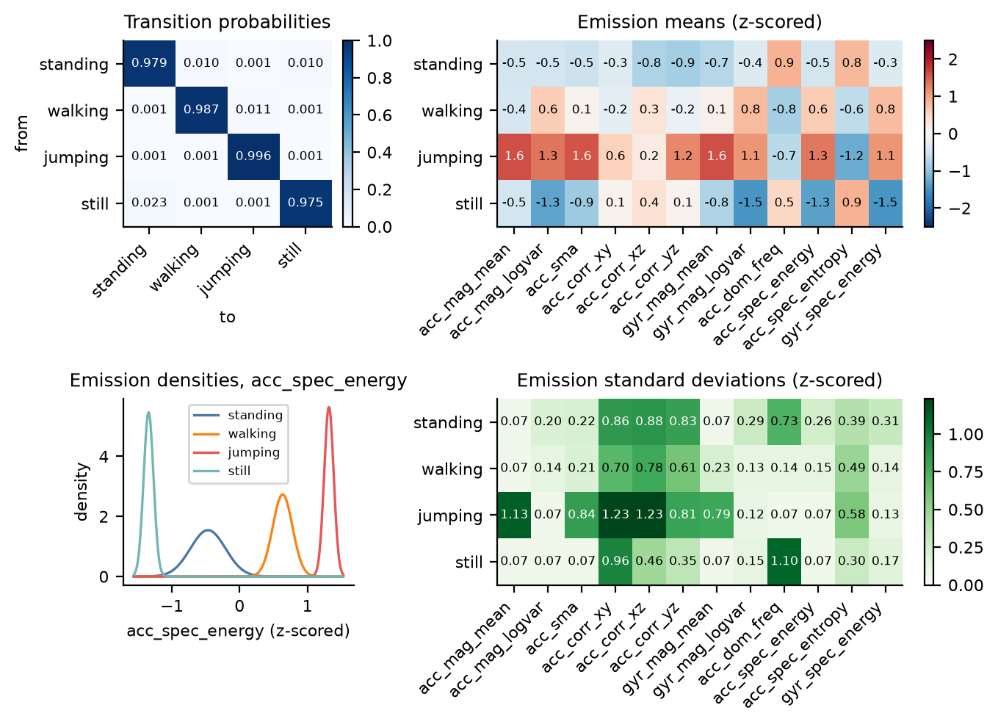
Figure 2. The learned model. Top: transition matrix and the emission mean of each feature per state. Bottom: the four emission Gaussians for acc_spec_energy, and the emission standard deviations. Values are z-scores.

5. Results and interpretation
The test files were never used for training, for the z-score statistics or for choosing features. In Table 4 a sample is one 2 s window.
Table 4. Test A and B together (16 files, 107 windows), with 95 % Wilson intervals. Test A alone: 84 windows, accuracy 1.00 (0.96–1.00). Test B alone: 23 windows, accuracy 1.00 (0.86–1.00).
State (activity) | Number of samples | Sensitivity | Specificity | Overall accuracy
Standing | 28 | 1.00 (0.88–1.00) | 1.00 (0.95–1.00) | 1.00 (0.97–1.00)
Walking | 28 | 1.00 (0.88–1.00) | 1.00 (0.95–1.00) | 1.00 (0.97–1.00)
Jumping | 25 | 1.00 (0.87–1.00) | 1.00 (0.96–1.00) | 1.00 (0.97–1.00)
Still | 26 | 1.00 (0.87–1.00) | 1.00 (0.95–1.00) | 1.00 (0.97–1.00)
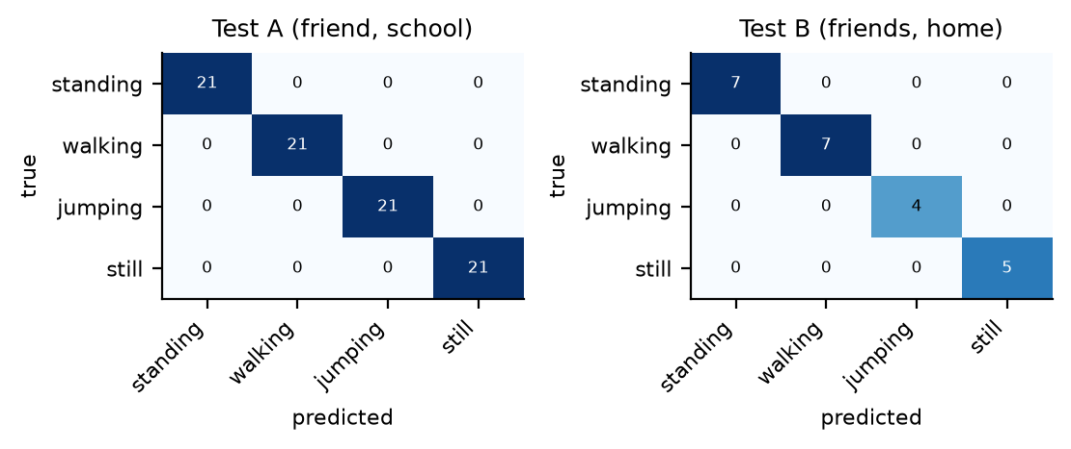
Figure 3. Confusion matrices for test A and test B: every window is on the diagonal.
Does it generalise? On these sets, yes. The model got every test window right on another person's phone on the same day (A), and on two more people's phones the next day, one of them Android (B). Classifying each window on its own, without the transitions, also scores 1.00 here, and the log-likelihood gap between the best and second-best state is never below 21, so these test windows are clear-cut. The intervals matter more than the point estimates: test B has only 4–7 windows per activity, so the 95 % interval for jumping sensitivity in test B alone is 0.51–1.00.
The harder check is the multi-activity session, decoded by a model trained without it (Figure 4). It is the only recording with real switches, but it comes from my phone on the training day and I used it to choose the features, so its 0.94 is a validation score rather than a test score. All three errors are still windows decoded as standing at 12–14 s, exactly where a tap on the table shows up in the signal. Every other window is correct, including the ones right after each change of activity.
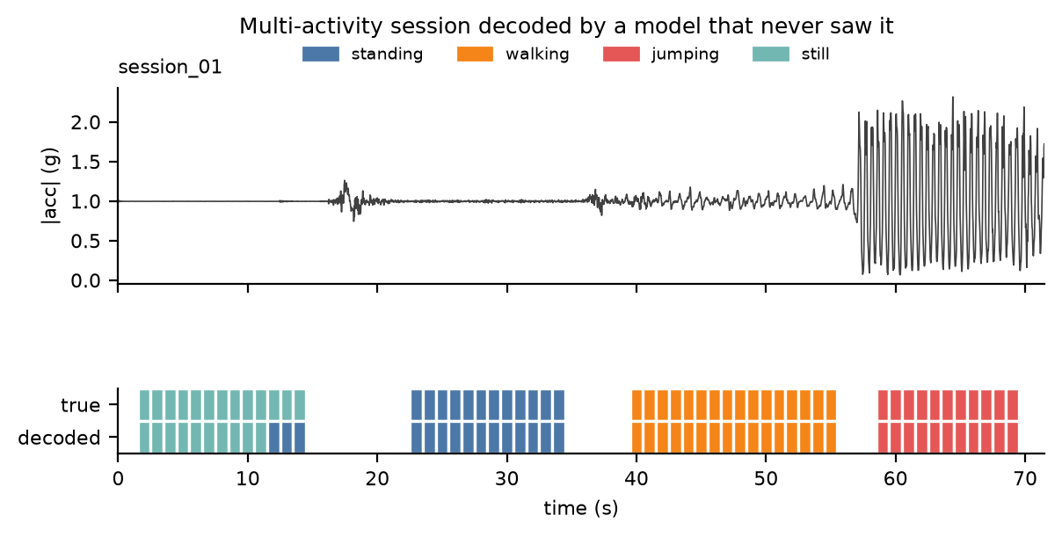
Figure 4. The held-out session: |acc| (top) and true versus decoded activity per window (bottom). The gaps are the unlabelled moments of picking up the phone or changing activity.

6. Discussion and conclusion
Easiest and hardest. Walking was the easiest: its rhythm shows clearly in the frequency features, and on every test window its log-likelihood is at least 61 above the next-best state. Standing had the smallest margin (about 22), and still versus standing was the hardest pair: both barely move, and what separates them is the small tremor of a hand. Within a 2 s window, |acc| varies by 0.44–0.64 mg when a phone lies still and by about 5–6 mg when an iPhone is held while standing. All the session errors are between these two.
Transitions. The learned diagonal is 0.975–0.996, so the model expects an activity to last from 40 s (still) to 275 s (jumping) before it changes. Activities do persist, so a strong diagonal is realistic, and it is what lets Viterbi smooth out single odd windows. The values themselves are not realistic. The off-diagonal entries come from only three switches in one session and a few windows that Baum–Welch reassigned, and every 0.001 is just the smoothing pseudo-count. Nobody jumps for four and a half minutes, and nothing in my data says, for example, that people go from standing to walking more often than from still to jumping. Learning that would need many natural recordings with switches.
Sensor noise and sampling rate. Sampling rate barely matters: resampling all data to 25 Hz or 10 Hz still gives 1.00 on the test files, because these activities happen below 3 Hz. The 99.6–102.1 Hz differences between phones disappear once everything is on the 50 Hz grid. Noise is the weak point (Figure 5b). Adding Gaussian noise of only 0.002 g to the test signals drops accuracy to 0.76, because every still window is then decoded as standing. The still state has learned a very narrow Gaussian (five of its features sit at the variance floor, Figure 2), and 2 mg of noise is about three to four times the resting noise of the iPhones. Test B has no still recording from the Samsung, so a phone with a noisier accelerometer is the most likely way for this model to fail in real use.
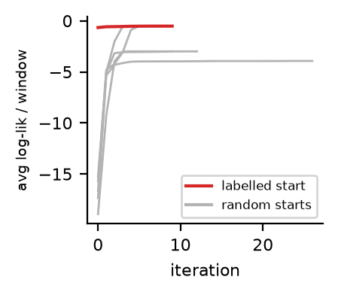  (a) Baum–Welch convergence | 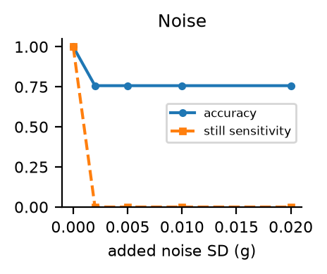  (b) noise added to test signals | 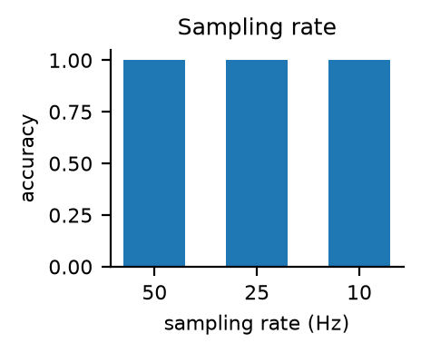  (c) lower sampling rates
Figure 5. (a) Average log-likelihood per window from the labelled start (red) and five random starts (grey). (b) Test accuracy and still sensitivity with added noise. (c) Test accuracy at 50, 25 and 10 Hz.
Improvements.
- Record still and standing on the Samsung and other Android phones before trusting the still class.
- Make still less fragile: put a floor at the typical sensor noise level inside the log-variance features, or add a little random noise to the training windows so the still Gaussian widens.
- Record more people, more phone positions (pocket, bag) and longer sessions with natural switches, both to test generalisation properly and to learn realistic transitions.
- Add activities such as sitting and climbing stairs, where the gyroscope and a barometer would help.
Conclusion. A 12-feature Gaussian HMM written from scratch recognised every unseen test window from three other people and three other phones, and Baum–Welch finds the same solution without labels. Its limits are clear and measurable. The training data come from one person and one phone, mostly from one long recording per activity. Still versus standing depends on sub-milli-g noise. The transition matrix reflects how I recorded rather than how people behave, and the test sets are small. The next step is more varied data: more people, more phones (especially Android) and longer natural sessions.

