# Recommended security settings

There will be two users that will have access to this database. The first user will be the developer user and this user will have full access to the database they will be able to make new tables new queries or what ever needs to be done they will be given the db_owner role. The second user will be a staff user this user will only have access to the views and will only be allowed to run the stored procedures they will not have any access to any of the code or tables they will be given the db_datareader role.

# Creating users and roles

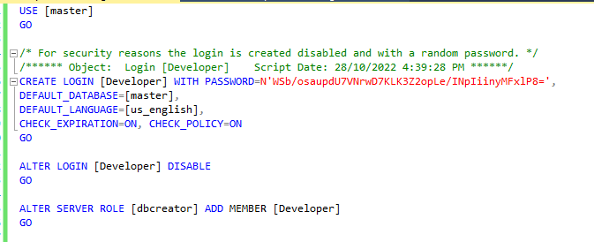

Create the Developer Login and give that login the db_creator role so that it can have access to everything.

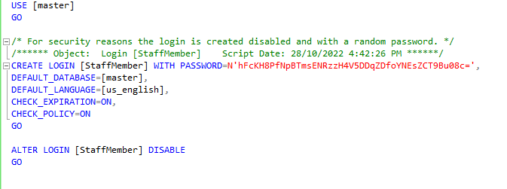

Create the staff member login and give it the db_datareader role to allow only reading the views and stored procedures.

Deny all premmisions to ensure that anyone logged in with the role of staffMember will not be able to do anything but select the views provided.